United States
SECURITIES AND EXCHANGE COMMISSION
Washington, D.C. 20549

Form 8-K

Current Report
Pursuant to Section 13 or 15(d) of the
Securities Exchange Act of 1934

August 6, 2026
Date of Report (Date of earliest event reported)



Priority Technology Holdings, Inc.
(Exact Name of Registrant as Specified in its Charter)

Delaware |  |  |  |  |  | 001-37872 |  |  |  |  |  | 47-4257046
(State or other jurisdiction of incorporation) |  |  |  |  |  | (Commission File Number) |  |  |  |  |  | (I.R.S. Employer Identification No.)

2001 Westside Parkway
Suite 155
Alpharetta, |  |  | Georgia |  |  |  |  |  | 30004
(Address of Principal Executive Offices) |  |  |  |  |  |  |  |  | (Zip Code)

Registrant's telephone number, including area code: (800) 935-5961

(Former name or former address, if changed since last report)

Check the appropriate box below if the Form 8-K filing is intended to simultaneously satisfy the filing obligation of the registrant under any of the following provisions (see General Instruction A.2. below):

☐ Written communications pursuant to Rule 425 under the Securities Act (17 CFR 230.425)

☐ Soliciting material pursuant to Rule 14a-12 under the Exchange Act (17 CFR 240.14a-12)

☐ Pre-commencement communications pursuant to Rule 14d-2(b) under the Exchange Act (17 CFR 240.14d-2(b))

☐ Pre-commencement communications pursuant to Rule 13e-4(c) under the Exchange Act (17 CFR 240.13e-4(c))

Securities registered pursuant to Section 12(b) of the Act:
Title of each class |  |  |  |  |  | Trading Symbol |  |  |  |  |  | Name of each exchange on which registered
Common stock, $0.001 par value |  |  |  |  |  | PRTH |  |  |  |  |  | NASDAQ

Indicate by check mark whether the registrant is an emerging growth company as defined in Rule 405 of the Securities Act of (1933 §230.405 of this chapter) or Rule 12b-2 of the Securities Exchange Act of 1934 (§240.12b-2 of this chapter).

Emerging growth company ☐

If an emerging growth company, indicate by check mark if the registrant has elected not to use the extended transition period for complying with any new or revised financial accounting standards provided pursuant to Section 13(a) of the Exchange Act. ☐

Item 2.02. Results of Operations and Financial Condition.
On August 6, 2026, Priority Technology Holdings, Inc. ("Priority Commerce") issued a press release announcing its financial results for the quarter ended June 30, 2026. A copy of that press release is attached as Exhibit 99.1 to this Current Report on Form 8-K.
Item 7.01. Regulation FD Disclosure.
On August 6, 2026, Priority Commerce will hold an earnings conference call and webcast at 10:00 a.m. (Eastern Time) to discuss the financial results for the quarter ended June 30, 2026. The press release referenced in Item 2.02 contains information about how to access the conference call and webcast. A copy of the slide presentation to be used during the earnings call and webcast is furnished as Exhibit 99.2 to this Current Report on Form 8-K. The slide presentation also will be available on our website, www.prioritycommerce.com under the "Investor Relations" section.
The information in this Current Report on Form 8-K, including Exhibit 99.1, is being furnished and shall not be deemed "filed" for the purposes of Section 18 of the Securities Exchange Act of 1934, as amended, or otherwise subject to the liabilities of that Section. The information in this Current Report on Form 8-K shall not be incorporated by reference into any registration statement or other document filed pursuant to the Securities Act of 1933, as amended.
Item 9.01. Financial Statements and Exhibits.
(d) Exhibits – The following exhibit is furnished as part of this Current Report on Form 8-K.
Exhibit Number |  |  | Description
99.1 |  |  | Press Release of Priority Technology Holdings, Inc. dated August 6, 2026
99.2 |  |  | Supplemental slide presentation
104 |  |  | The cover page from this Current Report on Form 8-K, formatted in Inline XBRL

SIGNATURE

Pursuant to the requirements of the Securities Exchange Act of 1934, the registrant has duly caused this report to be signed on its behalf by the undersigned hereunto duly authorized.

Dated: August 6, 2026
PRIORITY TECHNOLOGY HOLDINGS, INC.
By: /s/ Timothy M. O'Leary
Name: Timothy M. O'Leary
Title: Chief Financial Officer

EXHIBIT 99.1

Priority Technology Holdings, Inc. Reports Second Quarter Financial Results
Second Quarter Performance Driven by Strength of Unified Commerce Platform
ALPHARETTA, GA - August 6, 2026 -- Priority Technology Holdings, Inc. (NASDAQ: PRTH) ("Priority Commerce" or the "Company"), delivers payments and banking solutions that power connected commerce. Through a unified platform of payables, merchant services, and banking and treasury, Priority Commerce helps businesses manage money more effectively and unlock growth. The Priority Commerce Engine accelerates cash flow, improves working capital, reduces costs, and creates new revenue opportunities and today has announced its second quarter 2026 financial results including strong year-over-year revenue growth.
Highlights of Consolidated Results and Additional Information1
Second Quarter 2026 Financial Highlights compared with Second Quarter 2025
•Revenue of $262.3 million increased 9.4% from $239.8 million, including organic growth of 7.2%
•Gross profit of $94.4 million increased 7.9% from $87.5 million
•Adjusted gross profit (a non-GAAP measure2) of $99.9 million increased 8.1% from $92.4 million
•Gross profit margin of 36.0% decreased by nearly 50 basis points from 36.5%
•Adjusted gross profit margin (a non-GAAP measure2) of 38.1% decreased by nearly 40 basis points from 38.5%
•Operating income of $33.0 million decreased 11.8% from $37.4 million
•Net Income of $9.9 million decreased 9.3% from $10.9 million
•Adjusted EBITDA (a non-GAAP measure2) of $59.4 million increased 6.0% from $56.0 million
•Diluted EPS of $0.12 decreased by $0.02, or by 14.3%, from $0.14
•Adjusted Diluted EPS (a non-GAAP measure2) of $0.29 increased by $0.03, or 11.5%, from $0.26
(1)Certain amounts/percentages may not compute accurately due to rounding.
(2)See "Non-GAAP Financial Measures" and the reconciliations of Adjusted Gross Profit (non-GAAP), Adjusted Gross Profit Margin (non-GAAP), Adjusted EBITDA (non-GAAP), and Adjusted EPS- diluted (non-GAAP) to their most comparable GAAP measures provided within this document for additional information.
"Strong second quarter results reflect the continued success of Priority’s Connected Commerce engine, with over 9% revenue growth and 8% adjusted gross profit growth,” said Tom Priore, Chairman & CEO of Priority. “The growing base of partners leveraging our platform for payments and treasury solutions to improve visibility into their financial environment with total command of their cashflow reinforces our belief in our vision for the future of commerce and confidence to affirm our full year 2026 financial guidance.”
EXHIBIT 99.1
1

Full Year 2026 Financial Guidance
Priority Commerce's outlook remains strong and we affirm our full year 2026 guidance:
•Revenue forecast to range between $1.01 billion to $1.04 billion, a growth rate of 6% to 9% compared to fiscal 2025 results
•Adjusted gross profit (a non-GAAP measure) forecast to range between $405 million and $425 million
•Adjusted EBITDA (a non-GAAP measure) forecast to range between $230 million to $245 million
Conference Call
The Company will host a conference call on Thursday, August 6, 2026 at 10:00 a.m. EDT to discuss its second quarter financial results. Participants can access the call by phone in the U.S. or Canada at (833) 636-1319 or internationally at (412) 902-4286.
The Internet webcast link and accompanying slide presentation can be accessed at https://viavid.webcasts.com/starthere.jsp?ei=1770268&tp_key=a6ff1aab23 and will also be posted in the "Investor Relations" section of the Company's website at https://ir.prioritycommerce.com/.
An audio replay of the call will be available shortly after the conference call until August 20, 2026, at 11:59 p.m. EDT. To listen to the audio replay, dial (844) 512-2921 or (412) 317-6671 and enter conference ID number 10210738. Alternatively, you may access the webcast replay in the "Investor Relations" section of the Company's website at https://ir.prioritycommerce.com.

Non-GAAP Financial Measures
This communication includes certain non-GAAP financial measures that we regularly review to evaluate our business and trends, measure our performance, prepare financial projections, allocate resources, and make strategic decisions. We believe these non-GAAP measures help to illustrate the underlying financial and business trends relating to our results of operations and comparability between current and prior periods. We also use these non-GAAP measures to establish and monitor operational goals. However, these non-GAAP measures are not superior to or a substitute for prominent measurements calculated in accordance with GAAP. Rather, the non-GAAP measures are meant to be a complement to understanding measures prepared in accordance with GAAP.
EXHIBIT 99.1
2
Adjusted Gross Profit and Adjusted Gross Profit Margin
The Company's adjusted gross profit metric represents revenues less cost of revenue (excluding depreciation and amortization). Adjusted gross profit margin is adjusted gross profit divided by revenues. We review these non-GAAP measures to evaluate our underlying profit trends. The reconciliation of adjusted gross profit to its most comparable GAAP measure is provided below:
(in thousands) |  |  | Three Months Ended June 30, |  |  |  |  |  |  |  |  |  |  |  | Six Months Ended June 30,
 |  |  | 2026 |  |  |  |  |  | 2025 |  |  |  |  |  | 2026 |  |  |  |  |  | 2025
Revenues |  |  | $ | 262,256 |  |  |  |  | $ | 239,812 |  |  |  |  | $ | 511,814 |  |  |  |  | $ | 464,442
Cost of revenue (excluding depreciation and amortization) |  |  | (162,358) |  |  |  |  |  | (147,399) |  |  |  |  |  | (313,145) |  |  |  |  |  | (284,752)
Adjusted gross profit |  |  | $ | 99,898 |  |  |  |  | $ | 92,413 |  |  |  |  | $ | 198,669 |  |  |  |  | $ | 179,690
Adjusted gross profit margin |  |  | 38.1 |  | % |  |  |  | 38.5 |  | % |  |  |  | 38.8 |  | % |  |  |  | 38.7 |  | %
Depreciation and amortization of revenue generating assets |  |  | (5,469) |  |  |  |  |  | (4,911) |  |  |  |  |  | (10,743) |  |  |  |  |  | (9,597)
Gross profit |  |  | $ | 94,429 |  |  |  |  | $ | 87,502 |  |  |  |  | $ | 187,926 |  |  |  |  | $ | 170,093
Gross profit margin |  |  | 36.0 |  | % |  |  |  | 36.5 |  | % |  |  |  | 36.7 |  | % |  |  |  | 36.6 |  | %

EBITDA and Adjusted EBITDA
EBITDA and adjusted EBITDA are performance measures. EBITDA is earnings before interest, income tax, depreciation, and amortization expenses ("EBITDA"). Adjusted EBITDA begins with EBITDA but further excludes certain non-cash costs, such as stock-based compensation and the write-off of the carrying value of investments or other assets, as well as debt extinguishment and modification expenses and other expenses and income items considered non-recurring, such as acquisition integration expenses, certain professional fees, and litigation settlements. We review the non-GAAP adjusted EBITDA measure to evaluate our business and trends, measure our performance, prepare financial projections, allocate resources, and make strategic decisions.
The reconciliation of adjusted EBITDA to its most comparable GAAP measure is provided below:
(in thousands) |  |  | Three Months Ended June 30, |  |  |  |  |  |  |  |  |  |  |  | Six Months Ended June 30,
 |  |  | 2026 |  |  |  |  |  | 2025 |  |  |  |  |  | 2026 |  |  |  |  |  | 2025
Net income |  |  | $ | 9,863 |  |  |  |  | $ | 10,879 |  |  |  |  | $ | 19,623 |  |  |  |  | $ | 19,147
Interest expense |  |  | 21,051 |  |  |  |  |  | 23,054 |  |  |  |  |  | 42,067 |  |  |  |  |  | 46,230
Income tax expense |  |  | 3,774 |  |  |  |  |  | 4,423 |  |  |  |  |  | 7,420 |  |  |  |  |  | 6,673
Depreciation and amortization |  |  | 20,893 |  |  |  |  |  | 14,093 |  |  |  |  |  | 38,508 |  |  |  |  |  | 27,870
EBITDA |  |  | 55,581 |  |  |  |  |  | 52,449 |  |  |  |  |  | 107,618 |  |  |  |  |  | 99,920
Debt modification and extinguishment expenses |  |  | — |  |  |  |  |  | — |  |  |  |  |  | — |  |  |  |  |  | 38
Selling, general and administrative (non-recurring) |  |  | 1,531 |  |  |  |  |  | 395 |  |  |  |  |  | 5,500 |  |  |  |  |  | 2,594
Non-cash stock-based compensation |  |  | 2,283 |  |  |  |  |  | 3,206 |  |  |  |  |  | 4,371 |  |  |  |  |  | 4,792
Adjusted EBITDA |  |  | $ | 59,395 |  |  |  |  | $ | 56,050 |  |  |  |  | $ | 117,489 |  |  |  |  | $ | 107,344

EXHIBIT 99.1
3

Further detail of certain of these adjustments, and where these items are recorded in our consolidated statements of operations, is provided below:

(in thousands) |  |  | Three Months Ended June 30, |  |  |  |  |  |  |  |  |  |  |  | Six Months Ended June 30,
 |  |  | 2026 |  |  |  |  |  | 2025 |  |  |  |  |  | 2026 |  |  |  |  |  | 2025
Selling, general and administrative expenses (non-recurring):
Legal fees(1) |  |  | 1,385 |  |  |  |  |  | 314 |  |  |  |  |  | 3,210 |  |  |  |  |  | 1,610
Professional, accounting and consulting fees(2) |  |  | 42 |  |  |  |  |  | 64 |  |  |  |  |  | 2,105 |  |  |  |  |  | 1,108
Other expenses, net(3) |  |  | 104 |  |  |  |  |  | 17 |  |  |  |  |  | 185 |  |  |  |  |  | 36
Litigation settlement |  |  | — |  |  |  |  |  | — |  |  |  |  |  | — |  |  |  |  |  | (160)
 |  |  | $ | 1,531 |  |  |  |  | $ | 395 |  |  |  |  | $ | 5,500 |  |  |  |  | $ | 2,594
(1) These legal expenses primarily relate to litigation matters, mergers and acquisitions, and other transactions (e.g., the on-going special committee process), all of which are non-recurring in nature.
(2) These professional, accounting, and consulting fees are associated with non-recurring projects, including professional fees and incremental audit fees incurred for valuation and audit work related to the on-going special committee process, acquisitions, disposals, and automation initiatives.
(3) These other expenses primarily include non-recurring director and management fees related to the on-going special committee process as well as non-recurring fees for web and security hosting, and software licenses.

EXHIBIT 99.1
4
Adjusted Earnings Per Share (Adjusted EPS)

Adjusted EPS is a performance measure. Adjusted EPS is calculated by dividing adjusted net income attributable to common shareholders by weighted average number shares outstanding for the respective periods.

Adjusted net income attributable to common shareholders begins with net income attributable to common shareholders adjusted to exclude various items listed below. We believe adjusted EPS is a measure that is useful to investors and management in understanding our ongoing profitability and in analysis of ongoing profitability trends.
(in thousands) |  |  |  |  |  | Three Months Ended June 30, |  |  |  |  |  |  |  |  |  |  |  | Six Months Ended June 30,
 |  |  |  |  |  | 2026 |  |  |  |  |  | 2025 |  |  |  |  |  | 2026 |  |  |  |  |  | 2025
Reconciliation of Adjusted EPS
Net income attributable to common shareholders |  |  |  |  |  | $ | 9,863 |  |  |  |  | $ | 10,879 |  |  |  |  | $ | 19,623 |  |  |  |  | $ | 19,147
Debt extinguishment and modification costs |  |  |  |  |  | — |  |  |  |  |  | — |  |  |  |  |  | — |  |  |  |  |  | 38
Stock based compensation |  |  |  |  |  | 2,283 |  |  |  |  |  | 3,206 |  |  |  |  |  | 4,371 |  |  |  |  |  | 4,792
Other non-recurring expenses |  |  |  |  |  | 1,531 |  |  |  |  |  | 395 |  |  |  |  |  | 5,500 |  |  |  |  |  | 2,594
Amortization of acquisition related intangible assets |  |  |  |  |  | 15,742 |  |  |  |  |  | 9,417 |  |  |  |  |  | 28,365 |  |  |  |  |  | 18,731
Tax impact of adjustments(1) |  |  |  |  |  | (5,084) |  |  |  |  |  | (3,244) |  |  |  |  |  | (9,941) |  |  |  |  |  | (6,800)
Adjusted net income attributable to common share holders |  |  |  |  |  | $ | 24,335 |  |  |  |  | $ | 20,653 |  |  |  |  | $ | 47,918 |  |  |  |  | $ | 38,502
Weighted average common shares outstanding (basic) |  |  |  |  |  | 81,549 |  |  |  |  |  | 78,981 |  |  |  |  |  | 81,462 |  |  |  |  |  | 78,878
Effect of dilutive potential common shares |  |  |  |  |  | 2,274 |  |  |  |  |  | 856 |  |  |  |  |  | 2,274 |  |  |  |  |  | 1,090
Weighted average common shares outstanding (diluted) |  |  |  |  |  | 83,823 |  |  |  |  |  | 79,837 |  |  |  |  |  | 83,736 |  |  |  |  |  | 79,968
Earnings per common share:
Basic |  |  |  |  |  | $ | 0.12 |  |  |  |  | $ | 0.14 |  |  |  |  | $ | 0.24 |  |  |  |  | $ | 0.24
Diluted |  |  |  |  |  | $ | 0.12 |  |  |  |  | $ | 0.14 |  |  |  |  | $ | 0.23 |  |  |  |  | $ | 0.24
Adjusted earnings per common share
Basic |  |  |  |  |  | $ | 0.30 |  |  |  |  | $ | 0.26 |  |  |  |  | $ | 0.59 |  |  |  |  | $ | 0.49
Diluted |  |  |  |  |  | $ | 0.29 |  |  |  |  | $ | 0.26 |  |  |  |  | $ | 0.57 |  |  |  |  | $ | 0.48
(1) The tax impact calculated using the blended statutory income tax rate (i.e. 26.0% for three and six months ended June 30, 2026 and 2025)

EXHIBIT 99.1
5
Priority Commerce does not provide a reconciliation of forward-looking non-GAAP financial measures to their comparable GAAP financial measures because it could not do so without unreasonable effort due to the unavailability of the information needed to calculate reconciling items and due to the variability, complexity and limited visibility of the adjusting items that would be excluded from the non-GAAP financial measures in future periods. When planning, forecasting and analyzing future periods, the Company does so primarily on a non-GAAP basis without preparing a GAAP analysis as that would require estimates for various cash and non-cash reconciling items that would be difficult to predict with reasonable accuracy. For example, stock-based compensation expense would be difficult to estimate because it depends on the Company's future hiring and retention needs, as well as the future fair market value of the Company's common stock, all of which are difficult to predict and subject to constant change. As a result, the Company does not believe that a GAAP reconciliation would provide meaningful supplemental information about the Company's outlook.

EXHIBIT 99.1
6

About Priority Commerce
Priority Commerce delivers payments and banking solutions that power connected commerce. Through a unified platform of payables, merchant services, and banking and treasury, we help businesses manage money more effectively and unlock growth. The Priority Commerce Engine accelerates cash flow, improves working capital, reduces costs, and creates new revenue opportunities. Learn more about Priority Commerce (NASDAQ: PRTH) at prioritycommerce.com
Forward-Looking Statements
This press release contains "forward-looking statements" within the meaning of the Private Securities Litigation Reform Act of 1995. Such statements include, but are not limited to, statements about future financial and operating results, our plans, objectives, expectations and intentions with respect to future operations, products and services, and other statements identified by words such as "may," "will," "should," "anticipates," "believes," "expects," "plans," "future," "intends," "could," "estimate," "predict," "projects," "targeting," "potential" or "contingent," "guidance," "outlook" or words of similar meaning. These forward-looking statements include, but are not limited to, our 2026 outlook and statements regarding our market and growth opportunities. Such forward-looking statements are based upon the current beliefs and expectations of our management and are inherently subject to significant business, economic and competitive risks, trends and uncertainties that could cause actual results to differ materially from those projected, expressed, or implied by such forward-looking statements. Our actual results could differ materially, and potentially adversely, from those discussed or implied herein.
We caution that it is very difficult to predict the impact of known factors, and it is impossible for us to anticipate all factors that could affect our actual results. All forward-looking statements are expressly qualified in their entirety by these cautionary statements. You should evaluate all forward-looking statements made in this press release in the context of the risks and uncertainties disclosed in our SEC filings, including our most recent Annual Report on Form 10-K filed with the SEC on March 10, 2026. These filings are available online at www.sec.gov or www.prioritycommerce.com.
We caution you that the important factors referenced above may not contain all of the factors that are important to you. In addition, we cannot assure you that we will realize the results or developments we expect or anticipate or, even if substantially realized, that they will result in the consequences we anticipate or affect us or our operations in the way we expect. You are cautioned not to place undue reliance on forward-looking statements as a predictor of future performance. The forward-looking statements included in this press release are made only as of the date hereof. We undertake no obligation to publicly update or revise any forward-looking statement as a result of new information, future events or otherwise, except as otherwise required by law. If we do update one or more forward-looking statements, no inference should be made that we will make additional updates with respect to those or other forward-looking statements. We qualify all of our forward-looking statements by these cautionary statements.
Priority Commerce Investor Inquiries:
priorityIR@icrinc.com

7
Priority Technology Holdings, Inc.
Unaudited Consolidated Statements of Operations and Comprehensive Income
(in thousands, except per share amounts)

 |  |  | Three Months Ended June 30, |  |  |  |  |  |  |  |  |  |  |  | Six Months Ended June 30,
 |  |  | 2026 |  |  |  |  |  | 2025 |  |  |  |  |  | 2026 |  |  |  |  |  | 2025
Revenues |  |  | $ | 262,256 |  |  |  |  | $ | 239,812 |  |  |  |  | $ | 511,814 |  |  |  |  | $ | 464,442
Operating expenses
Cost of revenue (excludes depreciation and amortization) |  |  | 162,358 |  |  |  |  |  | 147,399 |  |  |  |  |  | 313,145 |  |  |  |  |  | 284,752
Salary and employee benefits |  |  | 29,153 |  |  |  |  |  | 27,060 |  |  |  |  |  | 57,675 |  |  |  |  |  | 52,835
Depreciation and amortization |  |  | 20,893 |  |  |  |  |  | 14,093 |  |  |  |  |  | 38,508 |  |  |  |  |  | 27,870
Selling, general and administrative |  |  | 16,808 |  |  |  |  |  | 13,910 |  |  |  |  |  | 36,052 |  |  |  |  |  | 29,010
Total operating expenses |  |  | 229,212 |  |  |  |  |  | 202,462 |  |  |  |  |  | 445,380 |  |  |  |  |  | 394,467
Operating income |  |  | 33,044 |  |  |  |  |  | 37,350 |  |  |  |  |  | 66,434 |  |  |  |  |  | 69,975
Other expense
Interest expense |  |  | (21,051) |  |  |  |  |  | (23,054) |  |  |  |  |  | (42,067) |  |  |  |  |  | (46,230)
Debt extinguishment and modification costs |  |  | — |  |  |  |  |  | — |  |  |  |  |  | — |  |  |  |  |  | (38)
Other income, net |  |  | 1,644 |  |  |  |  |  | 1,006 |  |  |  |  |  | 2,676 |  |  |  |  |  | 2,113
Total other expense, net |  |  | (19,407) |  |  |  |  |  | (22,048) |  |  |  |  |  | (39,391) |  |  |  |  |  | (44,155)
Income before income taxes |  |  | 13,637 |  |  |  |  |  | 15,302 |  |  |  |  |  | 27,043 |  |  |  |  |  | 25,820
Income tax expense |  |  | 3,774 |  |  |  |  |  | 4,423 |  |  |  |  |  | 7,420 |  |  |  |  |  | 6,673
Net income attributable to common stockholders |  |  | $ | 9,863 |  |  |  |  | $ | 10,879 |  |  |  |  | $ | 19,623 |  |  |  |  | $ | 19,147
Other comprehensive income
Foreign currency translation adjustments |  |  | (111) |  |  |  |  |  | 217 |  |  |  |  |  | (464) |  |  |  |  |  | 260
Comprehensive income |  |  | $ | 9,752 |  |  |  |  | $ | 11,096 |  |  |  |  | $ | 19,159 |  |  |  |  | $ | 19,407
Earnings per common share:
Basic |  |  | $ | 0.12 |  |  |  |  | $ | 0.14 |  |  |  |  | $ | 0.24 |  |  |  |  | $ | 0.24
Diluted |  |  | $ | 0.12 |  |  |  |  | $ | 0.14 |  |  |  |  | $ | 0.23 |  |  |  |  | $ | 0.24
Adjusted earnings per common share(1):
Basic |  |  | $ | 0.30 |  |  |  |  | $ | 0.26 |  |  |  |  | $ | 0.59 |  |  |  |  | $ | 0.49
Diluted |  |  | $ | 0.29 |  |  |  |  | $ | 0.26 |  |  |  |  | $ | 0.57 |  |  |  |  | $ | 0.48
Weighted-average common shares outstanding:
Basic |  |  | 81,549 |  |  |  |  |  | 78,981 |  |  |  |  |  | 81,462 |  |  |  |  |  | 78,878
Diluted |  |  | 83,823 |  |  |  |  |  | 79,837 |  |  |  |  |  | 83,736 |  |  |  |  |  | 79,968

(1)Adjusted EPS in a non-GAAP earnings measure. See Adjusted EPS reconciliation for further detail.

8
Priority Technology Holdings, Inc.
Unaudited Consolidated Balance Sheets

(in thousands)
 |  |  | June 30, 2026 |  |  |  |  |  | December 31, 2025
Assets
Current assets:
Cash and cash equivalents |  |  | $ | 120,261 |  |  |  |  | $ | 77,192
Restricted cash |  |  | 17,439 |  |  |  |  |  | 16,457
Accounts receivable, net of allowances |  |  | 93,075 |  |  |  |  |  | 91,300
Prepaid expenses and other current assets |  |  | 28,161 |  |  |  |  |  | 32,145
Current portion of notes receivable, net of allowance |  |  | 1,751 |  |  |  |  |  | 2,062
Settlement assets |  |  | 1,372,510 |  |  |  |  |  | 1,295,896
Total current assets |  |  | 1,633,197 |  |  |  |  |  | 1,515,052
Notes receivable, less current portion |  |  | 20,952 |  |  |  |  |  | 17,629
Property, equipment and software, net |  |  | 62,329 |  |  |  |  |  | 58,636
Goodwill |  |  | 416,405 |  |  |  |  |  | 416,641
Intangible assets, net |  |  | 287,633 |  |  |  |  |  | 315,190
Deferred income taxes, net |  |  | 46,677 |  |  |  |  |  | 46,350
Other noncurrent assets |  |  | 29,198 |  |  |  |  |  | 29,306
Total assets |  |  | $ | 2,496,391 |  |  |  |  | $ | 2,398,804
Liabilities, Stockholders' Deficit and Non-controlling interest
Current liabilities:
Accounts payable and accrued expenses |  |  | $ | 57,520 |  |  |  |  | $ | 70,636
Accrued residual commissions |  |  | 44,415 |  |  |  |  |  | 40,463
Customer deposits and advance payments |  |  | 1,637 |  |  |  |  |  | 1,972
Current portion of long-term debt |  |  | 3,112 |  |  |  |  |  | —
Settlement obligations |  |  | 1,374,736 |  |  |  |  |  | 1,297,263
Total current liabilities |  |  | 1,481,420 |  |  |  |  |  | 1,410,334
Long-term debt, net of current portion, discounts and debt issuance costs |  |  | 1,044,685 |  |  |  |  |  | 1,039,358
Other noncurrent liabilities |  |  | 41,337 |  |  |  |  |  | 41,484
Total liabilities |  |  | 2,567,442 |  |  |  |  |  | 2,491,176
Stockholders' deficit:
Preferred stock |  |  | — |  |  |  |  |  | —
Common stock |  |  | 82 |  |  |  |  |  | 82
Treasury stock, at cost |  |  | (24,282) |  |  |  |  |  | (22,759)
Additional paid-in capital |  |  | 17,538 |  |  |  |  |  | 13,925
Accumulated other comprehensive loss |  |  | (674) |  |  |  |  |  | (210)
Accumulated deficit |  |  | (71,830) |  |  |  |  |  | (91,453)
Total stockholders' deficit attributable to stockholders of Priority Commerce |  |  | (79,166) |  |  |  |  |  | (100,415)
Non-controlling interests in consolidated subsidiaries |  |  | 8,115 |  |  |  |  |  | 8,043
Total stockholders' deficit |  |  | (71,051) |  |  |  |  |  | (92,372)
Total liabilities, stockholders' deficit and Non-controlling interest |  |  | $ | 2,496,391 |  |  |  |  | $ | 2,398,804

Priority Technology Holdings, Inc.
9
Unaudited Consolidated Statements of Cash Flows
(in thousands)
 |  |  | Six Months Ended June 30,
 |  |  | 2026 |  |  |  |  |  | 2025
Cash flows from operating activities:
Net income |  |  | $ | 19,623 |  |  |  |  | $ | 19,147
Adjustments to reconcile net income to net cash provided by operating activities:
Depreciation and amortization of assets |  |  | 38,508 |  |  |  |  |  | 27,870
Stock-based compensation, ESPP, and incentive units compensation |  |  | 4,371 |  |  |  |  |  | 4,792
Amortization of debt issuance costs and discounts |  |  | 949 |  |  |  |  |  | 882
Debt extinguishment and modification costs |  |  | — |  |  |  |  |  | 38
Deferred income tax |  |  | (327) |  |  |  |  |  | (2,318)
Change in contingent consideration |  |  | (679) |  |  |  |  |  | 2,039
Other non-cash items, net |  |  | (136) |  |  |  |  |  | (228)
Change in operating assets and liabilities:
Accounts receivable |  |  | (1,775) |  |  |  |  |  | (17,912)
Prepaid expenses and other current assets |  |  | (1,146) |  |  |  |  |  | (2,312)
Income taxes |  |  | 5,081 |  |  |  |  |  | (339)
Accounts payable and accrued expenses |  |  | (13,002) |  |  |  |  |  | (6,810)
Accrued residual commissions |  |  | 3,952 |  |  |  |  |  | 2,966
Customer deposits and advance payments |  |  | (335) |  |  |  |  |  | 1,187
Other assets, net |  |  | 433 |  |  |  |  |  | 1,043
Other liabilities, net |  |  | (172) |  |  |  |  |  | (2,965)
Net cash provided by operating activities |  |  | 55,345 |  |  |  |  |  | 27,080
Cash flows from investing activities:
Acquisition of business, net of cash acquired |  |  | — |  |  |  |  |  | (4,452)
Additions to property, equipment and software |  |  | (12,612) |  |  |  |  |  | (12,988)
Notes receivable, net |  |  | (3,012) |  |  |  |  |  | (1,430)
Short-term investments, net |  |  | (185,000) |  |  |  |  |  | —
Other investing activities |  |  | (2,400) |  |  |  |  |  | (2,275)
Net cash used in investing activities |  |  | (203,024) |  |  |  |  |  | (21,145)
Cash flows from financing activities:
Proceeds from issuance of long-term debt |  |  | 7,681 |  |  |  |  |  | —
Debt issuance and modification costs paid |  |  | — |  |  |  |  |  | (40)
Repayments of long-term debt |  |  | (191) |  |  |  |  |  | (10,000)
Shares withheld for taxes |  |  | (1,523) |  |  |  |  |  | (2,314)
Proceeds from exercise of stock options |  |  | — |  |  |  |  |  | 334
Settlement obligations, net |  |  | 77,359 |  |  |  |  |  | 190,863
Payment of deferred/contingent consideration |  |  | (96) |  |  |  |  |  | (752)
Net cash provided by financing activities |  |  | 83,230 |  |  |  |  |  | 178,091
Net change in cash and cash equivalents and restricted cash:
Net (decrease)/increase in cash and cash equivalents, and restricted cash |  |  | (64,449) |  |  |  |  |  | 184,026
Cash and cash equivalents and restricted cash at beginning of period |  |  | 1,345,998 |  |  |  |  |  | 993,864
Cash and cash equivalents and restricted cash at end of period |  |  | $ | 1,281,549 |  |  |  |  | $ | 1,177,890
Reconciliation of cash and cash equivalents, and restricted cash:
Cash and cash equivalents |  |  | $ | 120,261 |  |  |  |  | $ | 50,564
Restricted cash |  |  | 17,439 |  |  |  |  |  | 14,205
Cash and cash equivalents included in settlement assets (restricted in nature) |  |  | 1,143,849 |  |  |  |  |  | 1,113,121
Total cash and cash equivalents, and restricted cash |  |  | $ | 1,281,549 |  |  |  |  | $ | 1,177,890

Priority Technology Holdings, Inc.
10
Unaudited Reportable Segments' Results
(in thousands)

 |  |  | Three Months Ended June 30, |  |  |  |  |  |  |  |  |  |  |  | Six Months Ended June 30,
 |  |  | 2026 |  |  |  |  |  | 2025 |  |  |  |  |  | 2026 |  |  |  |  |  | 2025
Merchant Solutions:
Revenues |  |  | $ | 175,778 |  |  |  |  | $ | 163,230 |  |  |  |  | $ | 337,564 |  |  |  |  | $ | 314,920
Adjusted EBITDA |  |  | $ | 30,887 |  |  |  |  | $ | 27,749 |  |  |  |  | $ | 58,627 |  |  |  |  | $ | 53,454
Key Indicators:
Total card processing dollar value |  |  | $ | 19,549,972 |  |  |  |  | $ | 18,864,185 |  |  |  |  | $ | 37,886,641 |  |  |  |  | $ | 36,560,510
Total card transaction count |  |  | 228,600 |  |  |  |  |  | 230,721 |  |  |  |  |  | 440,039 |  |  |  |  |  | 439,674
Payables:
Revenues |  |  | $ | 30,430 |  |  |  |  | $ | 25,033 |  |  |  |  | $ | 62,871 |  |  |  |  | $ | 48,951
Adjusted EBITDA |  |  | $ | 3,110 |  |  |  |  | $ | 3,770 |  |  |  |  | $ | 8,564 |  |  |  |  | $ | 7,286
Key Indicators:
Buyer funded card processing dollar value |  |  | $ | 942,660 |  |  |  |  | $ | 788,500 |  |  |  |  | $ | 1,915,570 |  |  |  |  | $ | 1,505,400
Supplier funded issuing dollar value |  |  | $ | 255,414 |  |  |  |  | $ | 220,227 |  |  |  |  | $ | 497,801 |  |  |  |  | $ | 457,517
ACH transaction count |  |  | 4,726 |  |  |  |  |  | 4,776 |  |  |  |  |  | 9,785 |  |  |  |  |  | 9,417
Treasury Solutions:
Revenues |  |  | $ | 60,519 |  |  |  |  | $ | 52,658 |  |  |  |  | $ | 119,359 |  |  |  |  | $ | 102,746
Adjusted EBITDA |  |  | $ | 47,513 |  |  |  |  | $ | 45,558 |  |  |  |  | $ | 94,184 |  |  |  |  | $ | 88,001
Key Indicators:
Average CFTPay billed clients |  |  | 1,142,908 |  |  |  |  |  | 992,279 |  |  |  |  |  | 1,135,922 |  |  |  |  |  | 966,371
Average CFTPay monthly enrollments |  |  | 46,083 |  |  |  |  |  | 57,818 |  |  |  |  |  | 48,256 |  |  |  |  |  | 56,882
Average total account balances(1) |  |  | $ | 1,475,537 |  |  |  |  | $ | 1,145,715 |  |  |  |  | $ | 1,447,412 |  |  |  |  | $ | 1,093,530
(1) This represents the average total account balance in the Treasury Solutions segment, and excludes the deposits maintained in the Merchant Solutions and Payables segments. The total account and deposit balances as of June 30, 2026 and 2025, were $1.8 billion and $1.4 billion, respectively.

Priority Technology Holdings, Inc.
11
Unaudited Reportable Segments' Results
(in thousands)

 |  |  |  |  |  | Three Months Ended June 30, 2026
 |  |  |  |  |  | Merchant Solutions |  |  |  |  |  | Payables |  |  |  |  |  | Treasury Solutions |  |  |  |  |  | Corporate |  |  |  |  |  | Total
Reconciliation of Adjusted EBITDA to GAAP Measure:
Adjusted EBITDA |  |  |  |  |  | $ | 30,887 |  |  |  |  | $ | 3,110 |  |  |  |  | $ | 47,513 |  |  |  |  | $ | (22,115) |  |  |  |  | $ | 59,395
Interest expense |  |  |  |  |  | (1,147) |  |  |  |  |  | — |  |  |  |  |  | (256) |  |  |  |  |  | (19,648) |  |  |  |  |  | (21,051)
Depreciation and amortization |  |  |  |  |  | (13,094) |  |  |  |  |  | (1,289) |  |  |  |  |  | (5,297) |  |  |  |  |  | (1,213) |  |  |  |  |  | (20,893)
Selling, general and administrative (non-recurring) |  |  |  |  |  | — |  |  |  |  |  | — |  |  |  |  |  | — |  |  |  |  |  | (1,531) |  |  |  |  |  | (1,531)
Non-cash stock based compensation |  |  |  |  |  | — |  |  |  |  |  | (36) |  |  |  |  |  | — |  |  |  |  |  | (2,247) |  |  |  |  |  | (2,283)
Income (loss) before taxes |  |  |  |  |  | $ | 16,646 |  |  |  |  | $ | 1,785 |  |  |  |  | $ | 41,960 |  |  |  |  | $ | (46,754) |  |  |  |  | $ | 13,637
Income tax expense |  |  |  |  |  |  |  |  |  |  |  |  |  |  |  |  |  |  |  |  |  |  |  |  |  |  |  |  |  | (3,774)
Net income |  |  |  |  |  |  |  |  |  |  |  |  |  |  |  |  |  |  |  |  |  |  |  |  |  |  |  |  |  | $ | 9,863
 |  |  |  |  |  | Six Months Ended June 30, 2026
 |  |  |  |  |  | Merchant Solutions |  |  |  |  |  | Payables |  |  |  |  |  | Treasury Solutions |  |  |  |  |  | Corporate |  |  |  |  |  | Total
Reconciliation of Adjusted EBITDA to GAAP Measure:
Adjusted EBITDA |  |  |  |  |  | $ | 58,627 |  |  |  |  | $ | 8,564 |  |  |  |  | $ | 94,184 |  |  |  |  | $ | (43,886) |  |  |  |  | $ | 117,489
Interest expense |  |  |  |  |  | (2,229) |  |  |  |  |  | — |  |  |  |  |  | (669) |  |  |  |  |  | (39,169) |  |  |  |  |  | (42,067)
Depreciation and amortization |  |  |  |  |  | (23,011) |  |  |  |  |  | (2,577) |  |  |  |  |  | (10,500) |  |  |  |  |  | (2,420) |  |  |  |  |  | (38,508)
Selling, general and administrative (non-recurring) |  |  |  |  |  | — |  |  |  |  |  | — |  |  |  |  |  | — |  |  |  |  |  | (5,500) |  |  |  |  |  | (5,500)
Non-cash stock based compensation |  |  |  |  |  | — |  |  |  |  |  | (72) |  |  |  |  |  | (1) |  |  |  |  |  | (4,298) |  |  |  |  |  | (4,371)
Income (loss) before taxes |  |  |  |  |  | $ | 33,387 |  |  |  |  | $ | 5,915 |  |  |  |  | $ | 83,014 |  |  |  |  | $ | (95,273) |  |  |  |  | $ | 27,043
Income tax expense |  |  |  |  |  |  |  |  |  |  |  |  |  |  |  |  |  |  |  |  |  |  |  |  |  |  |  |  |  | (7,420)
Net income |  |  |  |  |  |  |  |  |  |  |  |  |  |  |  |  |  |  |  |  |  |  |  |  |  |  |  |  |  | $ | 19,623

 |  |  |  |  |  | Three Months Ended June 30, 2025
 |  |  |  |  |  | Merchant Solutions |  |  |  |  |  | Payables |  |  |  |  |  | Treasury Solutions |  |  |  |  |  | Corporate |  |  |  |  |  | Total
Reconciliation of Adjusted EBITDA to GAAP Measure:
Adjusted EBITDA |  |  |  |  |  | $ | 27,749 |  |  |  |  | $ | 3,770 |  |  |  |  | $ | 45,558 |  |  |  |  | $ | (21,027) |  |  |  |  | $ | 56,050
Interest expense |  |  |  |  |  | — |  |  |  |  |  | (790) |  |  |  |  |  | (243) |  |  |  |  |  | (22,021) |  |  |  |  |  | (23,054)
Depreciation and amortization |  |  |  |  |  | (6,633) |  |  |  |  |  | (1,262) |  |  |  |  |  | (4,941) |  |  |  |  |  | (1,257) |  |  |  |  |  | (14,093)
Selling, general and administrative (non-recurring) |  |  |  |  |  | — |  |  |  |  |  | — |  |  |  |  |  | — |  |  |  |  |  | (395) |  |  |  |  |  | (395)
Non-cash stock based compensation |  |  |  |  |  | 5 |  |  |  |  |  | (84) |  |  |  |  |  | (33) |  |  |  |  |  | (3,094) |  |  |  |  |  | (3,206)
Income (loss) before taxes |  |  |  |  |  | $ | 21,121 |  |  |  |  | $ | 1,634 |  |  |  |  | $ | 40,341 |  |  |  |  | $ | (47,794) |  |  |  |  | $ | 15,302
Income tax expense |  |  |  |  |  |  |  |  |  |  |  |  |  |  |  |  |  |  |  |  |  |  |  |  |  |  |  |  |  | (4,423)
Net income |  |  |  |  |  |  |  |  |  |  |  |  |  |  |  |  |  |  |  |  |  |  |  |  |  |  |  |  |  | $ | 10,879

Priority Technology Holdings, Inc.
12
Unaudited Reportable Segments' Results
(in thousands)

 |  |  |  |  |  | Six Months Ended June 30, 2025
 |  |  |  |  |  | Merchant Solutions |  |  |  |  |  | Payables |  |  |  |  |  | Treasury Solutions |  |  |  |  |  | Corporate |  |  |  |  |  | Total
Reconciliation of Adjusted EBITDA to GAAP Measure:
Adjusted EBITDA |  |  |  |  |  | $ | 53,454 |  |  |  |  | $ | 7,286 |  |  |  |  | $ | 88,001 |  |  |  |  | $ | (41,397) |  |  |  |  | $ | 107,344
Interest expense |  |  |  |  |  | — |  |  |  |  |  | (1,796) |  |  |  |  |  | (243) |  |  |  |  |  | (44,191) |  |  |  |  |  | (46,230)
Depreciation and amortization |  |  |  |  |  | (13,258) |  |  |  |  |  | (2,523) |  |  |  |  |  | (9,583) |  |  |  |  |  | (2,506) |  |  |  |  |  | (27,870)
Debt modification and extinguishment expenses |  |  |  |  |  | — |  |  |  |  |  | — |  |  |  |  |  | — |  |  |  |  |  | (38) |  |  |  |  |  | (38)
Selling, general and administrative (non-recurring) |  |  |  |  |  | — |  |  |  |  |  | — |  |  |  |  |  | — |  |  |  |  |  | (2,594) |  |  |  |  |  | (2,594)
Non-cash stock based compensation |  |  |  |  |  | 1 |  |  |  |  |  | (168) |  |  |  |  |  | (65) |  |  |  |  |  | (4,560) |  |  |  |  |  | (4,792)
Income (loss) before taxes |  |  |  |  |  | $ | 40,197 |  |  |  |  | $ | 2,799 |  |  |  |  | $ | 78,110 |  |  |  |  | $ | (95,286) |  |  |  |  | $ | 25,820
Income tax expense |  |  |  |  |  |  |  |  |  |  |  |  |  |  |  |  |  |  |  |  |  |  |  |  |  |  |  |  |  | (6,673)
Net income |  |  |  |  |  |  |  |  |  |  |  |  |  |  |  |  |  |  |  |  |  |  |  |  |  |  |  |  |  | $ | 19,147


13
R: 0 G: 62 B: 41 R: 1 G: 39 B: 26 R: 254 G: 109 B: 18 R: 255 G: 255 B: 255 R: 231 G: 229 B: 170 R: 166 G: 166 B: 166 R: 117 G: 209 B: 208 R: 131 G: 201 B: 126 R: 37 G: 37 B: 37 Priority Technology Holdings, Inc. (Nasdaq: PRTH) Supplemental Slides: Q2 2026 August 2026

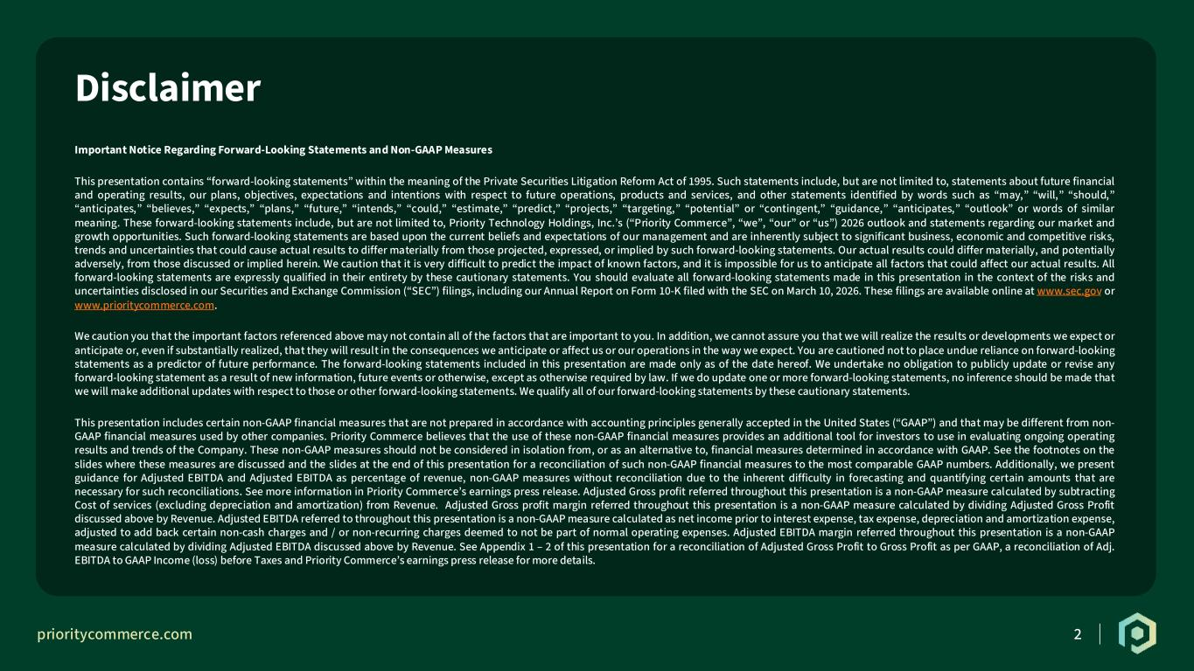
prioritycommerce.com R: 0 G: 62 B: 41 R: 1 G: 39 B: 26 R: 254 G: 109 B: 18 R: 255 G: 255 B: 255 R: 231 G: 229 B: 170 R: 166 G: 166 B: 166 R: 117 G: 209 B: 208 R: 131 G: 201 B: 126 R: 37 G: 37 B: 37 2 Disclaimer Important Notice Regarding Forward-Looking Statements and Non-GAAP Measures This presentation contains “forward-looking statements” within the meaning of the Private Securities Litigation Reform Act of 1995. Such statements include, but are not limited to, statements about future financial and operating results, our plans, objectives, expectations and intentions with respect to future operations, products and services, and other statements identified by words such as “may,” “will,” “should,” “anticipates,” “believes,” “expects,” “plans,” “future,” “intends,” “could,” “estimate,” “predict,” “projects,” “targeting,” “potential” or “contingent,” “guidance,” “anticipates,” “outlook” or words of similar meaning. These forward-looking statements include, but are not limited to, Priority Technology Holdings, Inc.’s (“Priority Commerce”, “we”, “our” or “us”) 2026 outlook and statements regarding our market and growth opportunities. Such forward-looking statements are based upon the current beliefs and expectations of our management and are inherently subject to significant business, economic and competitive risks, trends and uncertainties that could cause actual results to differ materially from those projected, expressed, or implied by such forward-looking statements. Our actual results could differ materially, and potentially adversely, from those discussed or implied herein. We caution that it is very difficult to predict the impact of known factors, and it is impossible for us to anticipate all factors that could affect our actual results. All forward-looking statements are expressly qualified in their entirety by these cautionary statements. You should evaluate all forward-looking statements made in this presentation in the context of the risks and uncertainties disclosed in our Securities and Exchange Commission (“SEC”) filings, including our Annual Report on Form 10-K filed with the SEC on March 10, 2026. These filings are available online at www.sec.gov or www.prioritycommerce.com. We caution you that the important factors referenced above may not contain all of the factors that are important to you. In addition, we cannot assure you that we will realize the results or developments we expect or anticipate or, even if substantially realized, that they will result in the consequences we anticipate or affect us or our operations in the way we expect. You are cautioned not to place undue reliance on forward-looking statements as a predictor of future performance. The forward-looking statements included in this presentation are made only as of the date hereof. We undertake no obligation to publicly update or revise any forward-looking statement as a result of new information, future events or otherwise, except as otherwise required by law. If we do update one or more forward-looking statements, no inference should be made that we will make additional updates with respect to those or other forward-looking statements. We qualify all of our forward-looking statements by these cautionary statements. This presentation includes certain non-GAAP financial measures that are not prepared in accordance with accounting principles generally accepted in the United States (“GAAP”) and that may be different from non- GAAP financial measures used by other companies. Priority Commerce believes that the use of these non-GAAP financial measures provides an additional tool for investors to use in evaluating ongoing operating results and trends of the Company. These non-GAAP measures should not be considered in isolation from, or as an alternative to, financial measures determined in accordance with GAAP. See the footnotes on the slides where these measures are discussed and the slides at the end of this presentation for a reconciliation of such non-GAAP financial measures to the most comparable GAAP numbers. Additionally, we present guidance for Adjusted EBITDA and Adjusted EBITDA as percentage of revenue, non-GAAP measures without reconciliation due to the inherent difficulty in forecasting and quantifying certain amounts that are necessary for such reconciliations. See more information in Priority Commerce’s earnings press release. Adjusted Gross profit referred throughout this presentation is a non-GAAP measure calculated by subtracting Cost of services (excluding depreciation and amortization) from Revenue. Adjusted Gross profit margin referred throughout this presentation is a non-GAAP measure calculated by dividing Adjusted Gross Profit discussed above by Revenue. Adjusted EBITDA referred to throughout this presentation is a non-GAAP measure calculated as net income prior to interest expense, tax expense, depreciation and amortization expense, adjusted to add back certain non-cash charges and / or non-recurring charges deemed to not be part of normal operating expenses. Adjusted EBITDA margin referred throughout this presentation is a non-GAAP measure calculated by dividing Adjusted EBITDA discussed above by Revenue. See Appendix 1 – 2 of this presentation for a reconciliation of Adjusted Gross Profit to Gross Profit as per GAAP, a reconciliation of Adj. EBITDA to GAAP Income (loss) before Taxes and Priority Commerce’s earnings press release for more details.

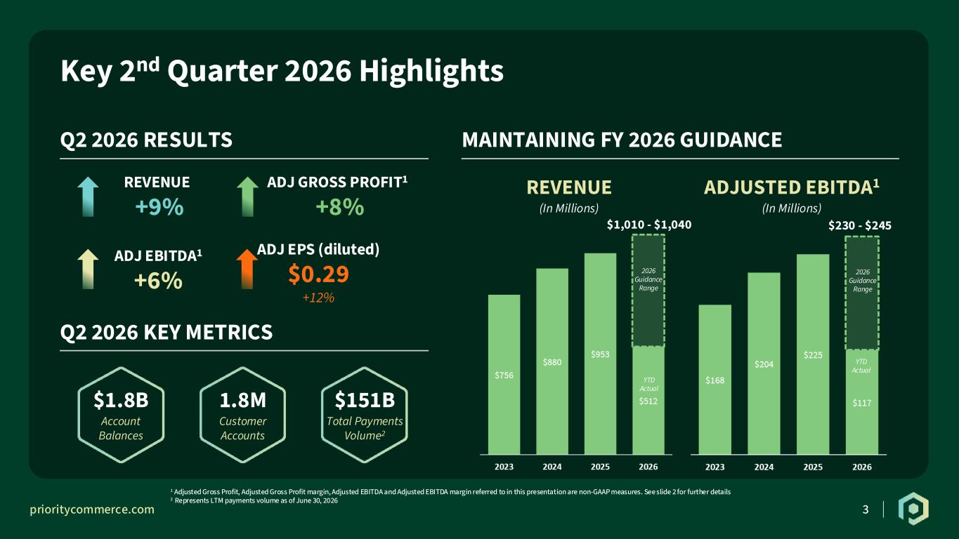
prioritycommerce.com R: 0 G: 62 B: 41 R: 1 G: 39 B: 26 R: 254 G: 109 B: 18 R: 255 G: 255 B: 255 R: 231 G: 229 B: 170 R: 166 G: 166 B: 166 R: 117 G: 209 B: 208 R: 131 G: 201 B: 126 R: 37 G: 37 B: 37 3 Key 2nd Quarter 2026 Highlights Q2 2026 RESULTS MAINTAINING FY 2026 GUIDANCE Q2 2026 KEY METRICS REVENUE +9% ADJ GROSS PROFIT1 +8% ADJ EBITDA1 +6% ADJ EPS (diluted) $0.29 $1.8B Account Balances 1.8M Customer Accounts $151B Total Payments Volume2 1 Adjusted Gross Profit, Adjusted Gross Profit margin, Adjusted EBITDA and Adjusted EBITDA margin referred to in this presentation are non-GAAP measures. See slide 2 for further details 2 Represents LTM payments volume as of June 30, 2026 +12% REVENUE (In Millions) ADJUSTED EBITDA1 (In Millions) $1,010 - $1,040 $230 - $245 2026 Guidance Range 2026 Guidance Range YTD Actual YTD Actual

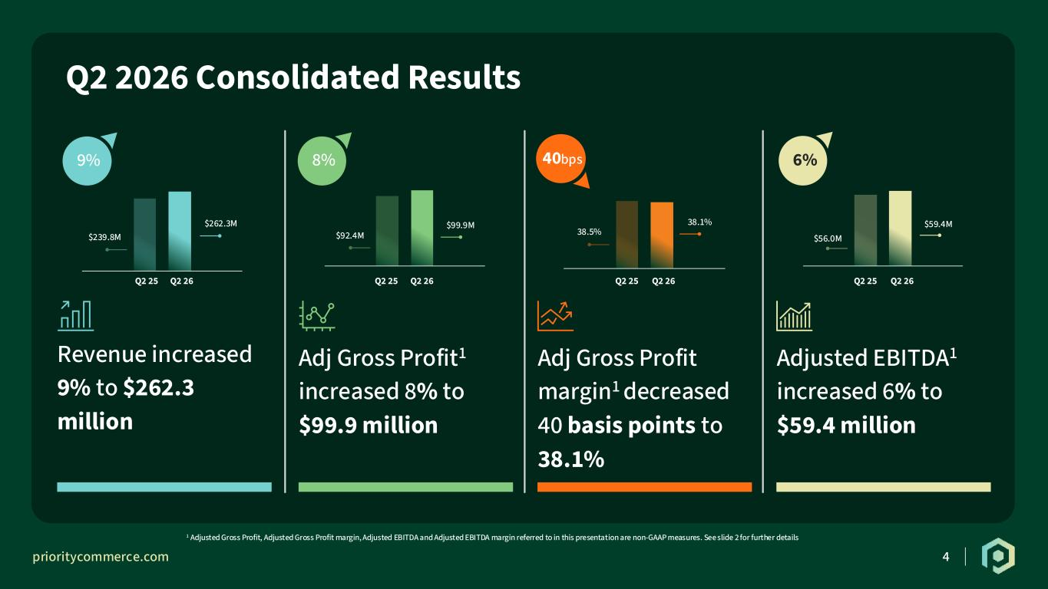
prioritycommerce.com R: 0 G: 62 B: 41 R: 1 G: 39 B: 26 R: 254 G: 109 B: 18 R: 255 G: 255 B: 255 R: 231 G: 229 B: 170 R: 166 G: 166 B: 166 R: 117 G: 209 B: 208 R: 131 G: 201 B: 126 R: 37 G: 37 B: 37 4 Q2 2026 Consolidated Results $92.4M $99.9M $56.0M $59.4M $239.8M $262.3M Q2 25 Q2 26 Q2 25 Q2 26 Q2 25 Q2 26Q2 25 Q2 26 9% 8% 6% Adjusted EBITDA1 increased 6% to $59.4 million Adj Gross Profit margin1 decreased 40 basis points to 38.1% Adj Gross Profit1 increased 8% to $99.9 million Revenue increased 9% to $262.3 million 1 Adjusted Gross Profit, Adjusted Gross Profit margin, Adjusted EBITDA and Adjusted EBITDA margin referred to in this presentation are non-GAAP measures. See slide 2 for further details 40bps 38.5% 38.1%

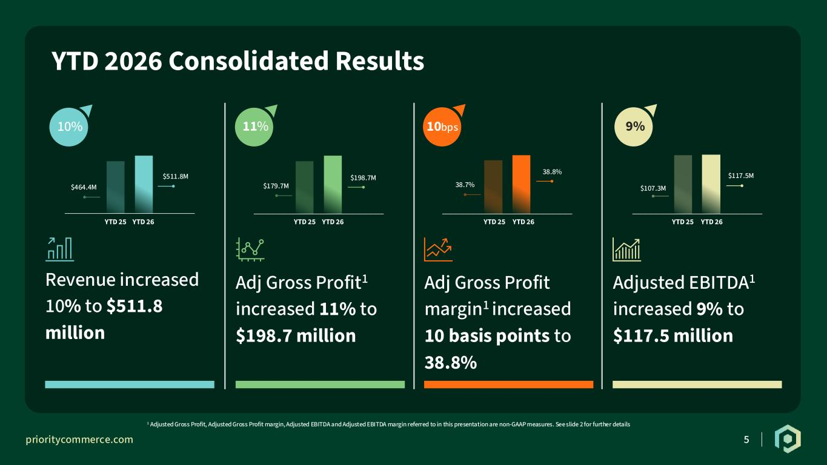
prioritycommerce.com R: 0 G: 62 B: 41 R: 1 G: 39 B: 26 R: 254 G: 109 B: 18 R: 255 G: 255 B: 255 R: 231 G: 229 B: 170 R: 166 G: 166 B: 166 R: 117 G: 209 B: 208 R: 131 G: 201 B: 126 R: 37 G: 37 B: 37 5 YTD 2026 Consolidated Results $179.7M $198.7M $107.3M $117.5M $464.4M $511.8M 10% 11% 9% Adjusted EBITDA1 increased 9% to $117.5 million Adj Gross Profit margin1 increased 10 basis points to 38.8% Adj Gross Profit1 increased 11% to $198.7 million Revenue increased 10% to $511.8 million 1 Adjusted Gross Profit, Adjusted Gross Profit margin, Adjusted EBITDA and Adjusted EBITDA margin referred to in this presentation are non-GAAP measures. See slide 2 for further details 10bps 38.7% 38.8% YTD 25 YTD 26 YTD 25 YTD 26 YTD 25 YTD 26YTD 25 YTD 26

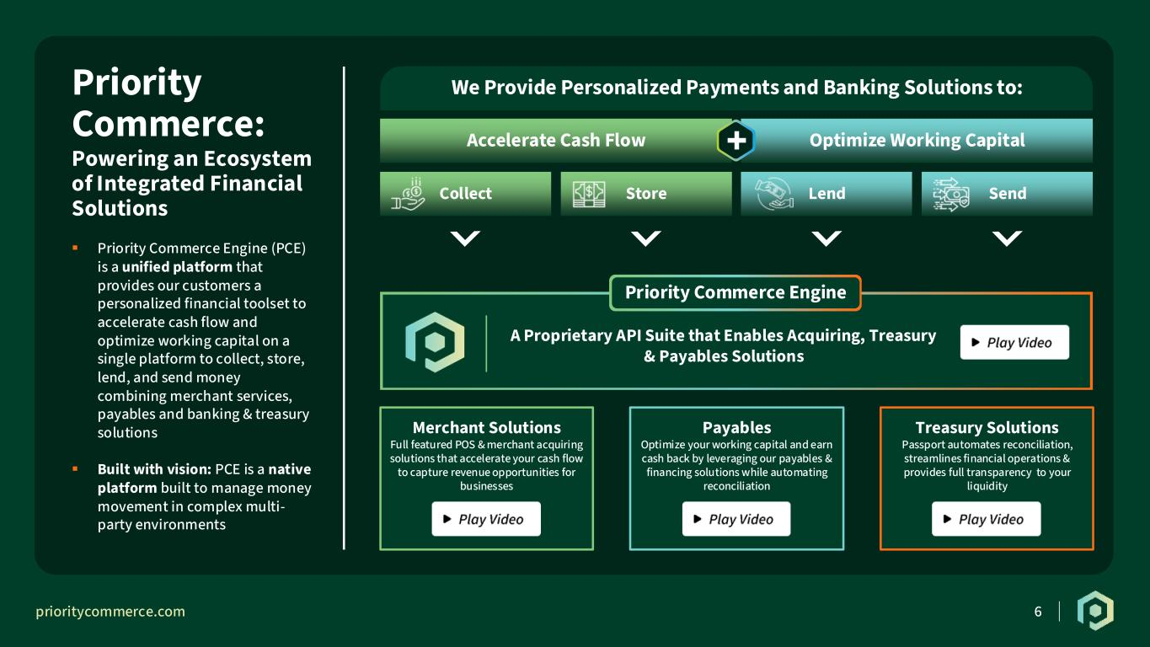
prioritycommerce.com R: 0 G: 62 B: 41 R: 1 G: 39 B: 26 R: 254 G: 109 B: 18 R: 255 G: 255 B: 255 R: 231 G: 229 B: 170 R: 166 G: 166 B: 166 R: 117 G: 209 B: 208 R: 131 G: 201 B: 126 R: 37 G: 37 B: 37 6 Accelerate Cash Flow Optimize Working Capital ▪ Priority Commerce Engine (PCE) is a unified platform that provides our customers a personalized financial toolset to accelerate cash flow and optimize working capital on a single platform to collect, store, lend, and send money combining merchant services, payables and banking & treasury solutions ▪ Built with vision: PCE is a native platform built to manage money movement in complex multi- party environments Priority Commerce: Powering an Ecosystem of Integrated Financial Solutions A Proprietary API Suite that Enables Acquiring, Treasury & Payables Solutions Treasury Solutions Passport automates reconciliation, streamlines financial operations & provides full transparency to your liquidity Merchant Solutions Full featured POS & merchant acquiring solutions that accelerate your cash flow to capture revenue opportunities for businesses Payables Optimize your working capital and earn cash back by leveraging our payables & financing solutions while automating reconciliation LendCollect Store We Provide Personalized Payments and Banking Solutions to: Send + Priority Commerce Engine

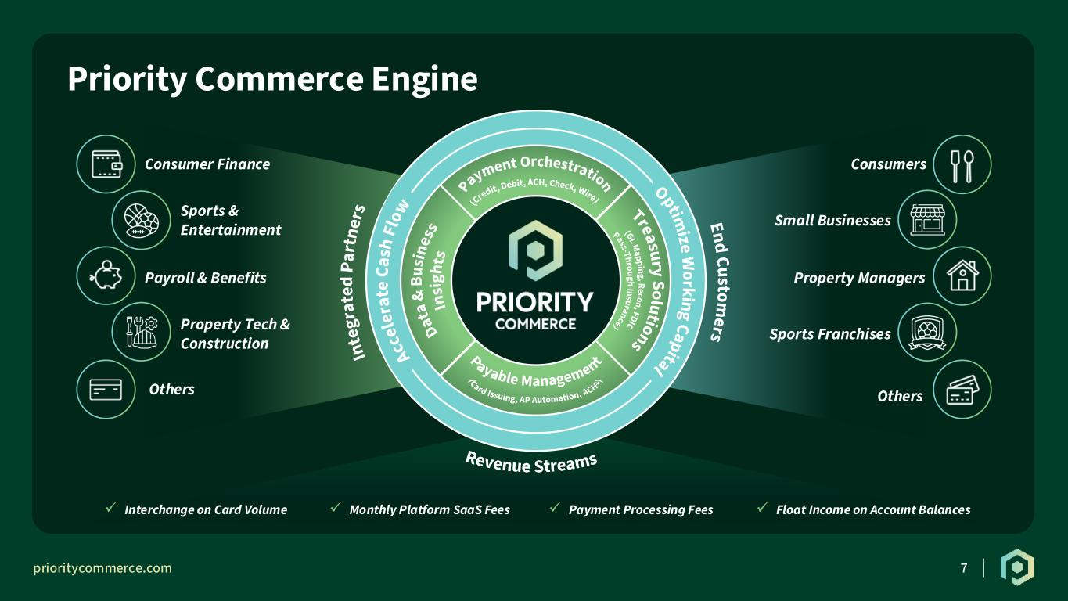
prioritycommerce.com R: 0 G: 62 B: 41 R: 1 G: 39 B: 26 R: 254 G: 109 B: 18 R: 255 G: 255 B: 255 R: 231 G: 229 B: 170 R: 166 G: 166 B: 166 R: 117 G: 209 B: 208 R: 131 G: 201 B: 126 R: 37 G: 37 B: 37 7 Priority Commerce Engine Acc el er at eC as h Fl ow Payment Orchestration Optim ize W orkingCapital TreasurySolutionsDat a& Bu sin es s In sig ht s Payable Management (Credit, Debit, ACH, Check, Wire) (GLMapping,Recon,FDIC Pass-Through Insurance) (Card Issuing, AP Automation, ACH+) In te gr at ed Pa rt ne rs Consumer Finance Sports & Entertainment Payroll & Benefits Property Tech & Construction Others Consumers Small Businesses Property Managers Others Sports Franchises ✓ Monthly Platform SaaS Fees✓ Interchange on Card Volume ✓ Payment Processing Fees ✓ Float Income on Account Balances End Custom ers Revenue Streams


prioritycommerce.com R: 0 G: 62 B: 41 R: 1 G: 39 B: 26 R: 254 G: 109 B: 18 R: 255 G: 255 B: 255 R: 231 G: 229 B: 170 R: 166 G: 166 B: 166 R: 117 G: 209 B: 208 R: 131 G: 201 B: 126 R: 37 G: 37 B: 37 8 Second Quarter 2026 Financial Results

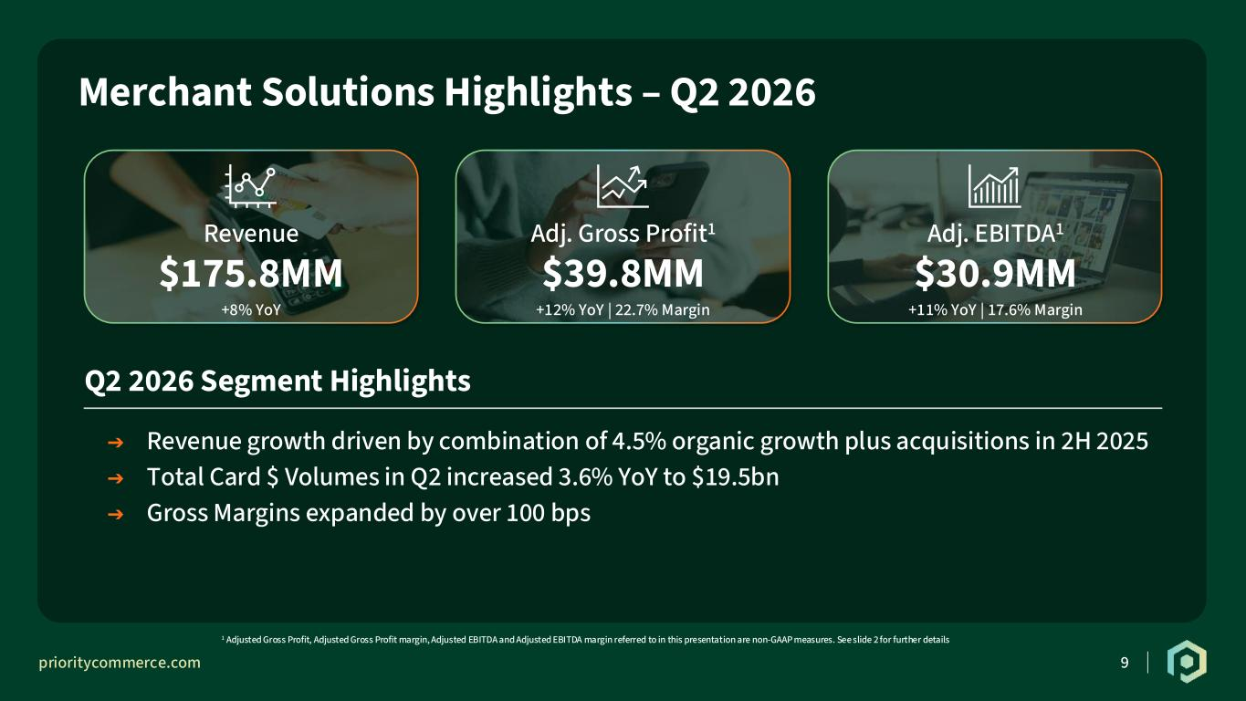
prioritycommerce.com R: 0 G: 62 B: 41 R: 1 G: 39 B: 26 R: 254 G: 109 B: 18 R: 255 G: 255 B: 255 R: 231 G: 229 B: 170 R: 166 G: 166 B: 166 R: 117 G: 209 B: 208 R: 131 G: 201 B: 126 R: 37 G: 37 B: 37 9 Merchant Solutions Highlights – Q2 2026 1 Adjusted Gross Profit, Adjusted Gross Profit margin, Adjusted EBITDA and Adjusted EBITDA margin referred to in this presentation are non-GAAP measures. See slide 2 for further details Revenue $175.8MM +8% YoY Adj. Gross Profit1 $39.8MM +12% YoY | 22.7% Margin Adj. EBITDA1 $30.9MM +11% YoY | 17.6% Margin Q2 2026 Segment Highlights ➔ Revenue growth driven by combination of 4.5% organic growth plus acquisitions in 2H 2025 ➔ Total Card $ Volumes in Q2 increased 3.6% YoY to $19.5bn ➔ Gross Margins expanded by over 100 bps

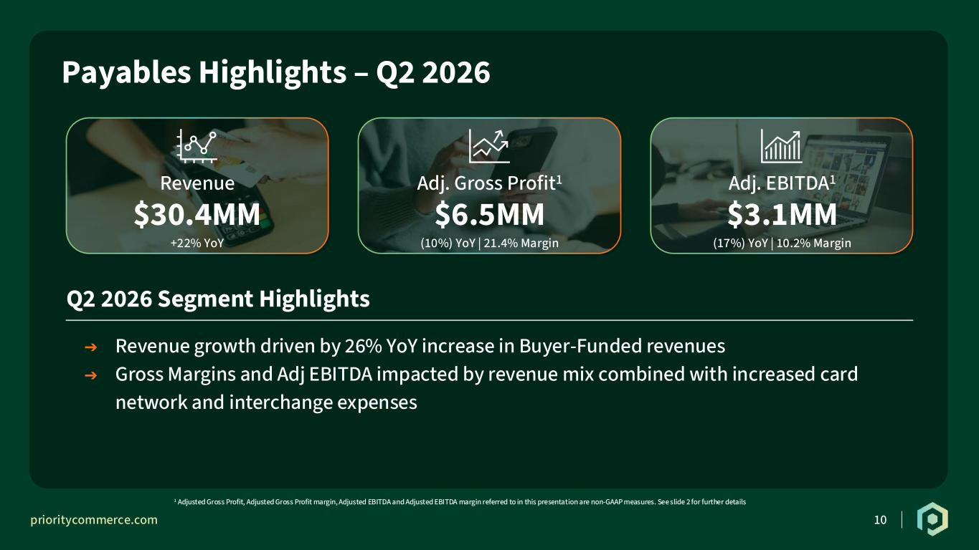
prioritycommerce.com R: 0 G: 62 B: 41 R: 1 G: 39 B: 26 R: 254 G: 109 B: 18 R: 255 G: 255 B: 255 R: 231 G: 229 B: 170 R: 166 G: 166 B: 166 R: 117 G: 209 B: 208 R: 131 G: 201 B: 126 R: 37 G: 37 B: 37 10 Payables Highlights – Q2 2026 1 Adjusted Gross Profit, Adjusted Gross Profit margin, Adjusted EBITDA and Adjusted EBITDA margin referred to in this presentation are non-GAAP measures. See slide 2 for further details Revenue $30.4MM +22% YoY Adj. Gross Profit1 $6.5MM (10%) YoY | 21.4% Margin Adj. EBITDA1 $3.1MM (17%) YoY | 10.2% Margin Q2 2026 Segment Highlights ➔ Revenue growth driven by 26% YoY increase in Buyer-Funded revenues ➔ Gross Margins and Adj EBITDA impacted by revenue mix combined with increased card network and interchange expenses

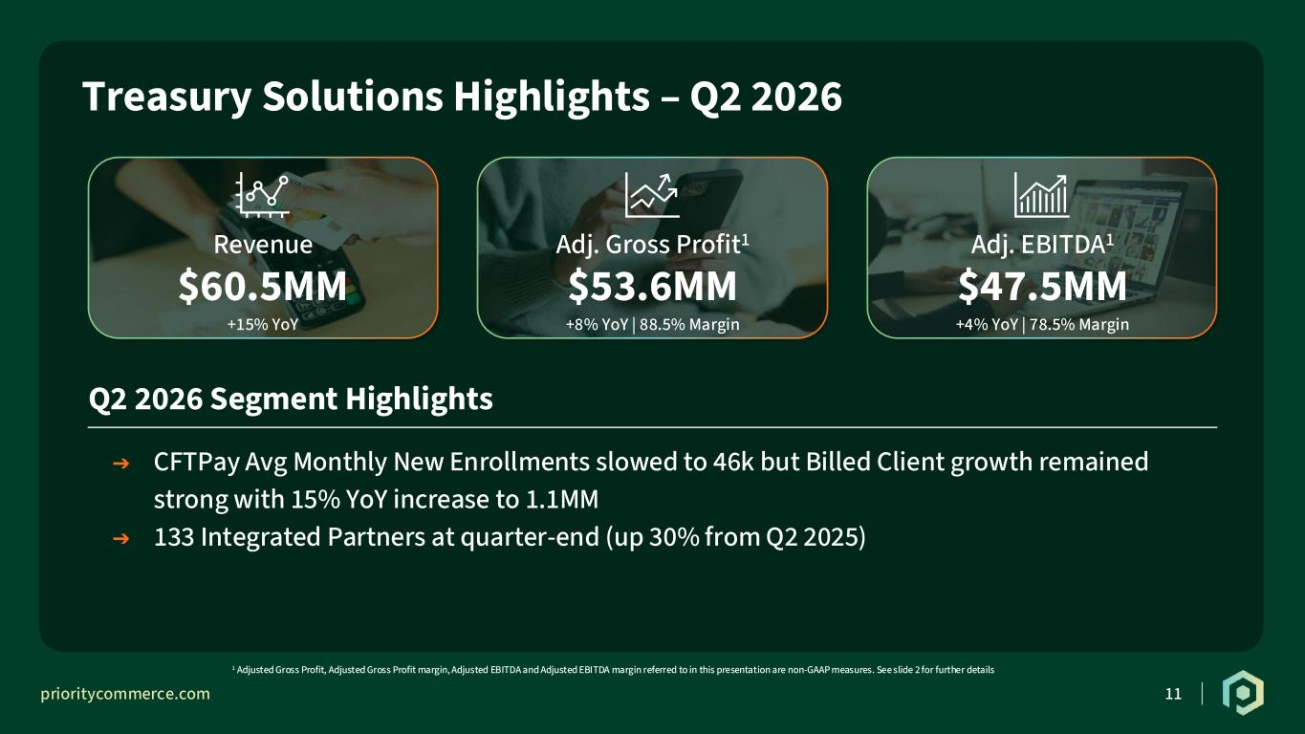
prioritycommerce.com R: 0 G: 62 B: 41 R: 1 G: 39 B: 26 R: 254 G: 109 B: 18 R: 255 G: 255 B: 255 R: 231 G: 229 B: 170 R: 166 G: 166 B: 166 R: 117 G: 209 B: 208 R: 131 G: 201 B: 126 R: 37 G: 37 B: 37 11 Treasury Solutions Highlights – Q2 2026 1 Adjusted Gross Profit, Adjusted Gross Profit margin, Adjusted EBITDA and Adjusted EBITDA margin referred to in this presentation are non-GAAP measures. See slide 2 for further details Revenue $60.5MM +15% YoY Adj. Gross Profit1 $53.6MM +8% YoY | 88.5% Margin Adj. EBITDA1 $47.5MM +4% YoY | 78.5% Margin Q2 2026 Segment Highlights ➔ CFTPay Avg Monthly New Enrollments slowed to 46k but Billed Client growth remained strong with 15% YoY increase to 1.1MM ➔ 133 Integrated Partners at quarter-end (up 30% from Q2 2025)

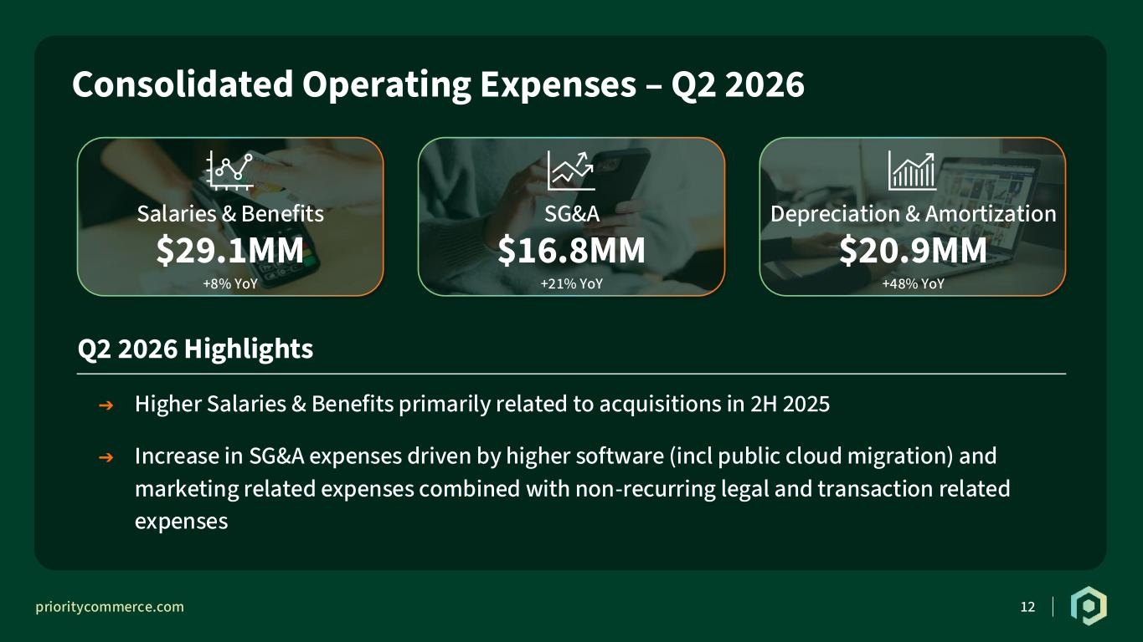
prioritycommerce.com R: 0 G: 62 B: 41 R: 1 G: 39 B: 26 R: 254 G: 109 B: 18 R: 255 G: 255 B: 255 R: 231 G: 229 B: 170 R: 166 G: 166 B: 166 R: 117 G: 209 B: 208 R: 131 G: 201 B: 126 R: 37 G: 37 B: 37 12 Consolidated Operating Expenses – Q2 2026 Salaries & Benefits $29.1MM +8% YoY SG&A $16.8MM +21% YoY Depreciation & Amortization $20.9MM +48% YoY Q2 2026 Highlights ➔ Higher Salaries & Benefits primarily related to acquisitions in 2H 2025 ➔ Increase in SG&A expenses driven by higher software (incl public cloud migration) and marketing related expenses combined with non-recurring legal and transaction related expenses

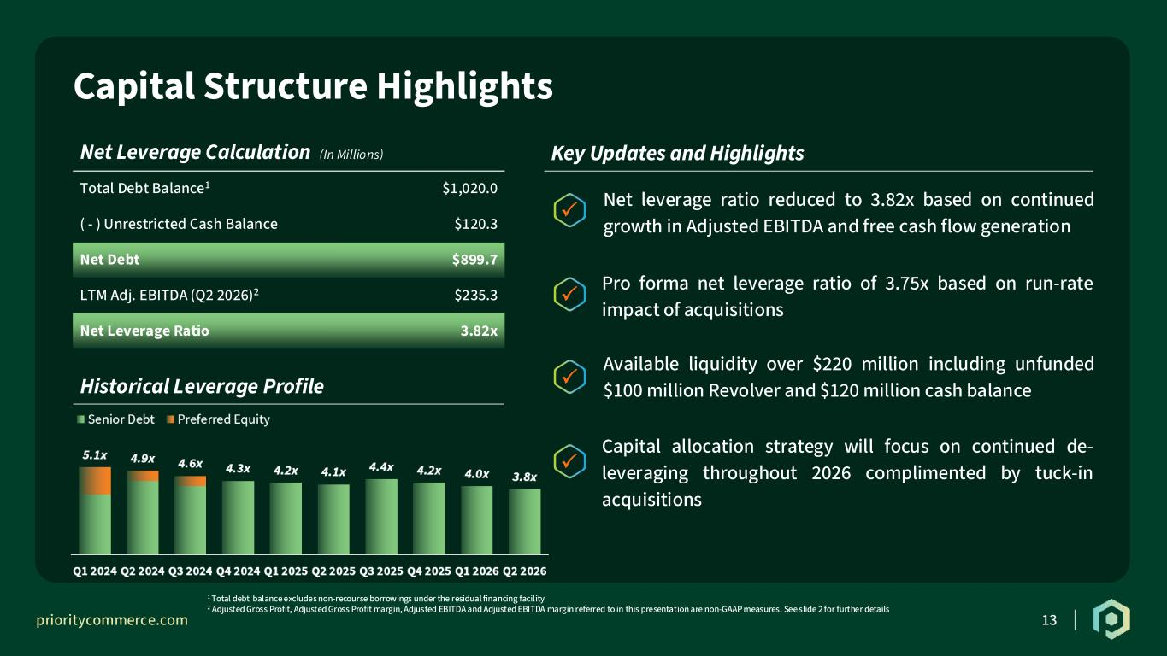
prioritycommerce.com R: 0 G: 62 B: 41 R: 1 G: 39 B: 26 R: 254 G: 109 B: 18 R: 255 G: 255 B: 255 R: 231 G: 229 B: 170 R: 166 G: 166 B: 166 R: 117 G: 209 B: 208 R: 131 G: 201 B: 126 R: 37 G: 37 B: 37 13 Capital Structure Highlights Net Leverage Calculation (In Millions) Total Debt Balance1 $1,020.0 ( - ) Unrestricted Cash Balance $120.3 Net Debt $899.7 LTM Adj. EBITDA (Q2 2026)2 $235.3 Net Leverage Ratio 3.82x 1 Total debt balance excludes non-recourse borrowings under the residual financing facility 2 Adjusted Gross Profit, Adjusted Gross Profit margin, Adjusted EBITDA and Adjusted EBITDA margin referred to in this presentation are non-GAAP measures. See slide 2 for further details Key Updates and Highlights   Available liquidity over $220 million including unfunded $100 million Revolver and $120 million cash balance Pro forma net leverage ratio of 3.75x based on run-rate impact of acquisitions Capital allocation strategy will focus on continued de- leveraging throughout 2026 complimented by tuck-in acquisitions Historical Leverage Profile   Net leverage ratio reduced to 3.82x based on continued growth in Adjusted EBITDA and free cash flow generation


prioritycommerce.com R: 0 G: 62 B: 41 R: 1 G: 39 B: 26 R: 254 G: 109 B: 18 R: 255 G: 255 B: 255 R: 231 G: 229 B: 170 R: 166 G: 166 B: 166 R: 117 G: 209 B: 208 R: 131 G: 201 B: 126 R: 37 G: 37 B: 37 14 Appendix

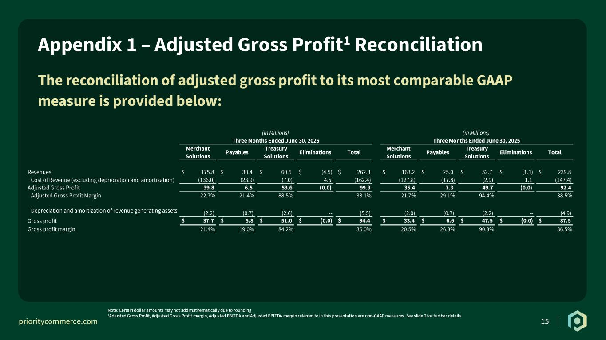
prioritycommerce.com R: 0 G: 62 B: 41 R: 1 G: 39 B: 26 R: 254 G: 109 B: 18 R: 255 G: 255 B: 255 R: 231 G: 229 B: 170 R: 166 G: 166 B: 166 R: 117 G: 209 B: 208 R: 131 G: 201 B: 126 R: 37 G: 37 B: 37 15 The reconciliation of adjusted gross profit to its most comparable GAAP measure is provided below: Appendix 1 – Adjusted Gross Profit1 Reconciliation Note: Certain dollar amounts may not add mathematically due to rounding 1Adjusted Gross Profit, Adjusted Gross Profit margin, Adjusted EBITDA and Adjusted EBITDA margin referred to in this presentation are non-GAAP measures. See slide 2 for further details. Merchant Solutions Payables Treasury Solutions Eliminations Total Merchant Solutions Payables Treasury Solutions Eliminations Total Revenues $ 175.8 $ 30.4 $ 60.5 $ (4.5) $ 262.3 $ 163.2 $ 25.0 $ 52.7 $ (1.1) $ 239.8 Cost of Revenue (excluding depreciation and amortization) (136.0) (23.9) (7.0) 4.5 (162.4) (127.8) (17.8) (2.9) 1.1 (147.4) Adjusted Gross Profit 39.8 6.5 53.6 (0.0) 99.9 35.4 7.3 49.7 (0.0) 92.4 Adjusted Gross Profit Margin 22.7% 21.4% 88.5% 38.1% 21.7% 29.1% 94.4% 38.5% Depreciation and amortization of revenue generating assets (2.2) (0.7) (2.6) -- (5.5) (2.0) (0.7) (2.2) -- (4.9) Gross profit $ 37.7 $ 5.8 $ 51.0 $ (0.0) $ 94.4 $ 33.4 $ 6.6 $ 47.5 $ (0.0) $ 87.5 Gross profit margin 21.4% 19.0% 84.2% 36.0% 20.5% 26.3% 90.3% 36.5% (in Millions) (in Millions) Three Months Ended June 30, 2026 Three Months Ended June 30, 2025

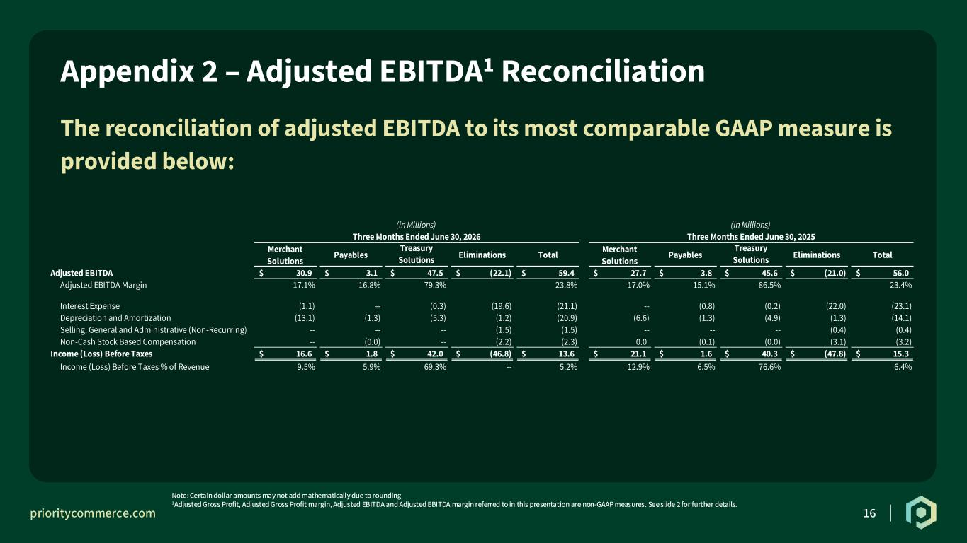
prioritycommerce.com R: 0 G: 62 B: 41 R: 1 G: 39 B: 26 R: 254 G: 109 B: 18 R: 255 G: 255 B: 255 R: 231 G: 229 B: 170 R: 166 G: 166 B: 166 R: 117 G: 209 B: 208 R: 131 G: 201 B: 126 R: 37 G: 37 B: 37 16 The reconciliation of adjusted EBITDA to its most comparable GAAP measure is provided below: Appendix 2 – Adjusted EBITDA1 Reconciliation Note: Certain dollar amounts may not add mathematically due to rounding 1Adjusted Gross Profit, Adjusted Gross Profit margin, Adjusted EBITDA and Adjusted EBITDA margin referred to in this presentation are non-GAAP measures. See slide 2 for further details. (in Millions) (in Millions) Three Months Ended June 30, 2026 Three Months Ended June 30, 2025 Merchant Solutions Payables Treasury Solutions Eliminations Total Merchant Solutions Payables Treasury Solutions Eliminations Total Adjusted EBITDA 30.9$ 3.1$ 47.5$ (22.1)$ 59.4$ 27.7$ 3.8$ 45.6$ (21.0)$ 56.0$ Adjusted EBITDA Margin 17.1% 16.8% 79.3% 23.8% 17.0% 15.1% 86.5% 23.4% Interest Expense (1.1) -- (0.3) (19.6) (21.1) -- (0.8) (0.2) (22.0) (23.1) Depreciation and Amortization (13.1) (1.3) (5.3) (1.2) (20.9) (6.6) (1.3) (4.9) (1.3) (14.1) Selling, General and Administrative (Non-Recurring) -- -- -- (1.5) (1.5) -- -- -- (0.4) (0.4) Non-Cash Stock Based Compensation -- (0.0) -- (2.2) (2.3) 0.0 (0.1) (0.0) (3.1) (3.2) Income (Loss) Before Taxes 16.6$ 1.8$ 42.0$ (46.8)$ 13.6$ 21.1$ 1.6$ 40.3$ (47.8)$ 15.3$ Income (Loss) Before Taxes % of Revenue 9.5% 5.9% 69.3% -- 5.2% 12.9% 6.5% 76.6% 6.4%

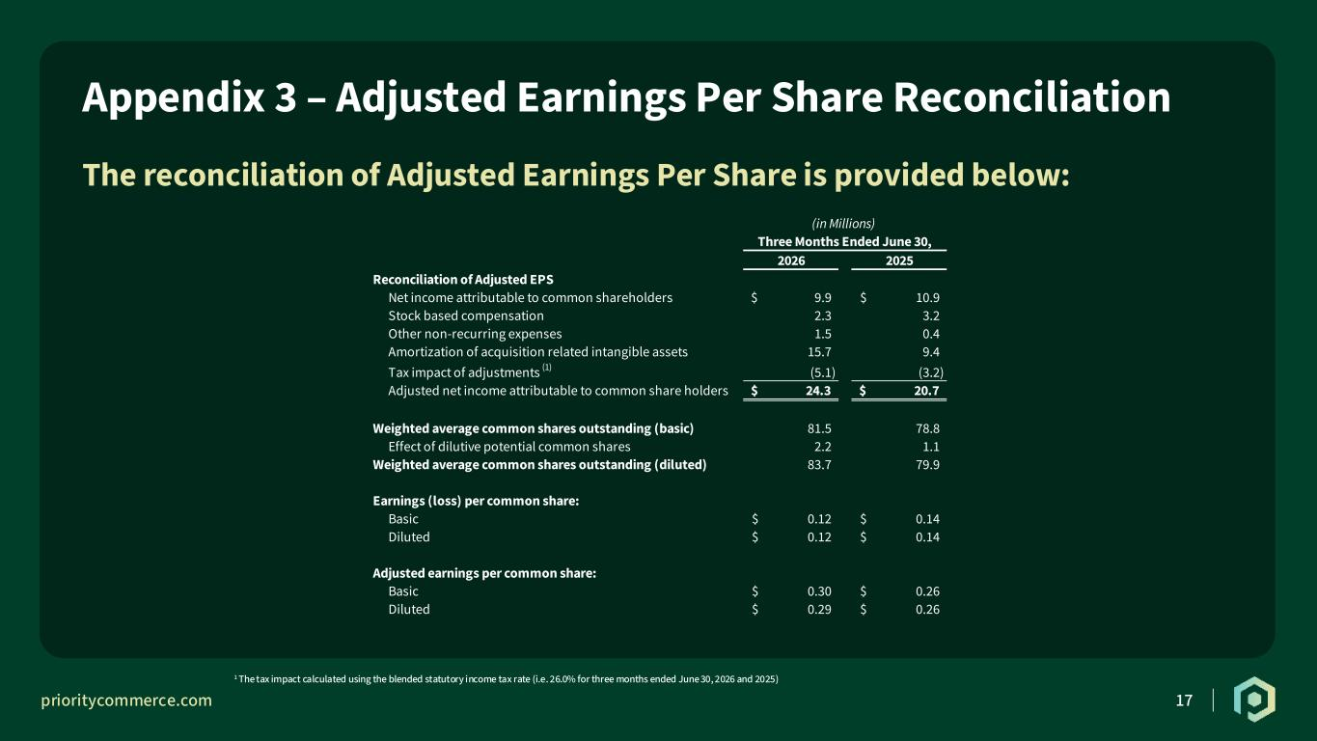
prioritycommerce.com R: 0 G: 62 B: 41 R: 1 G: 39 B: 26 R: 254 G: 109 B: 18 R: 255 G: 255 B: 255 R: 231 G: 229 B: 170 R: 166 G: 166 B: 166 R: 117 G: 209 B: 208 R: 131 G: 201 B: 126 R: 37 G: 37 B: 37 17 The reconciliation of Adjusted Earnings Per Share is provided below: Appendix 3 – Adjusted Earnings Per Share Reconciliation 1 The tax impact calculated using the blended statutory income tax rate (i.e. 26.0% for three months ended June 30, 2026 and 2025) (in Millions) Three Months Ended June 30, 2026 2025 Reconciliation of Adjusted EPS Net income attributable to common shareholders 9.9$ 10.9$ Stock based compensation 2.3 3.2 Other non-recurring expenses 1.5 0.4 Amortization of acquisition related intangible assets 15.7 9.4 Tax impact of adjustments (1) (5.1) (3.2) Adjusted net income attributable to common share holders 24.3$ 20.7$ Weighted average common shares outstanding (basic) 81.5 78.8 Effect of dilutive potential common shares 2.2 1.1 Weighted average common shares outstanding (diluted) 83.7 79.9 Earnings (loss) per common share: Basic 0.12$ 0.14$ Diluted 0.12$ 0.14$ Adjusted earnings per common share: Basic 0.30$ 0.26$ Diluted 0.29$ 0.26$

