United States

SECURITIES AND EXCHANGE COMMISSION

Washington, D.C. 20549

Form 8-K

Current Report

Pursuant to Section 13 or 15(d) of the

Securities Exchange Act of 1934

February 3, 2021

Date of Report (Date of earliest event reported)

Priority Technology Holdings, Inc.

(Exact Name of Registrant as Specified in its Charter)

Delaware |  | 001-37872 |  |  |  | 47-4257046
(State or other jurisdiction of incorporation) |  | (Commission File Number) |  |  |  | (I.R.S. Employer Identification No.)
2001 Westside Parkway |  |  |  |  |  | 30004
Suite 155
Alpharetta, |  | Georgia
(Address of Principal Executive Offices) |  |  |  |  |  | (Zip Code)

Registrant’s telephone number, including area code: (800) 935-5961

(Former name or former address, if changed since last report)

Check the appropriate box below if the Form 8-K filing is intended to simultaneously satisfy the filing obligation of the registrant under any of the following provisions (see General Instruction A.2. below):

- Written communications pursuant to Rule 425 under the Securities Act (17 CFR 230.425)

- Soliciting material pursuant to Rule 14a-12 under the Exchange Act (17 CFR 240.14a-12)

- Pre-commencement communications pursuant to Rule 14d-2(b) under the Exchange Act (17 CFR 240.14d-2(b))

- Pre-commencement communications pursuant to Rule 13e-4(c) under the Exchange Act (17 CFR 240.13e-4(c))

 |  | Securities registered pursuant to Section 12(b) of the Act:
Title of each class |  | Trading Symbol |  |  | Name of each exchange on which registered
Common stock, $0.001 par value |  | PRTH |  |  | Nasdaq Global Market

Indicate by check mark whether the registrant is an emerging growth company as defined in Rule 405 of the Securities Act of (1933 §230.405 of this chapter) or Rule 12b-2 of the Securities Exchange Act of 1934 (§240.12b-2 of this chapter).

Emerging growth company ☒

If an emerging growth company, indicate by check mark if the registrant has elected not to use the extended transition period for complying with any new or revised financial accounting standards provided pursuant to Section 13(a) of the Exchange Act. ☐

Item 7.01 Regulation FD Disclosure

Executives of Priority Technology Holdings, Inc. (the "Company") will present to various investors at the A.G.P. Emerging Growth Technology Conference on February 4, 2021. The Company will reiterate its previously disclosed guidance for the fourth quarter of 2020.

Exhibit Number |  | Description
99.1 |  | Press Release of Priority Technology Holdings, Inc. dated February 3, 2021
99.1 |  | A.G.P Emerging Growth Technology Conference Presentation
104 |  | The cover page from this Current Report on Form 8-K, formatted in Inline XBRL.

SIGNATURE

Pursuant to the requirements of the Securities Exchange Act of 1934, the registrant has duly caused this report to be signed on its behalf by the undersigned hereunto duly authorized.

Dated: February 3, 2021

PRIORITY TECHNOLOGY HOLDINGS, INC.

By: /s/ Bradley J. Miller

Name: Bradley J. Miller

Title: General Counsel and Chief Risk Officer



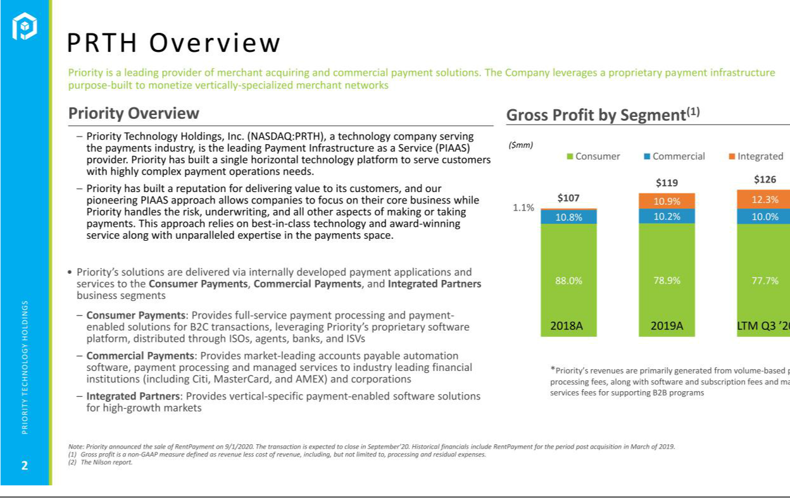

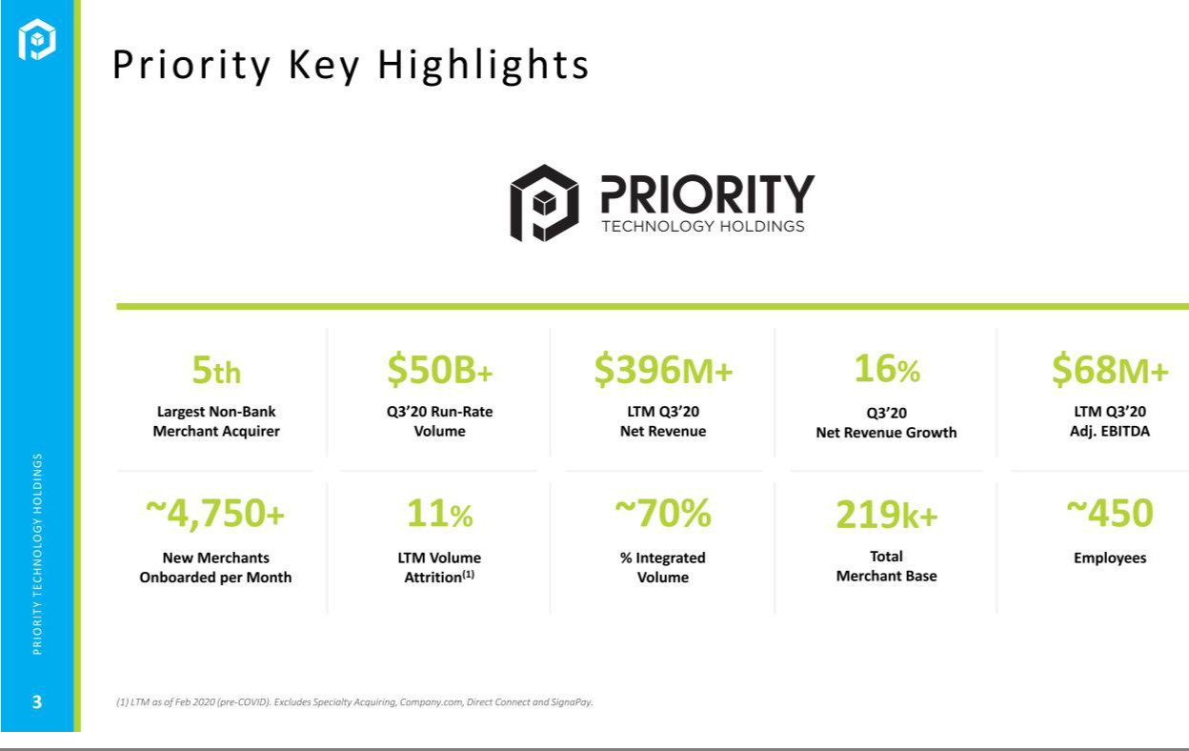

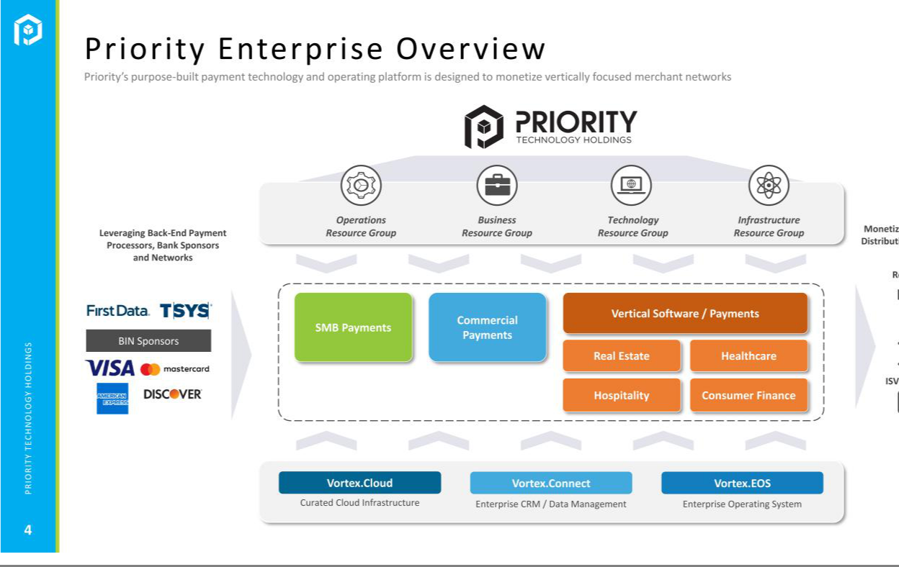



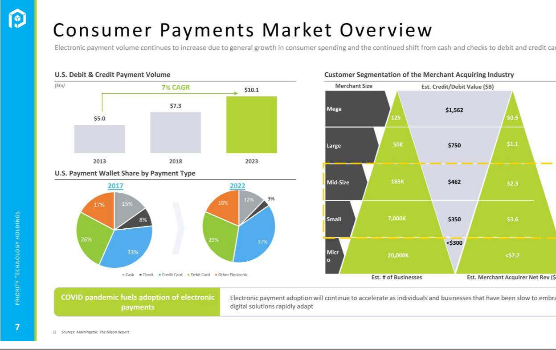

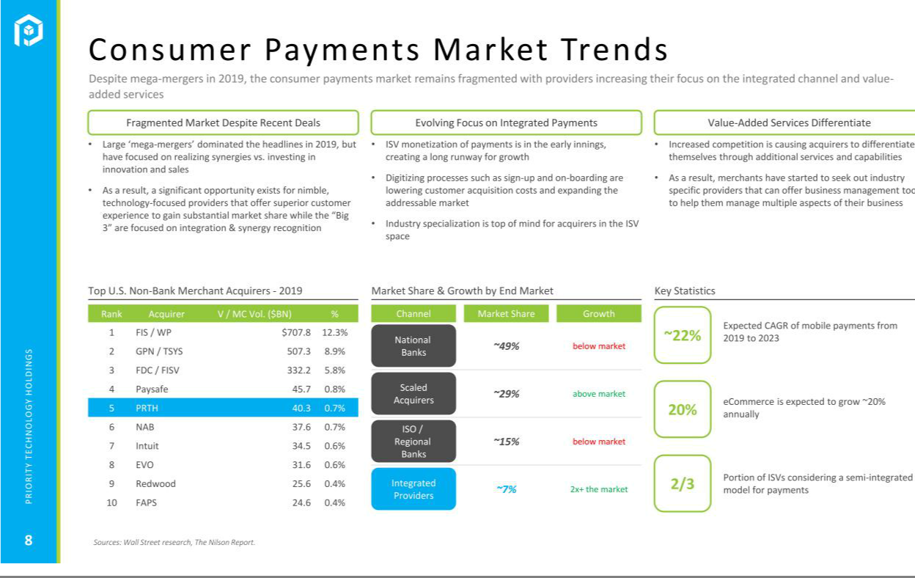

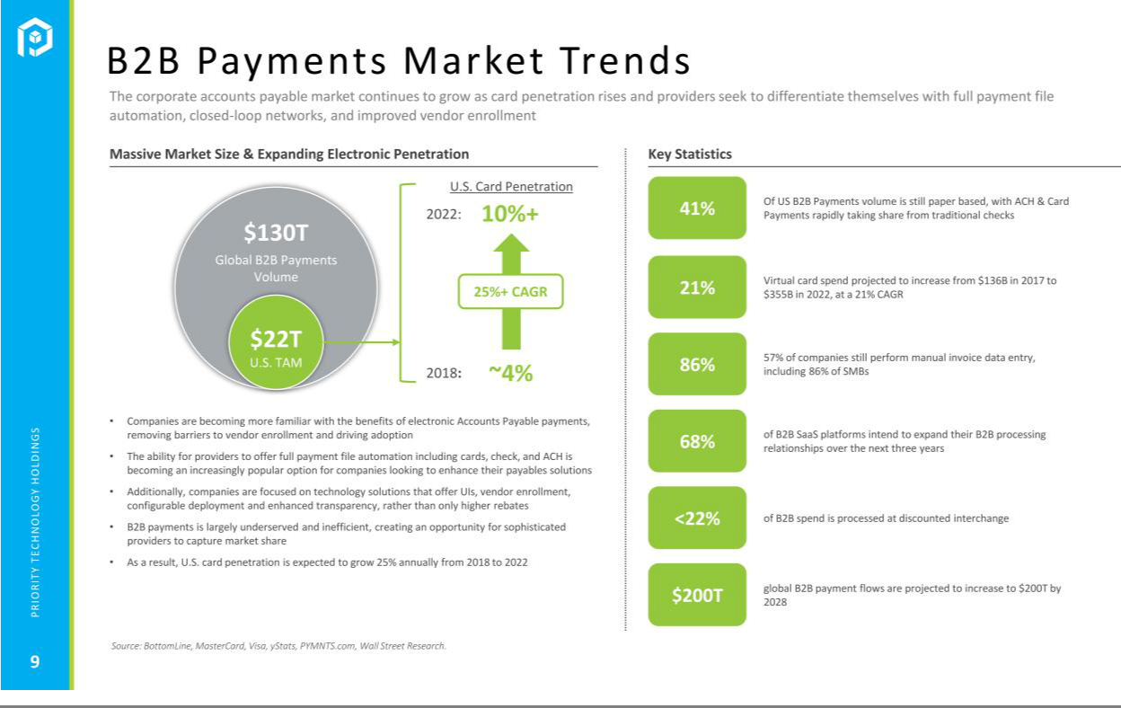

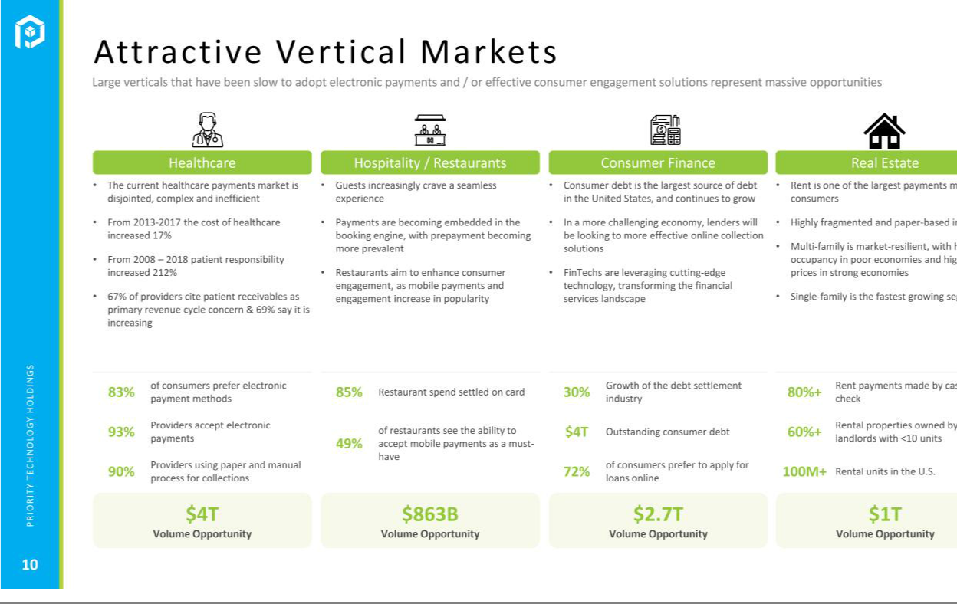



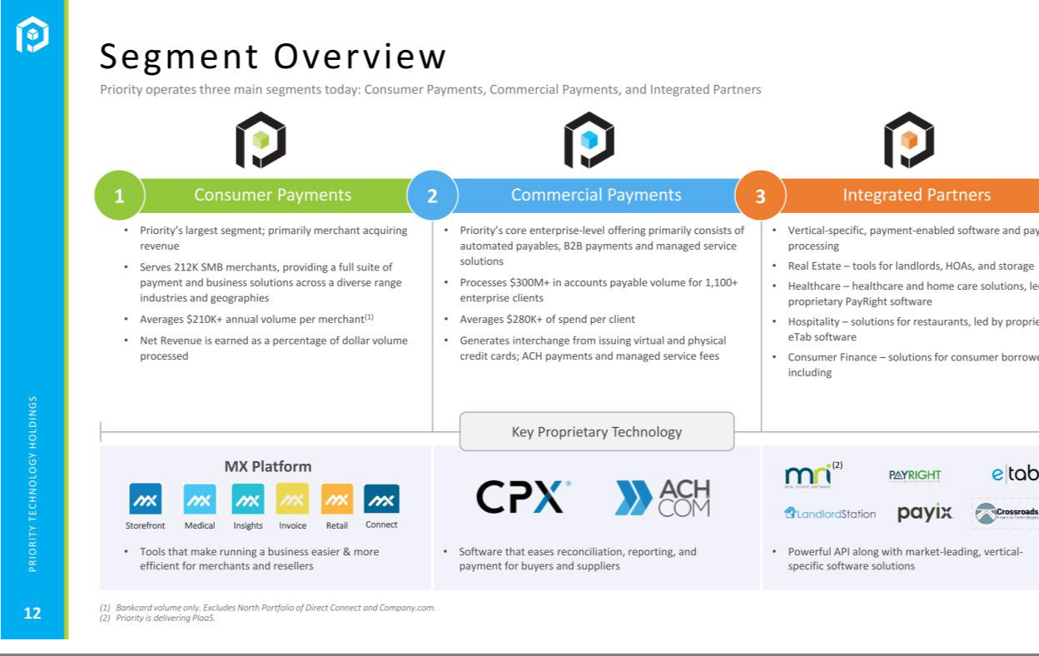

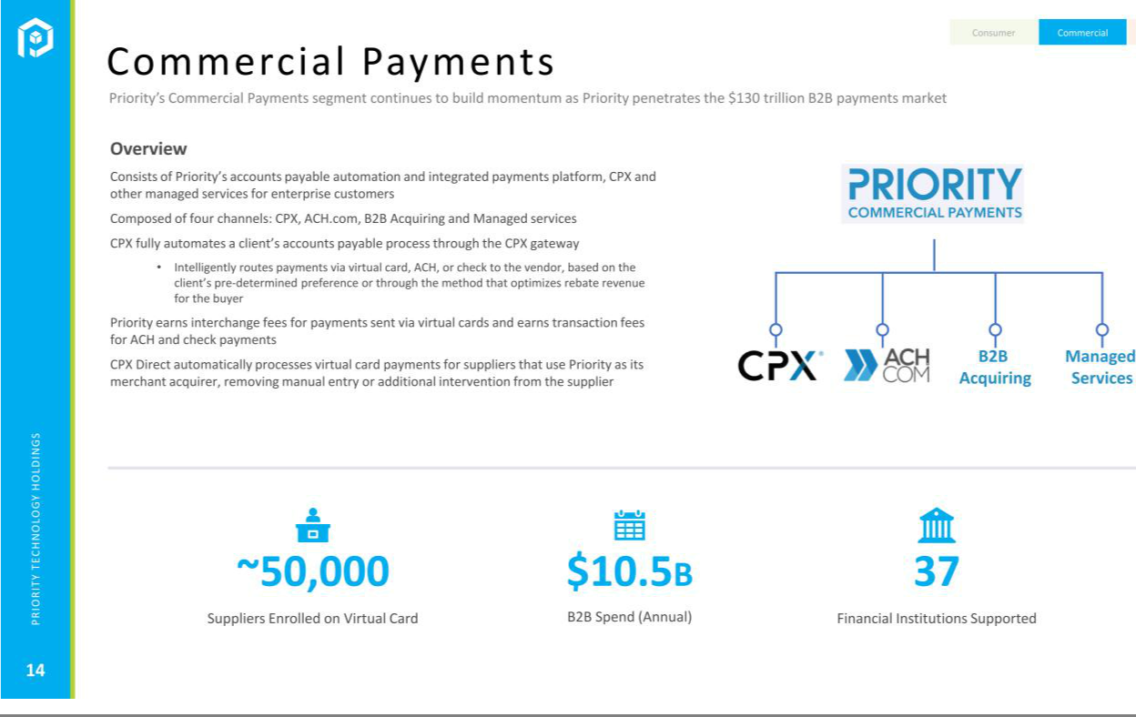

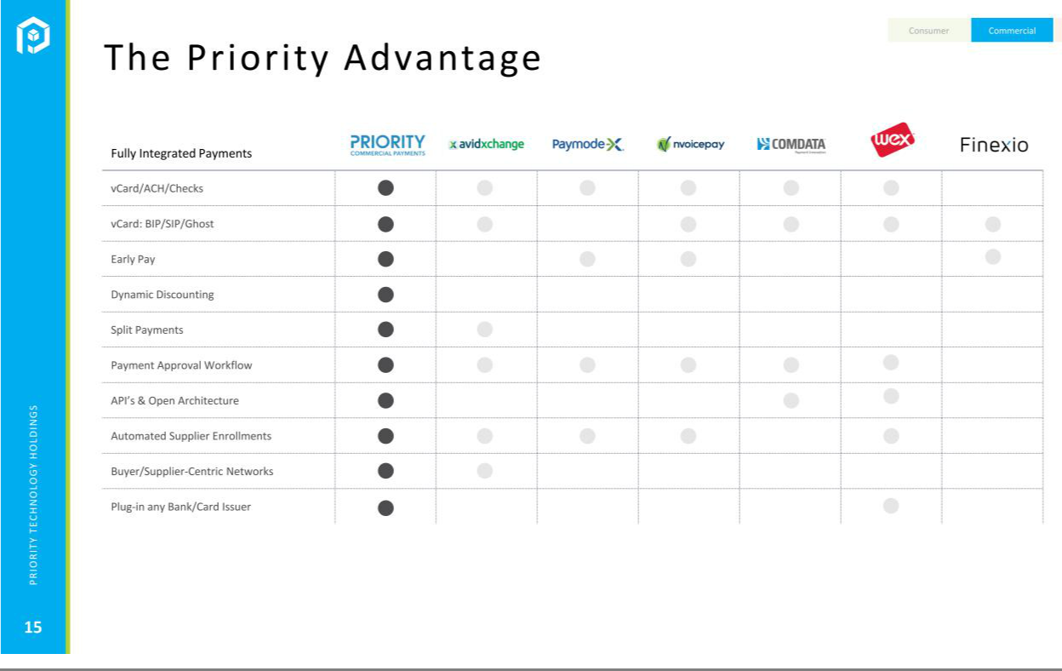

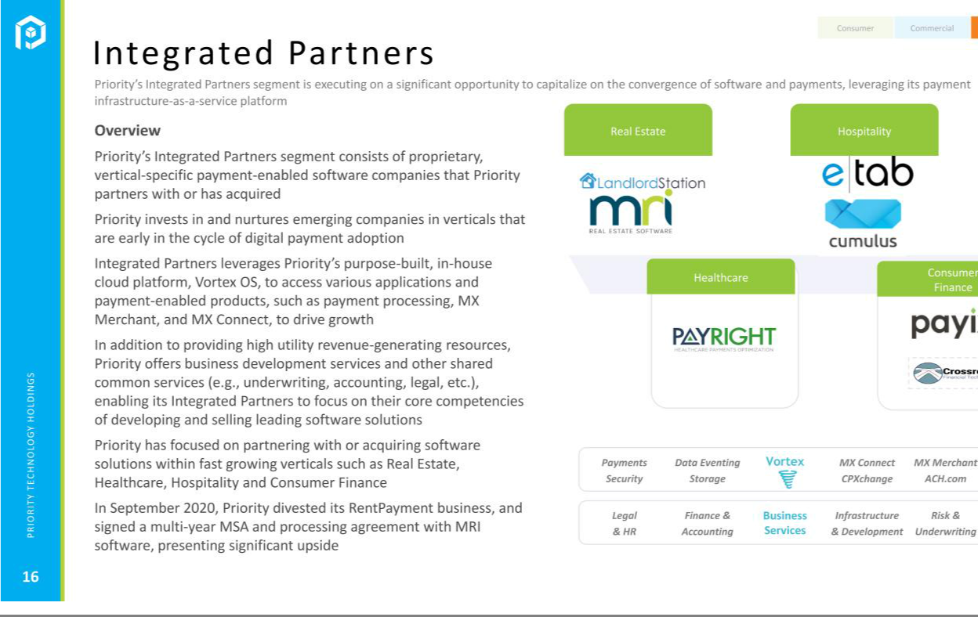

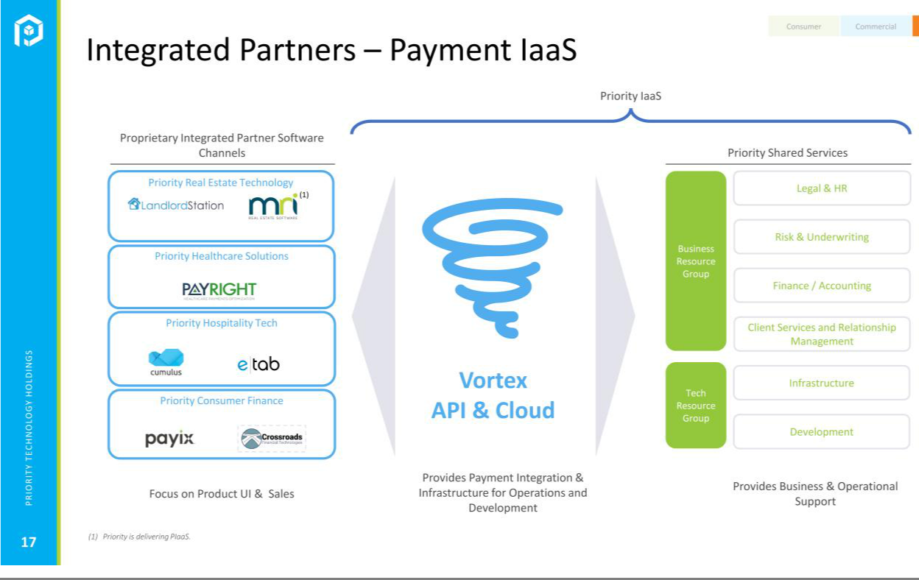



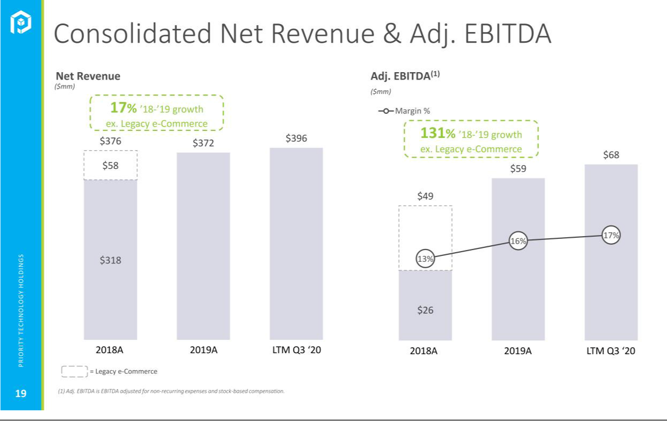

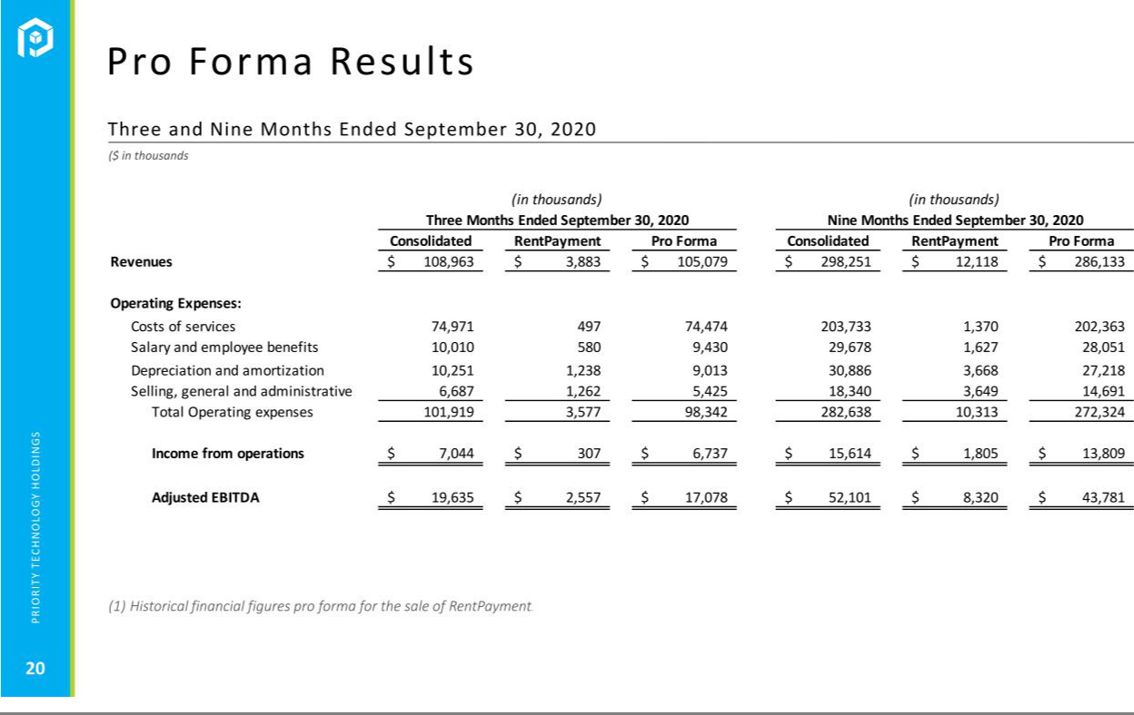



*For Immediate Release*

Investor and Media Inquiries:

Dave Faupel

dave.faupel@prth.com

Priority Technology Holdings, Inc. to Participate in A.G.P. Emerging Growth Technology Conference

ALPHARETTA, Ga. - (February 3, 2021) -- Priority Technology Holdings, Inc. (NASDAQ: PRTH) (“Priority”) today announced that is participating in the A.G.P. Emerging Growth Technology Conference on Thursday, February 4, 2021. Virtual one-on-one meetings will be held throughout the day and the presentation can be found here http://prth.com/assets/AGP-Technology-Conference.pdf

In these meetings, the Company will reiterate its previously disclosed guidance for the fourth quarter of 2020 financial results to match, if not exceed, third quarter of 2020 revenue of $105.1 million and adjusted EBITDA of $17.1 million, excluding the RentPayment business results. The strong momentum experienced in the third quarter of 2020 continued through the fourth quarter of 2020. Priority’s third quarter 2020 earnings release on November 12, 2020 provides a reconciliation of net income to the non-GAAP adjusted EBITDA measure, and provides pro forma results summaries excluding the RentPayment business.

About Priority Technology Holdings, Inc.

Priority is a leading provider of merchant acquiring, integrated payment software and corporate payment solutions, offering unique product and service capabilities to its merchant network and distribution partners. Priority’s enterprise operates from a purpose-built payments infrastructure that includes tailored customer service offerings and bespoke technology development, allowing the Company to provide end-to-end solutions for payment and payment-adjacent software. Additional information can be found at www.PRTH.com.

Forward Looking Statements

This press release contains “forward-looking statements” within the meaning of the Private Securities Litigation Reform Act of 1995. Such statements include, but are not limited to, statements about future financial and operating results, our plans, objectives, expectations and intentions with respect to future operations, products and services, and other statements identified by words such as “may,” “will,” “should,” “anticipates,” “believes,” “expects,” “plans,” “future,” “intends,” “could,” “estimate,”

“predict,” “projects,” “targeting,” “potential” or “contingent,” “guidance,” “anticipates,” “outlook” or words of similar meaning. These forward-looking statements include, but are not limited to, our 2020 outlook and statements regarding our market and growth opportunities. Such forward-looking statements are based upon the current beliefs and expectations of our management and are inherently subject to significant business, economic and competitive risks, trends and uncertainties that could cause actual results to differ materially from those projected, expressed, or implied by such forward-looking statements. These forward-looking statements may include, but are not limited to, statements about the effects of the COVID-19 pandemic on our revenues and financial operating results. Our actual results could differ materially, and potentially adversely, from those discussed or implied herein.

We caution that it is very difficult to predict the impact of known factors, and it is impossible for us to anticipate all factors that could affect our actual results. All forward-looking statements are expressly qualified in their entirety by these cautionary statements. You should evaluate all forward-looking statements made in this press release in the context of the risks and uncertainties disclosed in our SEC filings, including our Annual Report on Form 10-K and our Quarterly Report on Form 10-Q filed with the SEC on March 30, 2020 and November 13, 2020, respectively. These filings are available online at www.sec.gov or www.PRTH.com.

