SEC Form 4

FORM 4

Check this box if no longer subject to Section
- Form 4 or Form 5 obligations may continue. See Instruction 1(b).

UNITED STATES SECURITIES AND EXCHANGE COMMISSION
Washington, D.C. 20549
Washington, D.C. 20549 |  | OMB APPROVAL
STATEMENT OF CHANGES IN BENEFICIAL OWNERSHIP
STATEMENT OF CHANGES IN BENEFICIAL OWNERSHIP |  | OMB Number: | 3235-0287
 |  | Estimated average burden
Filed pursuant to Section 16(a) of the Securities Exchange Act of 1934 |  | hours per response: | 0.5
or Section 30(h) of the Investment Company Act of 1940
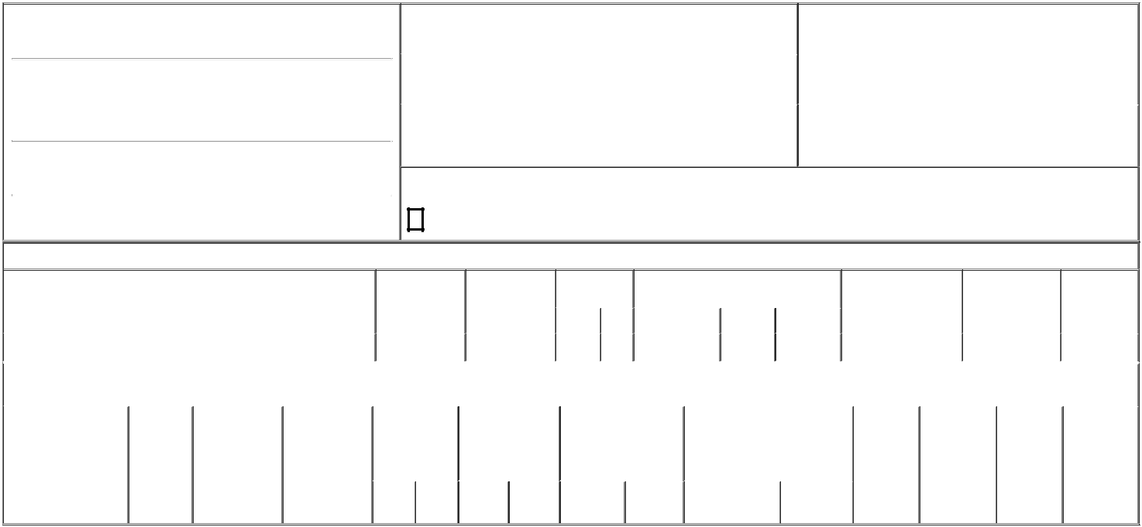

1. Name and Address of Reporting Person*
Kiewiet Sean

(Last) (First) (Middle)

C/O PRIORITY TECHNOLOGY HOLDINGS, INC.

2001 WESTSIDE PARKWAY, SUITE 155

(Street)
 | ALPHARETTA | GA | 30004
 | (City) | (State) | (Zip)

2. |  | Issuer Name and Ticker or Trading Symbol |  | 5. Relationship of Reporting Person(s) to Issuer
 | Priority Technology Holdings, Inc. [ PRTH ] |  |  | (Check all applicable)
 |  |  |  |  | Director | 10% Owner
 |  |  |  | X | Officer (give title | Other (specify below)
3. |  | Date of Earliest Transaction (Month/Day/Year) |  | X | Officer (give title | Other (specify below)
 |  |  |  | X | below) | Other (specify below)
04/01/2024 |  |  |  |  | Chief Strategy Officer
4. |  | If Amendment, Date of Original Filed (Month/Day/Year) |  | 6. Individual or Joint/Group Filing (Check Applicable Line)
 |  |  |  | X | Form filed by One Reporting Person
 |  |  |  |  | Form filed by More than One Reporting Person

Rule 10b5-1(c) Transaction Indication

- Check this box to indicate that a transaction was made pursuant to a contract, instruction or written plan that is intended to satisfy the affirmative defense conditions of Rule 10b5-1(c). See Instruction 10.

Table I - Non-Derivative Securities Acquired, Disposed of, or Beneficially Owned

 | 1. Title of Security (Instr. 3) |  |  |  | 2. Transaction | 2A. Deemed |  | 3. Transaction |  | 4. Securities Acquired (A) or Disposed Of |  |  |  | 5. Amount of Securities |  |  | 6. Ownership |  | 7. Nature of
 |  |  |  |  | Date | Execution Date, |  | Code (Instr. 8) (D) (Instr. 3, 4 and 5) |  |  |  |  |  | Beneficially Owned |  |  | Form: Direct (D) or |  | Indirect
 |  |  |  |  | (Month/Day/Year) | if any |  |  |  |  |  |  |  | Following Reported |  |  | Indirect (I) (Instr. 4) |  | Beneficial
 |  |  |  |  |  | (Month/Day/Year) |  | Code | V | Amount |  | (A) or (D) | Price | Transaction(s) (Instr. 3 |  |  |  |  | Ownership
 |  |  |  |  |  |  |  | Code | V | Amount |  | (A) or (D) | Price | and 4) |  |  |  |  | (Instr. 4)
 | Common Stock |  |  |  | 04/01/2024 |  |  | _{S}(1) |  | 10,000 |  | D | $3.3⁽²⁾ | 1,351,853 |  |  |  | D
 |  |  |  | Table II - Derivative Securities Acquired, Disposed of, or Beneficially Owned
 |  |  |  |  | (e.g., puts, calls, warrants, options, convertible securities)
 | 1. Title of Derivative | 2. | 3. Transaction | 3A. Deemed | 4. Transaction | 5. Number of |  | 6. Date Exercisable and |  |  | 7. Title and Amount of Securities |  |  |  | 8. Price of | 9. Number of |  | 10. | 11. Nature of
 | Security (Instr. 3) | Conversion | Date | Execution Date, | Code (Instr. 8) | Derivative |  | Expiration Date |  |  | Underlying Derivative Security |  |  |  | Derivative | derivative |  | Ownership | Indirect
 |  | or Exercise | (Month/Day/Year) | if any |  | Securities Acquired |  | (Month/Day/Year) |  |  | (Instr. 3 and 4) |  |  |  | Security | Securities |  | Form: | Beneficial
 |  | Price of |  | (Month/Day/Year) |  | (A) or Disposed of |  |  |  |  |  |  |  |  | (Instr. 5) | Beneficially |  | Direct (D) or | Ownership
 |  | Derivative |  |  |  | (D) (Instr. 3, 4 and |  |  |  |  |  |  |  |  |  | Owned |  | Indirect (I) | (Instr. 4)
 |  | Security |  |  |  | 5) |  |  |  |  |  |  |  |  |  | Following |  | (Instr. 4)
 |  |  |  |  |  |  |  |  |  |  |  |  |  |  |  | Reported
 |  |  |  |  |  |  |  |  |  |  |  |  | Amount or |  |  | Transaction(s)
 |  |  |  |  |  |  |  | Date |  | Expiration |  |  | Number of |  |  | (Instr. 4)
 |  |  |  |  | Code V | (A) | (D) | Exercisable |  | Date | Title |  | Shares

Explanation of Responses:

- The sales reported in this Form 4 were effected pursuant to a Rule 10b5-trading plan adopted by the reporting person.

- The price reported in Column 4 is a weighted average price. These shares were acquired in multiple transactions at prices ranging from $3.16 to $3.43, inclusive. The reporting person undertakes to provide to Priority Technology Holdings, Inc., any security holder of Priority Technology Holdings, Inc., or the staff of the Securities and Exchange Commission, upon request, full information regarding the number of shares sold at each separate price within the ranges set forth in footnote (2) to this Form 4.

Remarks:

/s/ Bradley J. Miller (Attorney-In-Fact) 04/02/2024

** Signature of Reporting Person Date

Reminder: Report on a separate line for each class of securities beneficially owned directly or indirectly.

* If the form is filed by more than one reporting person, see Instruction 4 (b)(v).

- Intentional misstatements or omissions of facts constitute Federal Criminal Violations See 18 U.S.C. 1001 and 15 U.S.C. 78ff(a). Note: File three copies of this Form, one of which must be manually signed. If space is insufficient, see Instruction 6 for procedure.
Persons who respond to the collection of information contained in this form are not required to respond unless the form displays a currently valid OMB Number.



