SEC Form 4

FORM 4

Check this box if no longer subject to Section 16. Form 4 or Form 5 obligations may continue. See Instruction 1(b).

Check this box to indicate that a transaction was made pursuant to a contract, instruction or written plan for the purchase or sale of equity securities of the issuer that is intended to satisfy the affirmative defense conditions of Rule 10b5-1(c). See Instruction 10.

UNITED STATES SECURITIES AND EXCHANGE COMMISSION
Washington, D.C. 20549
Washington, D.C. 20549 |  | OMB APPROVAL
STATEMENT OF CHANGES IN BENEFICIAL OWNERSHIP
STATEMENT OF CHANGES IN BENEFICIAL OWNERSHIP |  | OMB Number: | 3235-0287
 |  | Estimated average burden
Filed pursuant to Section 16(a) of the Securities Exchange Act of 1934 |  | hours per response: | 0.5
or Section 30(h) of the Investment Company Act of 1940
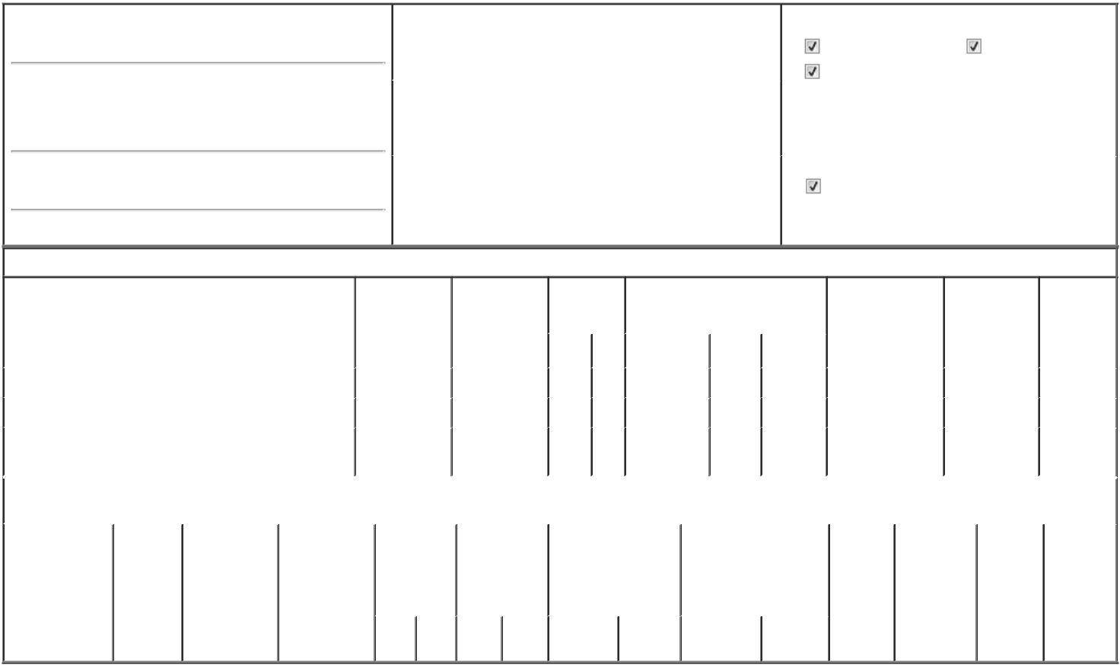

1. Name and Address of Reporting Person*
Priore Thomas Charles

(Last) (First) (Middle)

C/O PRIORITY TECHNOLOGY HOLDINGS, INC. 2001 WESTSIDE PARKWAY, SUITE 155

(Street)

ALPHARETTA GA 30004

(City) (State) (Zip)

2. |  | Issuer Name and Ticker or Trading Symbol |  | 5. Relationship of Reporting Person(s) to Issuer
Priority Technology Holdings, Inc. [ PRTH ] |  |  |  | (Check all applicable)
 |  |  |  | Director | 10% Owner
 |  |  |  | Officer (give title | Other (specify
 |  |  |  | below) | below)
3. |  | Date of Earliest Transaction (Month/Day/Year) |  | below) | below)
 |  |  |  | President, CEO and Chairman
01/17/2025
4. |  | If Amendment, Date of Original Filed (Month/Day/Year) |  | 6. Individual or Joint/Group Filing (Check Applicable Line)
 |  |  |  | Form filed by One Reporting Person
 |  |  |  | Form filed by More than One Reporting Person

Table I - Non-Derivative Securities Acquired, Disposed of, or Beneficially Owned

1. Title of Security (Instr. 3) |  |  | 2. Transaction |  |  | 2A. Deemed |  | 3. | 4. Securities Acquired (A) or Disposed |  |  |  |  | 5. Amount of |  | 6. Ownership |  | 7. Nature of
 |  |  | Date |  |  | Execution Date, |  | Transaction | Of (D) (Instr. 3, 4 and 5) |  |  |  |  | Securities |  | Form: Direct (D) |  | Indirect
 |  |  | (Month/Day/Year) |  |  | if any |  | Code (Instr. |  |  |  |  |  | Beneficially Owned |  | or Indirect (I) |  | Beneficial
 |  |  |  |  |  | (Month/Day/Year) |  | 8) |  |  |  |  |  | Following Reported |  | (Instr. 4) |  | Ownership
 |  |  |  |  |  |  |  |  |  |  |  |  |  | Transaction(s) (Instr. |  |  |  | (Instr. 4)
 |  |  |  |  |  |  |  | Code V | Amount |  | (A) or | Price |  | 3 and 4)
 |  |  |  |  |  |  |  | Code V | Amount |  | (D)
Common Stock |  |  |  | 01/17/2025 |  |  |  | _{S}(1) | 294,167 |  | D | $7.44⁽²⁾ |  | 34,025,319 |  |  | D
Common Stock |  |  |  | 01/21/2025 |  |  |  | _{S}(3) | 105,833 |  | D | $7.44⁽²⁾ |  | 33,919,486 |  |  | D
Common Stock |  |  |  |  |  |  |  |  |  |  |  |  |  | 12,500,000 |  |  | I | see
Common Stock |  |  |  |  |  |  |  |  |  |  |  |  |  |  |  |  | I | footnote⁽⁴⁾
 |  |  | Table II - Derivative Securities Acquired, Disposed of, or Beneficially Owned
 |  |  | (e.g., puts, calls, warrants, options, convertible securities)
1. Title of Derivative | 2. | 3. Transaction | 3A. Deemed |  | 4. Transaction | 5. Number of |  | 6. Date Exercisable and |  | 7. Title and Amount of |  |  |  | 8. Price of | 9. Number of |  | 10. | 11. Nature of
Security (Instr. 3) | Conversion | Date | Execution Date, |  | Code (Instr. 8) | Derivative |  | Expiration Date |  | Securities Underlying |  |  |  | Derivative | derivative |  | Ownership | Indirect
 | or Exercise | (Month/Day/Year) | if any |  |  | Securities |  | (Month/Day/Year) |  | Derivative Security (Instr. 3 |  |  |  | Security | Securities |  | Form: | Beneficial
 | Price of |  | (Month/Day/Year) |  |  | Acquired (A) or |  |  |  | and 4) |  |  |  | (Instr. 5) | Beneficially |  | Direct (D) | Ownership
 | Derivative |  |  |  |  | Disposed of (D) |  |  |  |  |  |  |  |  | Owned |  | or Indirect | (Instr. 4)
 | Security |  |  |  |  | (Instr. 3, 4 and |  |  |  |  |  |  |  |  | Following |  | (I) (Instr. 4)
 |  |  |  |  |  | 5) |  |  |  |  |  |  |  |  | Reported
 |  |  |  |  |  |  |  |  |  |  |  |  |  |  | Transaction(s)
 |  |  |  |  |  |  |  |  |  |  |  | Amount or |  |  | (Instr. 4)
 |  |  |  |  |  |  |  | Date | Expiration |  |  | Number of
 |  |  |  |  | Code V | (A) | (D) | Exercisable | Date | Title |  | Shares

Explanation of Responses:

- Shares sold on January 17, 2025, pursuant to underwritten public secondary offering as detailed in prospectus supplement filed with the SEC, dated January 15, 2025, pursuant to Rule 424(b)(5) and Registration No. 333-283519 (the Secondary Offering).

- This amount represents the $7.75 secondary public offering price per share of Common Stock of the Issuer, less the underwriting discount of $0.31 per share sold in the Secondary Offering.

- Shares sold on January 21, 2025, pursuant to the underwriters exercise of an option to purchase additional shares in the Secondary Offering.

- Includes 2,500,000 shares of PRTH common stock held by Lori A. Priore, the spouse of Thomas C. Priore, and Bernard H. Smyers, in their capacity as trustees of the Thomas C. Priore Irrevocable Insurance Trust u/a/d 1/8/2010, for the benefit of Lori A. Priore and the children of Thomas C. Priore and Lori A. Priore. Also includes 10,000,000 shares of PRTH common stock held by Lori A. Priore, the spouse of Thomas C. Priore, in her capacity as trustee of the Thomas Priore 2019 GRAT, for the benefit of Lori A. Priore and the children of Thomas C. Priore and Lori A. Priore.

Remarks:

/s/ Bradley J. Miller (Attorney-In- |  |  | 01/22/2025
Fact) |  |  | 01/22/2025
** Signature of Reporting Person |  |  | Date

Reminder: Report on a separate line for each class of securities beneficially owned directly or indirectly.

* If the form is filed by more than one reporting person, see Instruction 4 (b)(v).

- Intentional misstatements or omissions of facts constitute Federal Criminal Violations See 18 U.S.C. 1001 and 15 U.S.C. 78ff(a). Note: File three copies of this Form, one of which must be manually signed. If space is insufficient, see Instruction 6 for procedure.
Persons who respond to the collection of information contained in this form are not required to respond unless the form displays a currently valid OMB Number.



