As filed with the Securities and Exchange Commission on April 1, 2022

Registration No. 333-
 | UNITED STATES
 | SECURITIES AND EXCHANGE COMMISSION
 | Washington, D.C. 20549
 | FORM S-8
 | REGISTRATION STATEMENT
 | UNDER THE SECURITIES ACT OF 1933
 | Priority Technology Holdings, Inc.
 | (Exact name of registrant as specified in its charter)
Delaware | 47-4257046
(State or other jurisdiction of | (I.R.S. Employer
incorporation or organization) | Identification No.)
 | 2001 Westside Parkway
 | Suite 155
 | Alpharetta, GA 30004
 | (Address of Principal Executive Offices) (Zip Code)
 | Priority Technology Holdings, Inc. 2021 Employee Stock Purchase Plan
 | (Full title of the plan)

Bradley Miller
General Counsel, Chief Risk Officer and Corporate Secretary
Priority Technology Holdings, Inc.
2001 Westside Parkway
Suite 155
Alpharetta, GA 30004
(800) 935-5961
(Name and address, including zip code, and telephone number, including area code, of agent for service)

Copy to:
James Stevens
Troutman Pepper Hamilton Sanders LLP
600 Peachtree Street, NE
Suite 3000
Atlanta, Georgia 30308
(404) 885-3000

Indicate by check mark whether the registrant is a large accelerated filer, an accelerated filer, a non-accelerated filer, a smaller reporting company or an emerging growth company. See the definitions of “large accelerated filer,” “accelerated filer,” “smaller reporting company,” and “emerging growth company” in Rule 12b-2 of the Exchange Act.

Large accelerated filer ☐

Non-accelerated filer ☒

Accelerated filer ☐

Smaller reporting company ☒

Emerging growth company ☐

If an emerging growth company, indicate by check mark if the registrant has elected not to use the extended transition period for complying with any new or revised financial accounting standards provided pursuant to Section 7(a)(2)(B) of the Securities Act. ☐

PART I

INFORMATION REQUIRED IN THE SECTION 10(a) PROSPECTUS

The information specified in Item 1 and Item 2 of Part I of the Registration Statement on Form S-8 (the “Registration Statement”) is omitted from this filing in accordance with the provisions of Rule 428 under the Securities Act of 1933, as amended (the “Securities Act”), and the introductory note to Part I of the Registration Statement. The documents containing the information specified in Part I will be delivered to the participants in the plan covered by this Registration Statement as required by Rule 428(b)(1).

PART II

INFORMATION REQUIRED IN THE REGISTRATION STATEMENT

Item 3. Incorporation of Documents by Reference.

The following documents filed with the Securities and Exchange Commission (the “Commission”) by Priority Technology Holdings, Inc. (the “Registrant” or “Company”) pursuant to the Securities Act and the Securities Exchange Act of 1934, as amended (the “Exchange Act”), are incorporated herein by reference, to the extent that such documents are considered filed with the Commission:

- The Registrant’s Annual Report on Form 10-K for the fiscal year ended December 31, 2021, filed with the Commission on March 17, 2022 (File No. 001-37872).

- All reports filed pursuant to Section 13(a) or 15(d) of the Exchange Act since December 31, 2021.

- The description of the Registrant’s common stock contained in the Registrant’s Registration Statement on Form 8-A (File No. 001-37872) filed with the Commission on September 12, 2016, pursuant to Section 12(b) of the Exchange Act, including any amendment or report filed for the purpose of updating such description.

All documents subsequently filed by the Registrant pursuant to Sections 13(a), 13(c), 14 and 15(d) of the Exchange Act, prior to the filing of a post-effective amendment which indicates that all securities offered have been sold or which deregisters all securities then remaining unsold, shall be deemed to be incorporated by reference herein and to be a part hereof from the date of filing of such documents, to the extent such documents are considered filed with the Commission.

Any statement contained in a document incorporated or deemed to be incorporated by reference herein shall be deemed to be modified or superseded for purposes of this Registration Statement to the extent that a statement contained herein (or in any other subsequently filed document which also is incorporated or deemed to be incorporated by reference herein) modifies or supersedes such statement. Any such statement so modified or superseded shall not be deemed, except as so modified or superseded, to constitute a part of this Registration Statement.

You may request copies of these documents, at no cost to you, by writing or telephoning us at the below address. Exhibits to the filings, however, will not be sent, unless those exhibits have specifically been incorporated by reference in this document:

Priority Technology Holdings, Inc.
2001 Westside Parkway
Suite 155
Alpharetta, GA 30004
(800) 935-5961

Item 4. Description of Securities.

Not applicable.

Item 5. Interests of Named Experts and Counsel.

Not applicable.

2

Item 6. Indemnification of Directors and Officers.

The following summary is qualified in its entirety by reference to the complete Delaware General Corporation Law (“DGCL”), the Registrant’s Second Amended and Restated Certificate of Incorporation, as amended (“Certificate of Incorporation”), and the Registrant’s Amended and Restated Bylaws (“Bylaws”).

Section 145 of the DGCL provides that a corporation may indemnify directors and officers as well as other employees and individuals against expenses (including attorneys’ fees), judgments, fines and amounts paid in settlement actually and reasonably incurred by such person in connection with any threatened, pending or completed actions, suits or proceedings in which such person is made a party by reason of such person being or having been a director, officer, employee or agent of the registrant. The DGCL provides that Section 145 is not exclusive of other rights to which those seeking indemnification may be entitled under any bylaws, agreement, vote of stockholders or disinterested directors or otherwise. The Certificate of Incorporation and Bylaws provide for indemnification by the registrant of its directors and officers to the fullest extent permitted by the DGCL.

Section 102(b)(7) of the DGCL permits a corporation to provide in its Certificate of Incorporation that a director of the corporation shall not be personally liable to the corporation or its stockholders for monetary damages for breach of fiduciary duty as a director, except for liability (1) for any breach of the director’s duty of loyalty to the corporation or its stockholders, (2) for acts or omissions not in good faith or which involve intentional misconduct or a knowing violation of law, (3) for unlawful payments of dividends or unlawful stock repurchases, redemptions or other distributions or (4) for any transaction from which the director derived an improper personal benefit. The Registrant’s Certificate of Incorporation provides for such limitation of liability to the fullest extent permitted by the DGCL.

The Registrant’s Certificate of Incorporation permits the Company to purchase and maintain insurance on behalf of any person who is or was a director, officer, employee or agent of the Company, or is serving at the request of the Company as a director, officer, employee or agent of another corporation, partnership, joint venture, trust, employee benefit plan or other enterprise against any liability asserted against such person and incurred by such person in any such capacity, or arising out of such person’s status as such, whether or not the Company would have the power to indemnify such person against such liability under the provisions of law. In addition, the Registrant’s Certificate of Incorporation permits the Company to create a trust fund, grant a security interest and/or use other means (including, without limitation, letters of credit, surety bonds and/or other similar arrangements), as well as enter into contracts providing indemnification to the full extent authorized or permitted by the DGCL and including as part thereof provisions with respect to any or all of the foregoing to ensure the payment of such amounts as may become necessary to effect indemnification as provided therein, or elsewhere.

Item 7. Exemption From Registration Claimed.

Not applicable.

Item 8. Exhibits.

3

Exhibit |  | Description
4.1 |  | Second Amended and Restated Certificate of Incorporation of the Company (incorporated by reference to Exhibit 3.1 to the Company’s Current
 |  | Report on Form 8-K, filed July 31, 2018).
4.2 |  | Certificate of Amendment to the Certificate of Incorporation of the Company (incorporated by reference to Exhibit 2.3 to the Company’s Annual
 |  | Report on Form 10-K, filed March 17, 2022).
4.3 |  | Certificate of Designations of Senior Preferred Stock (incorporated by reference to Exhibit 3.3 to the Company’s Annual Report on Form 10-K,
 |  | filed March 17, 2022).
4.4 |  | Specimen Common Stock Certificate (incorporated by reference to Exhibit 4.2 to the Registration Statement on Form S-1, filed July 26, 2016).
4.5 |  | Amended and Restated Bylaws of the Company (incorporated by reference to Exhibit 3.2 to the Company’s Current Report on Form 8-K, filed
 |  | July 31, 2018).
5.1* |  | Opinion of Troutman Pepper Hamilton Sanders LLP
10.1 |  | Priority Technology Holdings, Inc. 2021 Employee Stock Purchase Plan (incorporated by reference to Exhibit 10.3.1 to the Company’s Annual
 |  | Report on Form 10-K, filed March 17, 2022).
23.1* |  | Consent of Ernst & Young LLP, Independent Registered Public Accounting Firm for the Company
23.2* |  | Consent of RSM US LLP
23.3* |  | Consent of Troutman Pepper Hamilton Sanders LLP (included in Exhibit 5.1)
24.1 |  | Power of Attorney (contained on the signature page hereto)
107* |  | Filing Fee Table

* Filed herewith.

Item 9. Undertakings.

- The undersigned Registrant hereby undertakes:

  - To file, during any period in which offers or sales are being made, a post-effective amendment to this registration statement:

    - To include any prospectus required by Section 10(a)(3) of the Securities Act; and

    - To reflect in the prospectus any facts or events arising after the effective date of this registration statement (or the most recent post-effective amendment thereof) which, individually or in the aggregate, represent a fundamental change in the information set forth in this registration statement. Notwithstanding the foregoing, any increase or decrease in volume of securities offered (if the total dollar value of securities offered would not exceed that which was registered) and any deviation from the low or high end of the estimated maximum offering range may be reflected in the form of prospectus filed with the Commission pursuant to Rule 424(b) if, in the aggregate, the changes in volume and price represent no more than 20% change in the maximum aggregate offering price set forth in the “Calculation of Registration Fee” table in the effective registration statement;

Provided, however, that paragraphs (a)(1)(i) and (a)(1)(ii) do not apply if the information required to be included in a post-effective amendment by those paragraphs is contained in reports filed with or furnished to the Commission by the Registrant pursuant to Section 13 or 15(d) of the Exchange Act that are incorporated by reference in this registration statement.

  - That, for the purpose of determining any liability under the Securities Act, each such post-effective amendment shall be deemed to be a new registration statement relating to the securities offered therein, and the offering of such securities at that time shall be deemed to be the initial bona fide offering thereof.

  - To remove from registration by means of a post-effective amendment any of the securities being registered which remain unsold at the termination of the offering.

- The undersigned Registrant hereby undertakes that, for purposes of determining any liability under the Securities Act, each filing of the Registrant’s annual report pursuant to Section 13(a) or Section 15(d) of the

4

Exchange Act (and, where applicable, each filing of an employee benefit plan’s annual report pursuant to Section 15(d) of the Exchange Act) that is incorporated by reference in this registration statement shall be deemed to be a new registration statement relating to the securities offered therein, and the offering of such securities at that time shall be deemed to be the initial bona fide offering thereof.

- Insofar as indemnification for liabilities arising under the Securities Act may be permitted to directors, officers and controlling persons of the Registrant pursuant to the foregoing provisions, or otherwise, the Registrant has been advised that, in the opinion of the Commission, such indemnification is against public policy as expressed in the Securities Act and is, therefore, unenforceable. In the event that a claim for indemnification against such liabilities (other than the payment by the Registrant of expenses incurred or paid by a director, officer or controlling person of the Registrant in the successful defense of any action, suit or proceeding) is asserted by such director, officer or controlling person in connection with the securities being registered, the Registrant will, unless in the opinion of its counsel the matter has been settled by controlling precedent, submit to a court of appropriate jurisdiction the question whether such indemnification by it is against public policy as expressed in the Securities Act and will be governed by the final adjudication of such issue.

5

SIGNATURES

Pursuant to the requirements of the Securities Act, the Registrant certifies that it has reasonable grounds to believe that it meets all of the requirements for filing on Form S-8 and has duly caused this Registration Statement to be signed on its behalf by the undersigned, thereunto duly authorized, in the City of Alpharetta, State of Georgia, on April 1, 2022.

PRIORITY TECHNOLOGY HOLDINGS, INC.

By: | /s/ Michael Vollkommer
Name: | Michael Vollkommer
Title: | Chief Financial Officer

6

POWERS OF ATTORNEY

Each person whose signature appears below constitutes and appoints Michael Vollkommer and Bradley Miller or any of them, his or her true and lawful attorneys-in-fact and agents, with full power of substitution and resubstitution, for him or her and in his or her name, place and stead, in any and all capacities, to sign any and all amendments to this Registration Statement, including post-effective amendments to this Registration Statement, registration statements filed pursuant to Rule 429 under the Securities Act, and any related registration statements necessary to register additional securities, and to file the same, with all exhibits thereto, and other documents in connection therewith with the Securities and Exchange Commission, granting unto said attorneys-in-fact and agents, and each of them, full power and authority to do and to perform each and every act and thing requisite and necessary to be done in and about the premises, as fully and to all intents and purposes as he or she might or would do in person, hereby ratifying and confirming all that said attorneys-in-fact and agents or any of them, or their or his substitute or substitutes, may lawfully do or cause to be done by virtue hereof.

Pursuant to the requirements of the Securities Act, this Registration Statement has been signed by the following persons in the capacities and on the dates indicated.

 | Signature |  |  | Title |  |  | Date
 |  |  | President, Chief Executive Officer and Chairman |  |  | April 1, 2022
/s/ Thomas C. Priore |  |  | (Principal Executive Officer)
Thomas C. Priore |  |  | Chief Financial Officer
 |  |  |  |  |  | April 1, 2022
/s/ Michael Vollkommer |  |  | (Principal Financial Officer)
Michael Vollkommer |  |  | Senior Vice President and
 |  |  |  |  |  | April 1, 2022
/s/ Rajiv Kumar |  |  | Chief Accounting Officer (Principal Accounting Officer)
Rajiv Kumar
/s/ John Priore |  |  | Director |  |  | April 1, 2022
John Priore
/s/ Michael Passilla |  |  | Director |  |  | April 1, 2022
Michael Passilla
/s/ Marietta C. Davis |  |  | Director |  |  | April 1, 2022
Marietta C. Davis
/s/ Christina M. Favilla |  |  | Director |  |  | April 1, 2022
Christina M. Favilla
/s/ Stephen W. Hipp |  |  | Director |  |  | April 1, 2022
Stephen W. Hipp

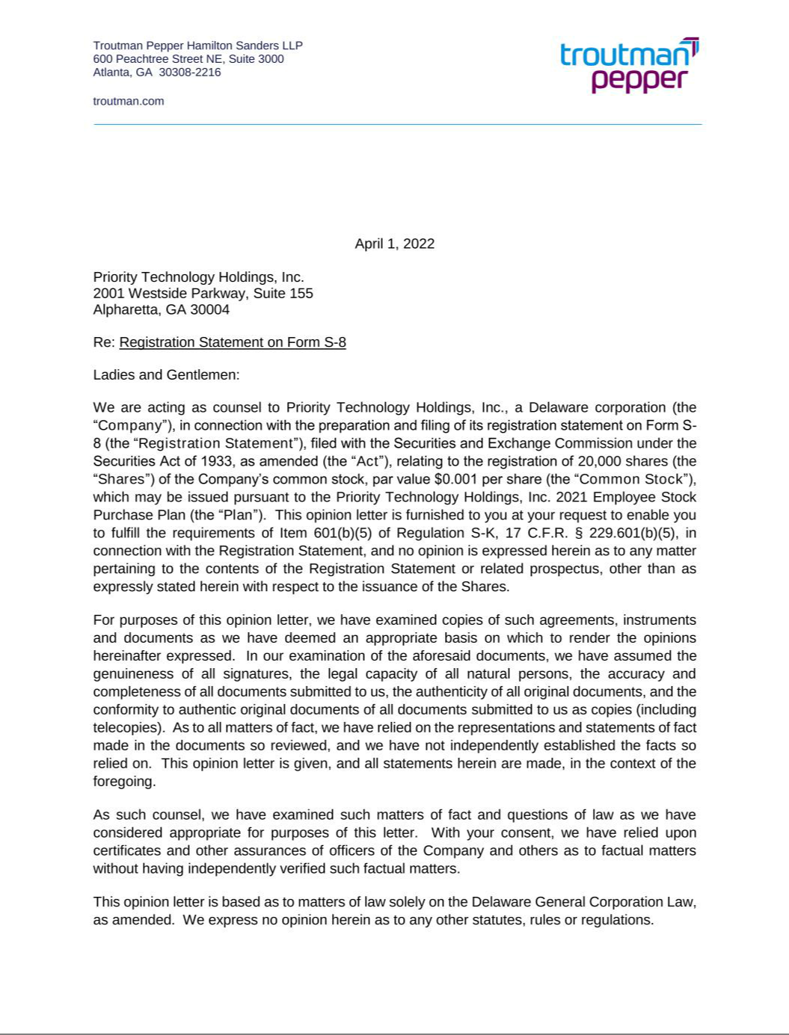

EXHIBIT 23.1

Consent of Independent Registered Public Accounting Firm

We consent to the incorporation by reference in the Registration Statement (Form S-8) pertaining to the Employees' Savings Plan of Priority Technology Holdings, Inc. of our report dated March 17, 2022, with respect to the consolidated financial statements of Priority Technology Holdings, Inc. included in its Annual Report (Form 10-K) for the year ended December 31, 2021, filed with the Securities and Exchange Commission.

/s/ Ernst & Young LLP

Atlanta, Georgia
April 1, 2022

1

Exhibit 23.2

Consent of Independent Registered Public Accounting Firm

We consent to the incorporation by reference in this Registration Statement on Form S-8 of Priority Technology Holdings, Inc. of our report dated March 30, 2020, except for the change in reportable segments described in Note 20 as to which the date is March 17, 2022, relating to the consolidated financial statements of Priority Technology Holdings, Inc., appearing in the Annual Report on Form 10-K of Priority Technology Holdings, Inc. for the year ended December 31, 2021.

/s/ RSM US LLP

Atlanta, Georgia

April 1, 2022

Exhibit 107

CALCULATION OF FILING FEE TABLES

FORM S-8
(Form Type)

Priority Technology Holdings, Inc.
(Exact Name of Registrant as Specified in its Charter)

Table 1: Newly Registered Securities

 |  |  |  | Proposed
 |  | Fee |  | Maximum | Maximum |  | Amount of
 | Security | Fee | Amount | Offering | Maximum |  | Amount of
Security Type | Security | Calculation | Amount | Price Per | Aggregate | Fee Rate | Registration
Security Type | Class Title | Rule | Registered(1) | Unit(2) | Offering Price(2) | Fee Rate | Fee(2)
Equity | Common stock, $0.001 | 457(c) and 457(h) | 20,000 | $5.59 | $111,800.00 | 0.0000927 | $10.36
 | par value per share
 |  | Total Offering Amounts |  |  | $111,800.00 |  | $10.36
 |  |  | Total Fee Offsets |  | — |  | —
 |  |  | Net Fee Due |  |  |  | $10.36

- Pursuant to Rule 416(a) promulgated under the Securities Act of 1933, as amended (the “Securities Act”), this Registration Statement shall also cover any additional shares of common stock, par value $0.001 per share (“Common Stock”), of Priority Technology Holdings, Inc. (the “Company”) that become issuable under the Priority Technology Holdings, Inc. 2021 Employee Stock Purchase Plan (the “Plan”) by reason of any future stock dividend, stock split, recapitalization or other similar transaction.

- Estimated in accordance with Rule 457(c) and Rule 457(h) of the Securities Act. The price shown is based upon the average of the high and low prices reported for the common stock on the Nasdaq Global Market on March 28, 2022.

