UNITED STATES

SECURITIES AND EXCHANGE COMMISSION

Washington, DC 20549

_________________

SCHEDULE 14A

PROXY STATEMENT PURSUANT TO SECTION 14(a) OF THE

SECURITIES EXCHANGE ACT OF 1934

________________

Filed by the Registrant X

Filed by a Party other than the Registrant ☐

Check the appropriate box:

- Preliminary Proxy Statement

- Confidential, For Use of the Commission Only (as permitted by Rule 14a-6(e)(2))

XDefinitive Proxy Statement

- Definitive Additional Materials

- Soliciting Material Pursuant to Section 240.14a-12

PRIORITY TECHNOLOGY HOLDINGS, INC.

(Name of Registrant as Specified in Its Charter)

______________________________________________________________

(Name of Person(s) Filing Proxy Statement, if Other Than the Registrant)

Payment of Filing Fee (Check the appropriate box):

- No fee required.

- Fee computed on table below per Exchange Act Rules 14a-6(i)(1) and 0-11.

  - Title of each class of securities to which transaction applies:

  - Aggregate number of securities to which transaction applies:

  - Per unit price of other underlying value of transaction computed pursuant to Exchange Act Rule 0-11 (set forth the amount on which the filing fee is calculated and state how it was determined):

  - Proposed maximum aggregate value of transaction:

  - Total fee paid:

- Fee paid previously with preliminary materials.

- Check box if any part of the fee is offset as provided by Exchange Act Rule 0-11(a)(2) and identify the filing for which

the offsetting fee was paid previously. Identify the previous filing by registration statement number, or the Form or Schedule and the date of its filing.

- Amount Previously Paid:

- Form, Schedule or Registration Statement No.:

- Filing Party:

- Date Filed:



PROXY STATEMENT AND NOTICE OF

2021 ANNUAL MEETING OF STOCKHOLDERS

Wednesday, June 9, 2021

9:30 a.m. EDT

Priority Technology Holdings, Inc., a Delaware corporation, is a leading provider of merchant acquiring and commercial payment solutions, offering unique product capabilities to small and mid-sized businesses, enterprises and distribution partners (retail and wholesale independent sales organizations, financial institutions and independent software vendors) in the United States. Its common stock is listed on the Nasdaq Global Market under the symbol ''PRTH."

i

April 29, 2021

Dear Stockholder:

The board of directors and officers of Priority Technology Holdings Inc. join me in extending to you a cordial invitation to attend our 2021 Annual Meeting of Stockholders. The meeting will be held on Wednesday, June 9, 2021, at 9:30 a.m. Eastern Daylight Time.

In light of the coronavirus, or COVID-19 pandemic and for the safety of all of our stakeholders, and taking into account recent federal, state and local guidance that has been issued, we have determined that the Annual Meeting will be held in a virtual meeting format only, via the Internet, with no physical in-person meeting. Stockholders will be able to attend, vote and submit questions (both before, and for a portion of, the meeting) from any location via the Internet at www.virtualshareholdermeeting.com/PRTH2021. If you plan to participate in the virtual meeting, please see “Proxy Statement Q&A.”

At the annual meeting, stockholders will be asked to vote on two proposals set forth in the Notice of 2021 Annual Meeting of Stockholders and the proxy statement following this letter.

Whether or not you plan to attend the virtual annual meeting, it is important that your shares of stock are represented and voted regardless of the size of your holdings. We urge you to vote promptly and submit your proxy via the Internet, by telephone or by signing, dating and returning the enclosed proxy card in the enclosed envelope. If you decide to attend the virtual annual meeting, you will be able to vote in person, even if you have submitted your proxy previously.

If you have any questions concerning the annual meeting and you are the stockholder of record of your shares of stock, please contact our Investor Relations representative at dave.faupel@prth.com or (229) 588-8354. If your shares of stock are held by a broker or other nominee (that is, in ''street name''), please contact your broker or other nominee for questions concerning the annual meeting.

We look forward to speaking with you on June 9th.

Sincerely,

/s/ Thomas C. Priore

Thomas C. Priore

President, Chief Executive Officer and Chairman

2001 Westside Parkway

Alpharetta, GA 30004

NOTICE OF 2021 ANNUAL MEETING OF STOCKHOLDERS

Notice is hereby given that the 2021 Annual Meeting of Stockholders (the "Annual Meeting") of Priority Technology Holdings, Inc. (the "Company") will be held at 9:30 a.m. EDT on June 9, 2021.

Our Annual Meeting can be accessed virtually via the Internet at: www.virtualshareholdermeeting.com/PRTH2021.

At the Annual Meeting, the Company's stockholders will be asked to vote on the following proposals:

- To elect the six directors nominated by our board of directors and named in the proxy statement.

- To approve the Priority Technology Holdings Inc. 2021 Employee Stock Purchase Plan.

- To approve an amendment to our Second Amended and Restated Certificate of Incorporation to eliminate supermajority voting requirements.

- To ratify the reappointment of Ernst and Young LLP (or "EY") as the Company's independent registered public accounting firm for the year ending December 31, 2021.

The Board of Directors recommends that you vote FOR each of the proposals listed above.

The stockholders may also transact any other business that may properly come before the Annual Meeting or any adjournments or postponements thereof.

Record Date: Close of business on April 9, 2021.

The solicitation of the enclosed proxy is made on behalf of the Board of Directors for use at the Annual Meeting to be held on June 9, 2021. It is expected that this Proxy Statement and related materials will first be provided to shareholders on or about April 29, 2021. Only stockholders of record at the close of business on April 9, 2020 are entitled to receive notice of, and to vote at, the virtual Annual Meeting or any adjournment or postponement thereof. If you do not attend the virtual Annual Meeting, you may vote your shares of stock via the Internet or by mail or telephone, as instructed in the proxy statement. Your vote is important.

Submitting your proxy does not affect your right to vote in person if you attend the virtual Annual Meeting. Therefore, we urge you to submit your proxy as soon as possible, regardless of whether you expect to attend the Annual Meeting.

In light of the current COVID-19 pandemic, we will monitor the need to change the time or date of our 2021 Annual Meeting of Stockholders, as permitted by guidance issued from the U.S. Securities and Exchange Commission ("SEC") and NASDAQ.

By Order of the Board of Directors,

/s/ Bradley Miller

Bradley Miller

General Counsel, Chief Risk Officer, and Corporate Secretary

Alpharetta, Georgia

April 29, 2021

IMPORTANT NOTICE REGARDING THE AVAILABILITY OF MATERIALS FOR THE MEETING

The proxy statement and our Annual Report are available via the Internet at [http://materials.proxyvote.com/74275G].

Proxy Statement
Table of Contents
 |  |  | Page
General Information about the Proxy Materials and the Annual Meeting |  |  |  |  | 1
Executive Officers and Board of Directors |  |  |  |  | 6
Corporate Governance |  |  |  |  | 9
Report of the Audit Committee |  |  |  | 13
Delinquent Section 16(a) Reports |  |  |  | 14
Compensation of Executive Officers |  |  |  | 15
Compensation of Directors |  |  |  | 18
Outstanding Equity Awards at 2020 Year End |  |  |  | 20
Security Ownership of Certain Beneficial Owners, Directors, and Executive Officers |  |  |  | 21
Transactions with Related Persons, Promoters, and Certain Control Persons |  |  |  | 23
Proposal Number One - Election of Directors |  |  |  | 24
Proposal Number Two - Approval of the 2021 Employee Stock Purchase Plan |  |  |  | 25
Proposal Number Three - Approval of Amendment to Eliminate Supermajority Voting Requirements |  |  |  | 27
Proposal Number Four - Ratification of Independent Registered Public Accounting Firm |  |  |  | 29
Other Matters |  |  |  | 33
Proxy Card |  |  |  | 34
Appendix 1: 2021 Stock Purchase Plan |  | Appendix 1
Annex 1: Certificate of Amendment to our Certificate |  |  | Annex 1

Table of Contents

GENERAL INFORMATION ABOUT THE PROXY MATERIALS AND THE ANNUAL MEETING

Why am I receiving this proxy statement?

The Board of Directors (the "Board") of Priority Technology Holdings, Inc. ("we," "us," "our," "Priority," "PRTH," or the "Company") is soliciting proxies for our 2021 Annual Meeting of Stockholders on June 9, 2021 (the "Annual Meeting"). This proxy statement and accompanying proxy card are being mailed on or about April 29, 2021 to stockholders of record as of April 9, 2021, the record date (the "Record Date") for the Annual Meeting.

You are receiving this proxy statement because you owned shares of the Company's common stock on the Record Date and are, therefore, entitled to vote at the Annual Meeting. By use of a proxy, you can vote regardless of whether you attend the Annual Meeting. This proxy statement provides information on the matters on which the Board would like you to vote so that you can make an informed decision.

What am I voting on?

The purpose of the Annual Meeting is for the Company's stockholders to vote on the following proposals:

- To elect the six directors nominated by our Board and named in the proxy statement.

- To approve the Priority Technology Holdings Inc. 2021 Employee Stock Purchase Plan (the "ESPP").

- To approve an amendment to our Second Amended and Restated Certificate of Incorporation to eliminate supermajority voting requirements (the “Amendment”).

- To ratify the reappointment of Ernst and Young LLP (or "EY") as the Company's independent registered public accounting firm for the year ending December 31, 2021.

Who is asking for my vote and approximately how much will these solicitation activities cost?

The Company is soliciting your proxy on behalf of the Board. Solicitation of proxies is being made by the Company through the mail, in person and by telecommunications. The cost of this solicitation will be borne by the Company.

Who can attend the Annual Meeting?

All stockholders of record, or their duly appointed proxies, may attend the Annual Meeting. Beneficial holders who hold shares of common stock "in street name" may also attend provided they obtain the appropriate documents from their broker or other nominee and present them at the Annual Meeting. As of the Record Date, there were 68,232,366 shares of common stock issued and 67,781,142 outstanding.

How can I attend the Annual Meeting?

1

Table of Contents

Stockholders as of the record date may attend and vote virtually at the Annual Meeting by logging in at www.virtualshareholdermeeting.com/PRTH2021. To log in, stockholders (or their authorized representatives) will need the control number provided on their proxy card, voting instruction form or Notice. If you are not a stockholder or do not have a control number, you may still access the meeting as a guest, but you will not be able to participate.

What are my voting rights?

Each share of common stock is entitled to one vote on each matter submitted to stockholders at the Annual Meeting.

Can I ask questions at the Virtual Annual Meeting?

Stockholders as of our record date who attend and participate in our virtual Annual Meeting at www.virtualshareholdermeeting.com/PRTH2021 will have an opportunity to submit questions live via the Internet during a designated portion of the meeting. These stockholders may also submit a question in advance of the Annual Meeting at www.proxyvote.com. In both cases, stockholders must have available their control number provided on their proxy card, voting instruction form or Notice.

What is the difference between holding shares of common stock as a stockholder of record and as a beneficial owner "in street name"?

If your shares of common stock are registered directly in your name with the Company's transfer agent, American Stock Transfer & Trust Company, you are considered the stockholder of record for these shares of stock. As the stockholder of record, you have the right to grant your voting proxy directly to the persons listed on your proxy card or vote in person at the Annual Meeting.

If your shares of stock are held in a brokerage account or through another nominee, such as a trustee, you are considered the beneficial owner of shares of stock held "in street name." These proxy materials are being forwarded to you together with a voting instruction card. As a beneficial owner, you have the right to direct your broker or other nominee how to vote, and you are also invited to attend the Annual Meeting. Because you are a beneficial owner and not the stockholder of record, you may not vote your shares of stock in person at the Annual Meeting unless you obtain a proxy from the broker or other nominee that holds your shares of stock. Your broker or other nominee should have provided directions for you to instruct the broker, trustee, or nominee on how to vote your shares of stock.

What is a broker non-vote?

If you are a beneficial owner whose shares of stock are held "in street name" and you do not provide voting instructions to your broker, your shares of stock will not be voted on any proposal as to which the broker does not have discretionary authority to vote. This is called a "broker non-vote." Your broker has discretionary authority to vote only on Proposal Number Two (ratification of auditor appointment). Therefore, your broker will not have discretion to vote on any other proposal unless you specifically instruct your broker how to vote your shares of stock by returning your completed and signed voting instruction card.

What constitutes a quorum?

A quorum is the minimum number of shares of stock required to be present to transact business at the Annual Meeting. Pursuant to the Company's bylaws, the presence at the Annual Meeting, in person, by proxy, or by remote communication, of

2

Table of Contents

the holders of at least a majority of the shares of stock entitled to be voted will constitute a quorum. Broker non-votes and abstentions will be counted as shares of stock that are present at the meeting for purposes of determining a quorum. If a quorum is not present, the meeting will be adjourned until a quorum is obtained.

What are my choices when casting a vote with respect to the election of the six nominated directors, and what vote is needed to elect the director nominees?

In voting on the election of the director nominees ("Proposal Number One"), stockholders may:

- vote for any of the nominees;

- vote against any of the nominees; or

- abstain from voting on any of the nominees.

Pursuant to our bylaws, a nominee must receive a plurality of the votes cast with respect to that director's election by the shares present or represented by proxy at the Annual Meeting and entitled to vote on the election of directors. This means that the nominees who receive the most votes will be elected to the open director positions. Votes to abstain on Proposal Number One and broker non-votes will not be considered shares of stock entitled to vote on the election of directors and thus will not affect the outcome of this vote.

What are my choices when voting on the approval of the Priority Technology Holdings, Inc. 2021 Employee Stock Purchase Plan, and what vote is needed to approve this proposal?

In voting on the approval of the ESPP ("Proposal Number Two"), stockholders may:

- vote to approve the ESPP;

- vote against approval of the ESPP; or

- abstain from voting on approval of the ESPP.

The approval of Proposal Number Two requires the affirmative vote of a majority of the votes properly cast at our Annual Meeting. Abstentions are not considered votes cast and thus will not affect the outcome of this proposal. A broker or other nominee will generally have discretionary authority to vote on this proposal because it is considered a routine matter, and, therefore, we do not expect broker non-votes with respect to this proposal.

What are my choices when voting on the approval to amend our Second Amended and Restated Certificate of Incorporation to eliminate supermajority voting requirements, and what vote is needed to approve this proposal?

In voting on the approval of the Amendment ("Proposal Number Three"), stockholders may:

- vote to approve the Amendment;

- vote against approval of the Amendment; or

- abstain from voting on approval of the Amendment.

The approval of Proposal Number Three requires the affirmative vote of a majority of the votes properly cast at our Annual Meeting. Abstentions are not considered votes cast and thus will not affect the outcome of this proposal. A broker or other nominee will generally have discretionary authority to vote on this proposal because it is considered a routine matter, and, therefore, we do not expect broker non-votes with respect to this proposal.

What are my choices when voting on the ratification of the appointment of EY as the Company's independent registered public accounting firm for the year ending December 31, 2021, and what vote is needed to approve this proposal?

3

Table of Contents

In voting on the ratification of EY ("Proposal Number Four"), stockholders may:

- vote to ratify EY's appointment;

- vote against ratifying EY's appointment; or

- abstain from voting on ratifying EY's appointment.

The approval of Proposal Number Four requires the affirmative vote of a majority of the votes properly cast at our Annual Meeting. Abstentions are not considered votes cast and thus will not affect the outcome of this proposal. A broker or other nominee will generally have discretionary authority to vote on this proposal because it is considered a routine matter, and, therefore, we do not expect broker non-votes with respect to this proposal.

How does the Board recommend that I vote?

The Board recommends a vote:

- FOR the election of the six nominated directors (Proposal Number One);

- FOR the approval of the ESPP (Proposal Number Two);

- FOR the approval of the Amendment (Proposal Number Three); and

- FOR the ratification of the appointment of EY(Proposal Number Four).

How do I vote?

If you are a stockholder of record, you may vote in one of four ways.

- First, you may vote over the Internet by completing the voting instructions form found at www.proxyvote.com. You will need your proxy card when voting over the Internet.

- Second, you may vote by touch-tone telephone by calling 1-800-690-6903.

- Third, you may vote by mail by signing, dating, and mailing your proxy card in the enclosed envelope.

- Fourth, you may vote in person at the virtual Annual Meeting.

If your shares of stock are held in a brokerage account or by another nominee, these proxy materials are being forwarded to you together with a voting instruction card from your broker or nominee.

Follow the instructions on the voting instruction card in order to vote your shares of stock by proxy or in person.

Can I change my vote?

Yes. Even after you have submitted your proxy card, you may change or revoke your vote at any time before your proxy votes your shares of stock by submitting written notice of revocation to Mr. Miller, the Company's General Counsel, Chief Risk Officer, and Corporate Secretary, at the Company's address set forth in the 2021 Notice of Annual Meeting, or by submitting another proxy card bearing a later date. Alternatively, if you have voted over the Internet or by telephone, you may change your vote by calling 1-800-690-6903 and following the instructions. Attendance at the virtual Annual Meeting will not constitute a revocation of a previously provided proxy unless you affirmatively indicate at the virtual Annual Meeting that you intend to vote your shares of stock in person by completing and delivering a written ballot.

4

Table of Contents

If you hold your shares of stock through a broker or other custodian and would like to change your voting instructions, please review the directions provided to you by that broker or custodian.

May I vote confidentially?

Yes. Our policy is to keep your individual votes confidential, except as appropriate to meet legal requirements, to allow for the tabulation and certification of votes, or to facilitate proxy solicitation.

Who will count the votes?

Bradley Miller, our General Counsel, Chief Risk Officer, and Corporate Secretary, will count the votes and act as the inspector of election for the Annual Meeting.

Where can I find the voting results of the Annual Meeting?

We intend to announce preliminary voting results at the Annual Meeting and publish final results in our current report on Form 8-K within four business days after the Annual Meeting.

What is "householding" of the Annual Meeting materials?

The U.S. Securities and Exchange Commission (the "SEC") has adopted rules that permit companies and intermediaries, such as brokers, to satisfy delivery requirements for proxy statements with respect to two or more stockholders sharing the same address by delivering a single proxy statement to those stockholders. This process, which is commonly referred to as "householding," potentially provides extra convenience for stockholders and cost savings for companies. The Company and some brokers "household" proxy materials, delivering a single proxy statement and annual report to multiple stockholders sharing an address unless contrary instructions have been received from the affected stockholders. If, at any time, you no longer wish to participate in householding and would prefer to receive a separate proxy statement and annual report, or if you are receiving multiple copies of the proxy statement and annual report and wish to receive only one, please notify your broker if your shares of stock are held in a brokerage account, or the Company if you hold shares of stock registered directly in your name. You can notify the Company by sending a written request to Mr. Miller at the Company's address set forth in the 2021 Notice of Annual Meeting or by calling us at (404) 952-2192.

How may I obtain a copy of the Company's Annual Report?

A copy of our 2020 Annual Report on Form 10-K (the "Annual Report") is available at www.prth.com. Stockholders may also obtain a free copy of our Annual Report by sending a request in writing to Mr. Miller at the Company's address set forth in the 2021 Notice of Annual Meeting or by calling us at (404) 952-2192.

Who can help answer my questions?

If you have any questions about the Annual Meeting or how to submit or revoke your proxy, or to request an invitation to the Annual Meeting, contact Mr. Miller at the Company's address set forth in the 2021 Notice of Annual Meeting or by calling us at (404) 952-2192.

5

EXECUTIVE OFFICERS AND BOARD OF DIRECTORS

The following table presents information with respect to our executive officers and directors, as of the date of this proxy statement:

Name | Age | Position
Thomas Priore | 52 | President, Chief Executive Officer and Chairman
Michael Vollkommer | 62 | Chief Financial Officer
Sean Kiewiet | 49 | Chief Technology Officer
Bradley Miller | 50 | General Counsel, Chief Risk Officer, and Corporate Secretary
Ranjana Ram | 38 | EVP, M&A and Corporate Development
Dave Faupel | 50 | Chief Marketing Officer
John Priore | 57 | Director
Marietta Davis | 61 | Director
Christina Favilla | 54 | Director
Stephen Hipp | 53 | Director
Michael Passilla | 54 | Director

Executive Officers

Thomas Priore has served as President, Chief Executive Officer and Chairman since December 2018 and as Executive Chairman and founding member of Priority from August 2005 through November 2018. Under Mr. Priore's strategic direction, Priority has emerged from a start-up organization to become the 13th largest merchant acquirer in the U.S. and a leading provider of commercial payment solutions to major global institutions. Prior to dedicating his full time to Priority, he founded ICP Capital, a boutique investment banking enterprise that became a market leader in structured finance reaching over $20 billion in assets under management. From 1999 until 2003, Mr. Priore was with Guggenheim Securities where he founded the Structured Finance Trading and Origination business and managed its Fixed Income Sales and Trading division. Previously, Mr. Priore spent eight years in PaineWebber's Fixed Income Sales and Trading department, rising to Vice President. Mr. Priore is a graduate of Harvard University and holds an MBA from Columbia University. Thomas Priore is the brother of John Priore, Priority's Vice-Chairman.

Michael Vollkommer has served as Chief Financial Officer of Priority since December 2018. Mr. Vollkommer is a CPA who has over 30 years of financial experience in a variety of industries, serving in executive-level positions within several global corporations. Prior to joining Priority, Mr. Vollkommer most recently served as the Chief Financial Officer of Vesta Corporation, an international provider of comprehensive fraud and payment solutions for online commerce, from October 2013 to October 2015, and before that was the Chief Financial Officer of Mueller Water Products from May 2007 to July 2008. From 2001 to 2006, Mr. Vollkommer was Executive Vice President and Chief Financial Officer of Certegy Inc., a public payment services company that was spun off from Equifax in 2001 and merged with certain divisions of Fidelity National Financial in 2006 to create FIS.

Sean Kiewiet co-founded Priority after serving as the Director of Technology for Cornerstone Payment Systems. Mr. Kiewiet has served as Chief Technology Officer of Priority since August 2005. Mr. Kiewiet previously worked in software development and architecture for Hypercom and Syntellect. Mr. Kiewiet's technology development background drives his vision for Priority to develop high-performing teams that deliberately target technologies at areas where the industry has been complacent and customers have been under-served.

Bradley Miller has served as Priority’s General Counsel and Chief Risk Officer since February 2020. Mr. Miller has over 25 years of legal and financial industry experience having served as EVP & General Counsel of United Community Banks, Inc. (UCBI), for over 12 years. Mr. Miller also served as Chief Risk Officer of UCBI for over five years while continuing to serve

as its General Counsel, responsible for the oversight of all legal, compliance, and enterprise risk functions. Prior to UCBI, Mr. Miller began his career with the international firm of Kilpatrick Stockton LLP (now Kilpatrick Townsend LLP) focusing his practice on consumer and commercial litigation, privacy, and regulatory matters. Mr. Miller is responsible for all facets of Priority’s legal, risk and compliance functions.

Ranjana Ram currently leads corporate development and acquisition strategies at Priority. Ms. Ram is a CFA charterholder and has been focused on executing on strategic growth and investment opportunities for the business going back to inception. Prior to working with Priority, Ms. Ram most recently served as Director at Institutional Credit Partners, an investment bank, where she led over 7 billion in publicly rated structured credit securitizations. Prior to that Ms. Ram worked at Credit Suisse focusing on portfolio and investment strategies.

Dave Faupel has served as Priorities Chief Marketing Officer since November 2020. With over 25 years of marketing experience across a wide array of industries, Mr. Faupel has an extensive background building high-performing marketing teams to drive brand awareness and profitable growth at leading fintech, martech and healthcare companies. Before joining Priority, Mr. Faupel was the VP of Marketing for North America for Sage, a global market leader for small and medium businesses to manage finances, operations and people. At Sage, Mr. Faupel helped to increase marketing-driven revenue and launched the newest cloud portfolio for small businesses in the US. Previously, Mr. Faupel served as Head of Worldwide Marketing for IBM Silverpop, leading the global launch of the IBM Marketing Cloud. Mr. Faupel has also held senior marketing roles at McKesson and with some of the largest marketing and communications agencies worldwide.

Non-Employee Directors

John Priore is the co-founder of Priority and has served as Vice-Chairman of Priority from December 2018 through March 2021. Prior to that, John Priore served as Chief Executive Officer of Priority since August 2005. He has over twenty-five years of experience in the payments industry. Prior to founding Priority, John Priore was the Executive Vice President of Financial Systems at Ingenico, and also served in a variety of positions at other firms, including NOVA, First Data and American Express. Mr. Priore is a member of the Technology Association of Georgia (TAG), a legacy member of the Alpharetta Technology Commission and currently serves on the board of directors for the Electronic Transactions Association. John Priore's commitment to the industry has helped propel Priority to be a leader in payments technology. John Priore is the brother of Thomas Priore, Priority's President, Chief Executive Officer and Chairman.

Marietta Davis has served as a director of Priority since January 2021. Ms. Davis works for IBM where she is the World-Wide Vice President and Managing Director for the Accenture relationship where she leads a global team focusing on growing IBM’s Cloud and Cognitive Application portfolio. Prior to joining IBM, Davis spent 16 years at Microsoft Corporation in a variety of leadership roles. Davis also serves in an advisory board role for The Posse Foundation, a non-profit organization that identifies, trains and mentors young, diverse leaders as they navigate college and enter the workforce.

Christina Favilla has served as a director of Priority since October 2019. Ms. Favilla served as Chief Operating Officer of Sterling National Bank from July 2017 until December 2018. She previously served as Chief Operating Officer of GE Capital's lending and leasing business from February 2012 until June 2017. Prior to 2012, she served as President of Discover Bank for six years. She also currently serves as a board member of a privately held fintech company. Ms. Favilla is a seasoned banking and financial services professional with a track record of growing business platforms in volatile regulatory environments. Her core skills include people leadership, risk management, P&L, and IT governance. Ms. Favilla holds an MBA in Information Systems from the Fordham Gabelli School of Business.

Stephen Hipp has served as a director of Priority since December 2020. Mr. Hipp retired from Goldman Sachs where he spent the last 16 years as the Managing Director of Specialty Lending Group focusing on financing middle market companies. Prior to Goldman Sachs, Mr. Hipp was the Senior Vice President of underwriting and portfolio management for GE Capital. Mr. Hipp started his career as an Auditor for Ernst and Young in 1990 and maintained his Certified Public Account certificate from July 1992 through July 1999.

Michael Passilla has served as a director of Priority since June 2019. Mr. Passilla served as Vice Chairman for JP Morgan Chase & Company from July 2016 until his retirement in June 2018, after serving as Chief Executive Officer of Chase Merchant Services from May 2013 to June 2016. He previously served as Chief Executive Officer of Elavon - US Bank, Inc. from August 2010 to April 2013, after serving as Executive Vice President of Global Business Development since August 2007. Mr. Passilla received a Bachelor of Business Administration from the University of Notre Dame in 1989 and an MBA from Northwestern University in 1995.

Family Relationships

Thomas Priore, our President, Chief Executive Officer and Chairman, and John Priore, a non-employee Director, are brothers.

Involvement in Certain Legal Proceedings

In 2015, approximately three years after reaching a civil settlement with regulators on the matter, and without admitting or denying the allegations against him, Thomas Priore consented to the entry of an order by the SEC against him (the "SEC Order") relating to his prior involvement as the majority owner, President and Chief Investment Officer of a registered investment adviser, ICP Asset Management, LLC. Under the SEC Order, Mr. Priore agreed to be barred from associating with any broker, dealer, investment adviser, municipal securities dealer or transfer agent, and from participating in any offering involving a penny stock, for a minimum of five years from the date of the SEC Order with the right to apply to the applicable regulatory body for reentry thereafter. The SEC Order does not, nor has it ever, prohibited Thomas Priore's involvement with the Company, or his service as President, Chief Executive Officer or Chairman.

Other than the above, to our knowledge, during the past ten years, none of our directors, executive officers, promoters, control persons, or nominees has been:

- the subject of any bankruptcy petition filed by or against any business of which such person was a general partner or executive officer either at the time of the bankruptcy or within two years prior to that time;

- convicted in a criminal proceeding or is subject to a pending criminal proceeding (excluding traffic violations and other minor offenses);

- subject to any order, judgment, or decree, not subsequently reversed, suspended or vacated, of any court of competent jurisdiction or any Federal or State authority, permanently or temporarily enjoining, barring, suspending or otherwise limiting his involvement in any type of business, securities or banking activities;

- found by a court of competent jurisdiction (in a civil action), the SEC or the Commodity Futures Trading Commission to have violated a federal or state securities or commodities law;

- the subject of, or a party to, any Federal or State judicial or administrative order, judgment, decree, or finding, not subsequently reversed, suspended or vacated, relating to an alleged violation of (a) any Federal or State securities or commodities law or regulation; (b) any law or regulation respecting financial institutions or insurance companies including, but not limited to, a temporary or permanent injunction, order of disgorgement or restitution, civil money penalty or temporary or permanent cease-and-desist order, or removal or prohibition order; or (c) any law or regulation prohibiting mail or wire fraud or fraud in connection with any business entity; or

- the subject of, or a party to, any sanction or order, not subsequently reversed, suspended or vacated, of any self-regulatory organization (as defined in Section 3(a)(26) of the Securities Exchange Act of 1934, as amended (15 U.S.C. 78c(a)(26))), any registered entity (as defined in Section 1(a)(29) of the Commodity Exchange Act (7 U.S.C. 1(a)(29))), or any equivalent exchange, association, entity or organization that has disciplinary authority over its members or persons associated with a member.

CORPORATE GOVERNANCE

Code of Ethics

We have adopted a Code of Ethics that applies to all of our employees, officers and directors. This includes our principal executive officer, principal financial officer, and principal accounting officer or controller, or persons performing similar functions. The full text of the Code of Ethics is posted on our website at www.prth.com. We intend to disclose on our website any future amendments of the Code of Ethics or waivers that exempt any principal executive officer, principal financial officer, principal accounting officer or controller, persons performing similar functions, or our directors from provisions in the Code of Ethics.

Board Leadership Structure and Role in Risk Oversight

Currently, the positions of Chief Executive Officer and Chairman of the Board are held by one individual, Thomas Priore. Although no formal policy currently exists, the Board has determined that, at present, Mr. Priore is able to devote his time to both the daily execution of the Company's business strategies and to the long-term strategic direction of the Company and having him serve in both roles is in the best interests of our stockholders.

Our Board oversees the risk management activities designed and implemented by our management. Our Board executes its oversight responsibility both directly and through its committees. Our Board also considers specific risk topics, including risks associated with our strategic initiatives, business plans and capital structure. Our management, including our executive officers, is primarily responsible for managing the risks associated with operation and business of the company and will provide appropriate updates to the Board and the Audit Committee. Our Board delegates to the Audit Committee oversight of its risk management process, and our other committees also consider risk as they perform their respective committee responsibilities. All committees report to the Board as appropriate, including when a matter rises to the level of material or enterprise risk.

Per our securities trading policy, all covered persons, including all executive officers and directors, are prohibited from purchasing Company securities on margin or pledging Company securities as collateral.

Independence of Directors

As a result of our common stock being listed on the Nasdaq Stock Market LLC ("NASDAQ"), Priority adheres to the rules of such exchange in determining whether a director is independent. A director is not independent unless the Board affirmatively determines that he or she does not have a relationship which, in the opinion of the Board, would interfere with the exercise of independent judgment in carrying out the responsibilities of a director in accordance with the NASDAQ corporate governance rules for listed companies. The Board has determined that a majority of our directors, specifically, Messrs, Passilla, Favilla, Hipp and Davis, are independent directors. Our independent directors have regularly scheduled meetings at which only independent directors are present.

Guidelines for Selecting Director Nominees

The Nominating and Governance Committee considers persons identified by its members, management, stockholders, investment bankers and others. The guidelines for selecting nominees, which the

Nominating and Governance Committee will take into consideration, include, but are not limited to, provide that persons to be nominated:

- should have demonstrated notable or significant achievements in business, education or public service;

- should possess the requisite intelligence, education and experience to make a significant contribution to the Board and bring a range of skills, diverse perspectives and backgrounds to its deliberations; and
- should have the highest ethical standards, a strong sense of professionalism and intense dedication to serving the interest of stockholders.

The Nominating and Governance Committee considers a number of qualifications relating to management and leadership experience, background, diversity of viewpoints, professional experience, education and skills, and integrity and professionalism in evaluating a person's candidacy for membership on the Board. The Nominating and Governance Committee may require certain skills or attributes, such as financial or accounting experience, to meet specific Board needs that arise from time to time and will also consider the overall experience and makeup of its members to obtain a broad and diverse mix of Board members. Any shareholder wishing to recommend a candidate for consideration as a possible director nominee for election at an upcoming meeting of shareholders must provide timely, written notice to Bradley Miller, the Company's General Counsel, Chief Risk Officer, and Corporate Secretary, at the Company's address set forth in the 2021 Notice of Annual Meeting. The Nominating and Governance Committee does not distinguish among nominees recommended by stockholders and other persons.

Stockholder and Interested Party Communications

Priority's Board does not provide a process for stockholders or other interested parties to send communications to the Board because management believed that it was premature to develop such processes given the limited liquidity of common stock at that time. However, management may establish a process for stockholder and interested party communications in the future.

Limitation on Directors' Liability

Our certificate of incorporation and bylaws will indemnify our directors to the fullest extent permitted by the Deleware General Corporation Law (the "DGCL"). The DGCL permits a corporation to limit or eliminate a director's personal liability to the corporation or the holders of its capital stock for breach of duty. This limitation is generally unavailable for acts or omissions by a director which

- were in bad faith, (ii) were the result of active and deliberate dishonesty and were material to the cause of action so adjudicated or (iii) involved a financial profit or other advantage to which such director was not legally entitled. The DGCL also prohibits limitations on director liability for acts or omissions which resulted in a violation of a statute prohibiting certain dividend declarations, certain payments to stockholders after dissolution and particular types of loans. The effect of these provisions is to eliminate the rights of our Company and our stockholders (through stockholders' derivative suits on behalf of our Company) to recover monetary damages against a director for breach of fiduciary duty as a director (including breaches resulting from grossly negligent behavior), except in the situations described above. These provisions will not limit the liability of directors under the federal securities laws of the United States.

Board Meetings

Our Board met seven times during 2020. Also during 2020, the Audit Committee met five times, the Nominating and Governance Committee met two times, and the Compensation Committee met four times. All of our then directors attended all of the Board meetings during 2020 and all of our then members of the Audit Committee, the Nominating and Governance Committee, and the Compensation Committee attended all of the respective committee meetings during 2020.

Policy Regarding Attendance at Annual Meetings of Stockholders

Each director of the Company is expected to be present at annual meetings of stockholders, absent exigent circumstances that prevents their attendance. Where a director is unable to attend an annual meeting in person but is able to do so by electronic

conferencing, the Company will arrange for the director's participation by means where the director can hear, and be heard, by those present at the meeting.

Executive Sessions

Executive sessions of non-management directors are held regularly throughout the year.

Board Committees

Our Board has the following standing committees: Audit Committee, Compensation Committee, and Nominating and Governance Committee. The charters for each committee are available in the investor relations section of our website at www.prth.com or in print by contacting Mr. Miller at the Company's address. The Board may also establish other committees to assist in the discharge of its responsibilities.

The table below identifies the committee members and committee chairperson (as indicated by a "C") as of the date of this proxy statement:

 |  |  |  |  |  | Nominating and Corporate
Director |  | Audit |  | Compensation |  | Governance
Thomas Priore
John Priore
Marietta Davis * |  | X |  |  |  | X
Christina Favilla * |  | X |  | X |  | C
Stephen Hipp * |  | X |  | C |  | X
Michael Passilla * |  | C |  | X |  | X
* Independent director

Audit Committee

The Board has established an Audit Committee comprised of independent directors. The Audit Committee consists of Michael Passilla, Marietta Davis, Christina Favilla and Stephen Hipp with Mr. Passilla as the chairman of the Audit Committee. Each member of the Audit Committee is independent under NASDAQ listing standards. The Audit Committee has a written charter. The purpose of the Audit Committee is, among other things, to appoint, retain, set compensation of, and supervise our independent accountants, review the results and scope of the audit and other accounting related services and review our accounting practices and systems of internal accounting and disclosure controls.

The Audit Committee is and at all times will be composed exclusively of "independent directors," as defined for Audit Committee members under NASDAQ listing standards and the rules and regulations of the SEC, who are "financially literate." "Financially literate" generally means being able to read and understand fundamental financial statements, including a company's balance sheet, income statement and cash flow statement. In addition, Priority is required to certify to the exchange that the committee has, and will continue to have, at least one member who has past employment experience in finance or accounting, requisite professional certification in accounting, or other comparable experience or background that results in the individual's financial sophistication.

Mr. Passilla serves as the financial expert on the Audit Committee.

Compensation Committee

The Board has established a Compensation Committee consisting of Stephen Hipp, Christina Favilla and Michael Passilla, with Mr. Hipp as the chairman of the Compensation Committee. The Compensation Committee has a written charter. Each member of the Compensation Committee is independent under NASDAQ listing standards. The purpose of the Compensation Committee is to review and approve compensation paid to our executive officers and directors and to administer incentive compensation plans, including authority to make and modify awards under such plans. Although the Compensation Committee values and solicits our executive officers’ input regarding executive and director compensation, it retains and exercises sole authority to make decisions regarding such compensation.

Nominating and Governance Committee

The Board has established a Nominating and Governance Committee comprised of Christina Favilla, Marietta Davis, Stephen Hipp and Michael Passilla, with Ms. Favilla as the chairwoman of the Nominating and Governance Committee. Each member of the Nominating and Governance Committee is independent under NASDAQ listing standards. The Nominating and Governance Committee has a written charter. The Nominating and Governance Committee is responsible for overseeing the selection of persons to be nominated to serve on our Board.

REPORT OF THE AUDIT COMMITTEE

The Audit Committee operates pursuant to a charter that is reviewed annually by the Audit Committee. Additionally, a brief description of the primary responsibilities of the Audit Committee is included in this proxy statement under "Corporate Governance-Board Committees-Audit Committee." Under the Audit Committee charter, management is responsible for the preparation, presentation and integrity of the Company's financial statements, the application of accounting and financial reporting principles and our internal controls and procedures designed to assure compliance with accounting standards and applicable laws and regulations. EY, our independent registered public accounting firm, is responsible for auditing our financial statements and expressing an opinion as to their conformity with accounting principles generally accepted in the United States of America.

In the performance of its oversight function, the Audit Committee reviewed and discussed the audited financial statements with management and EY. The Audit Committee also discussed with EY the matters required to be discussed by applicable requirements of the Public Company Accounting Oversight Board and the Securities and Exchange Commission. In addition, the Audit Committee received the written disclosures and the letters from EY required by applicable requirements of the Public Company Accounting Oversight Board regarding EY's communications with the Audit Committee concerning independence, and discussed with EY their independence.

Based upon the review and discussions described in the preceding paragraph, the Audit Committee recommended to the Board that the audited financial statements of the Company be included in its Annual Report on Form 10-K for the year ended December 31, 2020, filed with the SEC.

Submitted by the Audit Committee of the Company's Board of Directors:

Michael Passilla

Marietta Davis

Christina Favilla

Stephen Hipp

DELINQUENT SECTION 16(a) REPORTS

Section 16(a) of the Securities Exchange Act of 1934, as amended, requires the Company's directors, executive officers and stockholders who own more than 10% of the Company's stock to file forms with the SEC to report their ownership of the Company's stock and any changes in ownership. The Company assists its directors and executive officers by identifying reportable transactions of which it is aware and preparing and filing their forms on their behalf. All persons required to file forms with the SEC must also send copies of the forms to the Company. We have reviewed all forms provided to us. Given the remote working environment during the COVID-19 Pandemic and the challenges arising from obtaining the necessary signatures, the following Form 3s were late: Anthony Bonventre (1); Marietta Davis (1); Stephen Hipp (1); Ranjana Ram (1); and Pamela Tefft (1) and the following Form 4s were late: Sean Kiewiet (2). All Form 3s and Form 4s have since been filed.

COMPENSATION OF EXECUTIVE OFFICERS

Overview

Priority has opted to comply with the executive compensation disclosure rules applicable to "emerging growth companies" and "smaller reporting companies" as such terms are under the rules promulgated under the Securities Act of 1933, as amended. These rules require compensation disclosure for Priority's principal executive officer and its two most highly compensated executive officers other than its principal executive officer. These officers are referred to as the "Named Executive Officers" or "NEOs."

The NEOs for Priority's year ended December 31, 2020 were:

- Thomas Priore, its President, Chief Executive Officer and Chairman;

- Michael Vollkommer, its Chief Financial Officer; and

- Bradley Miller, its General Counsel, Chief Risk Officer, and Corporate Secretary as of February 2020.

Summary Compensation Table

The following table presents summary information regarding the total compensation for Priority's years ended December 31, 2020 and 2019 for the Named Executive Officers:

 |  |  |  |  |  |  |  |  |  |  |  |  | Change in Pension Value
 |  |  |  |  |  |  |  |  |  |  | Non-Equity Incentive |  | and Deferred |  | All Other Compensation
Name and Principal Position | Year |  | Salary $ |  | Bonus $ |  | Stock Awards $ |  | Option Awards $ |  | Compensation $ |  | Compensation Earnings $ |  | $ |  | Total $
Thomas Priore | 2020 |  | 737,500 |  | 874,682 |  | 874,682 | (1) | — |  | — |  | — |  | 400,000 | (2) | 2,886,864
President, Chief Executive Officer, and Chairman | 2019 |  | 500,000 |  | 600,000 |  | — |  | — |  | — |  | — |  | — |  | 1,100,000
Michael Vollkommer | 2020 |  | 425,000 |  | 287,500 |  | 750,000 | (3) | — |  | — |  | — |  | 11,400 | (4) | 1,473,900
Chief Financial Officer | 2019 |  | 425,000 |  | — |  | 253,927 | (3) | — |  | — |  | — |  | 8,859 | (4) | 678,927
Bradley Miller | 2020 |  | 273,689 | (5) | 157,500 |  | 250,000 | (6) | — |  | — |  | — |  | 10,310 | (7) | 691,499
General Counsel, Chief Risk Officer, and Corporate
Secretary | 2019 |  | — |  | — |  | — |  | — |  | — |  | — |  | — |  | —

- Pursuant an equity award agreement executed in February 2021 between the Company and Mr. Priore the board granted restricted stock units for 102,542 shares of the Company's common stock with a grant-date fair value of $874,682.
- A special transaction-related cash bonus of $400,000 was awarded by the Priority Real Estate Technology LLC (“PRET”) Board of Directors to Mr. Priore in connection with the sale of RentPayments in September 2020.
- Pursuant to the terms of an employment agreement and an equity award agreement executed in December 2018 between the Company and Mr. Vollkommer that provide for potential annual equity grants in December of each of the years 2018, 2019, 2020, 2021, and 2022, subject to annual approval by the Board. For 2020, the Board granted restricted stock units for 140,713 shares of the Company's common stock in December 2020 with a grant-date fair value of $750,000. For 2019, the Board granted restricted stock units for 107,143 shares of the Company's common stock in February 2020 with a grant-date fair value of $253,927. At vesting of the awards, the Company has not guaranteed that the vested award will have any specific monetary value, nor may Mr. Vollkommer or the Company elect settlement in any deliverable other than shares of the Company's common stock.

- Reflects a 401(k) plan matching contribution for Mr. Vollkommer.

- Mr. Miller joined the Company in February 2020. This reflects his salary from his start date in 2020. Accordingly, Mr. Miller did not receive any compensation from the Company in 2019.

- For 2020, the Board in February 2020 granted restricted stock units for 104,603 shares of the Company's common stock with a grant-date fair value of $250,000.

- Reflects a 401(k) plan matching contribution for Mr. Miller.

Narrative Disclosure to Summary Compensation Table

Mr. Thomas Priore

Mr. Thomas Priore is party to a director agreement among the Priority Payment Systems Holdings LLC and Pipeline Cynergy Holdings, LLC (together referred to as the "Employers") and Priority, dated May 21, 2014 (which we refer to as the "Thomas Priore Director Agreement"). In 2017 and through November 30, 2018, he served as Executive Chairman of Priority as an independent contractor. Effective December 1, 2018, he also became our President and Chief Executive Officer. As Chief Executive Officer, the Compensation Committee set performance goals for Mr. Priore based upon revenue, adjusted EBITDA (a non-GAAP measure), and personal performance goals for determining his short-term and long-term incentive. The 2020 target for both short-term and long-term incentives was $750,000. Mr. Priore exceeded his performance goals and, as a result, the Compensation Committee awarded him a short-term cash bonus incentive of $874,682 and a long-term stock award incentive of $874,682, vesting prospectively over two years.

Mr. Michael Vollkommer

Mr. Michael Vollkommer was appointed as our Chief Financial Officer, effective as of December 3, 2018. On December 21, 2018, Priority and Mr. Vollkommer entered into an Executive Employment Agreement (the "Vollkommer Employment Agreement") dated as of December 20, 2018.

Pursuant to the Vollkommer Employment Agreement, Mr. Vollkommer's receives an annual base salary ($425,000 in both 2020 and 2019) and is eligible for an annual discretionary bonus with a target ranging from 25%-50% of Mr. Vollkommer's annual base salary. No cash bonus was awarded for 2019. If Mr. Vollkommer is terminated for any reason other than Cause or if Mr. Vollkommer terminates his employment for Good Reason, then subject to his execution of a release, he would be entitled to continued payment of his base salary for a period of six months following the date of his termination.

Based on Mr. Vollkommer’s performance in 2020, the Compensation Committee awarded Mr. Vollkommer a discretionary bonus of $287,500.

Mr. Bradley Miller

The Compensation Committee has set a discretionary target bonus for Mr. Miller in the range of 25% - 50% of his base salary. Additionally, Mr. Miller may be awarded equity grants from time to time in the discretion of the Compensation Committee. Mr. Miller was granted 209,205 shares when he joined the Company in February 2020 which vest over three years subject to his achieving certain performance goals. Based on his performance in 2020, Mr. Miller was awarded 104,602 shares.

401(k) Plan

Priority maintains a tax-qualified 401(k) defined contribution plan available to substantially all of our employees. The 401(k) plan is available on the same terms to all of its U.S. employees, including Mr. Miller and Mr. Vollkommer. Mr. Priore does not participate in the plan. Each participant may elect to make a voluntary contribution of an amount between 0% to 100% of his or her eligible compensation to the 401(k) plan, subject to Internal Revenue Service limitations. The deferred amount is invested in accordance with the election of the participant in a variety of investment choices. Subject to certain limitations, Priority will match a participant's contributions to the 401(k) plan at a rate of 100% for the first 3% of employee contributions and 50% for the next 2%. All contributions under the plan are fully vested.

COMPENSATION OF DIRECTORS

The following table presents summary information regarding the total compensation for Priority's year ended December 31, 2020 for our non-employee directors:

 |  |  |  |  | Change in Pension Value and
 | Fees Earned or Paid |  | Option Awards | Non-Equity Incentive Plan | Non-qualified Deferred
Name of Director | in Cash $ | Stock Awards $ | $ | Compensation $ | Compensation $ | All Other Compensation $ |  | Total $
John Priore | 350,000 | — | — | — | — | 18,070 | (1) | 368,070
Marietta Davis * | — | — | — | — | — | — |  | —
Christina Favilla | 55,000 | 100,000 | — | — | — | — |  | 155,000
William Gahan ** | 41,667 | 100,000 | — | — | — | — |  | 141,667
Stephen Hipp | 2,823 | — | — | — | — | — |  | 2,823
Matthew Kearney *** | 62,500 | 100,000 | — | — | — | — |  | 162,500
Michael Passilla | 62,500 | 100,000 | — | — | — | — |  | 162,500

* Ms. Davis joined the Board on January 1, 2021.

- Mr. Gahan retired from the Board and became an employee of Priority as of December 10, 2020.

- Mr. Kearney retired from the Board as of December 31, 2020.

- Includes $18,070 in payments to Mr. John Priore for reimbursement of health insurance premiums for Mr. Priore and his eligible dependents, pursuant to his former employment agreement dated May 14, 2014 and amended November 13, 2018.

Narrative Disclosure to Director Compensation Table

Mr. John Priore

Until November 30, 2018, Mr. John Priore served as our President and Chief Executive Officer. Effective as of December 1, 2018, Mr. John Priore was appointed as our Vice-Chairman and served in that role through March 31, 2021.

Mr. John Priore entered into a Director Agreement with the Company dated December 1, 2018 (the “John Priore Director Agreement”). Pursuant to the John Priore Director Agreement, Mr. John Priore received a monthly fee of $20,833.34 ($250,000 per year) as Vice-Chairman. He was also eligible to receive a performance fee of up to $12,500 per quarter (up to $50,000 per year). Effective March 31, 2021, the John Priore Director Agreement terminated by its terms. Mr. John Priore, however, remains a director of the Company.

Independent Director Compensation

The independent directors have each entered an agreement to which each receives cash compensation of $50,000 per year, payable in monthly installments and a grant of restricted stock with a grant date fair value $100,000 which vests over four quarters. The chair of the Audit Committee received $15,000 in 2020 in addition to their director cash compensation. The chair of the Nominating and Corporate Governance Committee received $5,000 in 2020 in addition to their director cash compensation. Payment of each installment of the annual fee is subject to applicable restrictions under the debt and equity financing agreements of the Company and its subsidiaries. In the event any such restrictions prohibit payment of an installment

of the annual fee such amount will accrue interest at a rate of 6% per annum until such amount is permitted to be paid. The independent directors are reimbursed for reasonable and documented out-of-pocket expenses incurred by him in the performance of his duties.

OUTSTANDING EQUITY AWARDS AT 2020 YEAR END

The following table provides information regarding unexercised stock options, stock that has not yet vested, and equity incentive plan awards for each NEO outstanding as of the end of 2020. Each outstanding award is represented by a separate row that indicates the number of securities underlying the award.

 |  |  |  | Option Awards |  |  |  |  |  |  |  |  | Stock Awards
 |  |  |  |  |  |  |  |  |  |  |  |  | Equity Incentive Plan |  | Equity Incentive Plan
 |  |  |  |  |  | Equity Incentive Plan |  |  |  |  |  |  | Awards: Number of |  | Awards: Market or
 | Number of Securities |  | Number of Securities |  |  | Awards: Number of |  |  |  |  |  |  | Unearned Shares of Stock, |  | Payout Value of Unearned
 | Underlying |  | Underlying Unexercised |  |  | Securities Underlying |  | Option |  |  |  |  | Units, or Other Rights |  | Shares of Stock, Units or
 | Unexercised Options |  | Options (Unexercisable) |  |  | Unexercised |  | Exercise Price |  | Option Expiration |  |  | That Have Not Yet Vested |  | Other Rights That Have
Name | (Exercisable) (#) |  | (#) |  |  | Unearned Options (#) |  | ($) |  | Date |  |  | (#) |  | Not Yet Vested ($) (a)
Thomas Priore | — |  | — |  |  | — |  | — |  | — |  |  | — |  | —
Michael Vollkommer | — |  | — |  |  | — |  | — |  | — |  |  | 194,284 | (b) | 1,367,759
Bradley Miller | — |  | — |  |  | — |  | — |  | — |  |  | 104,603 | (c) | 736,405

- Based on the closing price per share of the Company's common stock of $7.04 as traded on the Nasdaq Global Market on December 31, 2020.

- This December 2018 equity award agreement also allows Mr. Vollkommer the eligibility to receive additional annual equity grants with a fair value of up to $750,000 each in December of each of the years 2019, 2020, 2021, and 2022, subject to Board approval. In February 2020, the Board approved the annual award for December 2019 by granting Mr. Vollkommer an additional 107,142 time-based restricted stock units of which 53,571 units vested on December 3, 2020 and 53,571 units are scheduled to vest on December 3, 2021. In December 2020, the Board approved the annual award for December 2020 by granting Mr. Vollkommer an additional 140,713 time-based restricted stock units which are scheduled to vest 50% in December 2021 and 50% in 2022. At vesting, the Company has not guaranteed that the vested award will have any specific monetary value, nor may Mr. Vollkommer or the Company elect settlement in any deliverable other than shares of the Company's common stock.

- The February 2020 equity award agreement granted Mr. Miller 209,205 performance based and time-based restricted stock units of which 104,602 units vested in February 2021, 52,302 units are scheduled to vest in February 2022 and 52,302 units are scheduled to vest in February 2023.

SECURITY OWNERSHIP OF CERTAIN BENEFICIAL OWNERS, DIRECTORS, AND EXECUTIVE OFFICERS

The following table sets forth information as of the Record Date regarding the beneficial ownership of our common stock by:

- each person known to be the beneficial owner of more than 5% of our outstanding shares of common stock;

- each director and each named executive officer; and

- all current executive officers and directors as a group.

Unless otherwise indicated, we believe that all persons named in the table have sole voting and investment power with respect to all shares of common stock beneficially owned by them.

 |  | Amount and Nature of Beneficial |  | Approximate Percentage of Outstanding
Name and Address of Beneficial Owner (1) |  | Ownership |  | Common Stock (2)
5% or Greater Stockholders (Other than below):
None
Directors and Named Executive Officers:
Thomas Priore (3) |  | 46,113,250 |  | 68.2 | %
John Priore (4) |  | 9,295,618 |  | 13.7 | %
Sean Kiewiet |  | 1,861,659 |  | 2.8 | %
Michael Vollkommer |  | 160,713 |  |  | *
Bradley Miller |  | 104,602 |  |  | *
Ranjana Ram |  | 164,353 |  |  | *
Dave Faupel |  | — |  |  | *
Marietta Davis (6) |  | 2,931 |  |  | *
Christina Favilla (5)(6) |  | 56,123 |  |  | *
Stephen Hipp (6) |  | 2,931 |  |  | *
Michael Passilla (5)(6) |  | 132,175 |  |  | *
All directors and executive officers as a group (11 individuals) |  | 57,894,355 |  | 85.4 | %

______________________________

- Less than 1%

  - Unless otherwise indicated, the business address of each of the individuals is c/o Priority Technology Holdings, Inc., 2001 Westside Parkway, Alpharetta, GA 30004.

  - The percentage of beneficial ownership of Priority is calculated based on 67,781,142 shares of common stock outstanding. Unless otherwise indicated, we believe that all persons named in the table have sole voting and investment power with respect to all shares of common stock beneficially owned by them as of the date indicated.

  - Includes 10,000,000 shares of the Company's common stock directly held by Lori A. Priore, the spouse of Thomas C. Priore, in her capacity as trustee of the Thomas Priore 2019 GRAT, for the benefit of Lori A. Priore and the children of Thomas C. Priore and Lori A. Priore. Also includes 2,500,000 shares of the Company's common stock held by Lori A. Priore, the spouse of Thomas C. Priore, and Bernard H. Smyers, in their capacity as trustees of the Thomas C. Priore Irrevocable Insurance Trust u/a/d 1/8/2010, for the benefit of Lori A. Priore and the children of Thomas C. Priore and Lori A. Priore.

As of the Record Date, Thomas Priore had pledged, hypothecated or granted security interests in substantially 46,113,250 shares of our common stock held by him pursuant to a margin loan agreement. In the event of a default under the margin loan agreement, the secured parties may foreclose upon any and all shares of common stock pledged to them.

- Includes 9,295,618 shares of the Company's common stock directly held by AESV Credit Card Consulting LLC, which is controlled by John Priore. John Priore may be deemed to beneficially own such shares of stock directly or indirectly controlled by him.

- On April 1, 2020, the four independent board members were each granted 53,192 restricted stock units which vest 25% on April 1, 2020, 25% on July 1, 2020, 25% on October 1, 2020, and 25% on January 1, 2021 subject to continued service as a director of Priority.

- On April 1, 2021, the four independent board members were each granted 11,724 restricted stock units which vest 25% on April 1, 2021, 25% on July 1, 2021, 25% on October 1, 2021, and 25% on January 1, 2022 subject to continued service as a director of Priority.

TRANSACTIONS WITH RELATED PERSONS

In-Kind Distributions of Common Stock of Priority

On April 6, 2020, Priority Incentive Equity Holdings, LLC ("PIEH") made in-kind distributions of 620,810 shares of common stock of Priority to Sean Kiewiet, a holder of ownership interest in PIEH. Thomas Priore is the managing member of Priority Investment Holdings LLC, which is the non-member manager of PIEH. Thomas Priore disclaimed beneficial ownership of the securities held by PIEH except to the extent of his pecuniary interest therein, if any.

PROPOSAL NUMBER ONE

ELECTION OF DIRECTORS

General

Our certificate of incorporation and bylaws currently provide that the number of directors constituting the Board shall be determined solely and exclusively by resolution duly adopted from time to time by the Board. There are six directors presently serving on our Board, and the number of directors to be elected at this Annual Meeting is six.

The Board proposes that the following six director nominees be elected to the Board to serve until the next annual meeting in 2022, or until his or her earlier resignation, death, or removal.

Nominees for Directors
Each nominee is listed below, along with their age as of the date of this proxy statement.
Name |  | Age
Thomas Priore |  | 52
John Priore |  | 57
Marietta Davis |  | 61
Christina Favilla |  | 54
Stephen P. Hipp |  | 53
Michael Passilla |  | 54

Certain biographical information about the nominees as of the date of this proxy statement can be found above under "Executive Officers and Board of Directors."

Vote Required

Pursuant to our bylaws, a nominee must receive the vote of a plurality of the votes cast with respect to that director's election by the shares present or represented by proxy at the Annual Meeting and entitled to vote on the election of directors. This means that the nominees who receive the most votes will be elected to the open director positions. Votes to abstain on Proposal Number One and broker non-votes will not be considered shares of stock entitled to vote on the election of directors and thus will not affect the outcome of this vote.

The Board recommends a vote FOR the election of each of the director nominees listed above.

PROPOSAL NUMBER TWO

APPROVAL OF THE PRIORITY TECHNOLOGY HOLDINGS, INC.

2021 EMPLOYEE STOCK PURCHASE PLAN

General

The Board approved the Priority Technology Holdings, Inc. 2021 Employee Stock Purchase Plan (the “2021 Stock Purchase Plan”) on April 16, 2021, subject to shareholder approval. If the shareholders approve the 2021 Stock Purchase Plan, it will become operative on July 1, 2021. The 2021 Stock Purchase Plan is intended to encourage a sense of proprietorship on the part of the Company’s eligible employees by assisting them in making regular purchases of shares of Common Stock, thereby further aligning the interests of employees and shareholders in the future growth and financial success of the Company.

The 2021 Stock Purchase Plan is intended to qualify for favorable tax treatment under Section 423 of the Internal Revenue Code. Under the 2021 Stock Purchase Plan, eligible employees of the Company and its designated subsidiaries may purchase Common Stock, subject to IRS and other limits set forth in the 2021 Stock Purchase Plan, during pre-specified offering periods at a discount established by the Company not to exceed 5% of fair market value. If the 2021 Stock Purchase Plan is approved by the Company’s shareholders, our executive officers will be eligible to participate in the plan on the same terms and conditions as all other participating employees.

The material terms of the 2021 Stock Purchase Plan are summarized below. The summary is subject to and qualified in its entirety by reference to the full text of the 2021 Stock Purchase Plan, which is included as Appendix 1 to this proxy statement and incorporated herein by reference.

Summary of the Material Terms of the 2021 Stock Purchase Plan

Purpose

The 2021 Stock Purchase Plan is designed to provide eligible employees of the Company and its designated subsidiaries with an opportunity to purchase Common Stock of the Company through payroll deductions. The 2021 Stock Purchase Plan is intended to qualify as an “employee stock purchase plan” under Section 423 of the Internal Revenue Code. Accordingly, the provisions of the plan shall be construed and operated in a manner consistent with the requirements of Section 423 of the Internal Revenue Code and the regulations promulgated thereunder.

Administration

The 2021 Stock Purchase Plan is administered by the Board, which may delegate authority under the 2021 Stock Purchase Plan to one or more persons designated by the Board, including members of a committee of the Board, members of management of the Company and/or members of the human resources function of the Company.

Shares Available Under the 2021 Stock Purchase Plan

The maximum number of shares of our Common Stock available for purchase under the 2021 Stock Purchase Plan is 20,000. The Company has not yet issued any shares of Common Stock under the 2021 Stock Purchase Plan. As of April 16, 2021, the closing price of a share of Common Stock was $6.96.

Eligible Employees

Any eligible person who is employed by, and who is classified as an employee on the payroll records, of the Company or any of its designated subsidiaries on the first day of an offering period is eligible to participate in the 2021 Stock Purchase Plan, except

that any employee who owns 5% or more of the combined voting power or value of all of the issued and outstanding stock of the Company, after giving effect to the grant of an option to purchase shares under the 2021 Stock Purchase Plan, will not be eligible to participate. To be eligible, the employee must not be customarily employed for 20 hours or less per week or for not more than five months per year and must have been employed for at least 30 days. As of April 16, 2021, the number of employees who would be eligible to participate in the 2021 Stock Purchase Plan was approximately 475, which number represents all of the officers and employees of the Company and its designated subsidiaries.

Offering

Under the 2021 Stock Purchase Plan, participants are offered, on the first day of the offering period, the option to purchase shares of Common Stock at a discount on the last day of the offering period. Unless a participant previously canceled his or her participation in the 2021 Stock Purchase Plan, the participant shall automatically purchase the number of whole shares of Common Stock that his or her accumulated payroll deductions will buy at the purchase price stated below. No fractional shares will be purchased. Accordingly, the balance of a participant’s contributions that results from not purchasing fractional shares will be carried forward to the next offering period unless the participant elects to withdraw from the 2021 Stock Purchase Plan or the administrator determines that such surplus shall not be carried forward subject to compliance with the Company’s insider trading policy. A participant may cancel his or her payroll deduction authorization at the time prior to the last day of the offering period established by the administrator. A participant will be deemed to have withdrawn from the 2021 Stock Purchase Plan if he or she ceases to be eligible to participate.

Offering Period

A decision on when to commence offering periods under the plan will be made if the 2021 Stock Purchase Plan is approved by the shareholders. Unless otherwise determined by the administrator, each offering period shall be for a period of three months, and it is expected that the initial offering period will begin on July 1, 2021.

Limitations

The 2021 Stock Purchase Plan limits the number of shares that a participant may purchase in a calendar year to the number of shares of Common Stock that has a fair market value (as of the date of grant of the option for the applicable offering period) equal to $25,000. Subject to the calendar year limits of $25,000, the participant may not contribute more than $5,000 per offering period (or such other amount as may be established by the administrator) nor more than forty percent (40%) of the Participant’s eligible compensation per offering period (or such other percentage as may be established by the administrator). The administrator may also set a maximum aggregate number of shares or maximum aggregate fair market value of shares that may be purchased with respect to any offering period.

Purchase Price

The purchase price per share with respect to an offering period shall be 95% of the lesser of the fair market value of a share on the first day of the offering period or the last day of the offering period; provided, however, the purchase price may be determined for subsequent offering periods by the Administrator subject to compliance with Section 423 of the Code (or any successor rule or provision or any other applicable law, regulation or stock exchange rule) or pursuant to an amendment to the Plan. For so long as the Common Stock is listed on NASDAQ or some other established stock exchange, the fair market value of a share of Common Stock on any given date will be equal to the closing sale price of Common Stock on the exchange on which it is listed on the immediately preceding trading date.

Acquisition of Shares

Any purchase of shares of Common Stock for a participant shall be effected at the end of each offering period. No participant has any rights as a shareholder until the issuance of the shares. No adjustments will be made for any dividends for which the record date is prior to the issuance of the shares. Notwithstanding any other provision of the 2021 Stock Purchase Plan, a

participant may not purchase in any offering period more than that number of whole shares which equals $25,000 divided by the fair market value of a share of Common Stock as of the first day of the offering period. Shares of Common Stock purchased under the Plan may be subject to any such holding restrictions that the Administrator shall determine to be appropriate with respect to any Offering Period consistent with Section 423 of the Code.

Change in Capitalization or Other Corporate Event

The number or kind of shares of Common Stock available for purchase under the 2021 Stock Purchase Plan, as well as the number or kind of shares covered by a purchase right under the 2021 Stock Purchase Plan that has not yet been exercised, shall be equitably adjusted as necessary or appropriate to reflect any stock dividend, extraordinary dividend, stock split or share recombination or any recapitalization, merger, consolidation, exchange of shares, spin-off, liquidation or dissolution of the Company or other similar transaction affecting the Common Stock.

Effect of a Change in Control

Upon a future Change in Control of the Company (as defined in the 2021 Stock Purchase Plan), the administrator, in its sole discretion, may take whatever action it deems necessary or appropriate in connection therewith, including, but not limited to (i) shortening any offering period then in progress such that the last day of the offering period is on or prior to the Change in Control, (ii) shortening an offering period then in progress and refunding each participant’s contributions, (iii) cancelling all outstanding share purchase rights and paying each holder thereof an amount equal to the difference between the per share fair market value on the date of the Change in Control and the purchase price as determined in accordance with the plan or (iv) granting a substitute right to purchase shares in the surviving entity in accordance with Section 424 of the Internal Revenue Code.

Term of Plan

The 2021 Stock Purchase Plan shall terminate on the earlier of (i) April 16, 2031, (ii) the termination of the plan by the administrator as discussed below or (iii) the date on which no more shares of Common Stock are available for issuance under the plan.

Non-Transferability

No right or interest of a participant under the 2021 Stock Purchase Plan is transferable except for transfers by will or the laws of descent and distribution.

Amendment or Alteration

The administrator may at any time amend, suspend, discontinue or terminate the 2021 Stock Purchase Plan; provided that if the plan is amended in a manner that is considered the adoption of a new plan pursuant to Section 423 of the Code, such amendment shall not be effective until approved by the Company’s shareholders.

New Plan Benefits

No purchases have been made at this time under the 2021 Stock Purchase Plan. Participation in the 2021 Stock Purchase Plan is voluntary and depends on each employee’s election to participate and his or her determination as to the level of contributions to the 2021 Stock Purchase Plan. Accordingly, it is not possible to determine the future benefits that will be received under the plan.

Federal Income Tax Consequences

Generally, no income will be taxable to a participant at the time shares of Common Stock are purchased under the 2021 Stock Purchase Plan. Upon the sale or disposition of shares of Common Stock purchased under the 2021 Stock Purchase Plan, the participant generally will be liable for tax, and the amount of the tax will depend on the holding period of the shares. If the shares are sold or otherwise disposed of more than one year after the purchase date and more than two years after the first day of the applicable offering period, or if the participant dies prior to such sale or other disposition, then the participant generally will recognize ordinary income measured as the lesser of: (i) the excess of the fair market value of the shares at the time of such sale or disposition or death over the purchase price paid by the participant, or (ii) the excess of the fair market value of the shares on the first day of the applicable offering period over the purchase price paid by the participant. Any gain in excess of the amount of ordinary income recognized by the participant generally will be treated as long-term capital gain.

If the shares are sold or otherwise disposed of before the expiration of the one-year or two-year holding periods described above, and before the participant’s death, the participant generally will recognize ordinary income in an amount equal to the excess of the fair market value of the shares on the date the shares are purchased over the purchase price. Any additional gain or loss on such sale or disposition will be long-term or short-term capital gain or loss, depending on the holding period of the shares.

The Company generally will not be entitled to a deduction with respect to shares of Common Stock purchased under the 2021 Stock Purchase Plan, unless the participant disposes of such shares prior to the expiration of the one-year or two-year holding periods described above. In that event, the Company generally will be entitled to a deduction only to the extent ordinary income is recognized by the participant upon a sale or disposition prior to the expiration of the holding periods described above.

Vote Required

The approval of Proposal Number Two requires the affirmative vote of a majority of the votes properly cast at our Annual Meeting. Abstentions are not considered votes cast and thus will not affect the outcome of this proposal. A broker or other nominee will generally have discretionary authority to vote on this proposal because it is considered a routine matter, and, therefore, we do not expect broker non-votes with respect to this proposal.

The Board recommends that you vote FOR approval of the Priority Technology Holdings, Inc. 2021 Employee Stock Purchase Plan.

PROPOSAL NUMBER THREE

APPROVAL OF AN AMENDMENT TO OUR SECOND AMENDED AND RESTATED CERTIFICATE OF INCORPORATION TO ELIMINATE SUPERMAJORITY VOTING

REQUIREMENTS

General

Our Board believes that each voting requirement in our Second Amended and Restated Certificate of Incorporation” (“Existing Certificate”) that calls for a greater than a simple majority vote are no longer needed and should be eliminated and replaced by a majority voting standard. Pursuant to this Proposal Three, we are proposing for stockholder approval a Certificate of Amendment to the Certificate to eliminate all such super-majority voting requirements contained in the Certificate. Our Board has determined that the Certificate of Amendment is in the best interests of the Company’s stockholders and unanimously adopted a resolution approving and declaring the advisability of the Certificate of Amendment, which changes the voting provisions in the Certificate as follows:

Amendments to the Certificate of Incorporation; Article V, Section A

Currently, if at any time when Priority Investment Holdings, LLC and Priority Incentive Equity Holdings, LLC or their affiliates (the “Priority Holders”) beneficially own, in the aggregate, less than 40% in voting power of the stock of the Company entitled to vote generally in the election of directors, the approval of at least 66 2/3% of the shares of the Company entitled to vote on such matter is required to amend, alter or repeal the Certificate. If this proposal is approved, the threshold approval for stockholders to amend or repeal the Certificate will be a vote of the majority of the outstanding shares of the Company entitled to vote on such amendment or repeal, which is the lowest allowable vote threshold under Delaware law.

Bylaw Amendments; Article V, Section B

Currently, if at any time the Priority Holders beneficially own, in the aggregate, less than 40% in voting power of the stock of the Company entitled to vote generally in the election of directors, the Certificate allows stockholders to amend or repeal our bylaws if at least 66 2/3% of the shares of the Company entitled to vote on such matter vote in favor of the amendment or repeal. If this proposal is approved, stockholders will have the ability to amend our bylaws with the affirmative vote of a majority of the shares cast and entitled to vote on such matter, which is the lowest allowable vote threshold under Delaware law.

Removal of Directors; Article VI, Section D

Currently, if at any time the Priority Holders beneficially own, in the aggregate, less than 40% in voting power of the stock of the Company entitled to vote generally in the election of directors, the approval of the holders of 66 2/3% of the votes that would be entitled to vote at an election of directors is required to remove a director from office prior to the expiration of his or her term with cause. If this proposal is approved, stockholders will have the ability to remove a director from office prior to the expiration of his or her term with cause with the affirmative vote of a majority of the shares of the Company entitled to vote at an election of directors, which is the lowest allowable vote threshold under Delaware law.

Stockholders’ Meeting; Article VII, Section B

Currently, if at any time the Priority Holders beneficially own, in the aggregate, at least 40% in voting power of the stock of the Company entitled to vote generally in the election of directors, any action required or permitted by the General Corporation Law of the State of Delaware to be taken at a stockholders’ meeting may be taken without a meeting and without prior notice and without a vote. If this proposal is approved, Priority Holders, regardless of their percentage of voting power of the stock of the Company, must hold a meeting in order to take any action.

This description of the proposed amendments to our Certificate is a summary and is qualified by the full text of the proposed Certificate of Amendment to our Certificate, which is attached to this Proxy Statement as Annex 1 and is incorporated herein by reference.

Vote Required

The approval of Proposal Number Three requires the affirmative vote of a majority of the votes properly cast at our Annual Meeting. Abstentions are not considered votes cast and thus will not affect the outcome of this proposal. A broker or other nominee will generally have discretionary authority to vote on this proposal because it is considered a routine matter, and, therefore, we do not expect broker non-votes with respect to this proposal

The Board of directors recommends that our shareholders vote FOR the approval of amendments to our Second Amended and Restated Certificate of Incorporation to eliminate supermajority voting requirements.

PROPOSAL NUMBER FOUR

RATIFICATION OF INDEPENDENT REGISTERED PUBLIC ACCOUNTING FIRM

General

The Audit Committee of the Board has appointed EY to serve as the Company's independent registered public accounting firm for the year ending December 31, 2021. The Board is submitting the appointment of EY as the Company's independent registered public accounting firm for stockholder ratification and recommends that stockholders ratify this appointment. Stockholder ratification of the appointment of EY is not required by law or otherwise. The Board is submitting this matter to stockholders for ratification because the Board believes it to be a good corporate governance practice. If the stockholders do not ratify the appointment, the Audit Committee may reconsider whether to retain EY. Even if the appointment is ratified, the Audit Committee may appoint a different independent registered public accounting firm at any time during the year if, in its discretion, it determines that such a change would be in the Company's best interest and that of the Company's stockholders. A representative of EY is expected to attend the Annual Meeting, and he or she will have the opportunity to make a statement and will be available to respond to appropriate questions. For additional information regarding the Company's relationship with EY, please refer to the Audit Committee Report above.

Principal Accounting Fees and Services

The following table shows the fees for professional services provided by EY, our independent registered public accounting firm for fiscal year 2020, and RSM US LLP (“RMS”), our independent registered public accounting firm for fiscal 2019, in each of the last two years, in each case, at such times as they served as our independent auditors.

 | 2020⁽¹⁾ |  |  |  | 2019⁽²⁾
Audit fees | $ | 1,038,000 |  | $ | 776,725
Audit-related fees |  | — |  |  | —
Tax fees |  | 681,209 |  |  | —
All other fees |  | 61,019 |  |  | —
Total | $ | 1,780,228 |  | $ | 776,725

- Represents fees for professional services provided by RSM and EY. EY has served as the Company's independent registered public accounting firm since June 2020.

- Represents fees for professional services provided by RMS, our independent registered public accounting firm for fiscal year ended December 31, 2019.

Amounts in the above table are based on fees billed, including out-of-pocket expenses, for services rendered for the year, even if the auditor did not bill the registrant for those services until after year end.

Fees for audit services for 2020 include the audit of the Company's consolidated financial statements as of and for the year ended December 31, 2020 and review of the Company's quarterly reports on Form 10-Q for the three months ended March 31, 2020, the three months and six months ended June 30, 2020, and the three months and nine months ended September 30, 2020. Fees for audit services for 2019 include the audit of the Company's consolidated financial statements as of and for the year ended December 31, 2019 and review of the Company's quarterly reports on Form 10-Q for the three months ended March 31, 2019, the three months and six months ended June 30, 2019, and the three months and nine months ended September 30, 2019.

Policy on Audit Committee Pre-Approval of Audit and Permissible Non-Audit Services of Independent Auditors

The Audit Committee has also adopted policies and procedures for pre-approving all non-audit work performed by EY. The Audit Committee has pre-approved the use, as needed, of EY for specific types of services that fall within categories of non-audit services, including various tax services. The Audit Committee receives regular updates as to the fees associated with the services that are subject to pre-approval. Services that do not fall within a pre-approved category require specific consideration

and pre-approval by the Audit Committee. All services rendered by EY in the table above were pre-approved by the Audit Committee.

Vote Required

The approval of Proposal Number Four requires the affirmative vote of a majority of the votes properly cast at our Annual Meeting. Abstentions will not affect the outcome of this proposal. A broker or other nominee will generally have discretionary authority to vote on this proposal because it is considered a routine matter, and, therefore, we do not expect broker non-votes with respect to this proposal.

The Board recommends a vote FOR the ratification of the appointment of Ernst and Young LLP as the Company's independent registered public accounting firm for the year ending December 31, 2021.

OTHER MATTERS

As of the date of this proxy statement, we know of no business that will be presented for consideration at the Annual Meeting, other than the items referred to above. If any other matter is properly brought before the Annual Meeting for action by stockholders, proxies in the enclosed form returned to the Company will be voted in accordance with the recommendation of the Board or, in the absence of such a recommendation, in accordance with the judgment of the proxy holder.

Stockholder Proposals and Director Nominations for the 2022 Annual Meeting

We expect that our 2022 Annual Meeting will be held in June 2022 consistent with our 2021 Annual Meeting. Stockholders of record who intend to nominate a candidate for director or submit a proposal at the annual meeting of stockholders in 2022 must provide written notice to the Company in accordance with our bylaws. Under our bylaws, such notice must be received at the Company's principal executive offices, addressed to the Secretary of the Company, not earlier than February 9, 2022 nor later than March 11, 2022, which are dates at least 90 days but not more than 120 days in advance of the first anniversary of the date of the 2021 Annual Meeting. Stockholders are also advised to review our bylaws, which contain additional requirements about advance notice of stockholder proposals and director nominations.

PRIORITY TECHNOLOGY HOLDINGS, INC.

2001 WESTSIDE PARKWAY

SUITE 155

ALPHARETTA, GEORGIA 30004

VOTE BY INTERNET

Before the Annual Meeting - Go to www.proxyvote.com

Use the Internet to transmit your voting instructions and for electronic delivery of information up until 11:59 P.M. Eastern Time on 6/08/2021. Have your proxy card in hand when you access the web site and follow the instructions to obtain your records and to create an electronic voting instruction form.

During the Annual Meeting - Go to www.virtualshareholdermeeting.com/PRTH2021.

You may attend the meeting via the Internet and vote during the meeting. Have the information that is printed in the box marked by the arrow available and follow the instructions.

ELECTRONIC DELIVERY OF FUTURE PROXY MATERIALS

If you would like to reduce the costs incurred by our company in mailing proxy materials, you can consent to receiving all future proxy statements, proxy cards and annual reports electronically via e-mail or the Internet. To sign up for electronic delivery, please follow the instructions above to vote using the Internet and, when prompted, indicate that you agree to receive or access proxy materials electronically in future years.

VOTE BY PHONE - 1-800-690-6903

Use any touch-tone telephone to transmit your voting instructions up until 11:59 P.M. Eastern Time on 6/08/2021. Have your proxy card in hand when you call and then follow the instructions.

VOTE BY MAIL

Mark, sign and date your proxy card and return it in the postage-paid envelope we have provided or return it to Vote Processing, c/o Broadridge, 51 Mercedes Way, Edgewood, NY 11717.

TO VOTE, MARK BLOCKS BELOW IN BLUE OR BLACK INK AS FOLLOWS:

KEEP THIS PORTION FOR YOUR RECORDS

--------------------------------------------------------------------------------------------------------------------------------------------------------------------------

DETACH AND RETURN THIS PORTION ONLY

THIS PROXY CARD IS VALID ONLY WHEN SIGNED AND DATED.

PRIORITY TECHNOLOGY HOLDINGS, INC.

The Board of Directors recommends that you vote FOR the election of the following six director nominees:

The Board of Directors recommends that you vote FOR proposals 2, 3 and

4.

Election of Directors | For |  | Against |  | Abstain |  |  | For |  | Against |  | Abstain
Nominees: |  |  |  |  |  |  | 2. Approval of the Priority Technology Holdings, Inc. 2021 Employee Stock
1a. Thomas Priore |  |  |  |  |  |  | Purchase Plan.
1b. John Priore
1c. Marietta Davis
1d. Christina Favilla
1e. Stephen Hipp
1f. Michael Passilla |  |  |  |  |  |  | 3. Vote to approve an amendment to our Second Amended and Restated
 |  |  |  |  |  |  | Certificate of Incorporation to eliminate supermajority voting requirements.
Please indicate if you plan to attend this meeting:
 | Yes |  | No |  |  |  | 4. Ratification of the appointment of Ernst and Young LLP as the Company's
 |  |  |  |  |  |  | independent registered public accounting firm for the year ending December
Please sign exactly as your name(s) appear(s) hereon. When signing as attorney, |  |  |  |  | 31, 2021.
executor, administrator, or other fiduciary, please give full title as such. Joint
owners should each sign personally. All holders must sign. If a corporation or
partnership, please sign in full corporate or partnership name by authorized
officer. |  |  |  |  |  |  | NOTE: To consider such other business as may properly come before the
 |  |  |  |  |  |  | Annual Meeting and any adjournments or postponements thereof.
Signature [PLEASE SIGN WITHIN BOX] |  |  | Date |  |  |  | Signature (Joint Owners) |  |  | Date

--------------------------------------------------------------------------------------------------------------------------------------------------------------------------

[control number]

Important Notice Regarding the Availability of Proxy Materials for the Annual Meeting:

The Notice and Proxy Statement and Annual Report are available at www.proxyvote.com.

--------------------------------------------------------------------------------------------------------------------------------------------------------------------------

PRIORITY TECHNOLOGY HOLDINGS, INC.

Annual Meeting of Stockholders

June 9, 2021 9:30 A.M. Eastern Daylight Time

This proxy is solicited by the Board of Directors

The undersigned hereby appoints Thomas C. Priore and Bradley Miller, and each of them, with power to act without the other and with power of substitution, as proxies and attorneys-in-fact and hereby authorizes them to represent and vote, as provided on the other side, all the shares of Priority Technology Holdings, Inc. common stock which the undersigned is entitled to vote and, in their discretion, to vote upon such other business as may properly come before the Annual Meeting of Stockholders of the Company to be held virtually on the Internet at www.virtualshareholdermeeting.com/PRTH2021 or any adjournment or postponement thereof, with all powers which the undersigned would possess if present at the meeting.

THIS PROXY CARD, WHEN PROPERLY EXECUTED, WILL BE VOTED IN THE MANNER DIRECTED HEREIN BY THE UNDERSIGNED. IF NO DIRECTION IS MADE BUT THE CARD IS SIGNED, THIS PROXY CARD WILL BE VOTED FOR THE ELECTION OF ALL SIX NOMINEES UNDER PROPOSAL 1, FOR THE APPROVAL OF THE ESPP UNDER PROPOSAL 2, FOR THE APPROVAL OF THE AMENDMENT UNDER PROPOSAL 3, FOR THE RATIFICATION OF THE APPOINTMENT OF EY UNDER PROPOSAL 4, AND IN THE DISCRETION OF THE PROXIES WITH RESPECT TO SUCH OTHER BUSINESS AS MAY PROPERLY COME BEFORE THE MEETING.

Continued and to be signed on reverse side



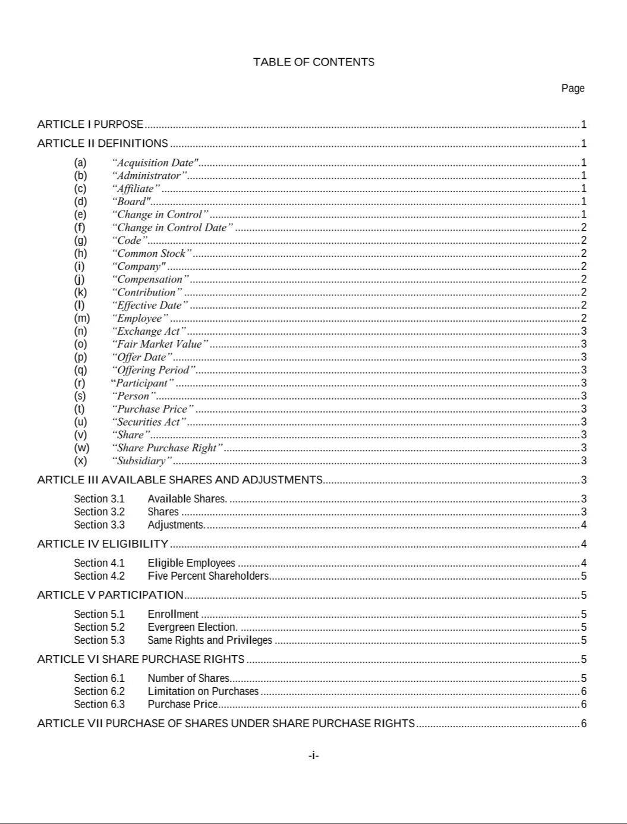

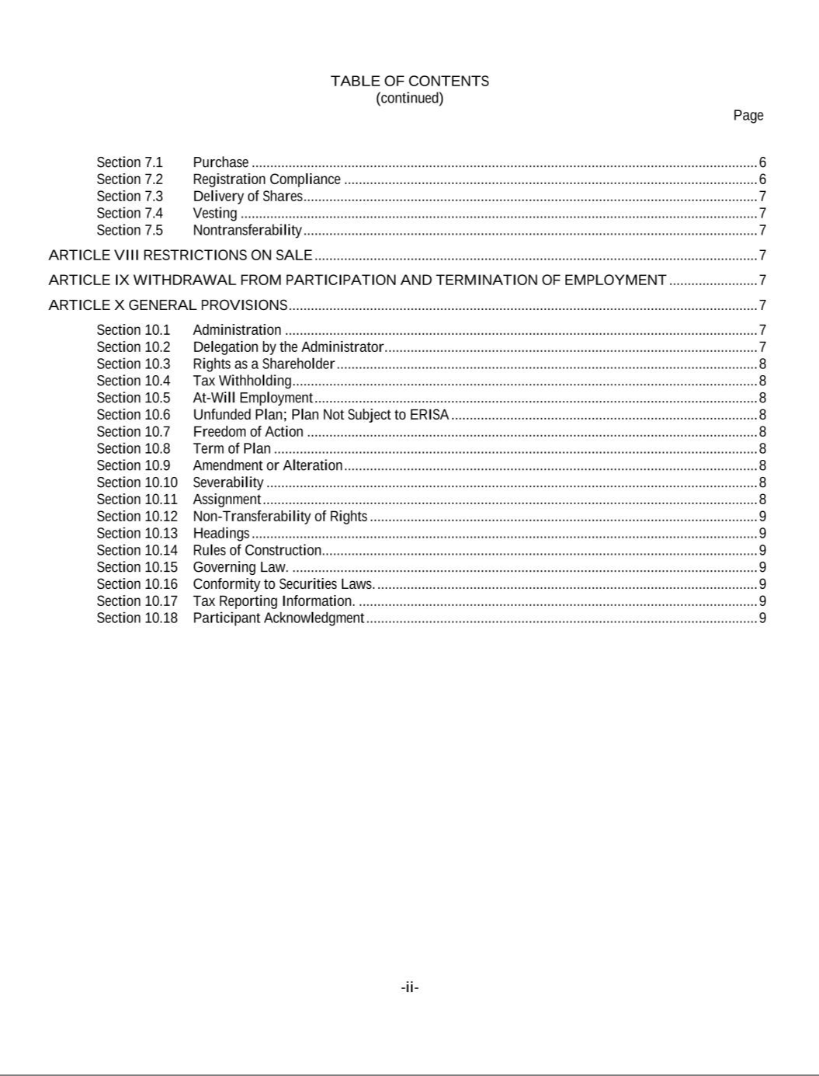

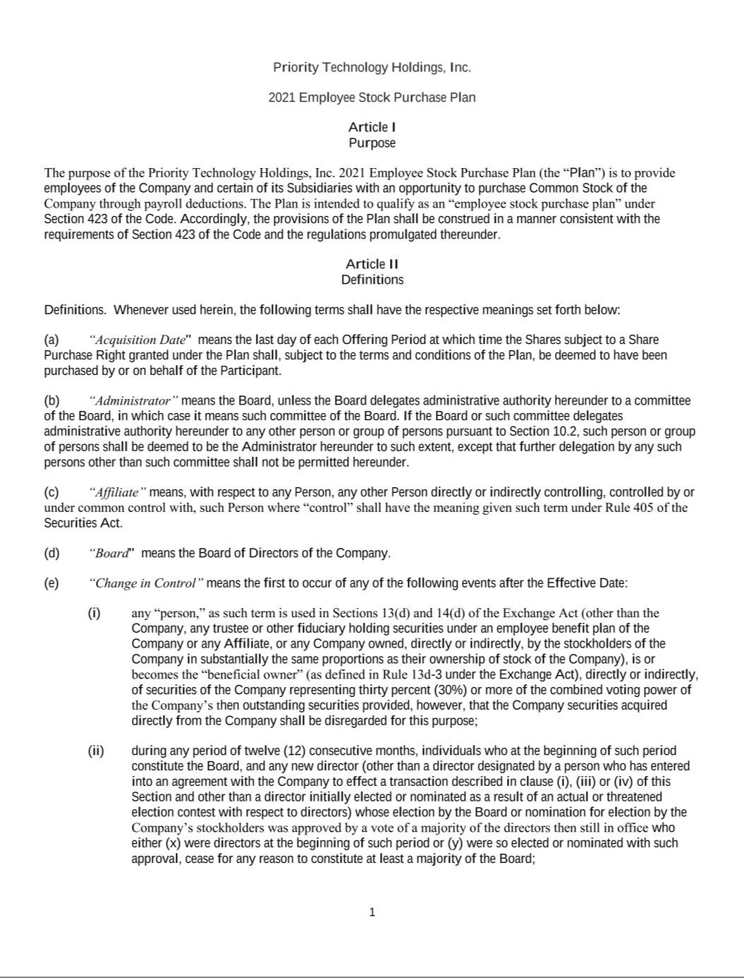

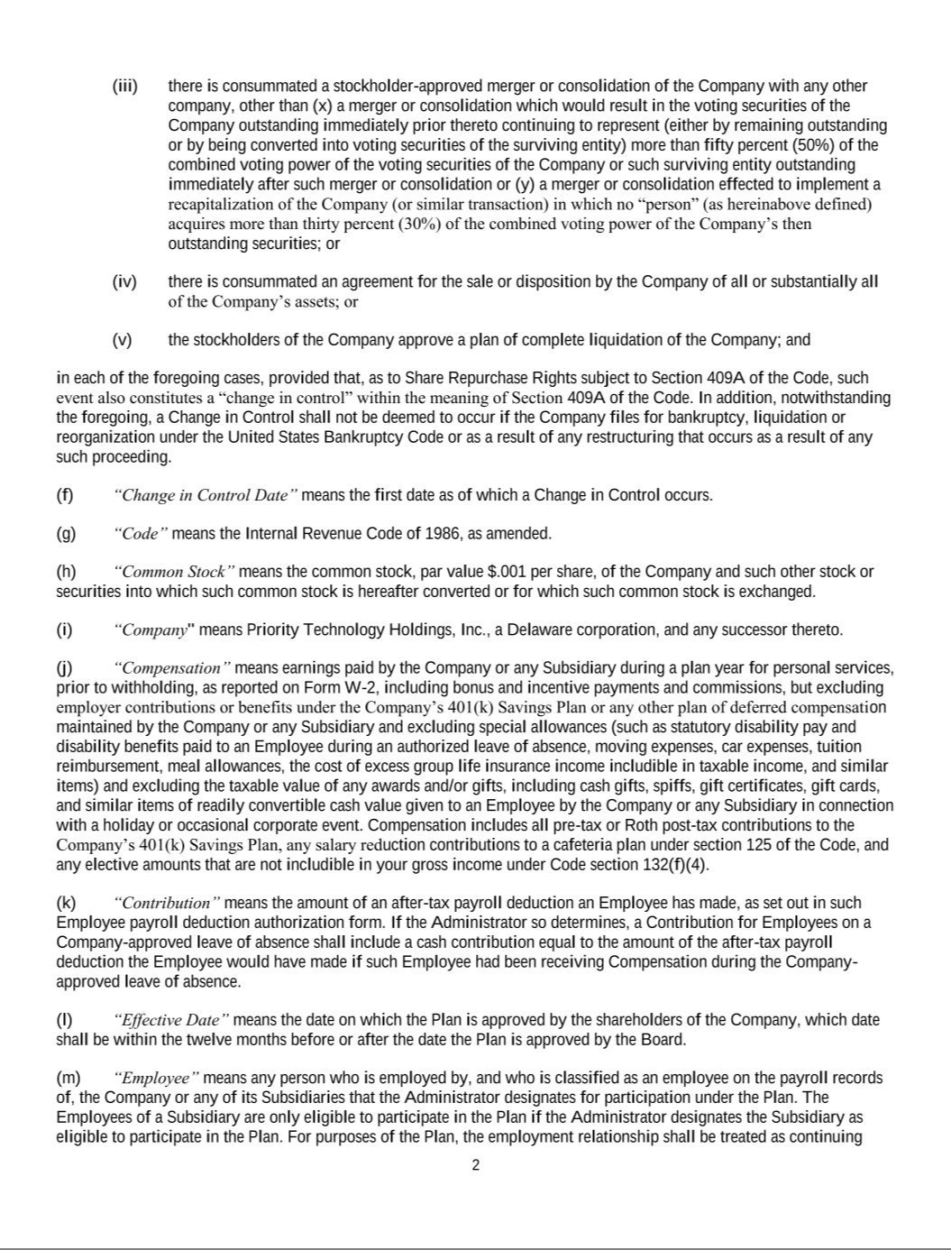

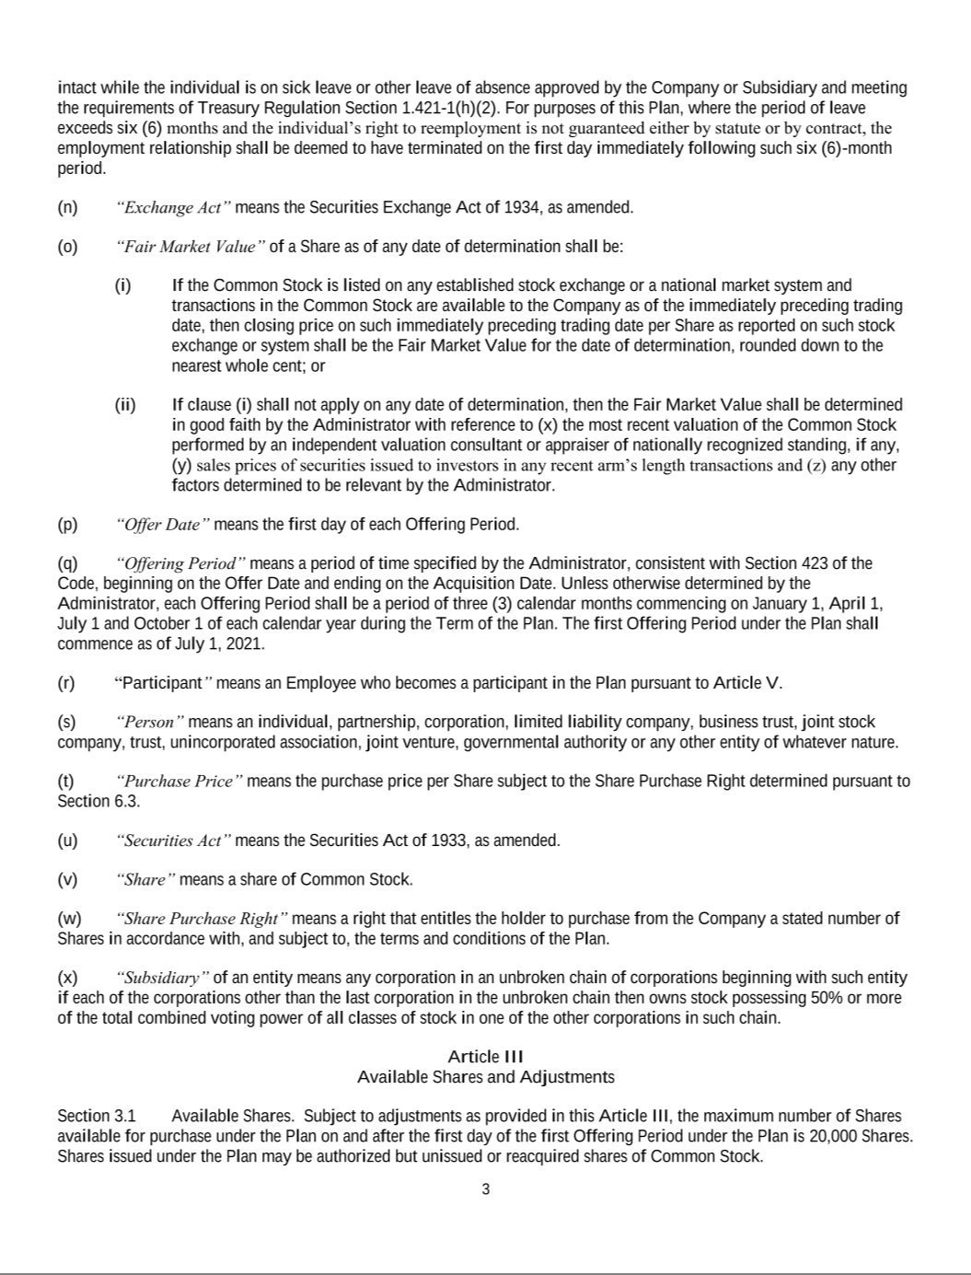

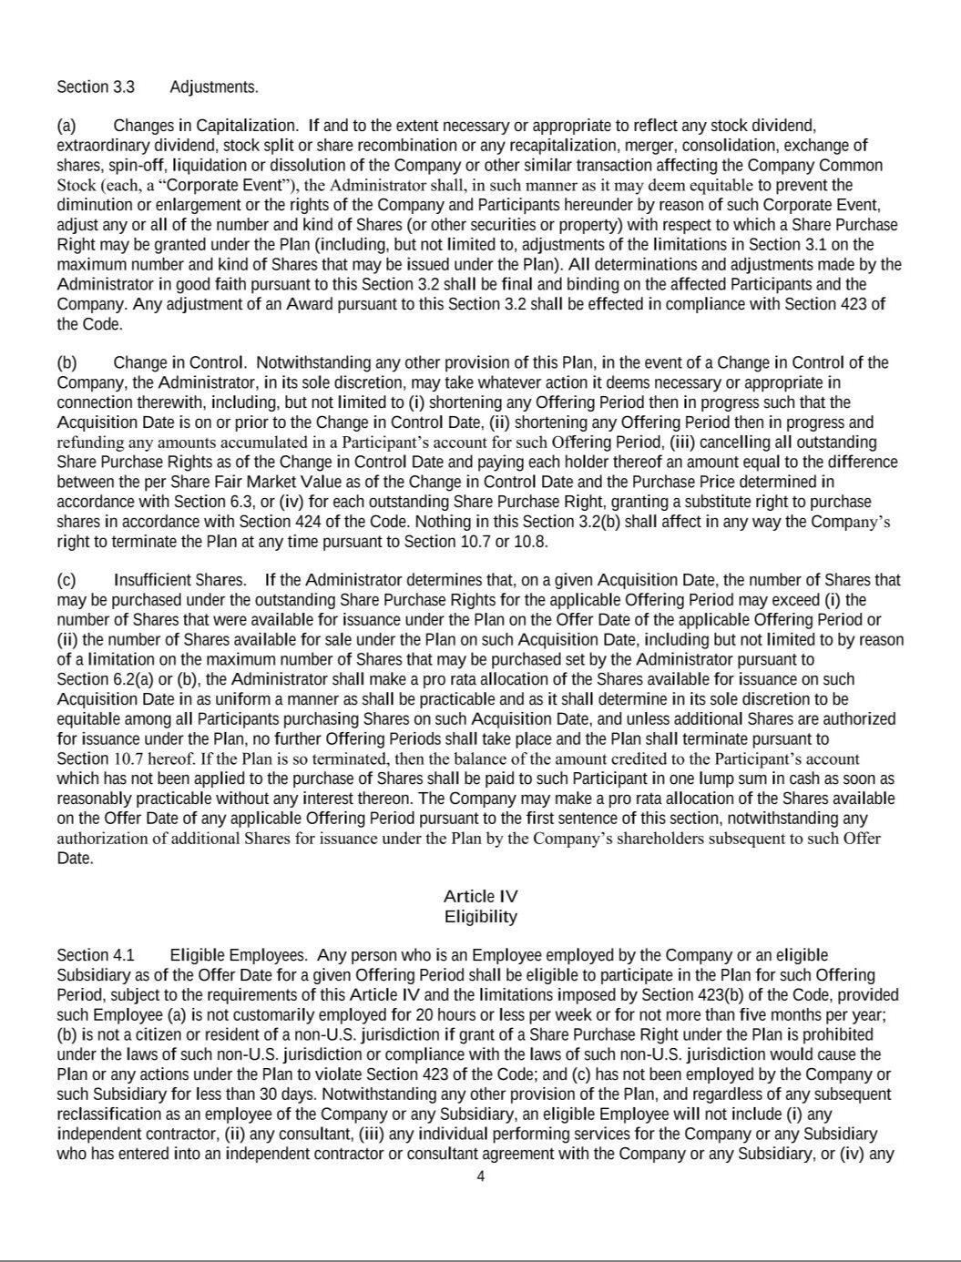

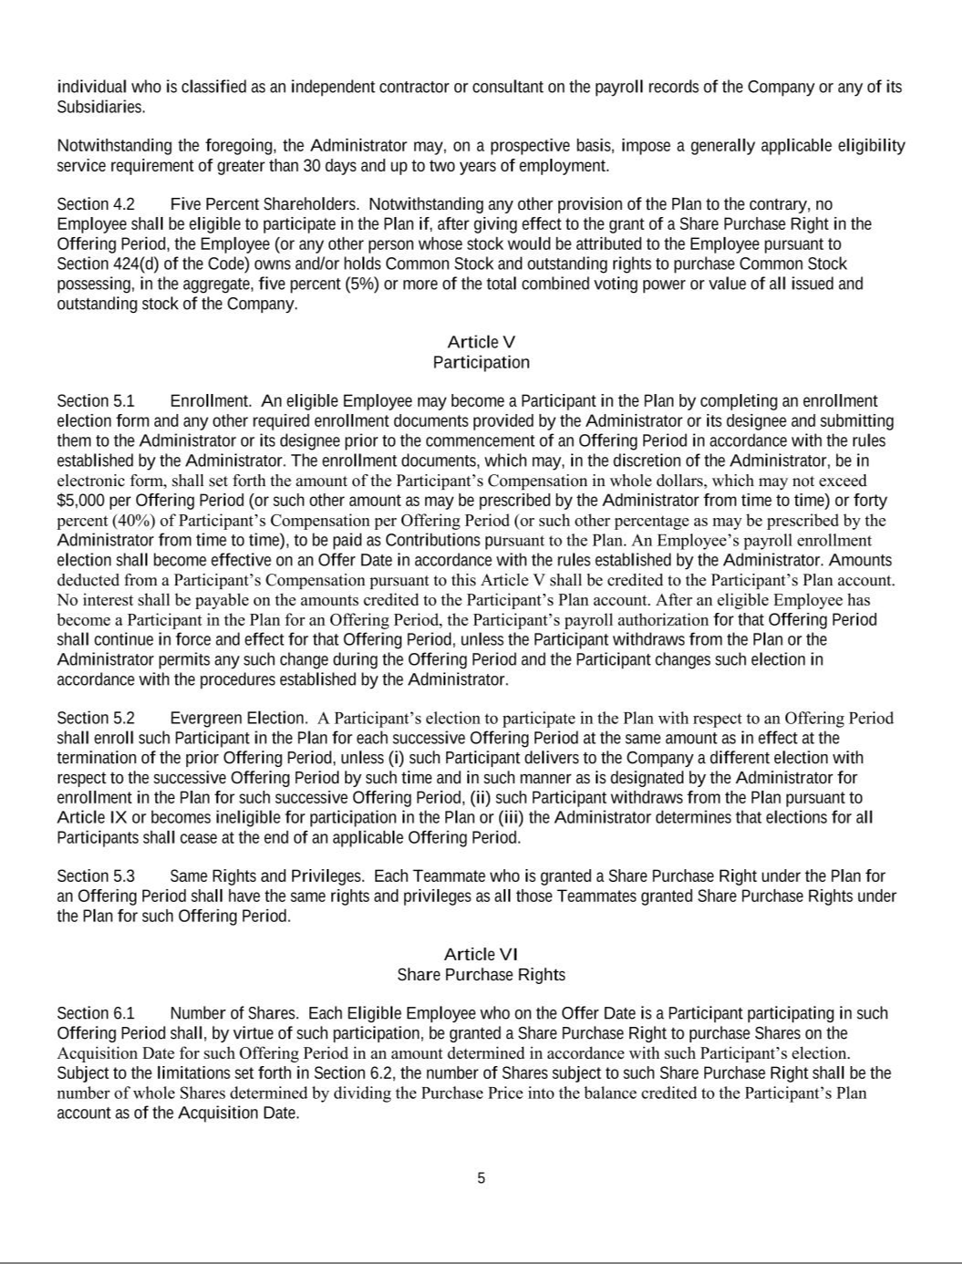



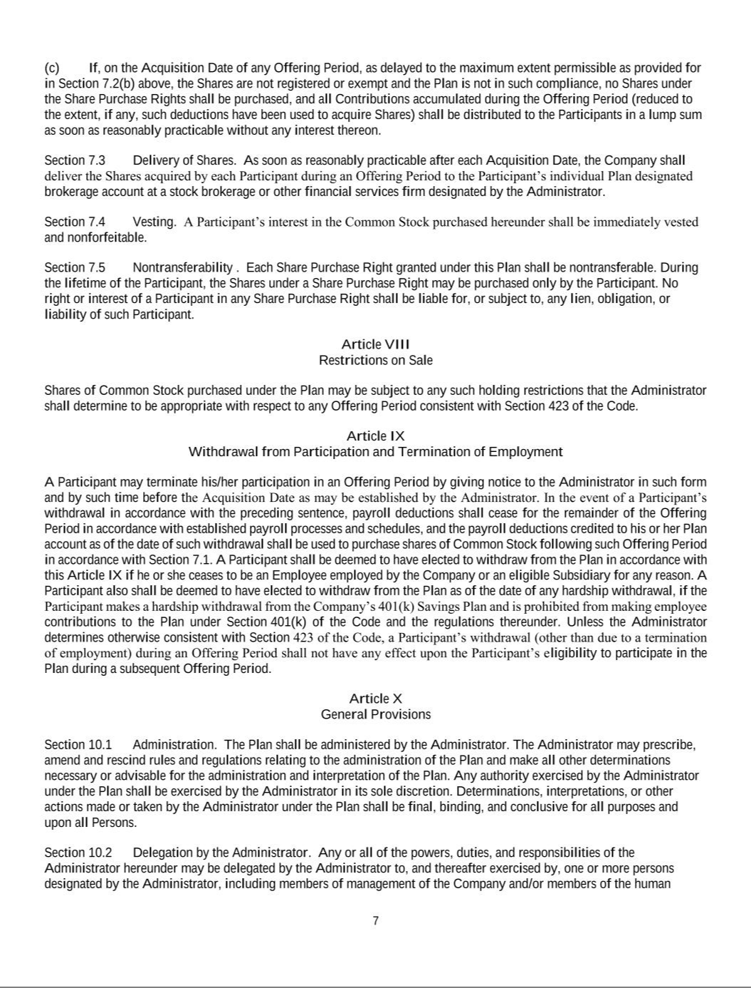

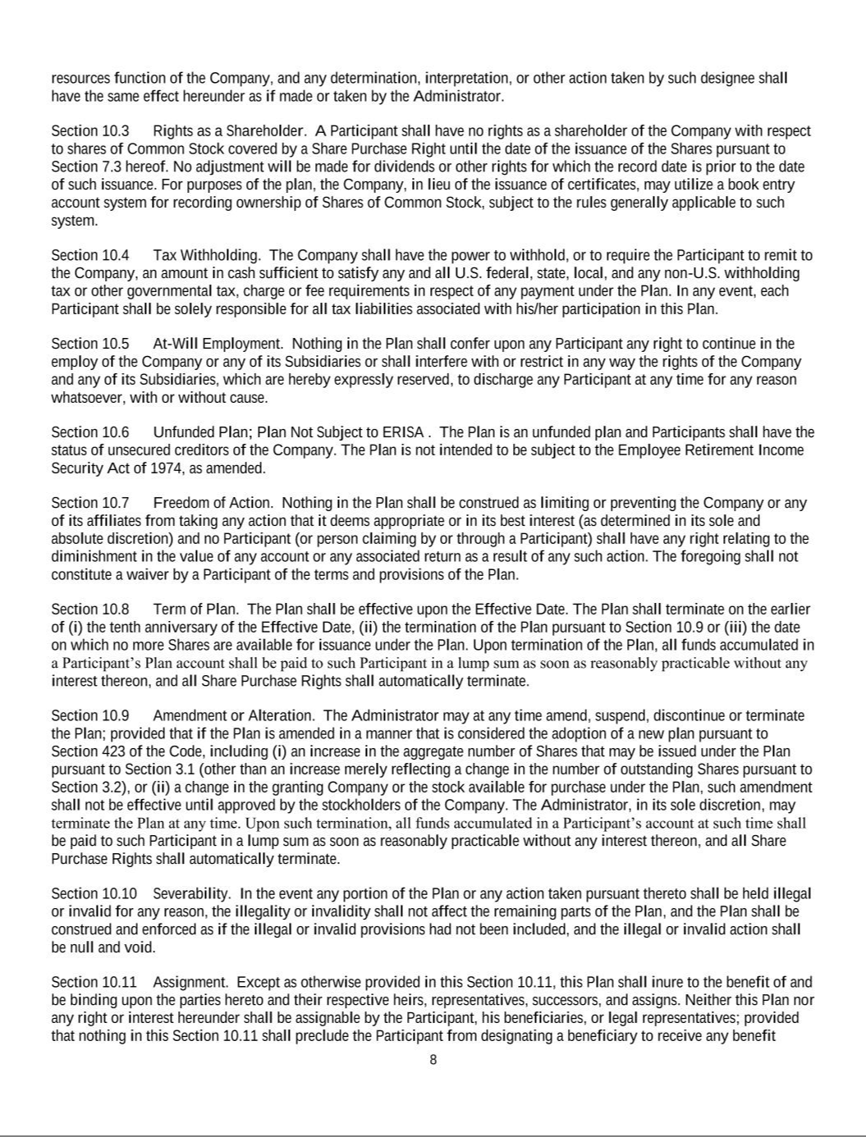

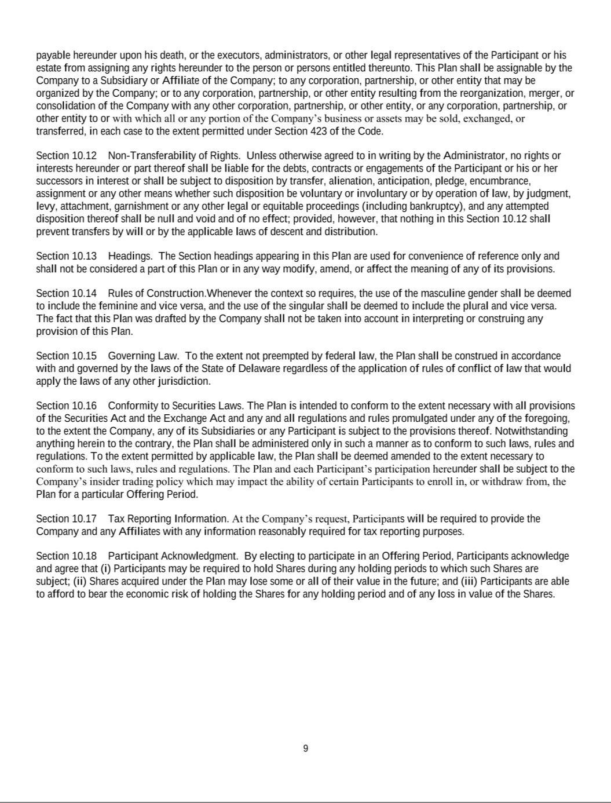

ANNEX 1

CERTIFICATE OF AMENDMENT TO THE

CERTIFICATE OF INCORPORATION OF
PRIORITY TECHNOLOGY HOLDINGS, INC.

Priority Technology Holdings, Inc., a corporation organized and existing under the laws of the Delaware (the “Company”), in accordance with the provisions of Section 242 of the General Corporation Law of the State of Delaware (the “Code”), the certificate of incorporation and bylaws of the Company, hereby executes and submits the following Certificate of Amendment to the Certificate of Incorporation:

- The name of the Company is Priority Technology Holdings, Inc.

- The Second Amended and Restated Certificate of Incorporation of the Company as granted by the Secretary of Delaware on July 25, 2018 (the “Certificate”) is hereby amended by striking Section A of Article V thereof in its entirety and inserting in lieu thereof the following:

“A. [Reserved]”

- The Certificate is hereby amended by striking Section B of Article V thereof in its entirety and inserting in lieu thereof the following:

“B. The Board of Directors is expressly authorized to make, repeal, alter, amend and rescind, in whole or in part, the bylaws of the Corporation (as in effect from time to time, the “Bylaws”) without the assent or vote of the stockholders in any manner not inconsistent with the laws of the State of Delaware or this Certificate of Incorporation.”

- The Certificate is hereby amended by striking Section D of Article VI thereof in its entirety and inserting in lieu thereof the following:

“D. Any or all of the directors (other than the directors elected by the holders of any series of Preferred Stock of the Corporation, voting separately as a series or together with one or more other such series, as the case may be) may be removed at any time either with or without cause by the affirmative vote of a majority in voting power of all outstanding shares of stock of the Corporation entitled to vote thereon, voting as a single class.”

- The Certificate is hereby amended by striking Section B of Article VII thereof in its entirety and inserting in lieu thereof the following:

“B. Any action required or permitted to be taken by the stockholders of the Corporation must be effected at a duly called annual or special meeting of such holders and may not be effected by any consent in writing by such holders; provided, however, that any action required or permitted to be taken by the holders of Preferred Stock, voting separately as a series or separately as a class with one or more other such series, may be taken without a meeting, without prior notice and without a vote, to the extent expressly so provided by the applicable certificate of designation relating to such series of Preferred Stock.”

- The Certificate is hereby amended by adding the following to Section C of Article XI: “12. “Exchange Act” means the Securities Exchange Act of 1934, as amended.
13. “Priority Holder” means Priority Investment Holdings, LLC and Priority Incentive Equity Holdings, LLC or their Affiliates.”

1

114776157v2

ANNEX 1

- That thereafter, pursuant to resolution of its Board of Directors, a meeting of the stockholders of said Company was duly called and held upon notice in accordance with Section 222 of the Code at which meeting the necessary number of shares as required by statute were voted in favor of the amendment.

- That said amendment was duly adopted in accordance with Section 242 of the Code.

- The Certificate of Amendment shall be effective upon the filing with the Secretary of State.

[Remainder of Page Intentionally Left Blank]

2

114776157v2

ANNEX 1

IN WITNESS WHEREOF, the Company has caused this Certificate of Amendment to be executed and attested by its duly authorized officers as of April 16, 2021.

PRIORITY TECHNOLOGY HOLDINGS, INC.

By: /s/ Bradley J. Miller

Name: Bradley J. Miller
Title: General Counsel and Secretary

3

114776157v2

