SEC Form 4

FORM 4

Check this box if no longer subject to Section 16. Form 4 or Form 5 obligations may continue. See Instruction 1(b).

Check this box to indicate that a transaction was made pursuant to a contract, instruction or written plan for the purchase or sale of equity securities of the issuer that is intended to satisfy the affirmative defense conditions of Rule 10b5-1(c). See Instruction 10.

UNITED STATES SECURITIES AND EXCHANGE COMMISSION
Washington, D.C. 20549
Washington, D.C. 20549 |  | OMB APPROVAL
STATEMENT OF CHANGES IN BENEFICIAL OWNERSHIP
STATEMENT OF CHANGES IN BENEFICIAL OWNERSHIP |  | OMB Number: | 3235-0287
 |  | Estimated average burden
Filed pursuant to Section 16(a) of the Securities Exchange Act of 1934 |  | hours per response: | 0.5
or Section 30(h) of the Investment Company Act of 1940
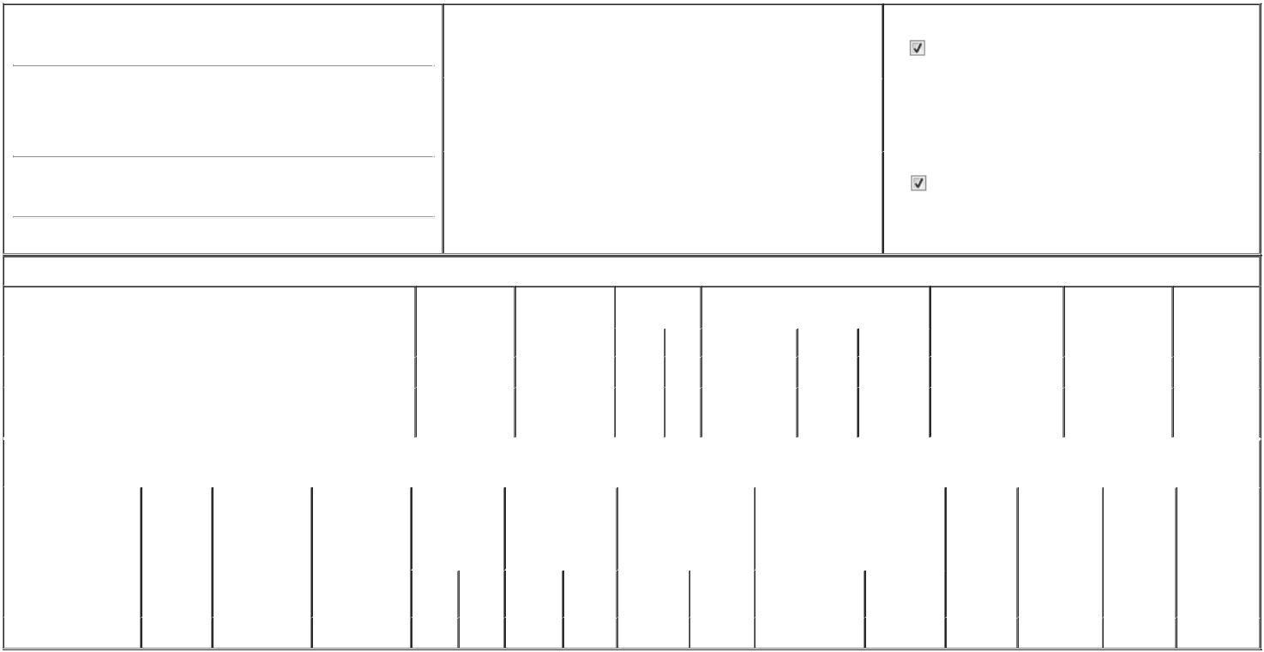

1. Name and Address of Reporting Person*
Passilla Michael

(Last) (First) (Middle)

C/O PRIORITY TECHNOLOGY HOLDINGS, INC.

2001 WESTSIDE PARKWAY, SUITE 155

(Street)

ALPHARETTA GA 30004

2. |  | Issuer Name and Ticker or Trading Symbol |  | 5. Relationship of Reporting Person(s) to Issuer
 | Priority Technology Holdings, Inc. [ PRTH ] |  |  | (Check all applicable)
 |  |  |  | Director | 10% Owner
 |  |  |  | Officer (give title | Other (specify below)
 |  |  |  | below) | Other (specify below)
3. |  | Date of Earliest Transaction (Month/Day/Year) |  | below)
02/05/2025
4. |  | If Amendment, Date of Original Filed (Month/Day/Year) |  | 6. Individual or Joint/Group Filing (Check Applicable Line)
 |  |  |  | Form filed by One Reporting Person
 |  |  |  | Form filed by More than One Reporting Person

(City) (State) (Zip)

Table I - Non-Derivative Securities Acquired, Disposed of, or Beneficially Owned

 | 1. Title of Security (Instr. 3) |  |  |  | 2. Transaction | 2A. Deemed |  | 3. Transaction |  | 4. Securities Acquired (A) or Disposed Of |  |  | 5. Amount of Securities |  |  | 6. Ownership |  | 7. Nature of
 |  |  |  |  | Date | Execution Date, |  | Code (Instr. 8) (D) (Instr. 3, 4 and 5) |  |  |  |  | Beneficially Owned |  |  | Form: Direct (D) or |  | Indirect
 |  |  |  |  | (Month/Day/Year) | if any |  |  |  |  |  |  | Following Reported |  |  | Indirect (I) (Instr. 4) |  | Beneficial
 |  |  |  |  |  | (Month/Day/Year) |  | Code | V | Amount | (A) or (D) | Price | Transaction(s) (Instr. 3 |  |  |  |  | Ownership
 |  |  |  |  |  |  |  |  |  |  |  |  | and 4) |  |  |  |  | (Instr. 4)
 | Common Stock |  |  |  |  |  |  |  |  |  |  |  | 124,117 |  |  |  | D
 | Common Stock |  |  |  |  |  |  |  |  |  |  |  | 76,052 |  |  |  | I | see
 | Common Stock |  |  |  |  |  |  |  |  |  |  |  |  |  |  |  | I | footnote⁽¹⁾
 |  |  |  | Table II - Derivative Securities Acquired, Disposed of, or Beneficially Owned
 |  |  |  |  | (e.g., puts, calls, warrants, options, convertible securities)
 | 1. Title of Derivative | 2. | 3. Transaction | 3A. Deemed | 4. Transaction | 5. Number of |  | 6. Date Exercisable and |  |  | 7. Title and Amount of Securities |  |  | 8. Price of | 9. Number of |  | 10. | 11. Nature of
 | Security (Instr. 3) | Conversion | Date | Execution Date, | Code (Instr. 8) | Derivative |  | Expiration Date |  |  | Underlying Derivative Security |  |  | Derivative | derivative |  | Ownership | Indirect
 |  | or Exercise | (Month/Day/Year) | if any |  | Securities Acquired |  | (Month/Day/Year) |  |  | (Instr. 3 and 4) |  |  | Security | Securities |  | Form: | Beneficial
 |  | Price of |  | (Month/Day/Year) |  | (A) or Disposed of |  |  |  |  |  |  |  | (Instr. 5) | Beneficially |  | Direct (D) or | Ownership
 |  | Derivative |  |  |  | (D) (Instr. 3, 4 and |  |  |  |  |  |  |  |  | Owned |  | Indirect (I) | (Instr. 4)
 |  | Security |  |  |  | 5) |  |  |  |  |  |  |  |  | Following |  | (Instr. 4)
 |  |  |  |  |  |  |  |  |  |  |  |  |  |  | Reported
 |  |  |  |  |  |  |  |  |  |  |  | Amount or |  |  | Transaction(s)
 |  |  |  |  |  |  |  | Date |  | Expiration |  | Number of |  |  | (Instr. 4)
 |  |  |  |  | Code V | (A) | (D) | Exercisable |  | Date | Title | Shares
 | Restricted Stock Unit | (2) | 02/05/2025 |  | A | 9,747 |  |  | (3) | (3) | Common Stock | 9,747 | $0 |  | 0 |  | D

Explanation of Responses:

- Shares acquired by Posillipo Ventures, Inc., a limited liability company of which the reporting person is a managing member.

- Each restricted stock unit represents a contingent right to receive one share of the Issuer's common stock.

- On February 5, 2025, the Reporting Person was granted 9,747 restricted stock units which vest 25% on April 1, 2025, 25% on July 1, 2025, 25% on October 1, 2025, and 25% on January 1, 2026 subject to the Reporting Person's continued service as a director of the Issuer.

Remarks:

 | /s/ Bradley J. Miller, Attorney-in-Fact |  |  | 03/19/2025
 | ** Signature of Reporting Person |  | Date
Reminder: Report on a separate line for each class of securities beneficially owned directly or indirectly.
* If the form is filed by more than one reporting person, see Instruction 4 (b)(v).
** Intentional misstatements or omissions of facts constitute Federal Criminal Violations See 18 U.S.C. 1001 and 15 U.S.C. 78ff(a).
Note: File three copies of this Form, one of which must be manually signed. If space is insufficient, see Instruction 6 for procedure.
Persons who respond to the collection of information contained in this form are not required to respond unless the form displays a currently valid OMB Number.



