As filed with the Securities and Exchange Commission on July 18, 2025

Registration No. 333-

UNITED STATES

SECURITIES AND EXCHANGE COMMISSION

Washington, D.C. 20549

FORM S-8

REGISTRATION STATEMENT

UNDER THE SECURITIES ACT OF 1933


Priority Technology Holdings, Inc.

(Exact name of registrant as specified in its charter)

Delaware

47-4257046

(State or other jurisdiction of

incorporation or organization)

(I.R.S. Employer

Identification No.)

2001 Westside Parkway

Suite 155

Alpharetta, GA 30004

(Address, including zip code, and telephone number, including area code, of registrant’s principal executive offices)

Priority Technology Holdings, Inc. 2021 Employee Stock Purchase Plan

(Full title of the plan)

Bradley Miller

General Counsel, Chief Risk Officer and Corporate Secretary

Priority Technology Holdings, Inc.

2001 Westside Parkway

Suite 155

Alpharetta, GA 30004

(800) 935-5961

(Name, address, including zip code, and telephone number, including area code, of agent for service)

Copy to:

James Stevens

Troutman Pepper Locke LLP

600 Peachtree Street, NE

Suite 3000

Atlanta, Georgia 30308

(404) 885-3000

Indicate by check mark whether the registrant is a large accelerated filer, an accelerated filer, a non-accelerated filer, a smaller reporting company or an emerging growth company. See the definitions of “large accelerated filer,” “accelerated filer,” “smaller reporting company,” and “emerging growth company” in Rule 12b-2 of the Exchange Act.

Large accelerated filer ☐

Accelerated filer ☒

Non-accelerated filer ☐

Smaller reporting company ☒

Emerging growth company ☐

If an emerging growth company, indicate by check mark if the registrant has elected not to use the extended transition period for complying with any new or revised financial accounting standards provided pursuant to Section 7(a)(2)(B) of the Securities Act. ☐

INCORPORATION BY REFERENCE OF CONTENTS

OF REGISTRATION STATEMENT ON FORM S-8

Priority Technology Holdings, Inc. (the “Registrant”) is filing this Registration Statement on Form S-8 (this “Registration Statement”) with the Securities and Exchange Commission (the “Commission”) to register an additional 200,000 shares of its common stock, par value $0.001 per share (“Common Stock”) in connection with the amendment of the Registrant’s 2021 Employee Stock Purchase Plan, as amended (the “2021 Employee Stock Purchase Plan”), which was approved by the Registrant’s shareholders on June 13, 2025.

The additional shares of Common Stock issuable pursuant to the 2021 Employee Stock Purchase Plan are securities of the same class as other securities for which Registration Statements on Form S-8 were filed with the Commission on April 1, 2022 (File No. 333-264064) and December 21, 2022 (File No. 333-268919) (the “Prior Registration Statements”). Accordingly, and pursuant to General Instruction E to Form S-8, the contents of the Prior Registration Statement are incorporated by reference herein, including the periodic reports that the Registrant filed after the Prior Registration Statement to maintain current information about the Registrant, except to the extent supplemented, amended or superseded by the information set forth below.

PART II

INFORMATION REQUIRED IN THE REGISTRATION STATEMENT

Item 3. Incorporation of Documents by Reference.

The following documents filed with the Commission by the Registrant pursuant to the Securities Act of 1933, as amended (the “Securities Act”) and the Securities Exchange Act of 1934, as amended (the “Exchange Act”), are incorporated herein by reference, to the extent that such documents are considered filed with the Commission:

- The Registrant’s Annual Report on Form 10-K for the fiscal year ended December 31, 2024, filed with the Commission on March 6, 2025 (File No. 001-37872).

- The Registrant’s Quarterly Report on Form 10-Q for the quarter ended March 31, 2025, filed with the Commission on May 6, 2025 (File No. 001-37872).

- The Registrant’s Current Reports on Form 8-K, filed with the Commission on January 15, 2025, February 27, 2025, June 13, 3025 and July 8, 2025.

- The description of the Registrant’s capital stock contained in Exhibit 4.5 to the Registrant’s Annual Report on Form 10-K for the year ended December 31, 2024 including any amendment or report filed for the purpose of updating such description.

All documents subsequently filed by the Registrant pursuant to Sections 13(a), 13(c), 14 and 15(d) of the Exchange Act (other than Current Reports on Form 8-K furnished pursuant to Item 2.02 or Item 7.01 of Form 8-K, including any exhibits included with such information that are related to such items), prior to the filing of a post-effective amendment which indicates that all securities offered have been sold or which deregisters all securities then remaining unsold, shall be deemed to be incorporated by reference herein and to be a part hereof from the date of filing of such documents, to the extent such documents are considered filed with the Commission.

Any statement contained in a document incorporated or deemed to be incorporated by reference herein shall be deemed to be modified or superseded for purposes of this Registration Statement to the extent that a statement contained herein (or in any other subsequently filed document which also is incorporated or deemed to be incorporated by reference herein) modifies or supersedes such statement. Any such statement so modified or superseded shall not be deemed, except as so modified or superseded, to constitute a part of this Registration Statement.

You may request copies of these documents, at no cost to you, by writing or telephoning us at the below address. Exhibits to the filings, however, will not be sent, unless those exhibits have specifically been incorporated by reference in this document:

Priority Technology Holdings, Inc.

2001 Westside Parkway

Suite 155

Alpharetta, GA 30004

(800) 935-5961

Item 8. | Exhibits.
Exhibit Number | Description
4.1 | Second Amended and Restated Certificate of Incorporation of the Registrant (incorporated by reference to Exhibit 3.1 to the Registrant’s
 | Current Report on Form 8-K, filed July 31, 2018)
4.2 | Certificate of Amendment to the Certificate of Incorporation of the Registrant (incorporated by reference to Exhibit 2.3 to the
 | Registrant’s Annual Report on Form 10-K, filed March 6, 2025)
4.3 | Certificate of Designations of Senior Preferred Stock (incorporated by reference to Exhibit 3.3 to the Registrant’s Annual Report on
 | Form 10-K, filed March 6, 2025)
4.4 | Specimen Common Stock Certificate (incorporated by reference to Exhibit 4.2 to the Registration Statement on Form S-1, filed July 26,
 | 2016)
4.5 | Amended and Restated Bylaws of the Registrant (incorporated by reference to Exhibit 3.2 to the Registrant’s Current Report on Form 8-
 | K, filed July 31, 2018)
5.1* | Opinion of Troutman Pepper Locke LLP
10.1 | Priority Technology Holdings, Inc. 2021 Employee Stock Purchase Plan (incorporated by reference to Exhibit 10.3 to the Registrant’s
 | Annual Report on Form 10-K, filed March 6, 2025)
10.2* | Amendment No. 2 to Priority Technology Holdings, Inc. 2021 Employee Stock Purchase Plan
23.1* | Consent of Ernst & Young LLP, Independent Registered Public Accounting Firm for the Registrant
23.2* | Consent of Troutman Pepper Locke LLP (included in Exhibit 5.1)
24.1 | Power of Attorney (contained on the signature page hereto)
107* | Filing Fee Table

* Filed herewith.

SIGNATURES

Pursuant to the requirements of the Securities Act, the Registrant certifies that it has reasonable grounds to believe that it meets all of the requirements for filing on Form S-8 and has duly caused this Registration Statement to be signed on its behalf by the undersigned, thereunto duly authorized, in the City of Alpharetta, State of Georgia, on July 18, 2025.

PRIORITY TECHNOLOGY HOLDINGS, INC.

By: | /s/ Timothy M. O'Leary
Name: | Timothy M. O’Leary
Title: | Chief Financial Officer

POWERS OF ATTORNEY

Each person whose signature appears below hereby constitute and appoint Thomas C. Priore and Timothy M. O’Leary, or any one of them, his or her true and lawful attorneys-in-fact and agents, with full power of substitution and resubstitution, for him or her and in his or her name, place, and stead, in any and all capacities, to sign any and all amendments to the Registration Statement, including post-effective amendments thereto and any registration statements filed pursuant to Rule 462 under the Securities Act of 1933, as amended, and to file the same, with all exhibits hereto, and other documents in connection therewith, with the Securities and Exchange Commission, and does hereby grant unto said attorneys-in-fact and agents, and each of them, full power and authority to do and perform each and every act and thing requisite and necessary to be done in and about the premises, as fully to all intents and purposes as he might or could do in person, hereby ratifying and confirming all that said attorneys-in-fact and agents, or any of them, or their or his substitutes, may lawfully do or cause to be done by virtue hereof.

Pursuant to the requirements of the Securities Act, this Registration Statement has been signed by the following persons in the capacities and on the dates indicated.

 | Signature |  |  | Title |  |  | Date
 |  |  | President, Chief Executive Officer and Chairman
/s/ Thomas C. Priore |  |  | (Principal Executive Officer) |  |  | July 18, 2025
Thomas C. Priore
 |  |  | Chief Financial Officer
/s/ Timothy M. O'Leary |  |  | (Principal Financial Officer) |  |  | July 18, 2025
Timothy M. O’Leary
 |  |  | Senior Vice President and
/s/ Rajiv Kumar |  |  | Chief Accounting Officer (Principal Accounting Officer) |  |  | July 18, 2025
Rajiv Kumar
/s/ Marc Crisafulli |  |  | Director |  |  | July 18, 2025
Marc Crisafulli
/s/ Marietta C. Davis |  |  | Director |  |  | July 18, 2025
Marietta C. Davis
/s/ Christina M. Favilla |  |  | Director |  |  | July 18, 2025
Christina M. Favilla
/s/ Clayton Main |  |  | Director |  |  | July 18, 2025
Clayton Main
/s/ Michael Passilla |  |  | Director |  |  | July 18, 2025
Michael Passilla

Exhibit 107

CALCULATION OF FILING FEE TABLES

FORM S-8

(Form Type)

Priority Technology Holdings, Inc.

(Exact Name of Registrant as Specified in its Charter)

Table 1: Newly Registered Securities

 |  |  |  | Proposed
 |  |  |  | Maximum
 |  | Fee |  | Offering | Maximum |  | Amount of
 | Security | Fee | Amount | Price Per | Aggregate |  | Registration
Security Type | Security | Calculation | Amount | Price Per | Aggregate | Fee Rate | Registration
Security Type | Class Title | Rule | Registered(1) | Unit(2) | Offering Price(2) | Fee Rate | Fee(2)
Equity | Common stock, $0.001 | 457(c) and 457(h) | 200,000 | $7.23 | $1,446,000 | 0.00015310 | $221.38
 | par value per share
 |  | Total Offering Amounts |  |  | $1,446,000 |  | $221.38
 |  |  | Total Fee Offsets |  | — |  | —
 |  |  | Net Fee Due |  |  |  | $221.38

- Pursuant to Rule 416(a) promulgated under the Securities Act of 1933, as amended (the “Securities Act”), this Registration Statement shall also cover any additional shares of common stock, par value $0.001 per share (“Common Stock”), of Priority Technology Holdings, Inc. (the “Company”) that become issuable under the Priority Technology Holdings, Inc. 2021 Employee Stock Purchase Plan (the “Plan”) by reason of any future stock dividend, stock split, recapitalization or other similar transaction.

- Estimated in accordance with Rule 457(c) and Rule 457(h) of the Securities Act. The price shown is based upon the average of the high and low prices reported for the common stock on the Nasdaq Global Market on July 14, 2025.

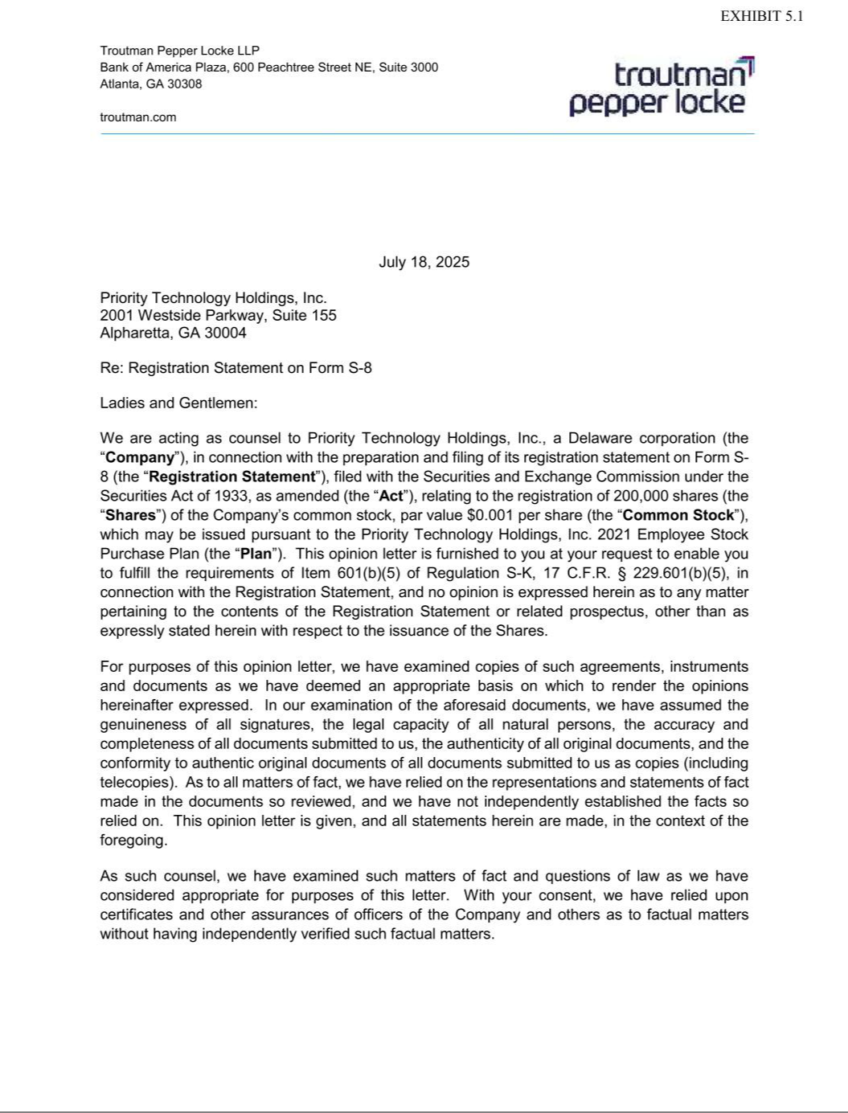

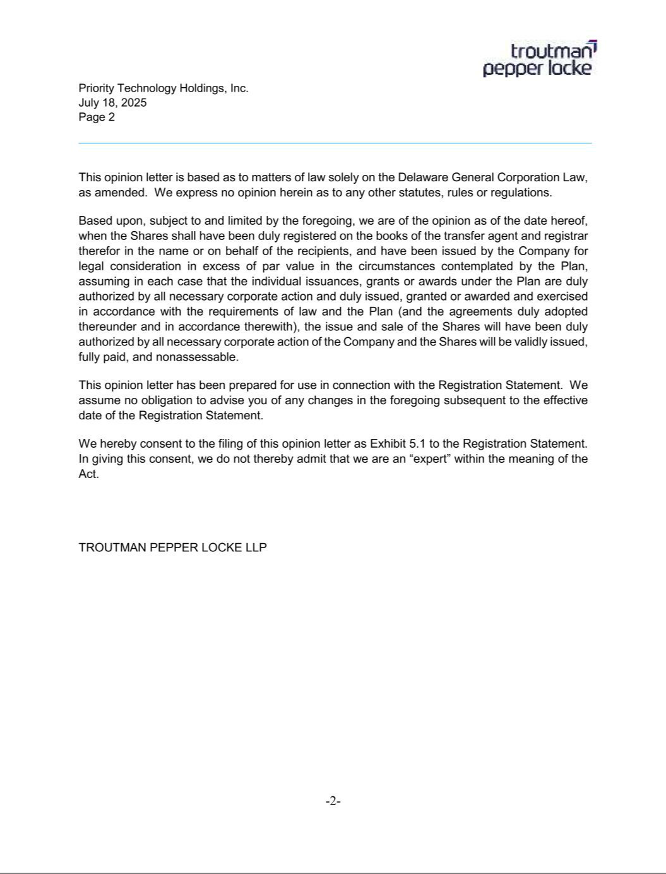

EXHIBIT 10.2

AMENDMENT NO. 2

TO THE PRIORITY TECHNOLOGY HOLDINGS, INC.

2021 EMPLOYEE STOCK PURCHASE PLAN

THIS AMENDMENT NO. 1 to the Priority Technology Holdings, Inc. 2021 Employee Stock Purchase Plan is made as of the 18th day of July, 2025, by Priority Technology Holdings, Inc., (the “Company”), to be effective as set forth herein.

WHEREAS, the Company previously established the Priority Technology Holdings, Inc. 2021 Employee Stock Purchase Plan (the “Plan”), which was adopted by the Company’s Board of Directors on April 16, 2021 and approved by the Company’s shareholders on June 9, 2021, and as amended on March 15, 2022, to provide employees of the Company and certain of its Subsidiaries with an opportunity to purchase Common Stock of the Company through payroll deductions;

WHEREAS, the Plan is intended to qualify as an “employee stock purchase plan” under Section 423 of the Internal Revenue Code (the “Code”);

WHEREAS, pursuant to Section 10.9 of the Plan, the Administrator (as defined in the Plan) may amend the Plan at any time, provided that if the Plan is amended in a manner that is considered the adoption of a new plan pursuant to Section 423 of the Code (e.g., increase shares available for issuance under the Plan), such amendment shall not be effective until approved by the Company’s shareholders;

WHEREAS, the Company has determined that it is in the best interest of the Company and its shareholders and now desires to amend the Plan to increase the aggregate number of shares of Company Common Stock available for issuance under the Plan to 19,587 shares, an increase of 200,000 shares, subject to approval of the Company’s shareholders; and

NOW, THEREFORE, the Plan is hereby amended, as follows, subject to and effective as of the date on which the amendment is approved by the Company’s shareholders:

- Section 3.1 of the Plan is hereby amended by deleting the present section in its entirety and substituting the following in lieu thereof:

Section 3.1 Available Shares.

Subject to adjustments as provided in this Article III, the maximum aggregate number of Shares available for purchase under the Plan after its approval by the Company’s stockholders at the Company’s stockholders meeting scheduled for June 13, 2025 (the “Stockholder Approval Date”) shall be increased by 200,000 Shares, which will increase the number of Shares available for purchase under the Plan from 19,587 Shares to 219,587

Shares

- The aggregate number of Shares available for purchase under the Plan shall be reduced on a one-for-one basis by the number of Shares issued or issuable for Offer Dates prior to the Stockholder Approval Date. Shares issued under the Plan may be authorized but unissued or reacquired shares of Common Stock.

- This Amendment No. 2 to the Plan is subject to approval by the shareholders of the Company at a meeting duly called for such purposes. The increase in the number of shares of Company Common Stock available for issuance may not be issued pursuant to the Plan unless and until such

EXHIBIT 10.2

amendment is approved by the shareholders within twelve months after the date first written above. Except as hereby modified, the Plan shall remain in full force and effect.

IN WITNESS WHEREOF, the Company has executed this Amendment No. 2 as of the date first written above.

PRIORITY TECHNOLOGY HOLDINGS, INC.

By: /s/ Thomas C. Priore
Name: Thomas C. Priore
Title: Chairman and CEO

EXHIBIT 23.1

Consent of Independent Registered Public Accounting Firm

We consent to the incorporation by reference in the Registration Statement (Form S-8) pertaining to the 2021 Employee Stock Purchase Plan of Priority Technology Holdings Inc. of our reports dated March 6, 2025, with respect to the consolidated financial statements of Priority Technology Holdings Inc. Company and the effectiveness of internal control over financial reporting of Priority Technology Holdings Inc. Company included in its Annual Report (Form 10-K) for the year ended December 31, 2024, filed with the Securities and Exchange Commission.

/s/ Ernst & Young LLP

Atlanta, GA

July 18, 2025

