As filed with the Securities and Exchange Commission on December 20, 2022

Registration No. 333-
UNITED STATES
SECURITIES AND EXCHANGE COMMISSION
Washington, D.C. 20549

FORM S-8
REGISTRATION STATEMENT
UNDER
THE SECURITIES ACT OF 1933
PRIORITY TECHNOLOGY HOLDINGS, INC.
(Exact name of Registrant as specified in its charter)

Delaware

47-4257046

(State or other jurisdiction of

(I.R.S. Employer

incorporation or organization)

Identification No.)

2001 Westside Parkway Suite 155, Alpharetta, GA 30004

(Address of Principal Executive Offices) (Zip Code)

Priority Technology Holdings, Inc. 2021 Employee Stock Purchase Plan
(Full title of the plan)

Bradley Miller
General Counsel, Chief Risk Officer and Corporate Secretary
Priority Technology Holdings, Inc.
2001 Westside Parkway
Suite 155
Alpharetta, GA 30004
(800) 935-5961
(Name and address of agent for service)
(Telephone number, including area code, of agent for service)

Copy to:
James Stevens
Troutman Pepper Hamilton Sanders LLP
600 Peachtree Street, NE
Suite 3000
Atlanta, Georgia 30308

(404) 885-3000

Indicate by check mark whether the Registrant is a large accelerated filer, an accelerated filer, a non-accelerated filer, a smaller reporting company or an emerging growth company. See the definitions of “large accelerated filer,” “accelerated filer,” “smaller reporting company” and “emerging growth company” in Rule 12b-2 of the Exchange Act.

Large accelerated filer ☐

Non-accelerated filer ☒

Accelerated filer ☐

Smaller reporting company ☒

Emerging growth company ☐

If an emerging growth company, indicate by check mark if the Registrant has elected not to use the extended transition period for complying with any new or revised financial accounting standards provided pursuant to Section 7(a)(2)(B) of the Securities Act. [ ]

EXPLANATORY NOTE

On April 1, 2022, Priority Technology Holdings, Inc. (the “Registrant”) filed a Registration Statement on Form S-8 (File No. 333-264064) (the “Prior Registration Statement”) with the Securities and Exchange Commission (the “Commission”) to register 20,000 shares of its common stock, par value $0.001 per share (“Common Stock”) reserved for future
grants of awards under the Registrant’s 2021 Employee Stock Purchase Plan (the “2021 Employee Stock Purchase Plan”). This Registration Statement registers 180,000 additional

shares of Common Stock in connection with the amendment of the 2021 Employee Stock Purchase Plan, which was approved by the Registrant’s shareholders on May 25, 2022. Accordingly, and pursuant to General Instruction E to Form S-8, the contents of the Prior Registration Statement are incorporated by reference herein, including the periodic reports
that the Registrant filed after the Prior Registration Statement to maintain current information about the Registrant.

PART II

INFORMATION REQUIRED IN THE REGISTRATION STATEMENT

Item 3. Incorporation of Documents by Reference.

The following documents filed with the Commission by the Registrant pursuant to the Securities Act and the Securities Exchange Act of 1934, as amended (the “Exchange

Act”), are incorporated herein by reference, to the extent that such documents are considered filed with the Commission:

- The Registrant’s Annual Report on Form 10-K for the fiscal year ended December 31, 2021, filed with the Commission on March 17, 2022 (File No. 001-37872);

- The Registrant’s Quarterly Reports on Form 10-Q for the quarters ended March 31, 2022, June 30, 2022, and September 30,2022, filed with the Commission on May 11, 2022, August 9, 2022, and November 10, 2022;

- The Registrant’s Current Report on Form 8-K, filed with the Commission on May 27, 2022; and

- The description of the Registrant’s common stock contained in the Registrant’s Registration Statement on Form 8-A (File No. 001-37872) filed with the Commission on September 12, 2016, as updated by Exhibit 4.5 to the Registrant’s Annual Report on Form 10-K for the year ended December 31, 2021, including any amendment or report filed for the purpose of updating such description.

All documents subsequently filed by the Registrant pursuant to Sections 13(a), 13(c), 14 and 15(d) of the Exchange Act, prior to the filing of a post-effective amendment which indicates that all securities offered have been sold or which deregisters all securities then remaining unsold, shall be deemed to be incorporated by reference herein and to be a part
hereof from the date of filing of such documents, to the extent such documents are considered filed with the Commission.

Any statement contained in a document incorporated or deemed to be incorporated by reference herein shall be deemed to be modified or superseded for purposes of this Registration Statement to the extent that a statement contained herein (or in any other subsequently filed document which also is incorporated or deemed to be incorporated by
reference herein) modifies or supersedes such statement. Any such statement so modified or superseded shall not be deemed, except as so modified or superseded, to constitute a part of this Registration Statement.

You may request copies of these documents, at no cost to you, by writing or telephoning us at the below address. Exhibits to the filings, however, will not be sent, unless those exhibits have specifically been incorporated by reference in this document:

Priority Technology Holdings, Inc.
2001 Westside Parkway
Suite 155
Alpharetta, GA 30004

(800) 935-5961

Item 8. Exhibits.
Exhibit |  | Description
4.1 |  | Second Amended and Restated Certificate of Incorporation of the Company (incorporated by reference to Exhibit 3.1 to the Company’s Current
4.1 |  | Report on Form 8-K, filed July 31, 2018).
4.2 |  | Certificate of Amendment to the Certificate of Incorporation of the Company (incorporated by reference to Exhibit 2.3 to the Company’s Annual
4.2 |  | Report on Form 10-K, filed March 17, 2022).
4.3 |  | Certificate of Designations of Senior Preferred Stock (incorporated by reference to Exhibit 3.3 to the Company’s Annual Report on Form 10-K,
4.3 |  | filed March 17, 2022).
4.4 |  | Specimen Common Stock Certificate (incorporated by reference to Exhibit 4.2 to the Registration Statement on Form S-1, filed July 26, 2016).
4.5 |  | Amended and Restated Bylaws of the Company (incorporated by reference to Exhibit 3.2 to the Company’s Current Report on Form 8-K, filed
4.5 |  | July 31, 2018).
5.1* |  | Opinion of Troutman Pepper Hamilton Sanders LLP
10.1 |  | Priority Technology Holdings, Inc. 2021 Employee Stock Purchase Plan (incorporated by reference to Exhibit 10.3.1 to the Company’s Annual
10.1 |  | Report on Form 10-K, filed March 17, 2022).
23.1* |  | Consent of Ernst & Young LLP, Independent Registered Public Accounting Firm for the Company
23.2* |  | Consent of RSM US LLP
24.1 |  | Power of Attorney (contained on the signature page hereto)
107* |  | Filing Fee Table

* Filed herewith.

SIGNATURES

Pursuant to the requirements of the Securities Act, the Registrant certifies that it has reasonable grounds to believe that it meets all of the requirements for filing on Form S-8

and has duly caused this Registration Statement to be signed on its behalf by the undersigned, thereunto duly authorized, in the City of Alpharetta, State of Georgia, on December 20, 2022.

PRIORITY TECHNOLOGY HOLDINGS, INC.

By: | /s/ Timothy M. O’Leary
Name: | Timothy M. O’Leary
Title: | Chief Financial Officer

POWERS OF ATTORNEY

Each person whose signature appears below constitutes and appoints Timothy M. O’Leary and Bradley Miller or any of them, his or her true and lawful attorneys-in-fact and agents, with full power of substitution and resubstitution, for him or her and in his or her name, place and stead, in any and all capacities, to sign any and all amendments to this
Registration Statement, including post-effective amendments to this Registration Statement, registration statements filed pursuant to Rule 429 under the Securities Act, and any related registration statements necessary to register additional securities, and to file the same, with all exhibits thereto, and other documents in connection therewith with the
Securities and Exchange Commission, granting unto said attorneys-in-fact and agents, and each of them, full power and authority to do and to perform each and every act and thing requisite and necessary to be done in and about the premises, as fully and to all intents and purposes as he or she might or would do in person,

hereby ratifying and confirming all that said attorneys-in-fact and agents or any of them, or their or his substitute or substitutes, may lawfully do or cause to be done by virtue hereof.

Pursuant to the requirements of the Securities Act, this Registration Statement has been signed by the following persons in the capacities and on the dates indicated.

 | Signature |  |  | Title |  |  | Date
 |  |  | President, Chief Executive Officer and Chairman |  |  | December 20, 2022
/s/ Thomas C. Priore |  |  | (Principal Executive Officer)
Thomas C. Priore
 |  |  | Chief Financial Officer |  |  | December 20, 2022
/s/ Timothy M. O’Leary |  |  | (Principal Financial Officer)
Timothy M. O’Leary

/s/ Rajiv Kumar

Rajiv Kumar

/s/ John Priore

John Priore

/s/ Michael Passilla

Michael Passilla

/s/ Marietta C. Davis

Marietta C. Davis

/s/ Christina M. Favilla

Christina M. Favilla

/s/ Stephen W. Hipp

Stephen W. Hipp

/s/ Marc Crisafulli

Marc Crisafulli

Senior Vice President and | December 20, 2022
Chief Accounting Officer (Principal Accounting Officer) | December 20, 2022
Director | December 20, 2022
Director | December 20, 2022
Director | December 20, 2022
Director | December 20, 2022
Director | December 20, 2022
Director | December 20, 2022

EXHIBIT 107

CALCULATION OF FILING FEE TABLES

FORM S-8
(Form Type)

Priority Technology Holdings, Inc.
(Exact Name of Registrant as Specified in its Charter)

Table 1: Newly Registered Securities

 |  |  |  | Proposed Maximum | Maximum Aggregate |  | Amount of
Security Type | Security Class Title | Fee Calculation Rule | Amount Registered (1) | Offering Price Per Unit(2) | Offering Price(2) | Fee Rate | Registration Fee(2)
Equity | Common stock, | 457(c) and 457(h) | 180,000 | $5.70 | 1,026,000 | 0.0001102 | $113.07
 | $0.001 par value per
 | share
 |  |  | Total Offering Amounts |  | 1,026,000 |  | $113.07
 |  |  | Total Fee Offsets |  | — |  | —
 |  |  | Net Fee Due |  |  |  | $113.07

- Pursuant to Rule 416(a) promulgated under the Securities Act of 1933, as amended (the “Securities Act”), this Registration Statement shall also cover any additional shares of common stock, par value $0.001 per share (“Common Stock”), of Priority Technology Holdings, Inc. (the “Company”) that become issuable under the Priority Technology Holdings, Inc. 2021 Employee Stock Purchase Plan (the “Plan”) by reason of any future stock dividend, stock split, recapitalization or other similar transaction.

- Estimated in accordance with Rule 457(c) and Rule 457(h) of the Securities Act. The price shown is based upon the average of the high and low prices reported for the common stock on the Nasdaq Global Market on December 19, 2022.

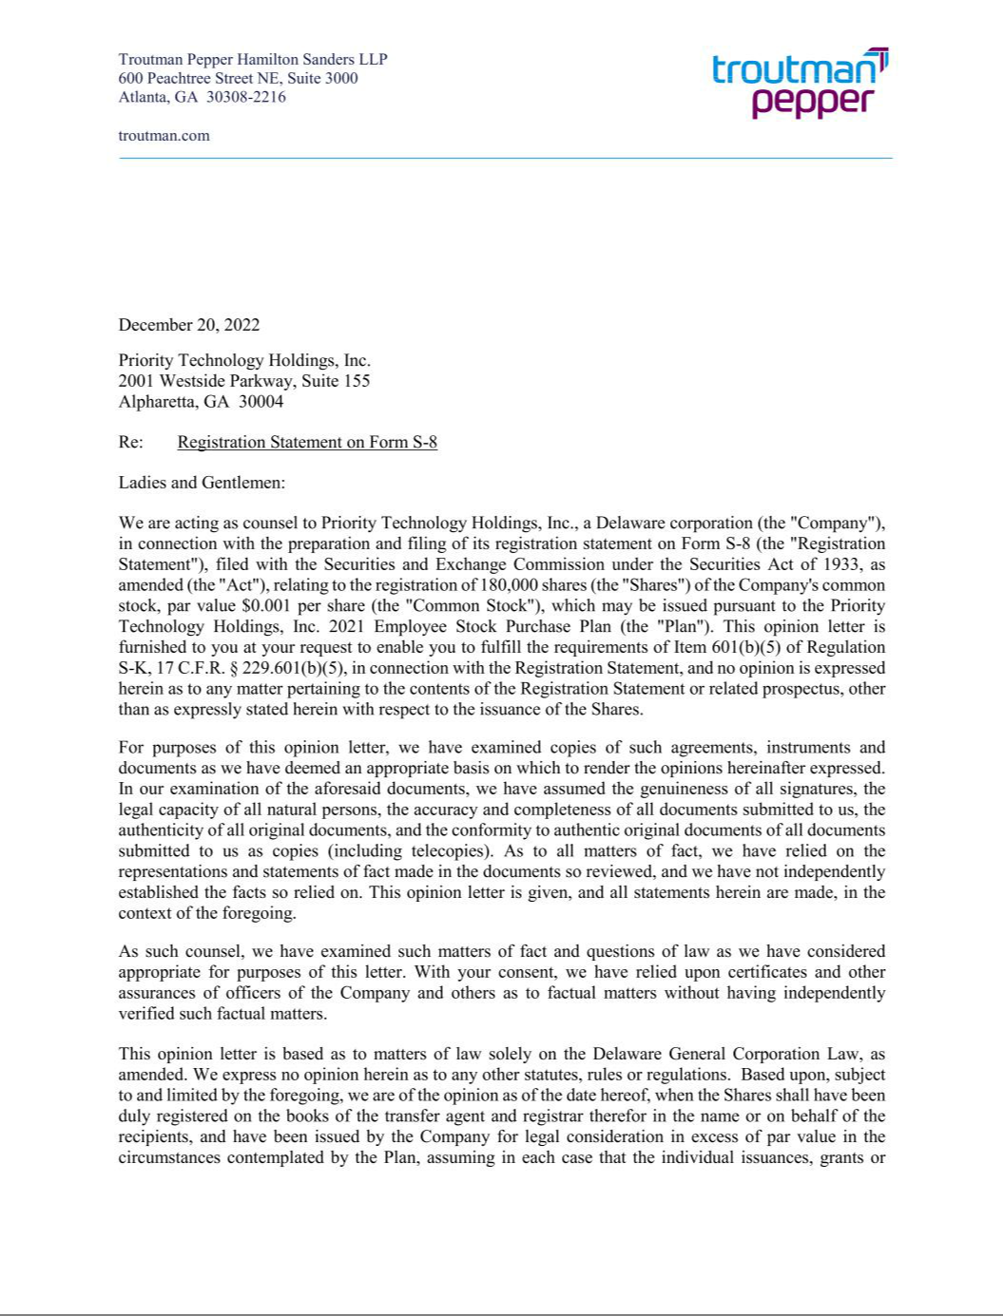

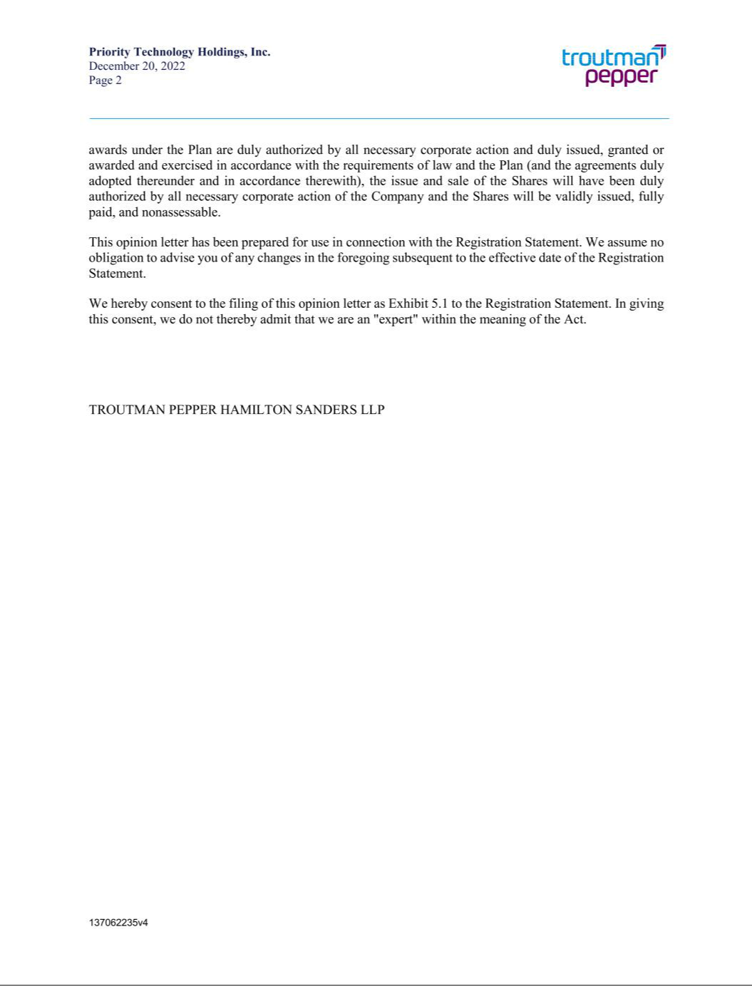

EXHIBIT 23.1

Consent of Independent Registered Public Accounting Firm

We consent to the incorporation by reference in the Registration Statement (Form S-8) pertaining to the 2021 Employees Stock Purchase Plan of Priority Technology Holdings, Inc. of our report dated March 17, 2022, with respect to the consolidated financial statements of Priority Technology Holdings, Inc. included in its Annual Report (Form 10-K) for the year ended December 31, 2021, filed with the Securities and Exchange Commission.

/s/ Ernst & Young LLP

Atlanta, Georgia

December 20, 2022

EXHIBIT 23.2

Consent of Independent Registered Public Accounting Firm

We consent to the incorporation by reference in this Registration Statement on Form S-8 of Priority Technology Holdings, Inc. of our report dated March 30, 2020, except for the change in reportable segments described in Note 20 as to which the date is March 17, 2022, relating to the consolidated financial statements of Priority Technology Holdings, Inc., appearing in the Annual Report on Form 10-K of Priority Technology Holdings, Inc. for the year ended December 31, 2021.

/s/ RSM US LLP

Atlanta, Georgia

December 20, 2022

