United States
SECURITIES AND EXCHANGE COMMISSION
Washington, D.C. 20549

Form 8-K

Current Report
Pursuant to Section 13 or 15(d) of the
Securities Exchange Act of 1934

August 25, 2026
Date of Report (Date of earliest event reported)



Priority Technology Holdings, Inc.
(Exact Name of Registrant as Specified in its Charter)

Delaware |  |  |  |  |  | 001-37872 |  |  |  |  |  | 47-4257046
(State or other jurisdiction of incorporation) |  |  |  |  |  | (Commission File Number) |  |  |  |  |  | (I.R.S. Employer Identification No.)

2001 Westside Parkway
Suite 155
Alpharetta, |  |  | Georgia |  |  |  |  |  | 30004
(Address of Principal Executive Offices) |  |  |  |  |  |  |  |  | (Zip Code)

Registrant's telephone number, including area code: (800) 935-5961

(Former name or former address, if changed since last report)

Check the appropriate box below if the Form 8-K filing is intended to simultaneously satisfy the filing obligation of the registrant under any of the following provisions (see General Instruction A.2. below):

☐ Written communications pursuant to Rule 425 under the Securities Act (17 CFR 230.425)

☐ Soliciting material pursuant to Rule 14a-12 under the Exchange Act (17 CFR 240.14a-12)

☐ Pre-commencement communications pursuant to Rule 14d-2(b) under the Exchange Act (17 CFR 240.14d-2(b))

☐ Pre-commencement communications pursuant to Rule 13e-4(c) under the Exchange Act (17 CFR 240.13e-4(c))

Securities registered pursuant to Section 12(b) of the Act:
Title of each class |  |  |  |  |  | Trading Symbol |  |  |  |  |  | Name of each exchange on which registered
Common stock, $0.001 par value |  |  |  |  |  | PRTH |  |  |  |  |  | NASDAQ

Indicate by check mark whether the registrant is an emerging growth company as defined in Rule 405 of the Securities Act of (1933 §230.405 of this chapter) or Rule 12b-2 of the Securities Exchange Act of 1934 (§240.12b-2 of this chapter).

Emerging growth company ☐

If an emerging growth company, indicate by check mark if the registrant has elected not to use the extended transition period for complying with any new or revised financial accounting standards provided pursuant to Section 13(a) of the Exchange Act. ☐

Item 1.01 Entry into a Material Definitive Agreement

On August 25, 2026, Priority Payment Systems, LLC (“PPS”), an indirect, wholly-owned subsidiary of Priority Technology Holdings, Inc. (the “Company”), entered into and simultaneously closed the transaction (the “Transaction”) contemplated by, a Membership Interest Purchase Agreement (the “Purchase Agreement”), by and among PPS as buyer, Convenient Payments Acquisition Subsidiary, LLC, as seller (“Seller”), and the Company (solely with respect to its guarantee of PPS’s payment obligations thereunder). Pursuant to the Purchase Agreement, PPS acquired all of the membership interests of Convenient Payments, LLC for a purchase price consisting of (i) $11,500,000, subject to certain adjustments as set forth in the Purchase Agreement, and (ii) up to an aggregate of $3,500,000 in earnout payments (the “Earnout Cap”) over a period of up to eight full fiscal quarters following the closing of the Transaction based on a specified percentage of gross profit (as defined and calculated as set forth in the Purchase Agreement) generated during each such fiscal quarter, up to the Earnout Cap, as set forth in the Purchase Agreement.

The foregoing description of the Purchase Agreement does not purport to be complete and is qualified in its entirety by reference to the complete text of the Purchase Agreement, which is filed as Exhibit 10.1 to this Current Report on Form 8-K and is incorporated herein by reference.

The Purchase Agreement contains various representations and warranties made by the parties solely for the benefit of the other parties to the Purchase Agreement. Such representations and warranties (a) have been made only for purposes of the Purchase Agreement, (b) have been qualified by confidential disclosures made to the other parties in connection with the Purchase Agreement, (c) are subject to materiality qualifications contained in the Purchase Agreement that may differ from what may be viewed as material by investors, (d) were made only as of the date of the Purchase Agreement or such other date as is specified in the Purchase Agreement, and (e) have been included in the Purchase Agreement for the purpose of allocating risk between the contracting parties rather than establishing matters as facts. Accordingly, investors should not rely on the representations or warranties or any descriptions thereof as characterizations of the actual state of facts or condition of the assets acquired, the Company, or any of its subsidiaries or affiliates. Moreover, information concerning the subject matter of the representations and warranties may change after the date of the Purchase Agreement, which subsequent information may or may not be reflected in the Company’s public disclosures.

Item 9.01 Financial Statements and Exhibits
(d) Exhibits – The following exhibit is furnished as part of this Current Report on Form 8-K.
Exhibit Number |  |  | Description
10.1 |  |  | Membership Interest Purchase Agreement by and between Priority Payment Systems LLC, as Buyer and Convenient Payments Acquisition Subsidiary, LLC, as Seller, dated August 25, 2026
99.1 |  |  | Press Release dated August 26, 2026
104 |  |  | Cover Page Interactive Data File (embedded within the Inline XBRL document)

SIGNATURE

Pursuant to the requirements of the Securities Exchange Act of 1934, the registrant has duly caused this report to be signed on its behalf by the undersigned hereunto duly authorized.

August 25, 2026
PRIORITY TECHNOLOGY HOLDINGS, INC.
By: /s/ Timothy O'Leary
Name: Timothy O'Leary
Title: Chief Financial Officer

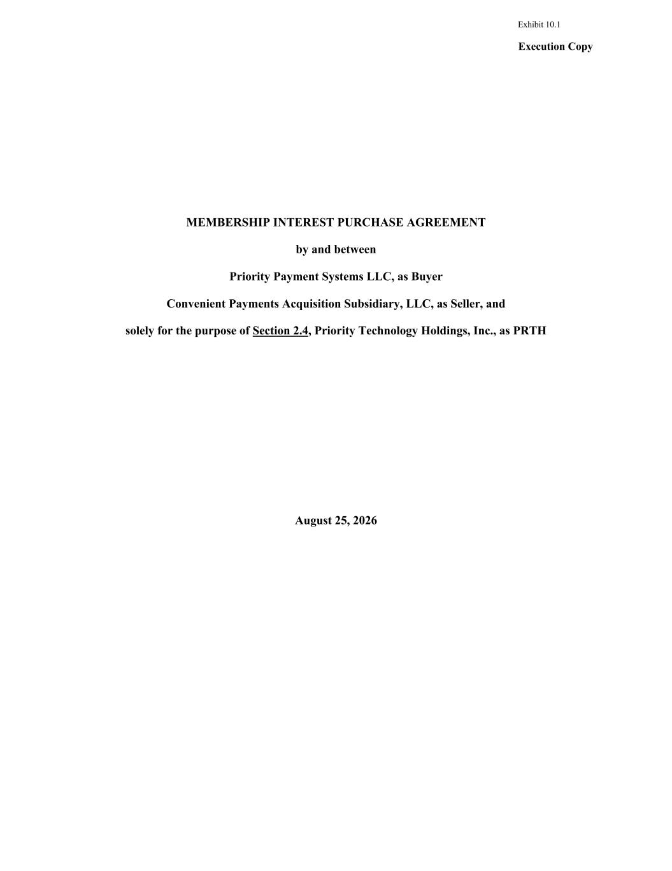

Execution Copy MEMBERSHIP INTEREST PURCHASE AGREEMENT by and between Priority Payment Systems LLC, as Buyer Convenient Payments Acquisition Subsidiary, LLC, as Seller, and solely for the purpose of Section 2.4, Priority Technology Holdings, Inc., as PRTH August 25, 2026 Exhibit 10.1


Certain Defined Terms Annex B-1 Estimated Closing Statement Annex B-2 Current Assets and Current Liabilities; Working Capital Target Calculation Annex B-3 Earnout Methodology Annex C Allocation Methodology

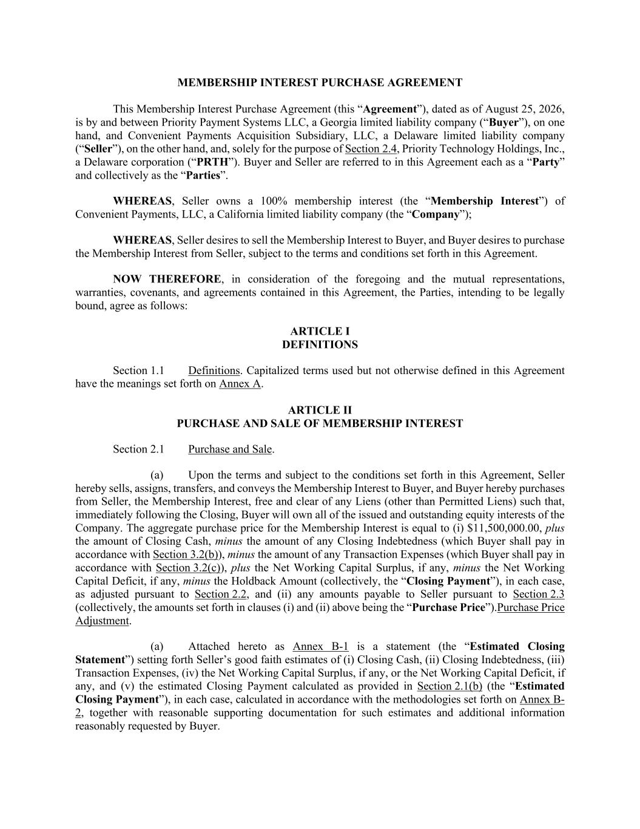
MEMBERSHIP INTEREST PURCHASE AGREEMENT This Membership Interest Purchase Agreement (this “Agreement”), dated as of August 25, 2026, is by and between Priority Payment Systems LLC, a Georgia limited liability company (“Buyer”), on one hand, and Convenient Payments Acquisition Subsidiary, LLC, a Delaware limited liability company (“Seller”), on the other hand, and, solely for the purpose of Section 2.4, Priority Technology Holdings, Inc., a Delaware corporation (“PRTH”). Buyer and Seller are referred to in this Agreement each as a “Party” and collectively as the “Parties”. WHEREAS, Seller owns a 100% membership interest (the “Membership Interest”) of Convenient Payments, LLC, a California limited liability company (the “Company”); WHEREAS, Seller desires to sell the Membership Interest to Buyer, and Buyer desires to purchase the Membership Interest from Seller, subject to the terms and conditions set forth in this Agreement. NOW THEREFORE, in consideration of the foregoing and the mutual representations, warranties, covenants, and agreements contained in this Agreement, the Parties, intending to be legally bound, agree as follows: ARTICLE I DEFINITIONS Section 1.1 Definitions. Capitalized terms used but not otherwise defined in this Agreement have the meanings set forth on Annex A. ARTICLE II PURCHASE AND SALE OF MEMBERSHIP INTEREST Section 2.1 Purchase and Sale. (a) Upon the terms and subject to the conditions set forth in this Agreement, Seller hereby sells, assigns, transfers, and conveys the Membership Interest to Buyer, and Buyer hereby purchases from Seller, the Membership Interest, free and clear of any Liens (other than Permitted Liens) such that, immediately following the Closing, Buyer will own all of the issued and outstanding equity interests of the Company. The aggregate purchase price for the Membership Interest is equal to (i) $11,500,000.00, plus the amount of Closing Cash, minus the amount of any Closing Indebtedness (which Buyer shall pay in accordance with Section 3.2(b)), minus the amount of any Transaction Expenses (which Buyer shall pay in accordance with Section 3.2(c)), plus the Net Working Capital Surplus, if any, minus the Net Working Capital Deficit, if any, minus the Holdback Amount (collectively, the “Closing Payment”), in each case, as adjusted pursuant to Section 2.2, and (ii) any amounts payable to Seller pursuant to Section 2.3 (collectively, the amounts set forth in clauses (i) and (ii) above being the “Purchase Price”).Purchase Price Adjustment. (a) Attached hereto as Annex B-1 is a statement (the “Estimated Closing Statement”) setting forth Seller’s good faith estimates of (i) Closing Cash, (ii) Closing Indebtedness, (iii) Transaction Expenses, (iv) the Net Working Capital Surplus, if any, or the Net Working Capital Deficit, if any, and (v) the estimated Closing Payment calculated as provided in Section 2.1(b) (the “Estimated Closing Payment”), in each case, calculated in accordance with the methodologies set forth on Annex B- 2, together with reasonable supporting documentation for such estimates and additional information reasonably requested by Buyer.

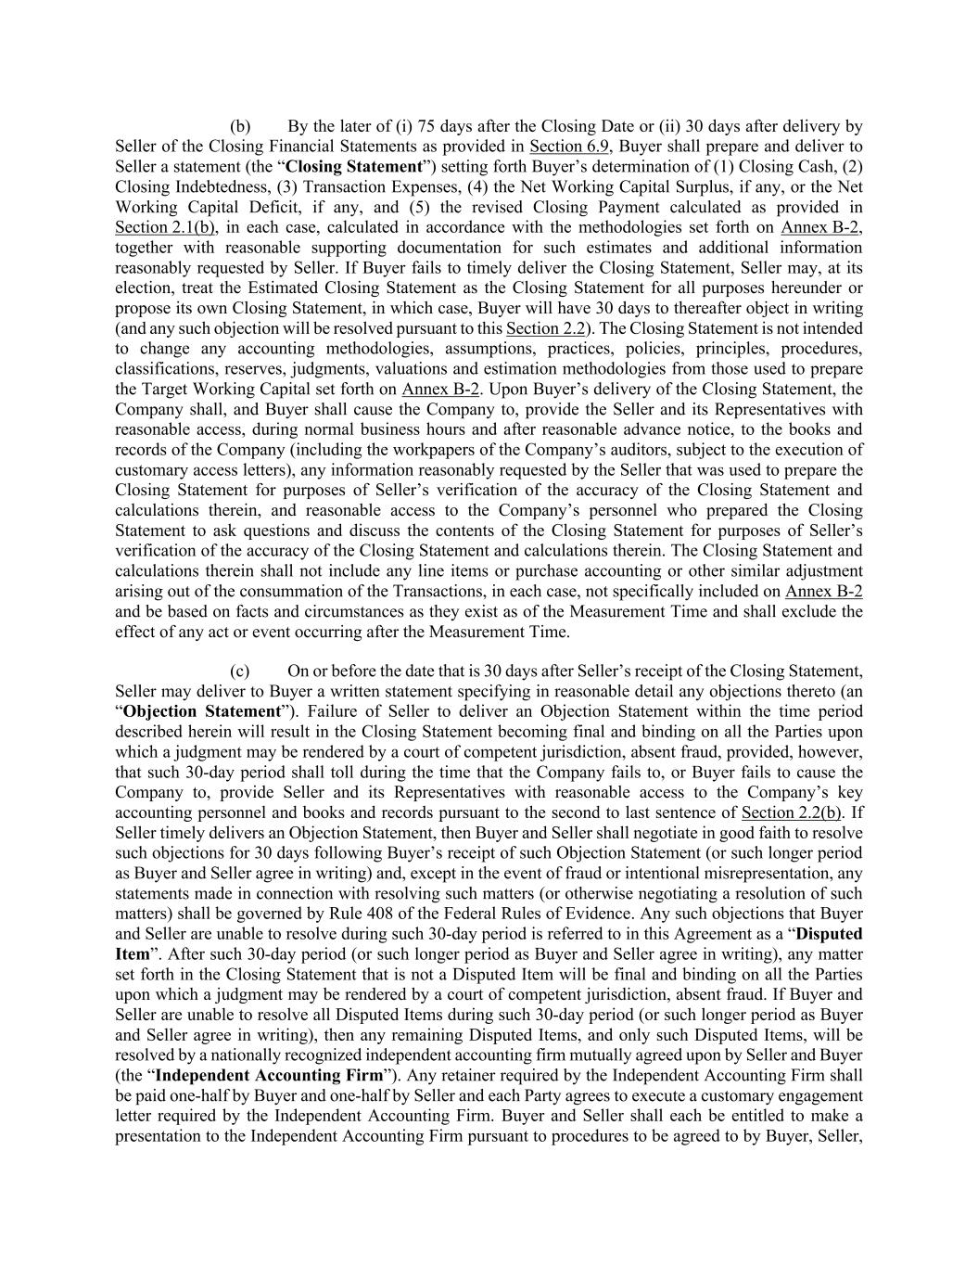
(b) By the later of (i) 75 days after the Closing Date or (ii) 30 days after delivery by Seller of the Closing Financial Statements as provided in Section 6.9, Buyer shall prepare and deliver to Seller a statement (the “Closing Statement”) setting forth Buyer’s determination of (1) Closing Cash, (2) Closing Indebtedness, (3) Transaction Expenses, (4) the Net Working Capital Surplus, if any, or the Net Working Capital Deficit, if any, and (5) the revised Closing Payment calculated as provided in Section 2.1(b), in each case, calculated in accordance with the methodologies set forth on Annex B-2, together with reasonable supporting documentation for such estimates and additional information reasonably requested by Seller. If Buyer fails to timely deliver the Closing Statement, Seller may, at its election, treat the Estimated Closing Statement as the Closing Statement for all purposes hereunder or propose its own Closing Statement, in which case, Buyer will have 30 days to thereafter object in writing (and any such objection will be resolved pursuant to this Section 2.2). The Closing Statement is not intended to change any accounting methodologies, assumptions, practices, policies, principles, procedures, classifications, reserves, judgments, valuations and estimation methodologies from those used to prepare the Target Working Capital set forth on Annex B-2. Upon Buyer’s delivery of the Closing Statement, the Company shall, and Buyer shall cause the Company to, provide the Seller and its Representatives with reasonable access, during normal business hours and after reasonable advance notice, to the books and records of the Company (including the workpapers of the Company’s auditors, subject to the execution of customary access letters), any information reasonably requested by the Seller that was used to prepare the Closing Statement for purposes of Seller’s verification of the accuracy of the Closing Statement and calculations therein, and reasonable access to the Company’s personnel who prepared the Closing Statement to ask questions and discuss the contents of the Closing Statement for purposes of Seller’s verification of the accuracy of the Closing Statement and calculations therein. The Closing Statement and calculations therein shall not include any line items or purchase accounting or other similar adjustment arising out of the consummation of the Transactions, in each case, not specifically included on Annex B-2 and be based on facts and circumstances as they exist as of the Measurement Time and shall exclude the effect of any act or event occurring after the Measurement Time. (c) On or before the date that is 30 days after Seller’s receipt of the Closing Statement, Seller may deliver to Buyer a written statement specifying in reasonable detail any objections thereto (an “Objection Statement”). Failure of Seller to deliver an Objection Statement within the time period described herein will result in the Closing Statement becoming final and binding on all the Parties upon which a judgment may be rendered by a court of competent jurisdiction, absent fraud, provided, however, that such 30-day period shall toll during the time that the Company fails to, or Buyer fails to cause the Company to, provide Seller and its Representatives with reasonable access to the Company’s key accounting personnel and books and records pursuant to the second to last sentence of Section 2.2(b). If Seller timely delivers an Objection Statement, then Buyer and Seller shall negotiate in good faith to resolve such objections for 30 days following Buyer’s receipt of such Objection Statement (or such longer period as Buyer and Seller agree in writing) and, except in the event of fraud or intentional misrepresentation, any statements made in connection with resolving such matters (or otherwise negotiating a resolution of such matters) shall be governed by Rule 408 of the Federal Rules of Evidence. Any such objections that Buyer and Seller are unable to resolve during such 30-day period is referred to in this Agreement as a “Disputed Item”. After such 30-day period (or such longer period as Buyer and Seller agree in writing), any matter set forth in the Closing Statement that is not a Disputed Item will be final and binding on all the Parties upon which a judgment may be rendered by a court of competent jurisdiction, absent fraud. If Buyer and Seller are unable to resolve all Disputed Items during such 30-day period (or such longer period as Buyer and Seller agree in writing), then any remaining Disputed Items, and only such Disputed Items, will be resolved by a nationally recognized independent accounting firm mutually agreed upon by Seller and Buyer (the “Independent Accounting Firm”). Any retainer required by the Independent Accounting Firm shall be paid one-half by Buyer and one-half by Seller and each Party agrees to execute a customary engagement letter required by the Independent Accounting Firm. Buyer and Seller shall each be entitled to make a presentation to the Independent Accounting Firm pursuant to procedures to be agreed to by Buyer, Seller,

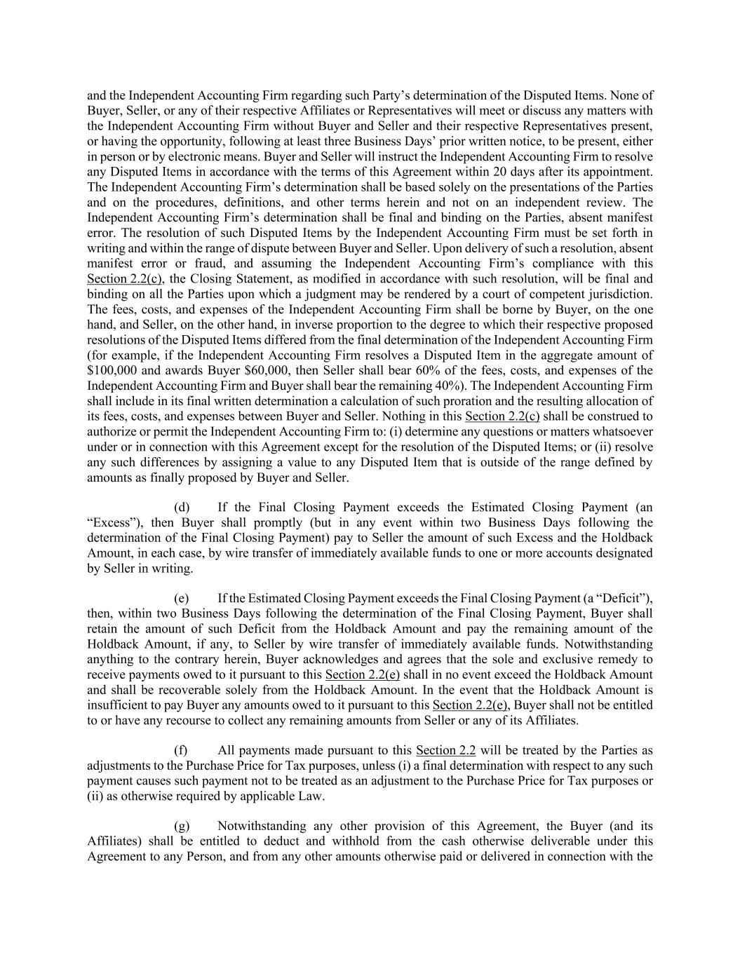
and the Independent Accounting Firm regarding such Party’s determination of the Disputed Items. None of Buyer, Seller, or any of their respective Affiliates or Representatives will meet or discuss any matters with the Independent Accounting Firm without Buyer and Seller and their respective Representatives present, or having the opportunity, following at least three Business Days’ prior written notice, to be present, either in person or by electronic means. Buyer and Seller will instruct the Independent Accounting Firm to resolve any Disputed Items in accordance with the terms of this Agreement within 20 days after its appointment. The Independent Accounting Firm’s determination shall be based solely on the presentations of the Parties and on the procedures, definitions, and other terms herein and not on an independent review. The Independent Accounting Firm’s determination shall be final and binding on the Parties, absent manifest error. The resolution of such Disputed Items by the Independent Accounting Firm must be set forth in writing and within the range of dispute between Buyer and Seller. Upon delivery of such a resolution, absent manifest error or fraud, and assuming the Independent Accounting Firm’s compliance with this Section 2.2(c), the Closing Statement, as modified in accordance with such resolution, will be final and binding on all the Parties upon which a judgment may be rendered by a court of competent jurisdiction. The fees, costs, and expenses of the Independent Accounting Firm shall be borne by Buyer, on the one hand, and Seller, on the other hand, in inverse proportion to the degree to which their respective proposed resolutions of the Disputed Items differed from the final determination of the Independent Accounting Firm (for example, if the Independent Accounting Firm resolves a Disputed Item in the aggregate amount of $100,000 and awards Buyer $60,000, then Seller shall bear 60% of the fees, costs, and expenses of the Independent Accounting Firm and Buyer shall bear the remaining 40%). The Independent Accounting Firm shall include in its final written determination a calculation of such proration and the resulting allocation of its fees, costs, and expenses between Buyer and Seller. Nothing in this Section 2.2(c) shall be construed to authorize or permit the Independent Accounting Firm to: (i) determine any questions or matters whatsoever under or in connection with this Agreement except for the resolution of the Disputed Items; or (ii) resolve any such differences by assigning a value to any Disputed Item that is outside of the range defined by amounts as finally proposed by Buyer and Seller. (d) If the Final Closing Payment exceeds the Estimated Closing Payment (an “Excess”), then Buyer shall promptly (but in any event within two Business Days following the determination of the Final Closing Payment) pay to Seller the amount of such Excess and the Holdback Amount, in each case, by wire transfer of immediately available funds to one or more accounts designated by Seller in writing. (e) If the Estimated Closing Payment exceeds the Final Closing Payment (a “Deficit”), then, within two Business Days following the determination of the Final Closing Payment, Buyer shall retain the amount of such Deficit from the Holdback Amount and pay the remaining amount of the Holdback Amount, if any, to Seller by wire transfer of immediately available funds. Notwithstanding anything to the contrary herein, Buyer acknowledges and agrees that the sole and exclusive remedy to receive payments owed to it pursuant to this Section 2.2(e) shall in no event exceed the Holdback Amount and shall be recoverable solely from the Holdback Amount. In the event that the Holdback Amount is insufficient to pay Buyer any amounts owed to it pursuant to this Section 2.2(e), Buyer shall not be entitled to or have any recourse to collect any remaining amounts from Seller or any of its Affiliates. (f) All payments made pursuant to this Section 2.2 will be treated by the Parties as adjustments to the Purchase Price for Tax purposes, unless (i) a final determination with respect to any such payment causes such payment not to be treated as an adjustment to the Purchase Price for Tax purposes or (ii) as otherwise required by applicable Law. (g) Notwithstanding any other provision of this Agreement, the Buyer (and its Affiliates) shall be entitled to deduct and withhold from the cash otherwise deliverable under this Agreement to any Person, and from any other amounts otherwise paid or delivered in connection with the

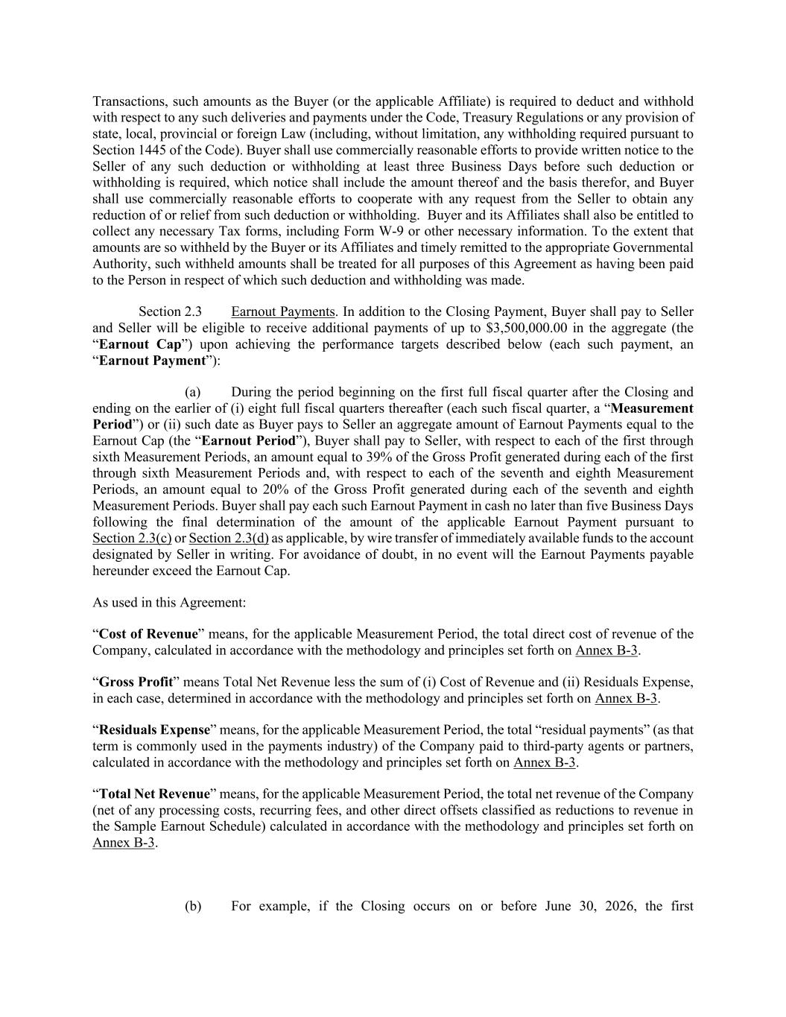
Transactions, such amounts as the Buyer (or the applicable Affiliate) is required to deduct and withhold with respect to any such deliveries and payments under the Code, Treasury Regulations or any provision of state, local, provincial or foreign Law (including, without limitation, any withholding required pursuant to Section 1445 of the Code). Buyer shall use commercially reasonable efforts to provide written notice to the Seller of any such deduction or withholding at least three Business Days before such deduction or withholding is required, which notice shall include the amount thereof and the basis therefor, and Buyer shall use commercially reasonable efforts to cooperate with any request from the Seller to obtain any reduction of or relief from such deduction or withholding. Buyer and its Affiliates shall also be entitled to collect any necessary Tax forms, including Form W-9 or other necessary information. To the extent that amounts are so withheld by the Buyer or its Affiliates and timely remitted to the appropriate Governmental Authority, such withheld amounts shall be treated for all purposes of this Agreement as having been paid to the Person in respect of which such deduction and withholding was made. Section 2.3 Earnout Payments. In addition to the Closing Payment, Buyer shall pay to Seller and Seller will be eligible to receive additional payments of up to $3,500,000.00 in the aggregate (the “Earnout Cap”) upon achieving the performance targets described below (each such payment, an “Earnout Payment”): (a) During the period beginning on the first full fiscal quarter after the Closing and ending on the earlier of (i) eight full fiscal quarters thereafter (each such fiscal quarter, a “Measurement Period”) or (ii) such date as Buyer pays to Seller an aggregate amount of Earnout Payments equal to the Earnout Cap (the “Earnout Period”), Buyer shall pay to Seller, with respect to each of the first through sixth Measurement Periods, an amount equal to 39% of the Gross Profit generated during each of the first through sixth Measurement Periods and, with respect to each of the seventh and eighth Measurement Periods, an amount equal to 20% of the Gross Profit generated during each of the seventh and eighth Measurement Periods. Buyer shall pay each such Earnout Payment in cash no later than five Business Days following the final determination of the amount of the applicable Earnout Payment pursuant to Section 2.3(c) or Section 2.3(d) as applicable, by wire transfer of immediately available funds to the account designated by Seller in writing. For avoidance of doubt, in no event will the Earnout Payments payable hereunder exceed the Earnout Cap. As used in this Agreement: “Cost of Revenue” means, for the applicable Measurement Period, the total direct cost of revenue of the Company, calculated in accordance with the methodology and principles set forth on Annex B-3. “Gross Profit” means Total Net Revenue less the sum of (i) Cost of Revenue and (ii) Residuals Expense, in each case, determined in accordance with the methodology and principles set forth on Annex B-3. “Residuals Expense” means, for the applicable Measurement Period, the total “residual payments” (as that term is commonly used in the payments industry) of the Company paid to third-party agents or partners, calculated in accordance with the methodology and principles set forth on Annex B-3. “Total Net Revenue” means, for the applicable Measurement Period, the total net revenue of the Company (net of any processing costs, recurring fees, and other direct offsets classified as reductions to revenue in the Sample Earnout Schedule) calculated in accordance with the methodology and principles set forth on Annex B-3. (b) For example, if the Closing occurs on or before June 30, 2026, the first

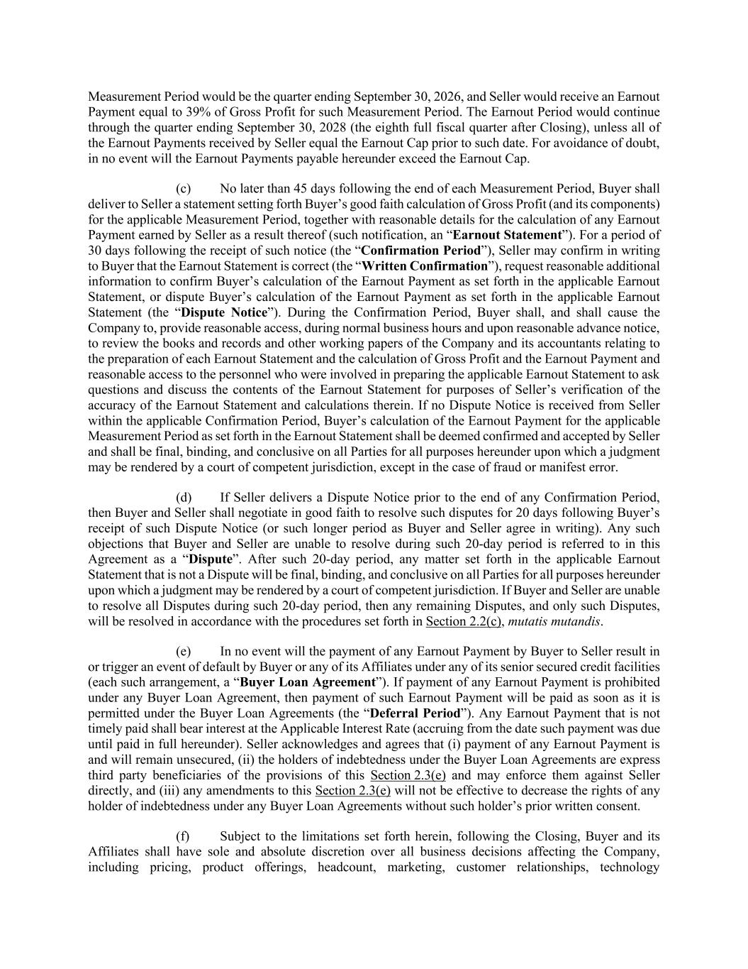
Measurement Period would be the quarter ending September 30, 2026, and Seller would receive an Earnout Payment equal to 39% of Gross Profit for such Measurement Period. The Earnout Period would continue through the quarter ending September 30, 2028 (the eighth full fiscal quarter after Closing), unless all of the Earnout Payments received by Seller equal the Earnout Cap prior to such date. For avoidance of doubt, in no event will the Earnout Payments payable hereunder exceed the Earnout Cap. (c) No later than 45 days following the end of each Measurement Period, Buyer shall deliver to Seller a statement setting forth Buyer’s good faith calculation of Gross Profit (and its components) for the applicable Measurement Period, together with reasonable details for the calculation of any Earnout Payment earned by Seller as a result thereof (such notification, an “Earnout Statement”). For a period of 30 days following the receipt of such notice (the “Confirmation Period”), Seller may confirm in writing to Buyer that the Earnout Statement is correct (the “Written Confirmation”), request reasonable additional information to confirm Buyer’s calculation of the Earnout Payment as set forth in the applicable Earnout Statement, or dispute Buyer’s calculation of the Earnout Payment as set forth in the applicable Earnout Statement (the “Dispute Notice”). During the Confirmation Period, Buyer shall, and shall cause the Company to, provide reasonable access, during normal business hours and upon reasonable advance notice, to review the books and records and other working papers of the Company and its accountants relating to the preparation of each Earnout Statement and the calculation of Gross Profit and the Earnout Payment and reasonable access to the personnel who were involved in preparing the applicable Earnout Statement to ask questions and discuss the contents of the Earnout Statement for purposes of Seller’s verification of the accuracy of the Earnout Statement and calculations therein. If no Dispute Notice is received from Seller within the applicable Confirmation Period, Buyer’s calculation of the Earnout Payment for the applicable Measurement Period as set forth in the Earnout Statement shall be deemed confirmed and accepted by Seller and shall be final, binding, and conclusive on all Parties for all purposes hereunder upon which a judgment may be rendered by a court of competent jurisdiction, except in the case of fraud or manifest error. (d) If Seller delivers a Dispute Notice prior to the end of any Confirmation Period, then Buyer and Seller shall negotiate in good faith to resolve such disputes for 20 days following Buyer’s receipt of such Dispute Notice (or such longer period as Buyer and Seller agree in writing). Any such objections that Buyer and Seller are unable to resolve during such 20-day period is referred to in this Agreement as a “Dispute”. After such 20-day period, any matter set forth in the applicable Earnout Statement that is not a Dispute will be final, binding, and conclusive on all Parties for all purposes hereunder upon which a judgment may be rendered by a court of competent jurisdiction. If Buyer and Seller are unable to resolve all Disputes during such 20-day period, then any remaining Disputes, and only such Disputes, will be resolved in accordance with the procedures set forth in Section 2.2(c), mutatis mutandis. (e) In no event will the payment of any Earnout Payment by Buyer to Seller result in or trigger an event of default by Buyer or any of its Affiliates under any of its senior secured credit facilities (each such arrangement, a “Buyer Loan Agreement”). If payment of any Earnout Payment is prohibited under any Buyer Loan Agreement, then payment of such Earnout Payment will be paid as soon as it is permitted under the Buyer Loan Agreements (the “Deferral Period”). Any Earnout Payment that is not timely paid shall bear interest at the Applicable Interest Rate (accruing from the date such payment was due until paid in full hereunder). Seller acknowledges and agrees that (i) payment of any Earnout Payment is and will remain unsecured, (ii) the holders of indebtedness under the Buyer Loan Agreements are express third party beneficiaries of the provisions of this Section 2.3(e) and may enforce them against Seller directly, and (iii) any amendments to this Section 2.3(e) will not be effective to decrease the rights of any holder of indebtedness under any Buyer Loan Agreements without such holder’s prior written consent. (f) Subject to the limitations set forth herein, following the Closing, Buyer and its Affiliates shall have sole and absolute discretion over all business decisions affecting the Company, including pricing, product offerings, headcount, marketing, customer relationships, technology

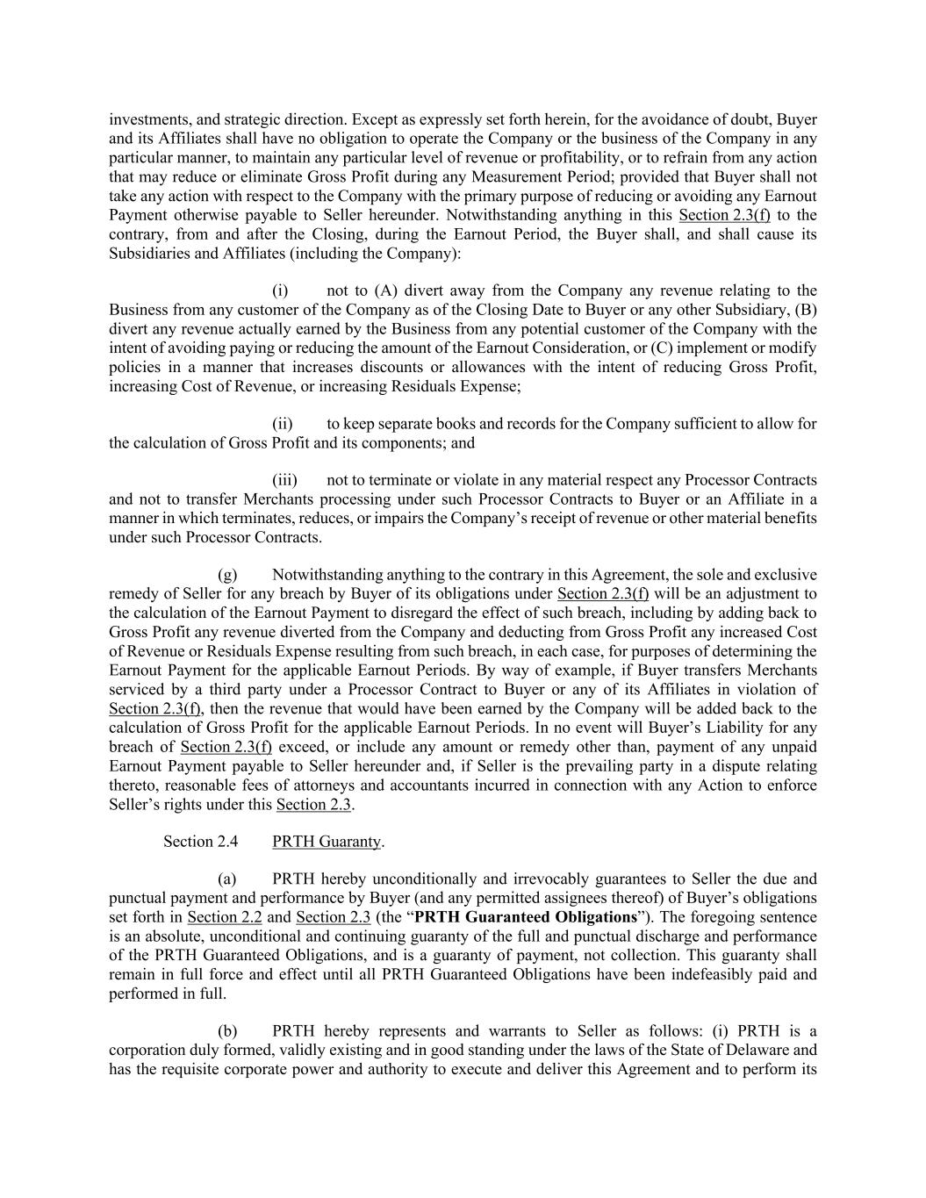
investments, and strategic direction. Except as expressly set forth herein, for the avoidance of doubt, Buyer and its Affiliates shall have no obligation to operate the Company or the business of the Company in any particular manner, to maintain any particular level of revenue or profitability, or to refrain from any action that may reduce or eliminate Gross Profit during any Measurement Period; provided that Buyer shall not take any action with respect to the Company with the primary purpose of reducing or avoiding any Earnout Payment otherwise payable to Seller hereunder. Notwithstanding anything in this Section 2.3(f) to the contrary, from and after the Closing, during the Earnout Period, the Buyer shall, and shall cause its Subsidiaries and Affiliates (including the Company): (i) not to (A) divert away from the Company any revenue relating to the Business from any customer of the Company as of the Closing Date to Buyer or any other Subsidiary, (B) divert any revenue actually earned by the Business from any potential customer of the Company with the intent of avoiding paying or reducing the amount of the Earnout Consideration, or (C) implement or modify policies in a manner that increases discounts or allowances with the intent of reducing Gross Profit, increasing Cost of Revenue, or increasing Residuals Expense; (ii) to keep separate books and records for the Company sufficient to allow for the calculation of Gross Profit and its components; and (iii) not to terminate or violate in any material respect any Processor Contracts and not to transfer Merchants processing under such Processor Contracts to Buyer or an Affiliate in a manner in which terminates, reduces, or impairs the Company’s receipt of revenue or other material benefits under such Processor Contracts. (g) Notwithstanding anything to the contrary in this Agreement, the sole and exclusive remedy of Seller for any breach by Buyer of its obligations under Section 2.3(f) will be an adjustment to the calculation of the Earnout Payment to disregard the effect of such breach, including by adding back to Gross Profit any revenue diverted from the Company and deducting from Gross Profit any increased Cost of Revenue or Residuals Expense resulting from such breach, in each case, for purposes of determining the Earnout Payment for the applicable Earnout Periods. By way of example, if Buyer transfers Merchants serviced by a third party under a Processor Contract to Buyer or any of its Affiliates in violation of Section 2.3(f), then the revenue that would have been earned by the Company will be added back to the calculation of Gross Profit for the applicable Earnout Periods. In no event will Buyer’s Liability for any breach of Section 2.3(f) exceed, or include any amount or remedy other than, payment of any unpaid Earnout Payment payable to Seller hereunder and, if Seller is the prevailing party in a dispute relating thereto, reasonable fees of attorneys and accountants incurred in connection with any Action to enforce Seller’s rights under this Section 2.3. Section 2.4 PRTH Guaranty. (a) PRTH hereby unconditionally and irrevocably guarantees to Seller the due and punctual payment and performance by Buyer (and any permitted assignees thereof) of Buyer’s obligations set forth in Section 2.2 and Section 2.3 (the “PRTH Guaranteed Obligations”). The foregoing sentence is an absolute, unconditional and continuing guaranty of the full and punctual discharge and performance of the PRTH Guaranteed Obligations, and is a guaranty of payment, not collection. This guaranty shall remain in full force and effect until all PRTH Guaranteed Obligations have been indefeasibly paid and performed in full. (b) PRTH hereby represents and warrants to Seller as follows: (i) PRTH is a corporation duly formed, validly existing and in good standing under the laws of the State of Delaware and has the requisite corporate power and authority to execute and deliver this Agreement and to perform its

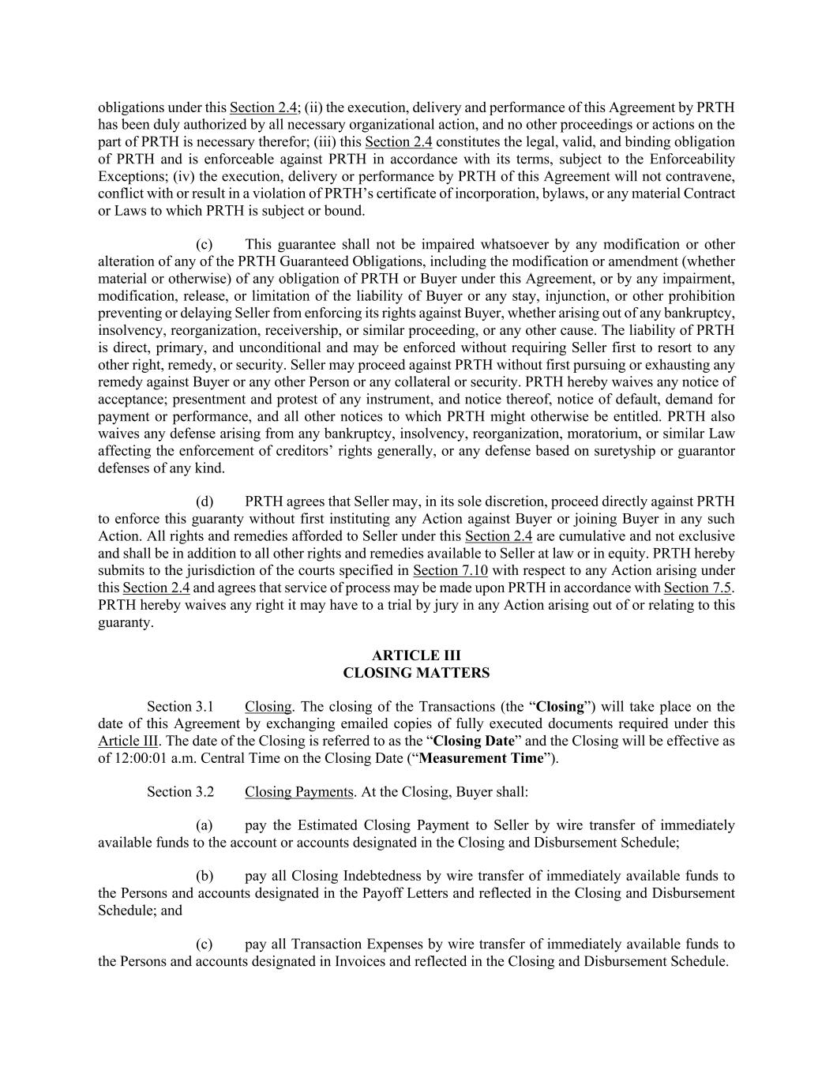
obligations under this Section 2.4; (ii) the execution, delivery and performance of this Agreement by PRTH has been duly authorized by all necessary organizational action, and no other proceedings or actions on the part of PRTH is necessary therefor; (iii) this Section 2.4 constitutes the legal, valid, and binding obligation of PRTH and is enforceable against PRTH in accordance with its terms, subject to the Enforceability Exceptions; (iv) the execution, delivery or performance by PRTH of this Agreement will not contravene, conflict with or result in a violation of PRTH’s certificate of incorporation, bylaws, or any material Contract or Laws to which PRTH is subject or bound. (c) This guarantee shall not be impaired whatsoever by any modification or other alteration of any of the PRTH Guaranteed Obligations, including the modification or amendment (whether material or otherwise) of any obligation of PRTH or Buyer under this Agreement, or by any impairment, modification, release, or limitation of the liability of Buyer or any stay, injunction, or other prohibition preventing or delaying Seller from enforcing its rights against Buyer, whether arising out of any bankruptcy, insolvency, reorganization, receivership, or similar proceeding, or any other cause. The liability of PRTH is direct, primary, and unconditional and may be enforced without requiring Seller first to resort to any other right, remedy, or security. Seller may proceed against PRTH without first pursuing or exhausting any remedy against Buyer or any other Person or any collateral or security. PRTH hereby waives any notice of acceptance; presentment and protest of any instrument, and notice thereof, notice of default, demand for payment or performance, and all other notices to which PRTH might otherwise be entitled. PRTH also waives any defense arising from any bankruptcy, insolvency, reorganization, moratorium, or similar Law affecting the enforcement of creditors’ rights generally, or any defense based on suretyship or guarantor defenses of any kind. (d) PRTH agrees that Seller may, in its sole discretion, proceed directly against PRTH to enforce this guaranty without first instituting any Action against Buyer or joining Buyer in any such Action. All rights and remedies afforded to Seller under this Section 2.4 are cumulative and not exclusive and shall be in addition to all other rights and remedies available to Seller at law or in equity. PRTH hereby submits to the jurisdiction of the courts specified in Section 7.10 with respect to any Action arising under this Section 2.4 and agrees that service of process may be made upon PRTH in accordance with Section 7.5. PRTH hereby waives any right it may have to a trial by jury in any Action arising out of or relating to this guaranty. ARTICLE III CLOSING MATTERS Section 3.1 Closing. The closing of the Transactions (the “Closing”) will take place on the date of this Agreement by exchanging emailed copies of fully executed documents required under this Article III. The date of the Closing is referred to as the “Closing Date” and the Closing will be effective as of 12:00:01 a.m. Central Time on the Closing Date (“Measurement Time”). Section 3.2 Closing Payments. At the Closing, Buyer shall: (a) pay the Estimated Closing Payment to Seller by wire transfer of immediately available funds to the account or accounts designated in the Closing and Disbursement Schedule; (b) pay all Closing Indebtedness by wire transfer of immediately available funds to the Persons and accounts designated in the Payoff Letters and reflected in the Closing and Disbursement Schedule; and (c) pay all Transaction Expenses by wire transfer of immediately available funds to the Persons and accounts designated in Invoices and reflected in the Closing and Disbursement Schedule.

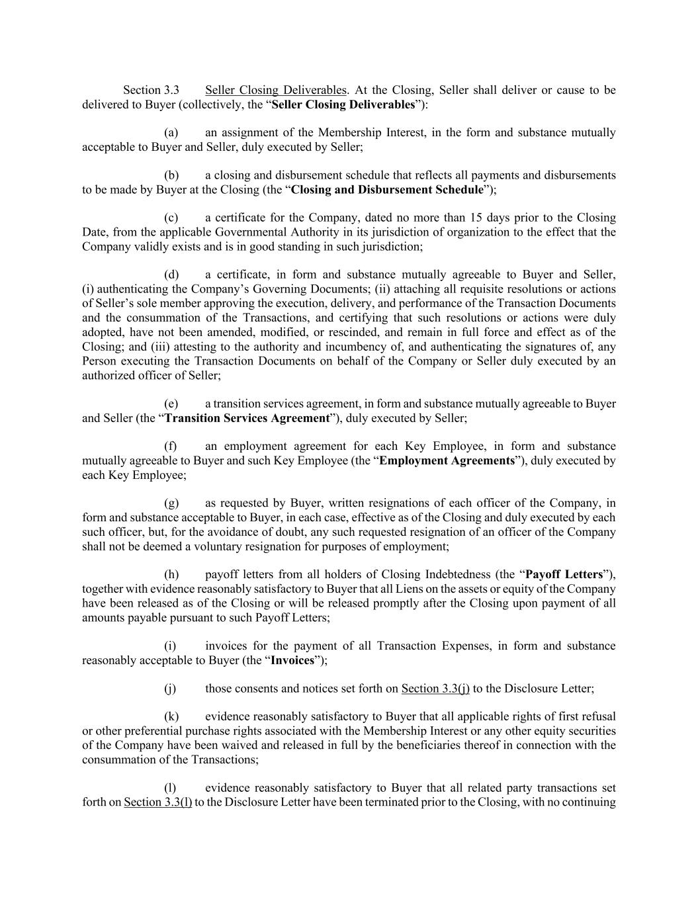
Section 3.3 Seller Closing Deliverables. At the Closing, Seller shall deliver or cause to be delivered to Buyer (collectively, the “Seller Closing Deliverables”): (a) an assignment of the Membership Interest, in the form and substance mutually acceptable to Buyer and Seller, duly executed by Seller; (b) a closing and disbursement schedule that reflects all payments and disbursements to be made by Buyer at the Closing (the “Closing and Disbursement Schedule”); (c) a certificate for the Company, dated no more than 15 days prior to the Closing Date, from the applicable Governmental Authority in its jurisdiction of organization to the effect that the Company validly exists and is in good standing in such jurisdiction; (d) a certificate, in form and substance mutually agreeable to Buyer and Seller, (i) authenticating the Company’s Governing Documents; (ii) attaching all requisite resolutions or actions of Seller’s sole member approving the execution, delivery, and performance of the Transaction Documents and the consummation of the Transactions, and certifying that such resolutions or actions were duly adopted, have not been amended, modified, or rescinded, and remain in full force and effect as of the Closing; and (iii) attesting to the authority and incumbency of, and authenticating the signatures of, any Person executing the Transaction Documents on behalf of the Company or Seller duly executed by an authorized officer of Seller; (e) a transition services agreement, in form and substance mutually agreeable to Buyer and Seller (the “Transition Services Agreement”), duly executed by Seller; (f) an employment agreement for each Key Employee, in form and substance mutually agreeable to Buyer and such Key Employee (the “Employment Agreements”), duly executed by each Key Employee; (g) as requested by Buyer, written resignations of each officer of the Company, in form and substance acceptable to Buyer, in each case, effective as of the Closing and duly executed by each such officer, but, for the avoidance of doubt, any such requested resignation of an officer of the Company shall not be deemed a voluntary resignation for purposes of employment; (h) payoff letters from all holders of Closing Indebtedness (the “Payoff Letters”), together with evidence reasonably satisfactory to Buyer that all Liens on the assets or equity of the Company have been released as of the Closing or will be released promptly after the Closing upon payment of all amounts payable pursuant to such Payoff Letters; (i) invoices for the payment of all Transaction Expenses, in form and substance reasonably acceptable to Buyer (the “Invoices”); (j) those consents and notices set forth on Section 3.3(j) to the Disclosure Letter; (k) evidence reasonably satisfactory to Buyer that all applicable rights of first refusal or other preferential purchase rights associated with the Membership Interest or any other equity securities of the Company have been waived and released in full by the beneficiaries thereof in connection with the consummation of the Transactions; (l) evidence reasonably satisfactory to Buyer that all related party transactions set forth on Section 3.3(l) to the Disclosure Letter have been terminated prior to the Closing, with no continuing

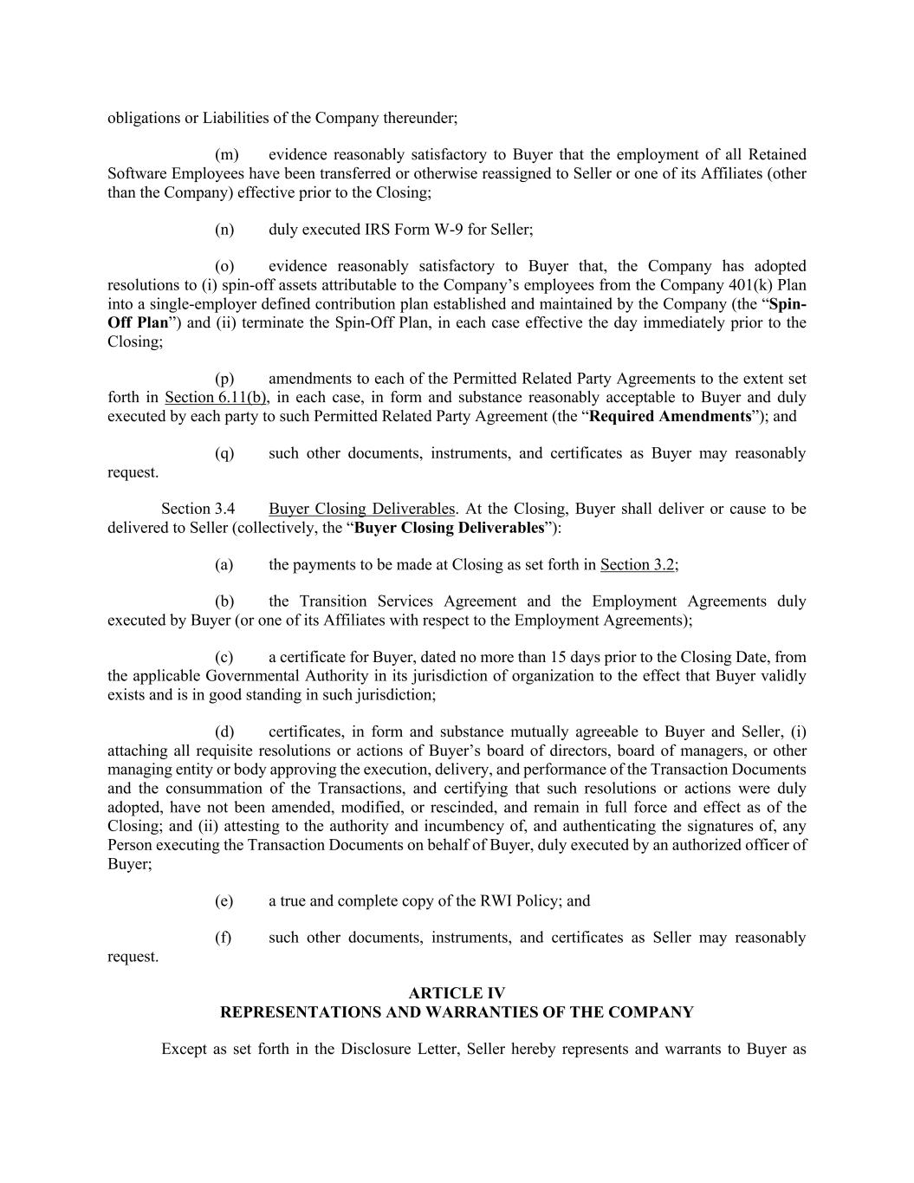
obligations or Liabilities of the Company thereunder; (m) evidence reasonably satisfactory to Buyer that the employment of all Retained Software Employees have been transferred or otherwise reassigned to Seller or one of its Affiliates (other than the Company) effective prior to the Closing; (n) duly executed IRS Form W-9 for Seller; (o) evidence reasonably satisfactory to Buyer that, the Company has adopted resolutions to (i) spin-off assets attributable to the Company’s employees from the Company 401(k) Plan into a single-employer defined contribution plan established and maintained by the Company (the “Spin- Off Plan”) and (ii) terminate the Spin-Off Plan, in each case effective the day immediately prior to the Closing; (p) amendments to each of the Permitted Related Party Agreements to the extent set forth in Section 6.11(b), in each case, in form and substance reasonably acceptable to Buyer and duly executed by each party to such Permitted Related Party Agreement (the “Required Amendments”); and (q) such other documents, instruments, and certificates as Buyer may reasonably request. Section 3.4 Buyer Closing Deliverables. At the Closing, Buyer shall deliver or cause to be delivered to Seller (collectively, the “Buyer Closing Deliverables”): (a) the payments to be made at Closing as set forth in Section 3.2; (b) the Transition Services Agreement and the Employment Agreements duly executed by Buyer (or one of its Affiliates with respect to the Employment Agreements); (c) a certificate for Buyer, dated no more than 15 days prior to the Closing Date, from the applicable Governmental Authority in its jurisdiction of organization to the effect that Buyer validly exists and is in good standing in such jurisdiction; (d) certificates, in form and substance mutually agreeable to Buyer and Seller, (i) attaching all requisite resolutions or actions of Buyer’s board of directors, board of managers, or other managing entity or body approving the execution, delivery, and performance of the Transaction Documents and the consummation of the Transactions, and certifying that such resolutions or actions were duly adopted, have not been amended, modified, or rescinded, and remain in full force and effect as of the Closing; and (ii) attesting to the authority and incumbency of, and authenticating the signatures of, any Person executing the Transaction Documents on behalf of Buyer, duly executed by an authorized officer of Buyer; (e) a true and complete copy of the RWI Policy; and (f) such other documents, instruments, and certificates as Seller may reasonably request. ARTICLE IV REPRESENTATIONS AND WARRANTIES OF THE COMPANY Except as set forth in the Disclosure Letter, Seller hereby represents and warrants to Buyer as

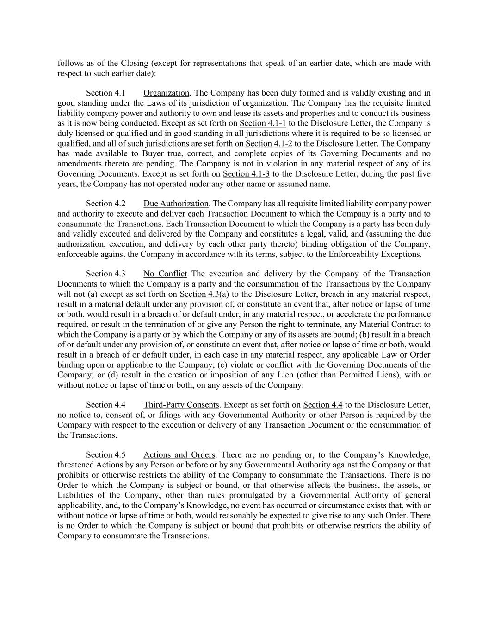
follows as of the Closing (except for representations that speak of an earlier date, which are made with respect to such earlier date): Section 4.1 Organization. The Company has been duly formed and is validly existing and in good standing under the Laws of its jurisdiction of organization. The Company has the requisite limited liability company power and authority to own and lease its assets and properties and to conduct its business as it is now being conducted. Except as set forth on Section 4.1-1 to the Disclosure Letter, the Company is duly licensed or qualified and in good standing in all jurisdictions where it is required to be so licensed or qualified, and all of such jurisdictions are set forth on Section 4.1-2 to the Disclosure Letter. The Company has made available to Buyer true, correct, and complete copies of its Governing Documents and no amendments thereto are pending. The Company is not in violation in any material respect of any of its Governing Documents. Except as set forth on Section 4.1-3 to the Disclosure Letter, during the past five years, the Company has not operated under any other name or assumed name. Section 4.2 Due Authorization. The Company has all requisite limited liability company power and authority to execute and deliver each Transaction Document to which the Company is a party and to consummate the Transactions. Each Transaction Document to which the Company is a party has been duly and validly executed and delivered by the Company and constitutes a legal, valid, and (assuming the due authorization, execution, and delivery by each other party thereto) binding obligation of the Company, enforceable against the Company in accordance with its terms, subject to the Enforceability Exceptions. Section 4.3 No Conflict The execution and delivery by the Company of the Transaction Documents to which the Company is a party and the consummation of the Transactions by the Company will not (a) except as set forth on Section 4.3(a) to the Disclosure Letter, breach in any material respect, result in a material default under any provision of, or constitute an event that, after notice or lapse of time or both, would result in a breach of or default under, in any material respect, or accelerate the performance required, or result in the termination of or give any Person the right to terminate, any Material Contract to which the Company is a party or by which the Company or any of its assets are bound; (b) result in a breach of or default under any provision of, or constitute an event that, after notice or lapse of time or both, would result in a breach of or default under, in each case in any material respect, any applicable Law or Order binding upon or applicable to the Company; (c) violate or conflict with the Governing Documents of the Company; or (d) result in the creation or imposition of any Lien (other than Permitted Liens), with or without notice or lapse of time or both, on any assets of the Company. Section 4.4 Third-Party Consents. Except as set forth on Section 4.4 to the Disclosure Letter, no notice to, consent of, or filings with any Governmental Authority or other Person is required by the Company with respect to the execution or delivery of any Transaction Document or the consummation of the Transactions. Section 4.5 Actions and Orders. There are no pending or, to the Company’s Knowledge, threatened Actions by any Person or before or by any Governmental Authority against the Company or that prohibits or otherwise restricts the ability of the Company to consummate the Transactions. There is no Order to which the Company is subject or bound, or that otherwise affects the business, the assets, or Liabilities of the Company, other than rules promulgated by a Governmental Authority of general applicability, and, to the Company’s Knowledge, no event has occurred or circumstance exists that, with or without notice or lapse of time or both, would reasonably be expected to give rise to any such Order. There is no Order to which the Company is subject or bound that prohibits or otherwise restricts the ability of Company to consummate the Transactions.

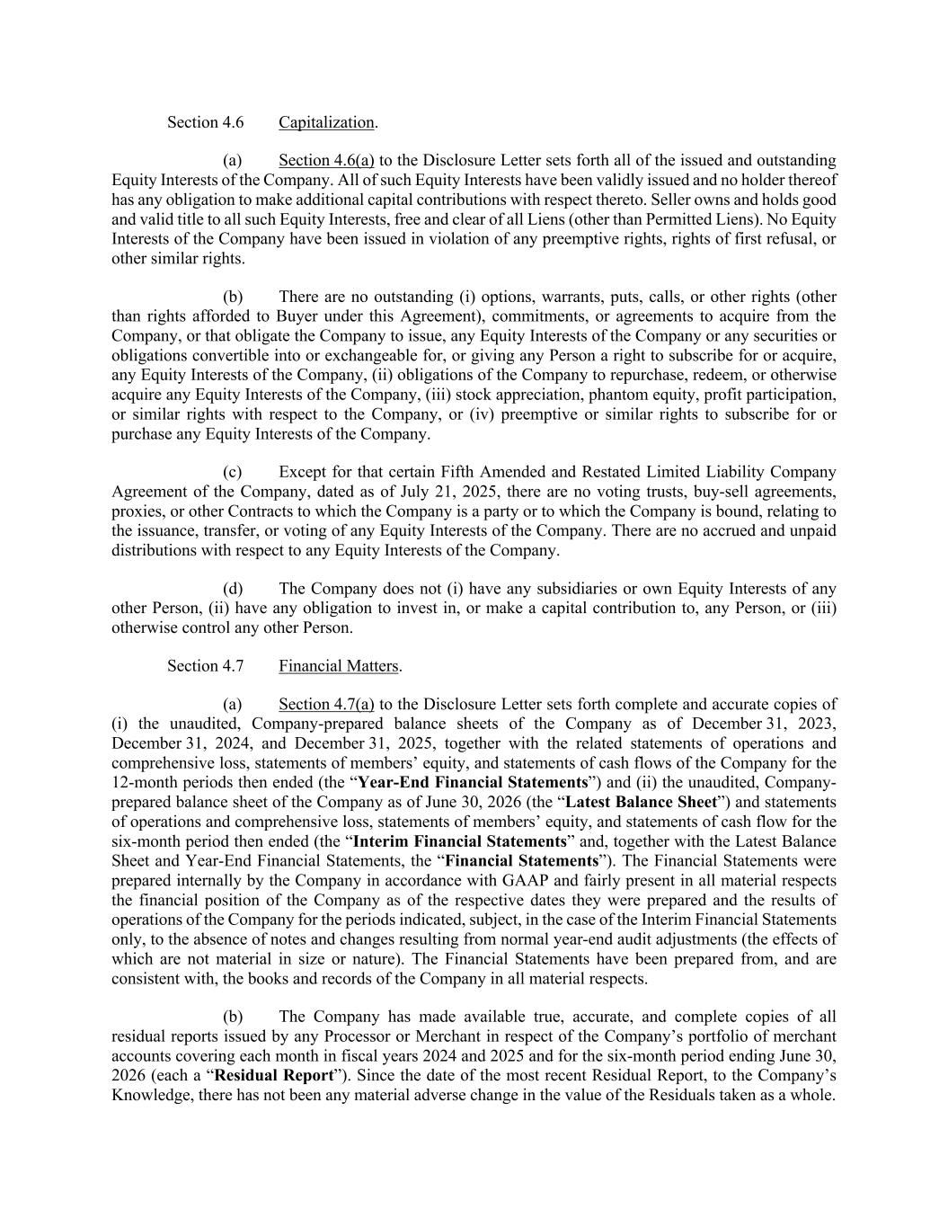
Section 4.6 Capitalization. (a) Section 4.6(a) to the Disclosure Letter sets forth all of the issued and outstanding Equity Interests of the Company. All of such Equity Interests have been validly issued and no holder thereof has any obligation to make additional capital contributions with respect thereto. Seller owns and holds good and valid title to all such Equity Interests, free and clear of all Liens (other than Permitted Liens). No Equity Interests of the Company have been issued in violation of any preemptive rights, rights of first refusal, or other similar rights. (b) There are no outstanding (i) options, warrants, puts, calls, or other rights (other than rights afforded to Buyer under this Agreement), commitments, or agreements to acquire from the Company, or that obligate the Company to issue, any Equity Interests of the Company or any securities or obligations convertible into or exchangeable for, or giving any Person a right to subscribe for or acquire, any Equity Interests of the Company, (ii) obligations of the Company to repurchase, redeem, or otherwise acquire any Equity Interests of the Company, (iii) stock appreciation, phantom equity, profit participation, or similar rights with respect to the Company, or (iv) preemptive or similar rights to subscribe for or purchase any Equity Interests of the Company. (c) Except for that certain Fifth Amended and Restated Limited Liability Company Agreement of the Company, dated as of July 21, 2025, there are no voting trusts, buy-sell agreements, proxies, or other Contracts to which the Company is a party or to which the Company is bound, relating to the issuance, transfer, or voting of any Equity Interests of the Company. There are no accrued and unpaid distributions with respect to any Equity Interests of the Company. (d) The Company does not (i) have any subsidiaries or own Equity Interests of any other Person, (ii) have any obligation to invest in, or make a capital contribution to, any Person, or (iii) otherwise control any other Person. Section 4.7 Financial Matters. (a) Section 4.7(a) to the Disclosure Letter sets forth complete and accurate copies of (i) the unaudited, Company-prepared balance sheets of the Company as of December 31, 2023, December 31, 2024, and December 31, 2025, together with the related statements of operations and comprehensive loss, statements of members’ equity, and statements of cash flows of the Company for the 12-month periods then ended (the “Year-End Financial Statements”) and (ii) the unaudited, Company- prepared balance sheet of the Company as of June 30, 2026 (the “Latest Balance Sheet”) and statements of operations and comprehensive loss, statements of members’ equity, and statements of cash flow for the six-month period then ended (the “Interim Financial Statements” and, together with the Latest Balance Sheet and Year-End Financial Statements, the “Financial Statements”). The Financial Statements were prepared internally by the Company in accordance with GAAP and fairly present in all material respects the financial position of the Company as of the respective dates they were prepared and the results of operations of the Company for the periods indicated, subject, in the case of the Interim Financial Statements only, to the absence of notes and changes resulting from normal year-end audit adjustments (the effects of which are not material in size or nature). The Financial Statements have been prepared from, and are consistent with, the books and records of the Company in all material respects. (b) The Company has made available true, accurate, and complete copies of all residual reports issued by any Processor or Merchant in respect of the Company’s portfolio of merchant accounts covering each month in fiscal years 2024 and 2025 and for the six-month period ending June 30, 2026 (each a “Residual Report”). Since the date of the most recent Residual Report, to the Company’s Knowledge, there has not been any material adverse change in the value of the Residuals taken as a whole.

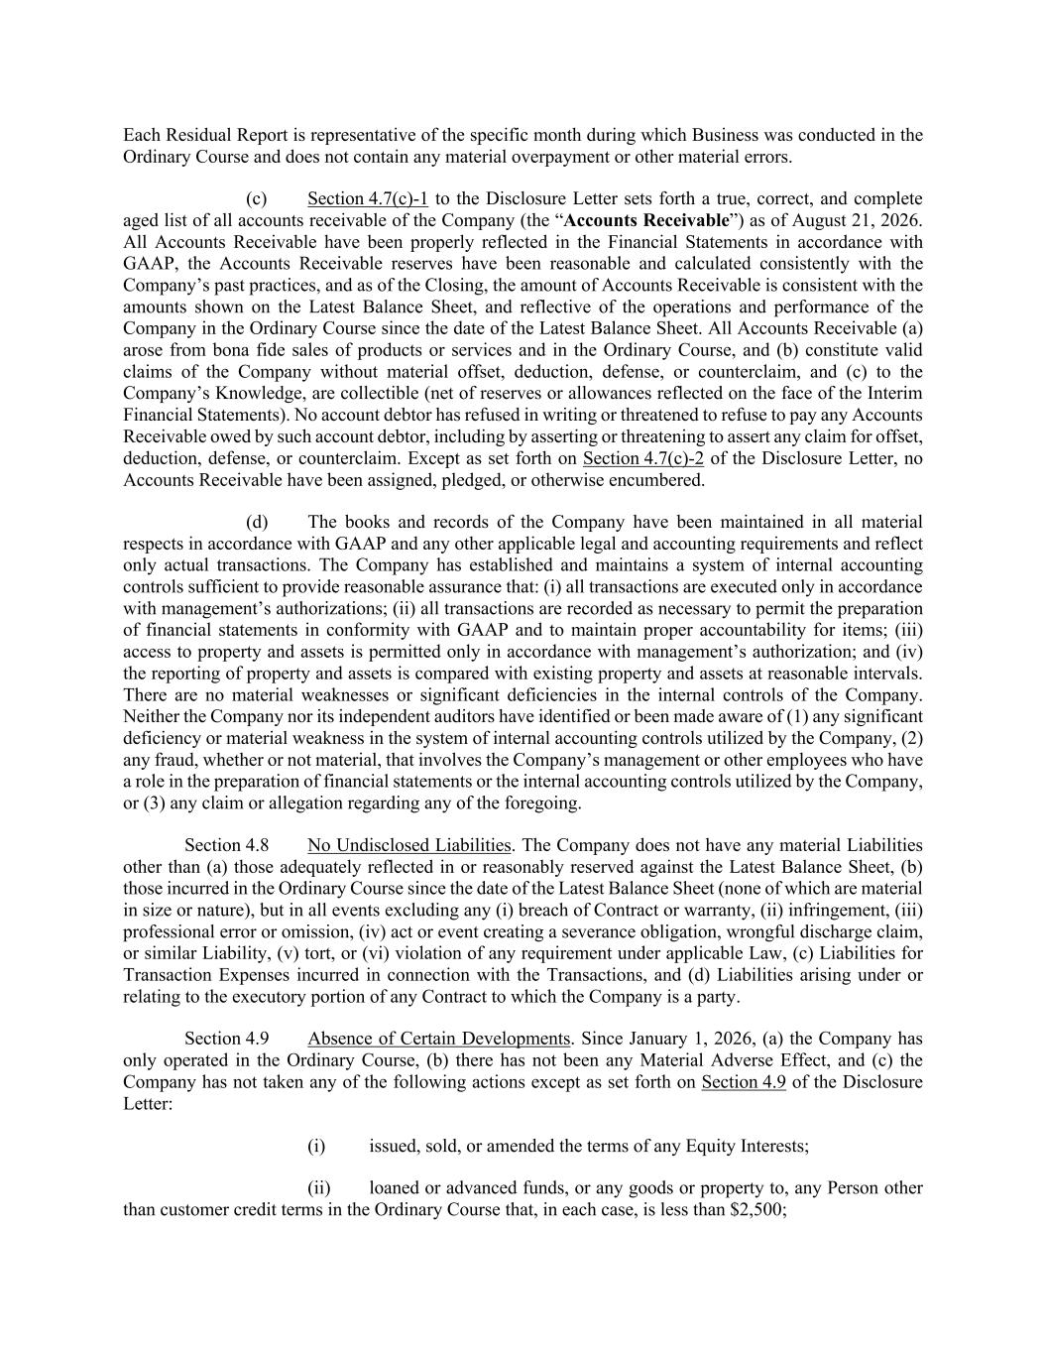
Each Residual Report is representative of the specific month during which Business was conducted in the Ordinary Course and does not contain any material overpayment or other material errors. (c) Section 4.7(c)-1 to the Disclosure Letter sets forth a true, correct, and complete aged list of all accounts receivable of the Company (the “Accounts Receivable”) as of August 21, 2026. All Accounts Receivable have been properly reflected in the Financial Statements in accordance with GAAP, the Accounts Receivable reserves have been reasonable and calculated consistently with the Company’s past practices, and as of the Closing, the amount of Accounts Receivable is consistent with the amounts shown on the Latest Balance Sheet, and reflective of the operations and performance of the Company in the Ordinary Course since the date of the Latest Balance Sheet. All Accounts Receivable (a) arose from bona fide sales of products or services and in the Ordinary Course, and (b) constitute valid claims of the Company without material offset, deduction, defense, or counterclaim, and (c) to the Company’s Knowledge, are collectible (net of reserves or allowances reflected on the face of the Interim Financial Statements). No account debtor has refused in writing or threatened to refuse to pay any Accounts Receivable owed by such account debtor, including by asserting or threatening to assert any claim for offset, deduction, defense, or counterclaim. Except as set forth on Section 4.7(c)-2 of the Disclosure Letter, no Accounts Receivable have been assigned, pledged, or otherwise encumbered. (d) The books and records of the Company have been maintained in all material respects in accordance with GAAP and any other applicable legal and accounting requirements and reflect only actual transactions. The Company has established and maintains a system of internal accounting controls sufficient to provide reasonable assurance that: (i) all transactions are executed only in accordance with management’s authorizations; (ii) all transactions are recorded as necessary to permit the preparation of financial statements in conformity with GAAP and to maintain proper accountability for items; (iii) access to property and assets is permitted only in accordance with management’s authorization; and (iv) the reporting of property and assets is compared with existing property and assets at reasonable intervals. There are no material weaknesses or significant deficiencies in the internal controls of the Company. Neither the Company nor its independent auditors have identified or been made aware of (1) any significant deficiency or material weakness in the system of internal accounting controls utilized by the Company, (2) any fraud, whether or not material, that involves the Company’s management or other employees who have a role in the preparation of financial statements or the internal accounting controls utilized by the Company, or (3) any claim or allegation regarding any of the foregoing. Section 4.8 No Undisclosed Liabilities. The Company does not have any material Liabilities other than (a) those adequately reflected in or reasonably reserved against the Latest Balance Sheet, (b) those incurred in the Ordinary Course since the date of the Latest Balance Sheet (none of which are material in size or nature), but in all events excluding any (i) breach of Contract or warranty, (ii) infringement, (iii) professional error or omission, (iv) act or event creating a severance obligation, wrongful discharge claim, or similar Liability, (v) tort, or (vi) violation of any requirement under applicable Law, (c) Liabilities for Transaction Expenses incurred in connection with the Transactions, and (d) Liabilities arising under or relating to the executory portion of any Contract to which the Company is a party. Section 4.9 Absence of Certain Developments. Since January 1, 2026, (a) the Company has only operated in the Ordinary Course, (b) there has not been any Material Adverse Effect, and (c) the Company has not taken any of the following actions except as set forth on Section 4.9 of the Disclosure Letter: (i) issued, sold, or amended the terms of any Equity Interests; (ii) loaned or advanced funds, or any goods or property to, any Person other than customer credit terms in the Ordinary Course that, in each case, is less than $2,500;

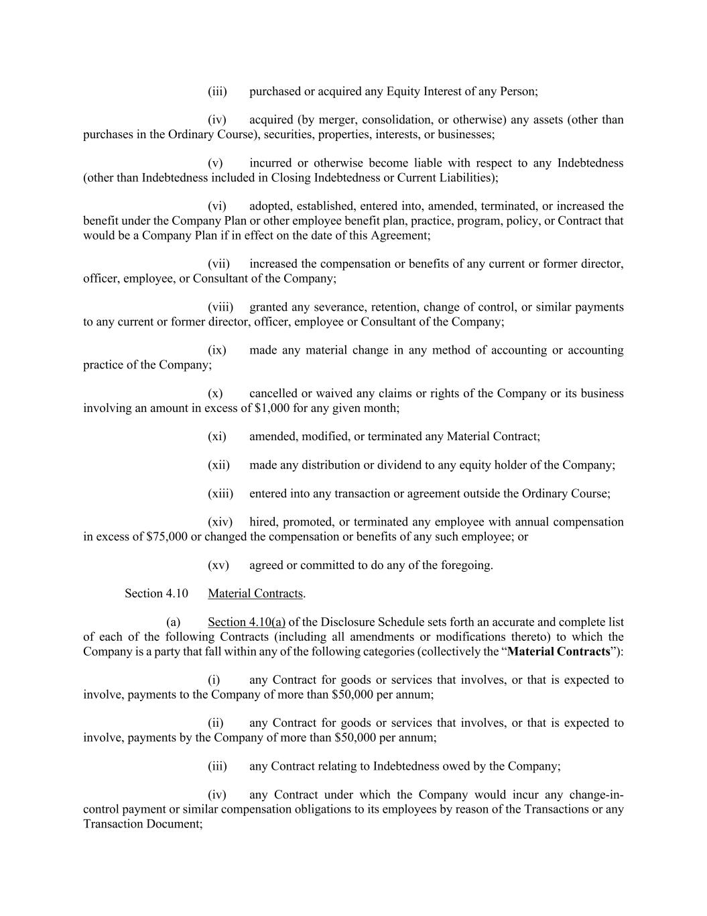
(iii) purchased or acquired any Equity Interest of any Person; (iv) acquired (by merger, consolidation, or otherwise) any assets (other than purchases in the Ordinary Course), securities, properties, interests, or businesses; (v) incurred or otherwise become liable with respect to any Indebtedness (other than Indebtedness included in Closing Indebtedness or Current Liabilities); (vi) adopted, established, entered into, amended, terminated, or increased the benefit under the Company Plan or other employee benefit plan, practice, program, policy, or Contract that would be a Company Plan if in effect on the date of this Agreement; (vii) increased the compensation or benefits of any current or former director, officer, employee, or Consultant of the Company; (viii) granted any severance, retention, change of control, or similar payments to any current or former director, officer, employee or Consultant of the Company; (ix) made any material change in any method of accounting or accounting practice of the Company; (x) cancelled or waived any claims or rights of the Company or its business involving an amount in excess of $1,000 for any given month; (xi) amended, modified, or terminated any Material Contract; (xii) made any distribution or dividend to any equity holder of the Company; (xiii) entered into any transaction or agreement outside the Ordinary Course; (xiv) hired, promoted, or terminated any employee with annual compensation in excess of $75,000 or changed the compensation or benefits of any such employee; or (xv) agreed or committed to do any of the foregoing. Section 4.10 Material Contracts. (a) Section 4.10(a) of the Disclosure Schedule sets forth an accurate and complete list of each of the following Contracts (including all amendments or modifications thereto) to which the Company is a party that fall within any of the following categories (collectively the “Material Contracts”): (i) any Contract for goods or services that involves, or that is expected to involve, payments to the Company of more than $50,000 per annum; (ii) any Contract for goods or services that involves, or that is expected to involve, payments by the Company of more than $50,000 per annum; (iii) any Contract relating to Indebtedness owed by the Company; (iv) any Contract under which the Company would incur any change-in- control payment or similar compensation obligations to its employees by reason of the Transactions or any Transaction Document;

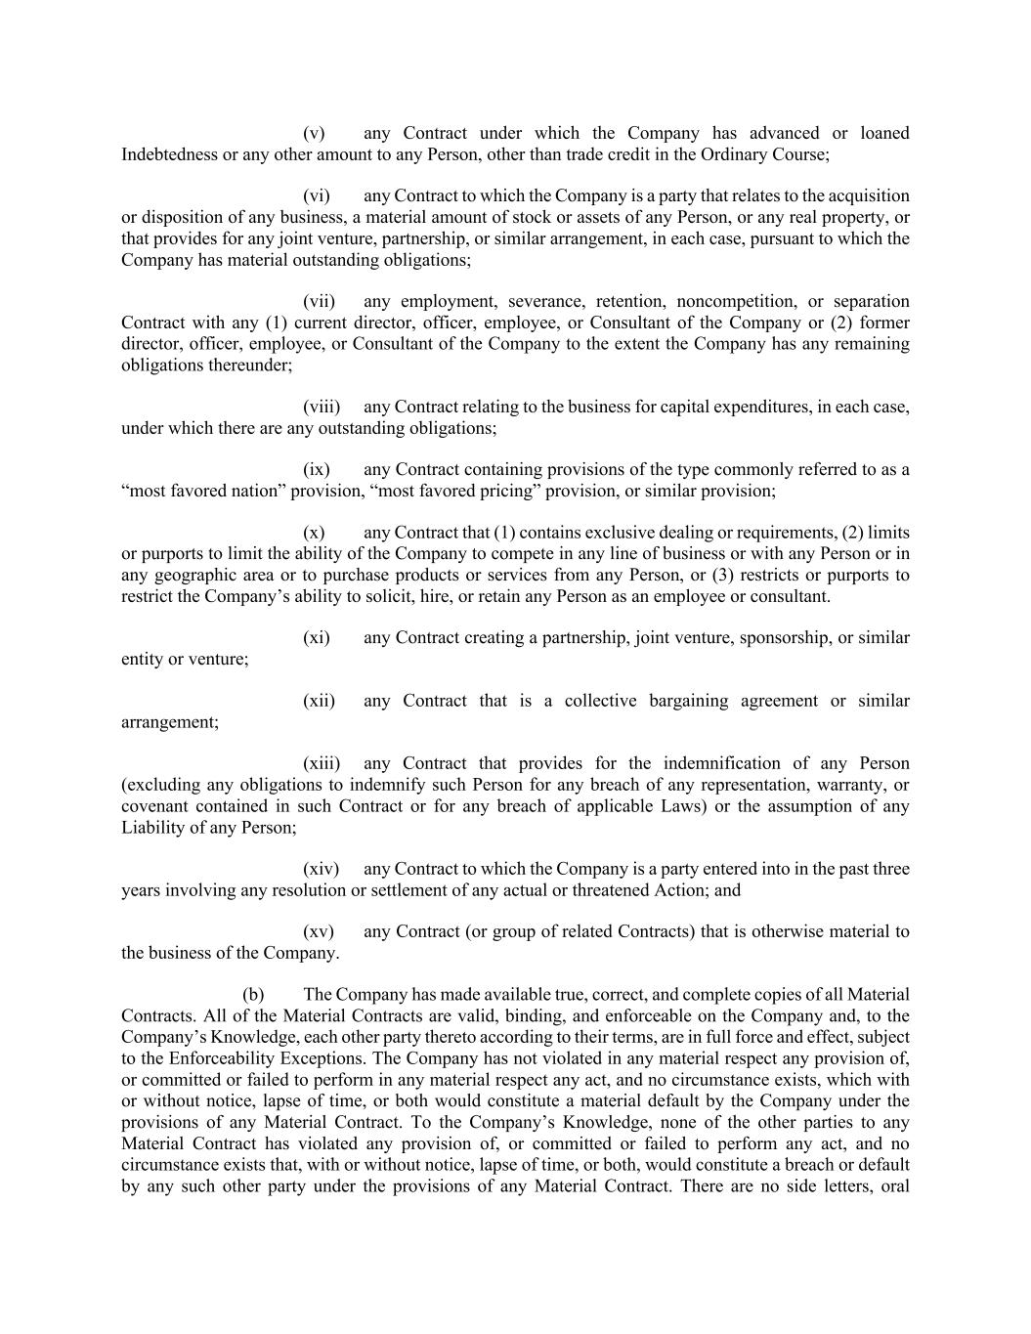
(v) any Contract under which the Company has advanced or loaned Indebtedness or any other amount to any Person, other than trade credit in the Ordinary Course; (vi) any Contract to which the Company is a party that relates to the acquisition or disposition of any business, a material amount of stock or assets of any Person, or any real property, or that provides for any joint venture, partnership, or similar arrangement, in each case, pursuant to which the Company has material outstanding obligations; (vii) any employment, severance, retention, noncompetition, or separation Contract with any (1) current director, officer, employee, or Consultant of the Company or (2) former director, officer, employee, or Consultant of the Company to the extent the Company has any remaining obligations thereunder; (viii) any Contract relating to the business for capital expenditures, in each case, under which there are any outstanding obligations; (ix) any Contract containing provisions of the type commonly referred to as a “most favored nation” provision, “most favored pricing” provision, or similar provision; (x) any Contract that (1) contains exclusive dealing or requirements, (2) limits or purports to limit the ability of the Company to compete in any line of business or with any Person or in any geographic area or to purchase products or services from any Person, or (3) restricts or purports to restrict the Company’s ability to solicit, hire, or retain any Person as an employee or consultant. (xi) any Contract creating a partnership, joint venture, sponsorship, or similar entity or venture; (xii) any Contract that is a collective bargaining agreement or similar arrangement; (xiii) any Contract that provides for the indemnification of any Person (excluding any obligations to indemnify such Person for any breach of any representation, warranty, or covenant contained in such Contract or for any breach of applicable Laws) or the assumption of any Liability of any Person; (xiv) any Contract to which the Company is a party entered into in the past three years involving any resolution or settlement of any actual or threatened Action; and (xv) any Contract (or group of related Contracts) that is otherwise material to the business of the Company. (b) The Company has made available true, correct, and complete copies of all Material Contracts. All of the Material Contracts are valid, binding, and enforceable on the Company and, to the Company’s Knowledge, each other party thereto according to their terms, are in full force and effect, subject to the Enforceability Exceptions. The Company has not violated in any material respect any provision of, or committed or failed to perform in any material respect any act, and no circumstance exists, which with or without notice, lapse of time, or both would constitute a material default by the Company under the provisions of any Material Contract. To the Company’s Knowledge, none of the other parties to any Material Contract has violated any provision of, or committed or failed to perform any act, and no circumstance exists that, with or without notice, lapse of time, or both, would constitute a breach or default by any such other party under the provisions of any Material Contract. There are no side letters, oral

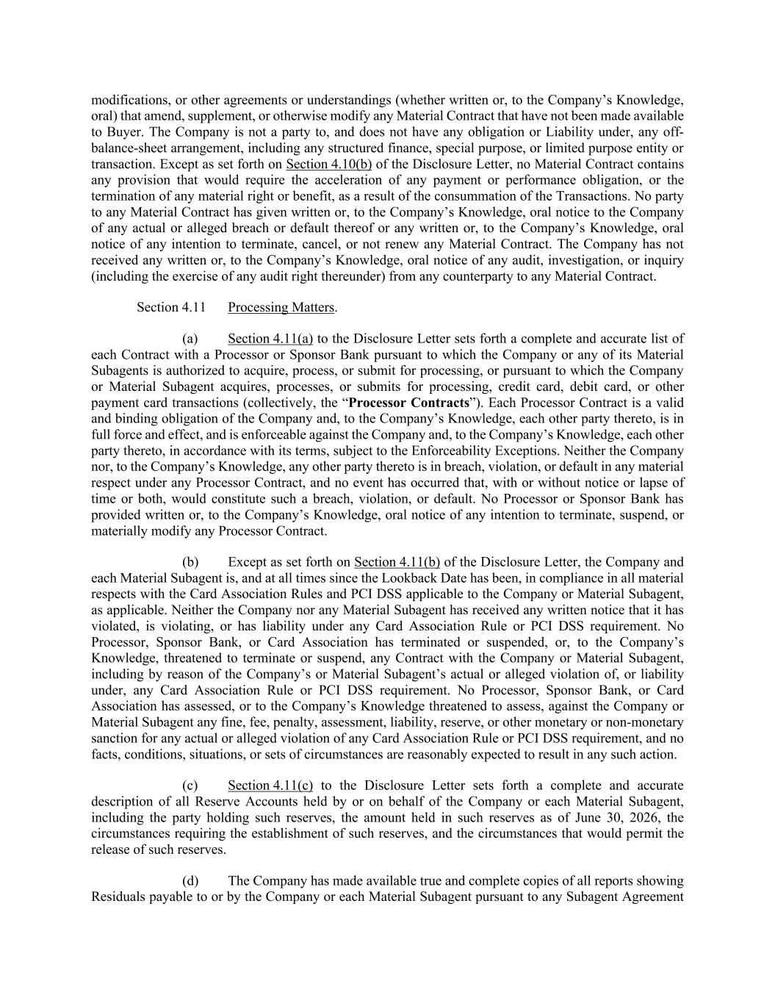
modifications, or other agreements or understandings (whether written or, to the Company’s Knowledge, oral) that amend, supplement, or otherwise modify any Material Contract that have not been made available to Buyer. The Company is not a party to, and does not have any obligation or Liability under, any off- balance-sheet arrangement, including any structured finance, special purpose, or limited purpose entity or transaction. Except as set forth on Section 4.10(b) of the Disclosure Letter, no Material Contract contains any provision that would require the acceleration of any payment or performance obligation, or the termination of any material right or benefit, as a result of the consummation of the Transactions. No party to any Material Contract has given written or, to the Company’s Knowledge, oral notice to the Company of any actual or alleged breach or default thereof or any written or, to the Company’s Knowledge, oral notice of any intention to terminate, cancel, or not renew any Material Contract. The Company has not received any written or, to the Company’s Knowledge, oral notice of any audit, investigation, or inquiry (including the exercise of any audit right thereunder) from any counterparty to any Material Contract. Section 4.11 Processing Matters. (a) Section 4.11(a) to the Disclosure Letter sets forth a complete and accurate list of each Contract with a Processor or Sponsor Bank pursuant to which the Company or any of its Material Subagents is authorized to acquire, process, or submit for processing, or pursuant to which the Company or Material Subagent acquires, processes, or submits for processing, credit card, debit card, or other payment card transactions (collectively, the “Processor Contracts”). Each Processor Contract is a valid and binding obligation of the Company and, to the Company’s Knowledge, each other party thereto, is in full force and effect, and is enforceable against the Company and, to the Company’s Knowledge, each other party thereto, in accordance with its terms, subject to the Enforceability Exceptions. Neither the Company nor, to the Company’s Knowledge, any other party thereto is in breach, violation, or default in any material respect under any Processor Contract, and no event has occurred that, with or without notice or lapse of time or both, would constitute such a breach, violation, or default. No Processor or Sponsor Bank has provided written or, to the Company’s Knowledge, oral notice of any intention to terminate, suspend, or materially modify any Processor Contract. (b) Except as set forth on Section 4.11(b) of the Disclosure Letter, the Company and each Material Subagent is, and at all times since the Lookback Date has been, in compliance in all material respects with the Card Association Rules and PCI DSS applicable to the Company or Material Subagent, as applicable. Neither the Company nor any Material Subagent has received any written notice that it has violated, is violating, or has liability under any Card Association Rule or PCI DSS requirement. No Processor, Sponsor Bank, or Card Association has terminated or suspended, or, to the Company’s Knowledge, threatened to terminate or suspend, any Contract with the Company or Material Subagent, including by reason of the Company’s or Material Subagent’s actual or alleged violation of, or liability under, any Card Association Rule or PCI DSS requirement. No Processor, Sponsor Bank, or Card Association has assessed, or to the Company’s Knowledge threatened to assess, against the Company or Material Subagent any fine, fee, penalty, assessment, liability, reserve, or other monetary or non-monetary sanction for any actual or alleged violation of any Card Association Rule or PCI DSS requirement, and no facts, conditions, situations, or sets of circumstances are reasonably expected to result in any such action. (c) Section 4.11(c) to the Disclosure Letter sets forth a complete and accurate description of all Reserve Accounts held by or on behalf of the Company or each Material Subagent, including the party holding such reserves, the amount held in such reserves as of June 30, 2026, the circumstances requiring the establishment of such reserves, and the circumstances that would permit the release of such reserves. (d) The Company has made available true and complete copies of all reports showing Residuals payable to or by the Company or each Material Subagent pursuant to any Subagent Agreement

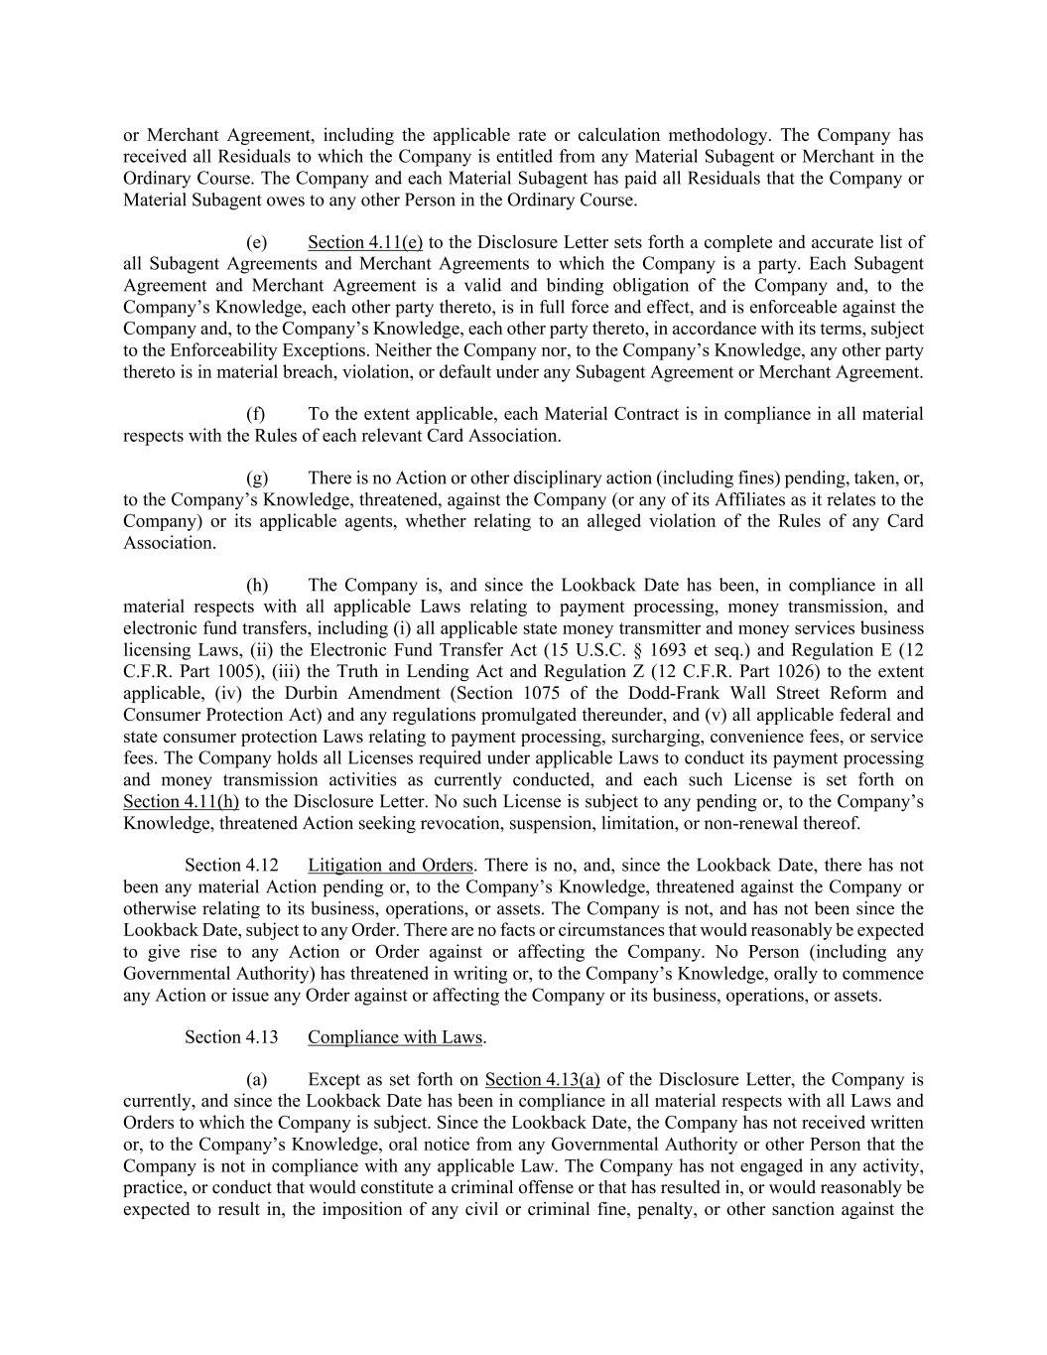
or Merchant Agreement, including the applicable rate or calculation methodology. The Company has received all Residuals to which the Company is entitled from any Material Subagent or Merchant in the Ordinary Course. The Company and each Material Subagent has paid all Residuals that the Company or Material Subagent owes to any other Person in the Ordinary Course. (e) Section 4.11(e) to the Disclosure Letter sets forth a complete and accurate list of all Subagent Agreements and Merchant Agreements to which the Company is a party. Each Subagent Agreement and Merchant Agreement is a valid and binding obligation of the Company and, to the Company’s Knowledge, each other party thereto, is in full force and effect, and is enforceable against the Company and, to the Company’s Knowledge, each other party thereto, in accordance with its terms, subject to the Enforceability Exceptions. Neither the Company nor, to the Company’s Knowledge, any other party thereto is in material breach, violation, or default under any Subagent Agreement or Merchant Agreement. (f) To the extent applicable, each Material Contract is in compliance in all material respects with the Rules of each relevant Card Association. (g) There is no Action or other disciplinary action (including fines) pending, taken, or, to the Company’s Knowledge, threatened, against the Company (or any of its Affiliates as it relates to the Company) or its applicable agents, whether relating to an alleged violation of the Rules of any Card Association. (h) The Company is, and since the Lookback Date has been, in compliance in all material respects with all applicable Laws relating to payment processing, money transmission, and electronic fund transfers, including (i) all applicable state money transmitter and money services business licensing Laws, (ii) the Electronic Fund Transfer Act (15 U.S.C. § 1693 et seq.) and Regulation E (12 C.F.R. Part 1005), (iii) the Truth in Lending Act and Regulation Z (12 C.F.R. Part 1026) to the extent applicable, (iv) the Durbin Amendment (Section 1075 of the Dodd-Frank Wall Street Reform and Consumer Protection Act) and any regulations promulgated thereunder, and (v) all applicable federal and state consumer protection Laws relating to payment processing, surcharging, convenience fees, or service fees. The Company holds all Licenses required under applicable Laws to conduct its payment processing and money transmission activities as currently conducted, and each such License is set forth on Section 4.11(h) to the Disclosure Letter. No such License is subject to any pending or, to the Company’s Knowledge, threatened Action seeking revocation, suspension, limitation, or non-renewal thereof. Section 4.12 Litigation and Orders. There is no, and, since the Lookback Date, there has not been any material Action pending or, to the Company’s Knowledge, threatened against the Company or otherwise relating to its business, operations, or assets. The Company is not, and has not been since the Lookback Date, subject to any Order. There are no facts or circumstances that would reasonably be expected to give rise to any Action or Order against or affecting the Company. No Person (including any Governmental Authority) has threatened in writing or, to the Company’s Knowledge, orally to commence any Action or issue any Order against or affecting the Company or its business, operations, or assets. Section 4.13 Compliance with Laws. (a) Except as set forth on Section 4.13(a) of the Disclosure Letter, the Company is currently, and since the Lookback Date has been in compliance in all material respects with all Laws and Orders to which the Company is subject. Since the Lookback Date, the Company has not received written or, to the Company’s Knowledge, oral notice from any Governmental Authority or other Person that the Company is not in compliance with any applicable Law. The Company has not engaged in any activity, practice, or conduct that would constitute a criminal offense or that has resulted in, or would reasonably be expected to result in, the imposition of any civil or criminal fine, penalty, or other sanction against the

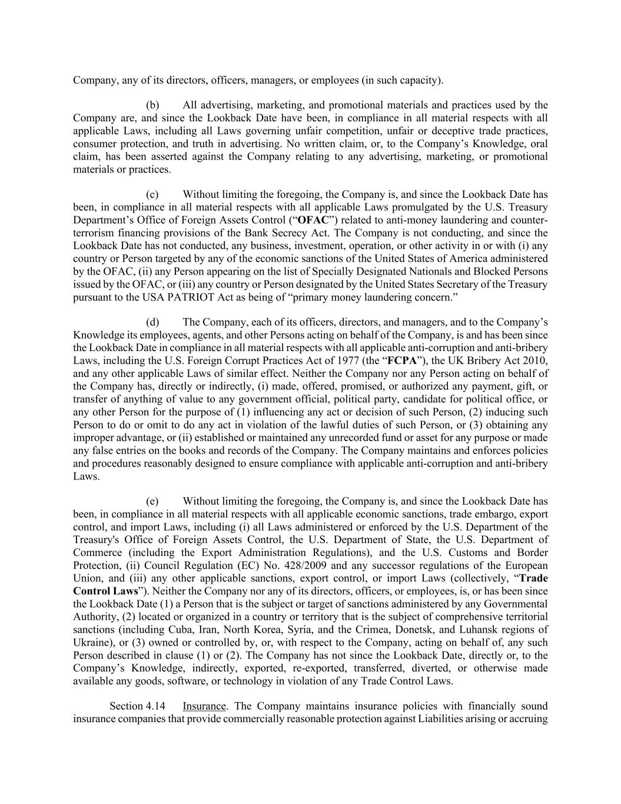
Company, any of its directors, officers, managers, or employees (in such capacity). (b) All advertising, marketing, and promotional materials and practices used by the Company are, and since the Lookback Date have been, in compliance in all material respects with all applicable Laws, including all Laws governing unfair competition, unfair or deceptive trade practices, consumer protection, and truth in advertising. No written claim, or, to the Company’s Knowledge, oral claim, has been asserted against the Company relating to any advertising, marketing, or promotional materials or practices. (c) Without limiting the foregoing, the Company is, and since the Lookback Date has been, in compliance in all material respects with all applicable Laws promulgated by the U.S. Treasury Department’s Office of Foreign Assets Control (“OFAC”) related to anti-money laundering and counter- terrorism financing provisions of the Bank Secrecy Act. The Company is not conducting, and since the Lookback Date has not conducted, any business, investment, operation, or other activity in or with (i) any country or Person targeted by any of the economic sanctions of the United States of America administered by the OFAC, (ii) any Person appearing on the list of Specially Designated Nationals and Blocked Persons issued by the OFAC, or (iii) any country or Person designated by the United States Secretary of the Treasury pursuant to the USA PATRIOT Act as being of “primary money laundering concern.” (d) The Company, each of its officers, directors, and managers, and to the Company’s Knowledge its employees, agents, and other Persons acting on behalf of the Company, is and has been since the Lookback Date in compliance in all material respects with all applicable anti-corruption and anti-bribery Laws, including the U.S. Foreign Corrupt Practices Act of 1977 (the “FCPA”), the UK Bribery Act 2010, and any other applicable Laws of similar effect. Neither the Company nor any Person acting on behalf of the Company has, directly or indirectly, (i) made, offered, promised, or authorized any payment, gift, or transfer of anything of value to any government official, political party, candidate for political office, or any other Person for the purpose of (1) influencing any act or decision of such Person, (2) inducing such Person to do or omit to do any act in violation of the lawful duties of such Person, or (3) obtaining any improper advantage, or (ii) established or maintained any unrecorded fund or asset for any purpose or made any false entries on the books and records of the Company. The Company maintains and enforces policies and procedures reasonably designed to ensure compliance with applicable anti-corruption and anti-bribery Laws. (e) Without limiting the foregoing, the Company is, and since the Lookback Date has been, in compliance in all material respects with all applicable economic sanctions, trade embargo, export control, and import Laws, including (i) all Laws administered or enforced by the U.S. Department of the Treasury's Office of Foreign Assets Control, the U.S. Department of State, the U.S. Department of Commerce (including the Export Administration Regulations), and the U.S. Customs and Border Protection, (ii) Council Regulation (EC) No. 428/2009 and any successor regulations of the European Union, and (iii) any other applicable sanctions, export control, or import Laws (collectively, “Trade Control Laws”). Neither the Company nor any of its directors, officers, or employees, is, or has been since the Lookback Date (1) a Person that is the subject or target of sanctions administered by any Governmental Authority, (2) located or organized in a country or territory that is the subject of comprehensive territorial sanctions (including Cuba, Iran, North Korea, Syria, and the Crimea, Donetsk, and Luhansk regions of Ukraine), or (3) owned or controlled by, or, with respect to the Company, acting on behalf of, any such Person described in clause (1) or (2). The Company has not since the Lookback Date, directly or, to the Company’s Knowledge, indirectly, exported, re-exported, transferred, diverted, or otherwise made available any goods, software, or technology in violation of any Trade Control Laws. Section 4.14 Insurance. The Company maintains insurance policies with financially sound insurance companies that provide commercially reasonable protection against Liabilities arising or accruing

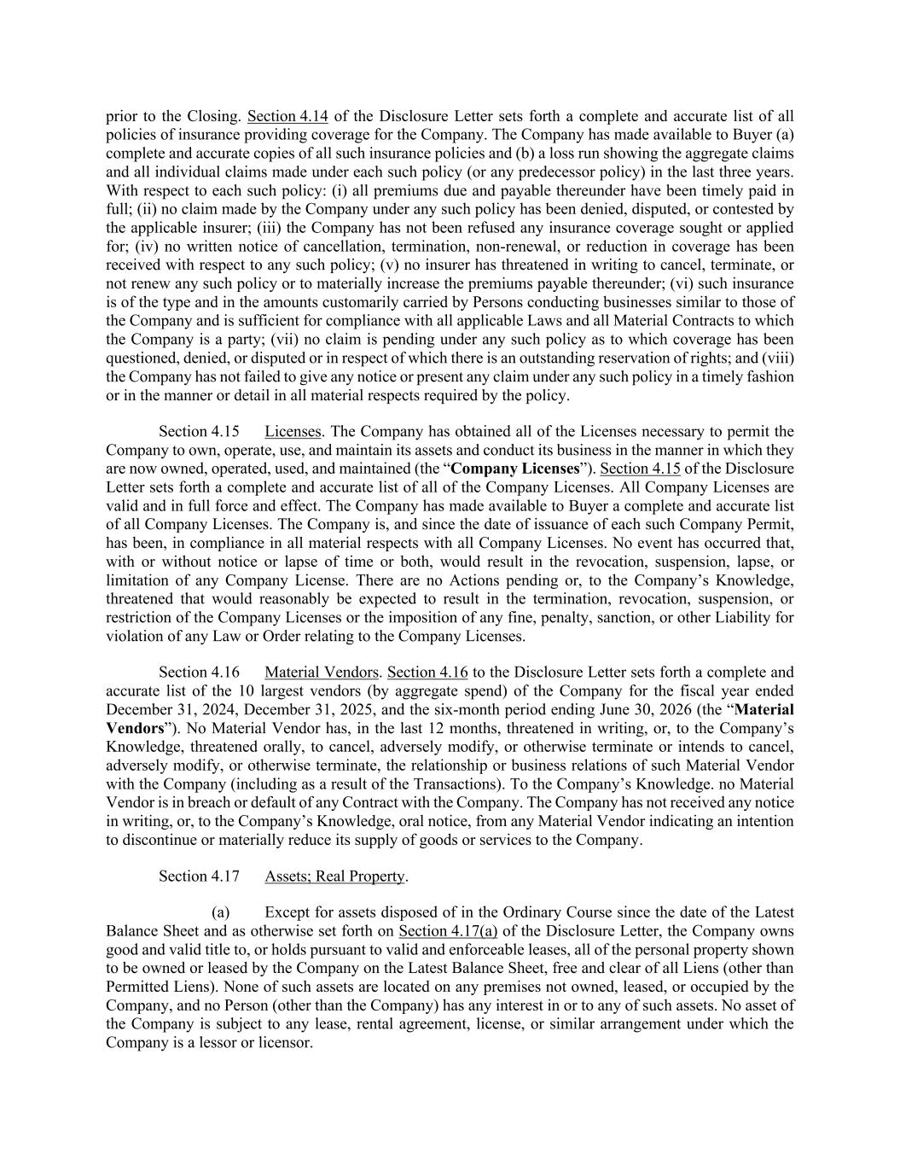
prior to the Closing. Section 4.14 of the Disclosure Letter sets forth a complete and accurate list of all policies of insurance providing coverage for the Company. The Company has made available to Buyer (a) complete and accurate copies of all such insurance policies and (b) a loss run showing the aggregate claims and all individual claims made under each such policy (or any predecessor policy) in the last three years. With respect to each such policy: (i) all premiums due and payable thereunder have been timely paid in full; (ii) no claim made by the Company under any such policy has been denied, disputed, or contested by the applicable insurer; (iii) the Company has not been refused any insurance coverage sought or applied for; (iv) no written notice of cancellation, termination, non-renewal, or reduction in coverage has been received with respect to any such policy; (v) no insurer has threatened in writing to cancel, terminate, or not renew any such policy or to materially increase the premiums payable thereunder; (vi) such insurance is of the type and in the amounts customarily carried by Persons conducting businesses similar to those of the Company and is sufficient for compliance with all applicable Laws and all Material Contracts to which the Company is a party; (vii) no claim is pending under any such policy as to which coverage has been questioned, denied, or disputed or in respect of which there is an outstanding reservation of rights; and (viii) the Company has not failed to give any notice or present any claim under any such policy in a timely fashion or in the manner or detail in all material respects required by the policy. Section 4.15 Licenses. The Company has obtained all of the Licenses necessary to permit the Company to own, operate, use, and maintain its assets and conduct its business in the manner in which they are now owned, operated, used, and maintained (the “Company Licenses”). Section 4.15 of the Disclosure Letter sets forth a complete and accurate list of all of the Company Licenses. All Company Licenses are valid and in full force and effect. The Company has made available to Buyer a complete and accurate list of all Company Licenses. The Company is, and since the date of issuance of each such Company Permit, has been, in compliance in all material respects with all Company Licenses. No event has occurred that, with or without notice or lapse of time or both, would result in the revocation, suspension, lapse, or limitation of any Company License. There are no Actions pending or, to the Company’s Knowledge, threatened that would reasonably be expected to result in the termination, revocation, suspension, or restriction of the Company Licenses or the imposition of any fine, penalty, sanction, or other Liability for violation of any Law or Order relating to the Company Licenses. Section 4.16 Material Vendors. Section 4.16 to the Disclosure Letter sets forth a complete and accurate list of the 10 largest vendors (by aggregate spend) of the Company for the fiscal year ended December 31, 2024, December 31, 2025, and the six-month period ending June 30, 2026 (the “Material Vendors”). No Material Vendor has, in the last 12 months, threatened in writing, or, to the Company’s Knowledge, threatened orally, to cancel, adversely modify, or otherwise terminate or intends to cancel, adversely modify, or otherwise terminate, the relationship or business relations of such Material Vendor with the Company (including as a result of the Transactions). To the Company’s Knowledge. no Material Vendor is in breach or default of any Contract with the Company. The Company has not received any notice in writing, or, to the Company’s Knowledge, oral notice, from any Material Vendor indicating an intention to discontinue or materially reduce its supply of goods or services to the Company. Section 4.17 Assets; Real Property. (a) Except for assets disposed of in the Ordinary Course since the date of the Latest Balance Sheet and as otherwise set forth on Section 4.17(a) of the Disclosure Letter, the Company owns good and valid title to, or holds pursuant to valid and enforceable leases, all of the personal property shown to be owned or leased by the Company on the Latest Balance Sheet, free and clear of all Liens (other than Permitted Liens). None of such assets are located on any premises not owned, leased, or occupied by the Company, and no Person (other than the Company) has any interest in or to any of such assets. No asset of the Company is subject to any lease, rental agreement, license, or similar arrangement under which the Company is a lessor or licensor.

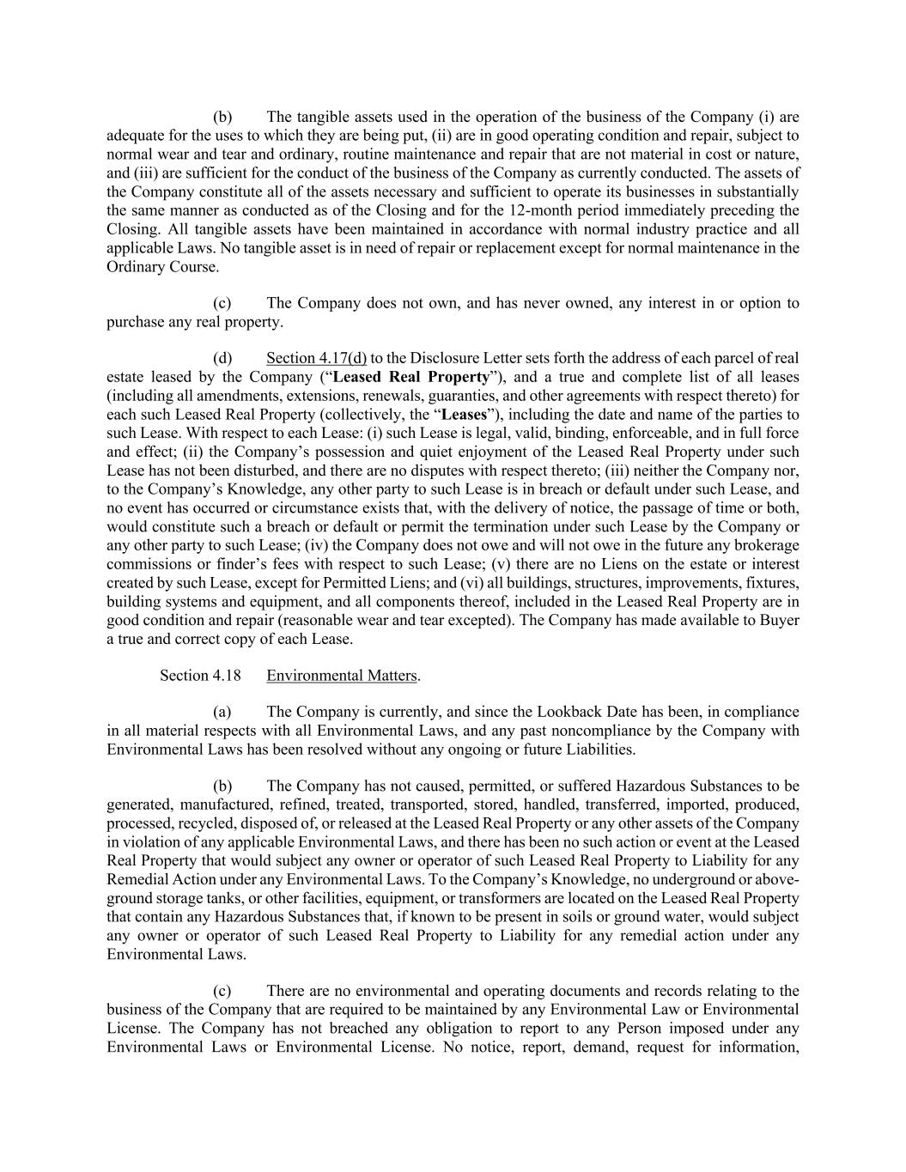
(b) The tangible assets used in the operation of the business of the Company (i) are adequate for the uses to which they are being put, (ii) are in good operating condition and repair, subject to normal wear and tear and ordinary, routine maintenance and repair that are not material in cost or nature, and (iii) are sufficient for the conduct of the business of the Company as currently conducted. The assets of the Company constitute all of the assets necessary and sufficient to operate its businesses in substantially the same manner as conducted as of the Closing and for the 12-month period immediately preceding the Closing. All tangible assets have been maintained in accordance with normal industry practice and all applicable Laws. No tangible asset is in need of repair or replacement except for normal maintenance in the Ordinary Course. (c) The Company does not own, and has never owned, any interest in or option to purchase any real property. (d) Section 4.17(d) to the Disclosure Letter sets forth the address of each parcel of real estate leased by the Company (“Leased Real Property”), and a true and complete list of all leases (including all amendments, extensions, renewals, guaranties, and other agreements with respect thereto) for each such Leased Real Property (collectively, the “Leases”), including the date and name of the parties to such Lease. With respect to each Lease: (i) such Lease is legal, valid, binding, enforceable, and in full force and effect; (ii) the Company’s possession and quiet enjoyment of the Leased Real Property under such Lease has not been disturbed, and there are no disputes with respect thereto; (iii) neither the Company nor, to the Company’s Knowledge, any other party to such Lease is in breach or default under such Lease, and no event has occurred or circumstance exists that, with the delivery of notice, the passage of time or both, would constitute such a breach or default or permit the termination under such Lease by the Company or any other party to such Lease; (iv) the Company does not owe and will not owe in the future any brokerage commissions or finder’s fees with respect to such Lease; (v) there are no Liens on the estate or interest created by such Lease, except for Permitted Liens; and (vi) all buildings, structures, improvements, fixtures, building systems and equipment, and all components thereof, included in the Leased Real Property are in good condition and repair (reasonable wear and tear excepted). The Company has made available to Buyer a true and correct copy of each Lease. Section 4.18 Environmental Matters. (a) The Company is currently, and since the Lookback Date has been, in compliance in all material respects with all Environmental Laws, and any past noncompliance by the Company with Environmental Laws has been resolved without any ongoing or future Liabilities. (b) The Company has not caused, permitted, or suffered Hazardous Substances to be generated, manufactured, refined, treated, transported, stored, handled, transferred, imported, produced, processed, recycled, disposed of, or released at the Leased Real Property or any other assets of the Company in violation of any applicable Environmental Laws, and there has been no such action or event at the Leased Real Property that would subject any owner or operator of such Leased Real Property to Liability for any Remedial Action under any Environmental Laws. To the Company’s Knowledge, no underground or above- ground storage tanks, or other facilities, equipment, or transformers are located on the Leased Real Property that contain any Hazardous Substances that, if known to be present in soils or ground water, would subject any owner or operator of such Leased Real Property to Liability for any remedial action under any Environmental Laws. (c) There are no environmental and operating documents and records relating to the business of the Company that are required to be maintained by any Environmental Law or Environmental License. The Company has not breached any obligation to report to any Person imposed under any Environmental Laws or Environmental License. No notice, report, demand, request for information,

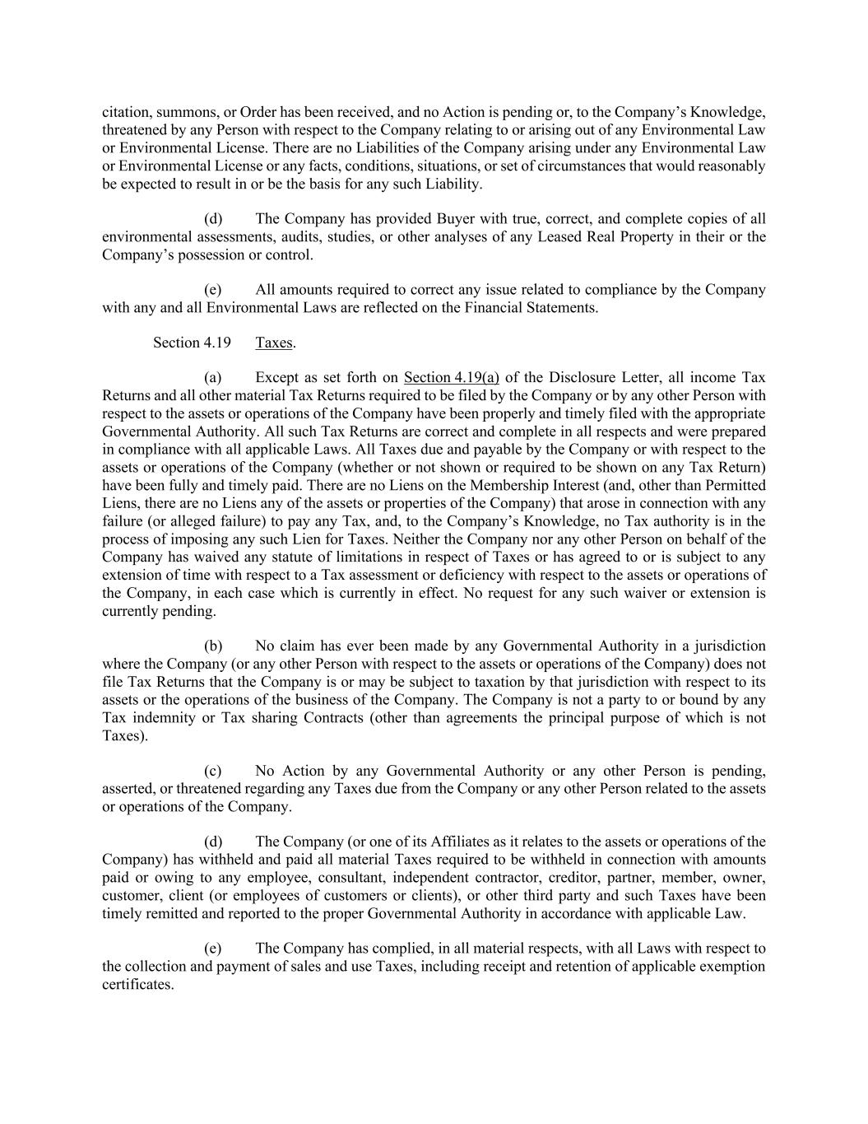
citation, summons, or Order has been received, and no Action is pending or, to the Company’s Knowledge, threatened by any Person with respect to the Company relating to or arising out of any Environmental Law or Environmental License. There are no Liabilities of the Company arising under any Environmental Law or Environmental License or any facts, conditions, situations, or set of circumstances that would reasonably be expected to result in or be the basis for any such Liability. (d) The Company has provided Buyer with true, correct, and complete copies of all environmental assessments, audits, studies, or other analyses of any Leased Real Property in their or the Company’s possession or control. (e) All amounts required to correct any issue related to compliance by the Company with any and all Environmental Laws are reflected on the Financial Statements. Section 4.19 Taxes. (a) Except as set forth on Section 4.19(a) of the Disclosure Letter, all income Tax Returns and all other material Tax Returns required to be filed by the Company or by any other Person with respect to the assets or operations of the Company have been properly and timely filed with the appropriate Governmental Authority. All such Tax Returns are correct and complete in all respects and were prepared in compliance with all applicable Laws. All Taxes due and payable by the Company or with respect to the assets or operations of the Company (whether or not shown or required to be shown on any Tax Return) have been fully and timely paid. There are no Liens on the Membership Interest (and, other than Permitted Liens, there are no Liens any of the assets or properties of the Company) that arose in connection with any failure (or alleged failure) to pay any Tax, and, to the Company’s Knowledge, no Tax authority is in the process of imposing any such Lien for Taxes. Neither the Company nor any other Person on behalf of the Company has waived any statute of limitations in respect of Taxes or has agreed to or is subject to any extension of time with respect to a Tax assessment or deficiency with respect to the assets or operations of the Company, in each case which is currently in effect. No request for any such waiver or extension is currently pending. (b) No claim has ever been made by any Governmental Authority in a jurisdiction where the Company (or any other Person with respect to the assets or operations of the Company) does not file Tax Returns that the Company is or may be subject to taxation by that jurisdiction with respect to its assets or the operations of the business of the Company. The Company is not a party to or bound by any Tax indemnity or Tax sharing Contracts (other than agreements the principal purpose of which is not Taxes). (c) No Action by any Governmental Authority or any other Person is pending, asserted, or threatened regarding any Taxes due from the Company or any other Person related to the assets or operations of the Company. (d) The Company (or one of its Affiliates as it relates to the assets or operations of the Company) has withheld and paid all material Taxes required to be withheld in connection with amounts paid or owing to any employee, consultant, independent contractor, creditor, partner, member, owner, customer, client (or employees of customers or clients), or other third party and such Taxes have been timely remitted and reported to the proper Governmental Authority in accordance with applicable Law. (e) The Company has complied, in all material respects, with all Laws with respect to the collection and payment of sales and use Taxes, including receipt and retention of applicable exemption certificates.

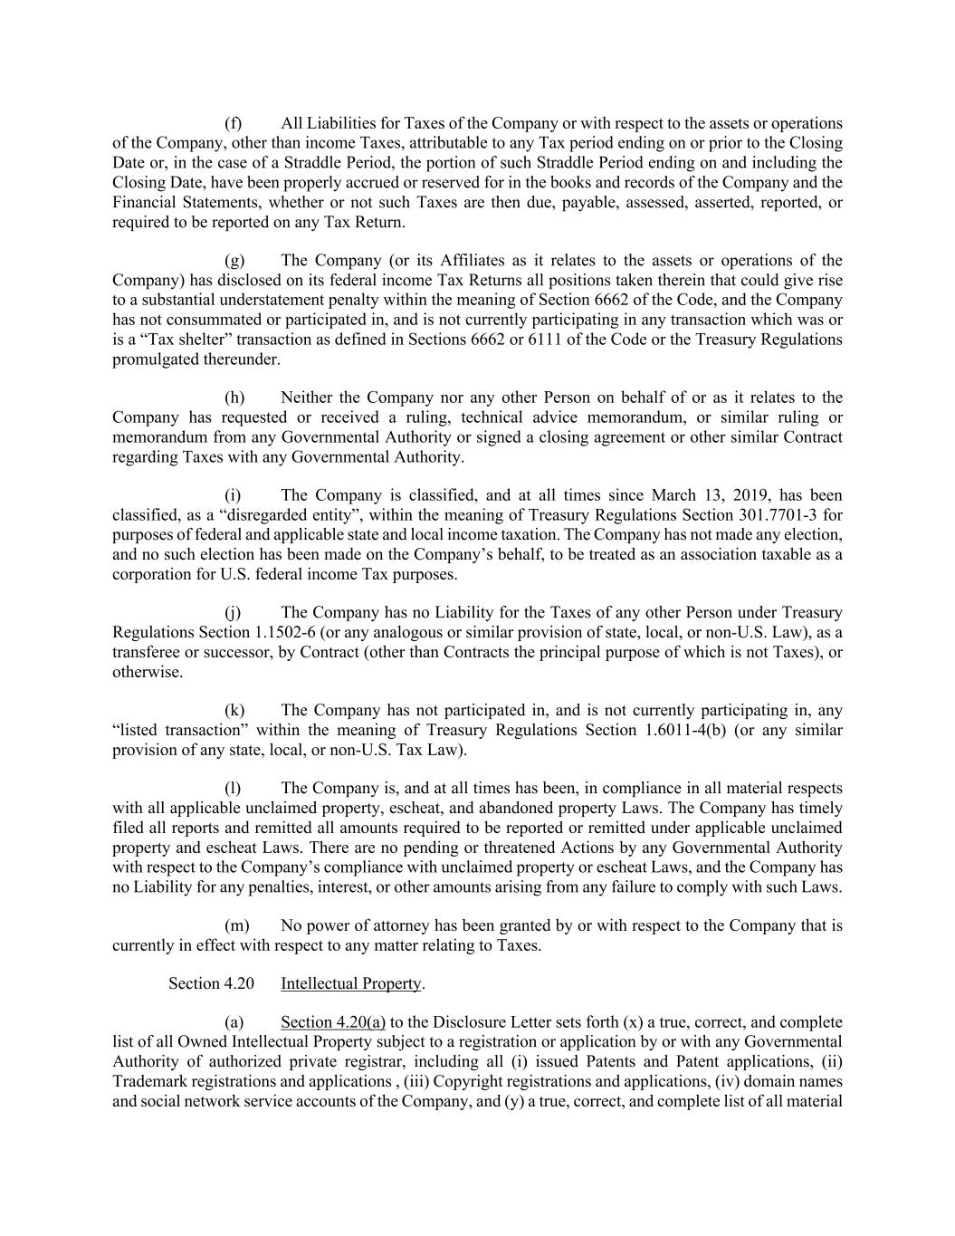
(f) All Liabilities for Taxes of the Company or with respect to the assets or operations of the Company, other than income Taxes, attributable to any Tax period ending on or prior to the Closing Date or, in the case of a Straddle Period, the portion of such Straddle Period ending on and including the Closing Date, have been properly accrued or reserved for in the books and records of the Company and the Financial Statements, whether or not such Taxes are then due, payable, assessed, asserted, reported, or required to be reported on any Tax Return. (g) The Company (or its Affiliates as it relates to the assets or operations of the Company) has disclosed on its federal income Tax Returns all positions taken therein that could give rise to a substantial understatement penalty within the meaning of Section 6662 of the Code, and the Company has not consummated or participated in, and is not currently participating in any transaction which was or is a “Tax shelter” transaction as defined in Sections 6662 or 6111 of the Code or the Treasury Regulations promulgated thereunder. (h) Neither the Company nor any other Person on behalf of or as it relates to the Company has requested or received a ruling, technical advice memorandum, or similar ruling or memorandum from any Governmental Authority or signed a closing agreement or other similar Contract regarding Taxes with any Governmental Authority. (i) The Company is classified, and at all times since March 13, 2019, has been classified, as a “disregarded entity”, within the meaning of Treasury Regulations Section 301.7701-3 for purposes of federal and applicable state and local income taxation. The Company has not made any election, and no such election has been made on the Company’s behalf, to be treated as an association taxable as a corporation for U.S. federal income Tax purposes. (j) The Company has no Liability for the Taxes of any other Person under Treasury Regulations Section 1.1502-6 (or any analogous or similar provision of state, local, or non-U.S. Law), as a transferee or successor, by Contract (other than Contracts the principal purpose of which is not Taxes), or otherwise. (k) The Company has not participated in, and is not currently participating in, any “listed transaction” within the meaning of Treasury Regulations Section 1.6011-4(b) (or any similar provision of any state, local, or non-U.S. Tax Law). (l) The Company is, and at all times has been, in compliance in all material respects with all applicable unclaimed property, escheat, and abandoned property Laws. The Company has timely filed all reports and remitted all amounts required to be reported or remitted under applicable unclaimed property and escheat Laws. There are no pending or threatened Actions by any Governmental Authority with respect to the Company’s compliance with unclaimed property or escheat Laws, and the Company has no Liability for any penalties, interest, or other amounts arising from any failure to comply with such Laws. (m) No power of attorney has been granted by or with respect to the Company that is currently in effect with respect to any matter relating to Taxes. Section 4.20 Intellectual Property. (a) Section 4.20(a) to the Disclosure Letter sets forth (x) a true, correct, and complete list of all Owned Intellectual Property subject to a registration or application by or with any Governmental Authority of authorized private registrar, including all (i) issued Patents and Patent applications, (ii) Trademark registrations and applications , (iii) Copyright registrations and applications, (iv) domain names and social network service accounts of the Company, and (y) a true, correct, and complete list of all material

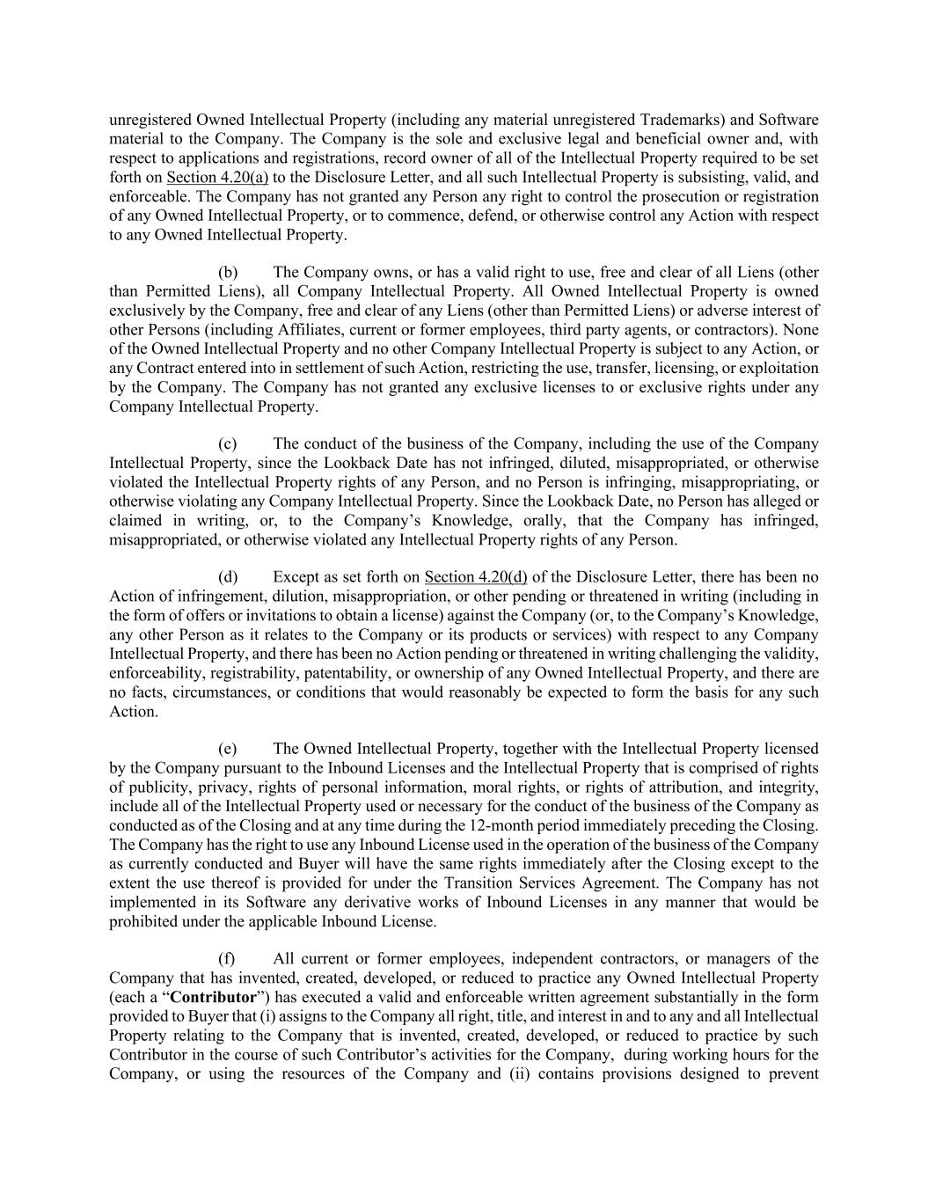
unregistered Owned Intellectual Property (including any material unregistered Trademarks) and Software material to the Company. The Company is the sole and exclusive legal and beneficial owner and, with respect to applications and registrations, record owner of all of the Intellectual Property required to be set forth on Section 4.20(a) to the Disclosure Letter, and all such Intellectual Property is subsisting, valid, and enforceable. The Company has not granted any Person any right to control the prosecution or registration of any Owned Intellectual Property, or to commence, defend, or otherwise control any Action with respect to any Owned Intellectual Property. (b) The Company owns, or has a valid right to use, free and clear of all Liens (other than Permitted Liens), all Company Intellectual Property. All Owned Intellectual Property is owned exclusively by the Company, free and clear of any Liens (other than Permitted Liens) or adverse interest of other Persons (including Affiliates, current or former employees, third party agents, or contractors). None of the Owned Intellectual Property and no other Company Intellectual Property is subject to any Action, or any Contract entered into in settlement of such Action, restricting the use, transfer, licensing, or exploitation by the Company. The Company has not granted any exclusive licenses to or exclusive rights under any Company Intellectual Property. (c) The conduct of the business of the Company, including the use of the Company Intellectual Property, since the Lookback Date has not infringed, diluted, misappropriated, or otherwise violated the Intellectual Property rights of any Person, and no Person is infringing, misappropriating, or otherwise violating any Company Intellectual Property. Since the Lookback Date, no Person has alleged or claimed in writing, or, to the Company’s Knowledge, orally, that the Company has infringed, misappropriated, or otherwise violated any Intellectual Property rights of any Person. (d) Except as set forth on Section 4.20(d) of the Disclosure Letter, there has been no Action of infringement, dilution, misappropriation, or other pending or threatened in writing (including in the form of offers or invitations to obtain a license) against the Company (or, to the Company’s Knowledge, any other Person as it relates to the Company or its products or services) with respect to any Company Intellectual Property, and there has been no Action pending or threatened in writing challenging the validity, enforceability, registrability, patentability, or ownership of any Owned Intellectual Property, and there are no facts, circumstances, or conditions that would reasonably be expected to form the basis for any such Action. (e) The Owned Intellectual Property, together with the Intellectual Property licensed by the Company pursuant to the Inbound Licenses and the Intellectual Property that is comprised of rights of publicity, privacy, rights of personal information, moral rights, or rights of attribution, and integrity, include all of the Intellectual Property used or necessary for the conduct of the business of the Company as conducted as of the Closing and at any time during the 12-month period immediately preceding the Closing. The Company has the right to use any Inbound License used in the operation of the business of the Company as currently conducted and Buyer will have the same rights immediately after the Closing except to the extent the use thereof is provided for under the Transition Services Agreement. The Company has not implemented in its Software any derivative works of Inbound Licenses in any manner that would be prohibited under the applicable Inbound License. (f) All current or former employees, independent contractors, or managers of the Company that has invented, created, developed, or reduced to practice any Owned Intellectual Property (each a “Contributor”) has executed a valid and enforceable written agreement substantially in the form provided to Buyer that (i) assigns to the Company all right, title, and interest in and to any and all Intellectual Property relating to the Company that is invented, created, developed, or reduced to practice by such Contributor in the course of such Contributor’s activities for the Company, during working hours for the Company, or using the resources of the Company and (ii) contains provisions designed to prevent

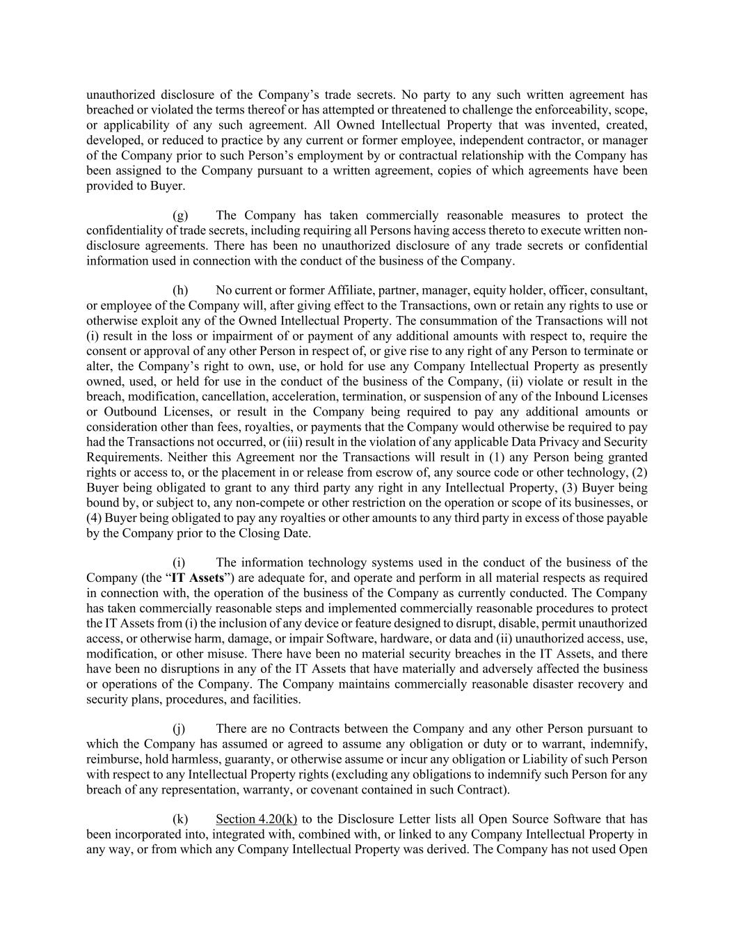
unauthorized disclosure of the Company’s trade secrets. No party to any such written agreement has breached or violated the terms thereof or has attempted or threatened to challenge the enforceability, scope, or applicability of any such agreement. All Owned Intellectual Property that was invented, created, developed, or reduced to practice by any current or former employee, independent contractor, or manager of the Company prior to such Person’s employment by or contractual relationship with the Company has been assigned to the Company pursuant to a written agreement, copies of which agreements have been provided to Buyer. (g) The Company has taken commercially reasonable measures to protect the confidentiality of trade secrets, including requiring all Persons having access thereto to execute written non- disclosure agreements. There has been no unauthorized disclosure of any trade secrets or confidential information used in connection with the conduct of the business of the Company. (h) No current or former Affiliate, partner, manager, equity holder, officer, consultant, or employee of the Company will, after giving effect to the Transactions, own or retain any rights to use or otherwise exploit any of the Owned Intellectual Property. The consummation of the Transactions will not (i) result in the loss or impairment of or payment of any additional amounts with respect to, require the consent or approval of any other Person in respect of, or give rise to any right of any Person to terminate or alter, the Company’s right to own, use, or hold for use any Company Intellectual Property as presently owned, used, or held for use in the conduct of the business of the Company, (ii) violate or result in the breach, modification, cancellation, acceleration, termination, or suspension of any of the Inbound Licenses or Outbound Licenses, or result in the Company being required to pay any additional amounts or consideration other than fees, royalties, or payments that the Company would otherwise be required to pay had the Transactions not occurred, or (iii) result in the violation of any applicable Data Privacy and Security Requirements. Neither this Agreement nor the Transactions will result in (1) any Person being granted rights or access to, or the placement in or release from escrow of, any source code or other technology, (2) Buyer being obligated to grant to any third party any right in any Intellectual Property, (3) Buyer being bound by, or subject to, any non-compete or other restriction on the operation or scope of its businesses, or (4) Buyer being obligated to pay any royalties or other amounts to any third party in excess of those payable by the Company prior to the Closing Date. (i) The information technology systems used in the conduct of the business of the Company (the “IT Assets”) are adequate for, and operate and perform in all material respects as required in connection with, the operation of the business of the Company as currently conducted. The Company has taken commercially reasonable steps and implemented commercially reasonable procedures to protect the IT Assets from (i) the inclusion of any device or feature designed to disrupt, disable, permit unauthorized access, or otherwise harm, damage, or impair Software, hardware, or data and (ii) unauthorized access, use, modification, or other misuse. There have been no material security breaches in the IT Assets, and there have been no disruptions in any of the IT Assets that have materially and adversely affected the business or operations of the Company. The Company maintains commercially reasonable disaster recovery and security plans, procedures, and facilities. (j) There are no Contracts between the Company and any other Person pursuant to which the Company has assumed or agreed to assume any obligation or duty or to warrant, indemnify, reimburse, hold harmless, guaranty, or otherwise assume or incur any obligation or Liability of such Person with respect to any Intellectual Property rights (excluding any obligations to indemnify such Person for any breach of any representation, warranty, or covenant contained in such Contract). (k) Section 4.20(k) to the Disclosure Letter lists all Open Source Software that has been incorporated into, integrated with, combined with, or linked to any Company Intellectual Property in any way, or from which any Company Intellectual Property was derived. The Company has not used Open

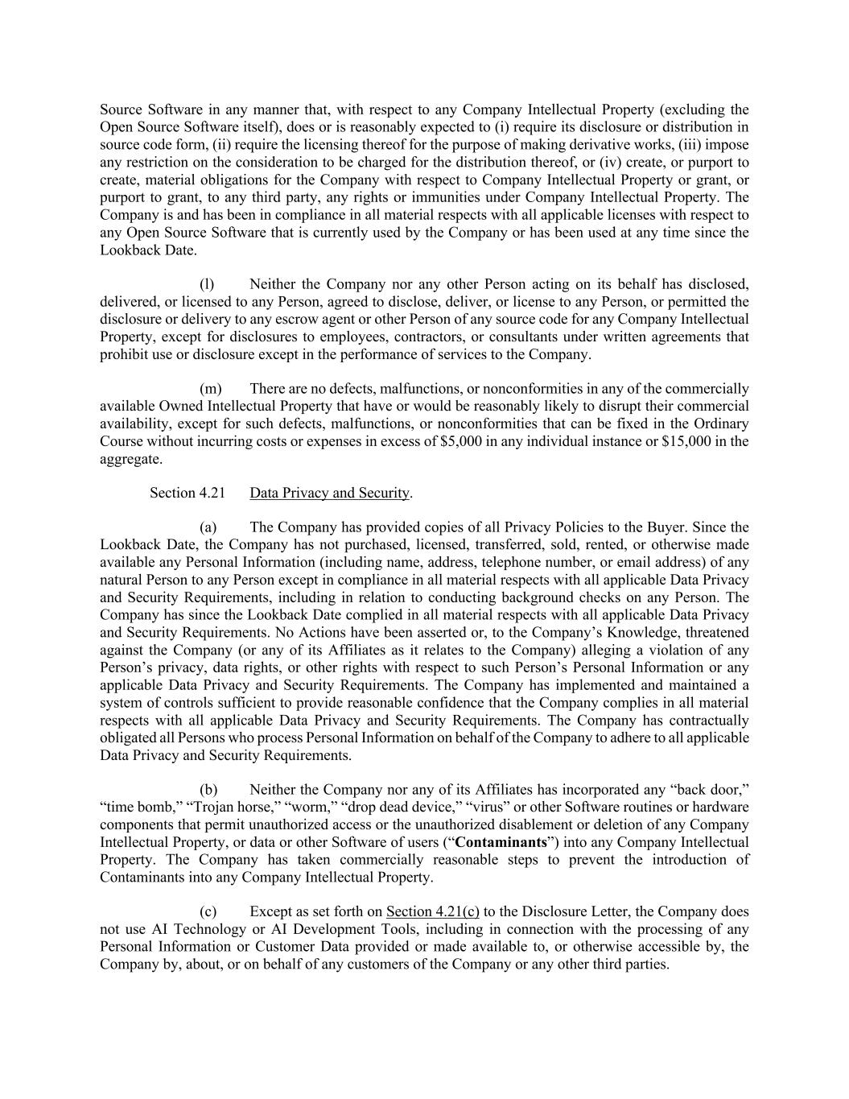
Source Software in any manner that, with respect to any Company Intellectual Property (excluding the Open Source Software itself), does or is reasonably expected to (i) require its disclosure or distribution in source code form, (ii) require the licensing thereof for the purpose of making derivative works, (iii) impose any restriction on the consideration to be charged for the distribution thereof, or (iv) create, or purport to create, material obligations for the Company with respect to Company Intellectual Property or grant, or purport to grant, to any third party, any rights or immunities under Company Intellectual Property. The Company is and has been in compliance in all material respects with all applicable licenses with respect to any Open Source Software that is currently used by the Company or has been used at any time since the Lookback Date. (l) Neither the Company nor any other Person acting on its behalf has disclosed, delivered, or licensed to any Person, agreed to disclose, deliver, or license to any Person, or permitted the disclosure or delivery to any escrow agent or other Person of any source code for any Company Intellectual Property, except for disclosures to employees, contractors, or consultants under written agreements that prohibit use or disclosure except in the performance of services to the Company. (m) There are no defects, malfunctions, or nonconformities in any of the commercially available Owned Intellectual Property that have or would be reasonably likely to disrupt their commercial availability, except for such defects, malfunctions, or nonconformities that can be fixed in the Ordinary Course without incurring costs or expenses in excess of $5,000 in any individual instance or $15,000 in the aggregate. Section 4.21 Data Privacy and Security. (a) The Company has provided copies of all Privacy Policies to the Buyer. Since the Lookback Date, the Company has not purchased, licensed, transferred, sold, rented, or otherwise made available any Personal Information (including name, address, telephone number, or email address) of any natural Person to any Person except in compliance in all material respects with all applicable Data Privacy and Security Requirements, including in relation to conducting background checks on any Person. The Company has since the Lookback Date complied in all material respects with all applicable Data Privacy and Security Requirements. No Actions have been asserted or, to the Company’s Knowledge, threatened against the Company (or any of its Affiliates as it relates to the Company) alleging a violation of any Person’s privacy, data rights, or other rights with respect to such Person’s Personal Information or any applicable Data Privacy and Security Requirements. The Company has implemented and maintained a system of controls sufficient to provide reasonable confidence that the Company complies in all material respects with all applicable Data Privacy and Security Requirements. The Company has contractually obligated all Persons who process Personal Information on behalf of the Company to adhere to all applicable Data Privacy and Security Requirements. (b) Neither the Company nor any of its Affiliates has incorporated any “back door,” “time bomb,” “Trojan horse,” “worm,” “drop dead device,” “virus” or other Software routines or hardware components that permit unauthorized access or the unauthorized disablement or deletion of any Company Intellectual Property, or data or other Software of users (“Contaminants”) into any Company Intellectual Property. The Company has taken commercially reasonable steps to prevent the introduction of Contaminants into any Company Intellectual Property. (c) Except as set forth on Section 4.21(c) to the Disclosure Letter, the Company does not use AI Technology or AI Development Tools, including in connection with the processing of any Personal Information or Customer Data provided or made available to, or otherwise accessible by, the Company by, about, or on behalf of any customers of the Company or any other third parties.

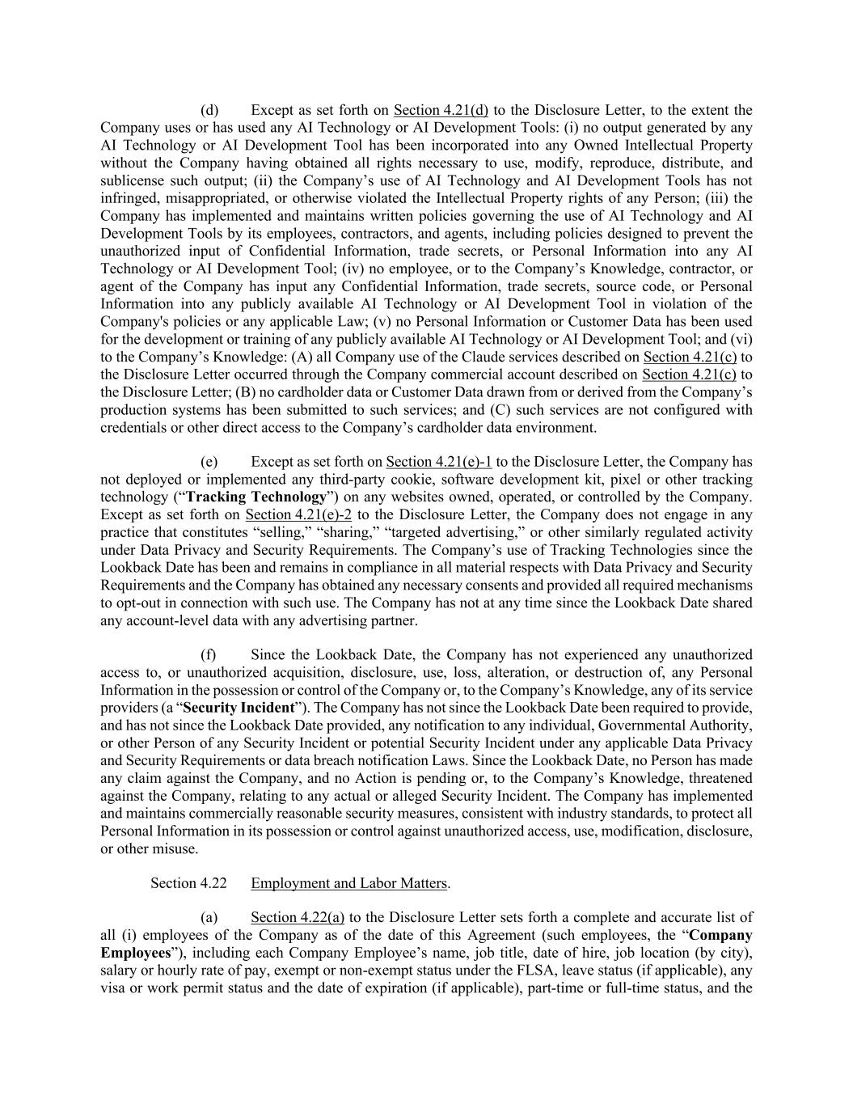
(d) Except as set forth on Section 4.21(d) to the Disclosure Letter, to the extent the Company uses or has used any AI Technology or AI Development Tools: (i) no output generated by any AI Technology or AI Development Tool has been incorporated into any Owned Intellectual Property without the Company having obtained all rights necessary to use, modify, reproduce, distribute, and sublicense such output; (ii) the Company’s use of AI Technology and AI Development Tools has not infringed, misappropriated, or otherwise violated the Intellectual Property rights of any Person; (iii) the Company has implemented and maintains written policies governing the use of AI Technology and AI Development Tools by its employees, contractors, and agents, including policies designed to prevent the unauthorized input of Confidential Information, trade secrets, or Personal Information into any AI Technology or AI Development Tool; (iv) no employee, or to the Company’s Knowledge, contractor, or agent of the Company has input any Confidential Information, trade secrets, source code, or Personal Information into any publicly available AI Technology or AI Development Tool in violation of the Company's policies or any applicable Law; (v) no Personal Information or Customer Data has been used for the development or training of any publicly available AI Technology or AI Development Tool; and (vi) to the Company’s Knowledge: (A) all Company use of the Claude services described on Section 4.21(c) to the Disclosure Letter occurred through the Company commercial account described on Section 4.21(c) to the Disclosure Letter; (B) no cardholder data or Customer Data drawn from or derived from the Company’s production systems has been submitted to such services; and (C) such services are not configured with credentials or other direct access to the Company’s cardholder data environment. (e) Except as set forth on Section 4.21(e)-1 to the Disclosure Letter, the Company has not deployed or implemented any third-party cookie, software development kit, pixel or other tracking technology (“Tracking Technology”) on any websites owned, operated, or controlled by the Company. Except as set forth on Section 4.21(e)-2 to the Disclosure Letter, the Company does not engage in any practice that constitutes “selling,” “sharing,” “targeted advertising,” or other similarly regulated activity under Data Privacy and Security Requirements. The Company’s use of Tracking Technologies since the Lookback Date has been and remains in compliance in all material respects with Data Privacy and Security Requirements and the Company has obtained any necessary consents and provided all required mechanisms to opt-out in connection with such use. The Company has not at any time since the Lookback Date shared any account-level data with any advertising partner. (f) Since the Lookback Date, the Company has not experienced any unauthorized access to, or unauthorized acquisition, disclosure, use, loss, alteration, or destruction of, any Personal Information in the possession or control of the Company or, to the Company’s Knowledge, any of its service providers (a “Security Incident”). The Company has not since the Lookback Date been required to provide, and has not since the Lookback Date provided, any notification to any individual, Governmental Authority, or other Person of any Security Incident or potential Security Incident under any applicable Data Privacy and Security Requirements or data breach notification Laws. Since the Lookback Date, no Person has made any claim against the Company, and no Action is pending or, to the Company’s Knowledge, threatened against the Company, relating to any actual or alleged Security Incident. The Company has implemented and maintains commercially reasonable security measures, consistent with industry standards, to protect all Personal Information in its possession or control against unauthorized access, use, modification, disclosure, or other misuse. Section 4.22 Employment and Labor Matters. (a) Section 4.22(a) to the Disclosure Letter sets forth a complete and accurate list of all (i) employees of the Company as of the date of this Agreement (such employees, the “Company Employees”), including each Company Employee’s name, job title, date of hire, job location (by city), salary or hourly rate of pay, exempt or non-exempt status under the FLSA, leave status (if applicable), any visa or work permit status and the date of expiration (if applicable), part-time or full-time status, and the

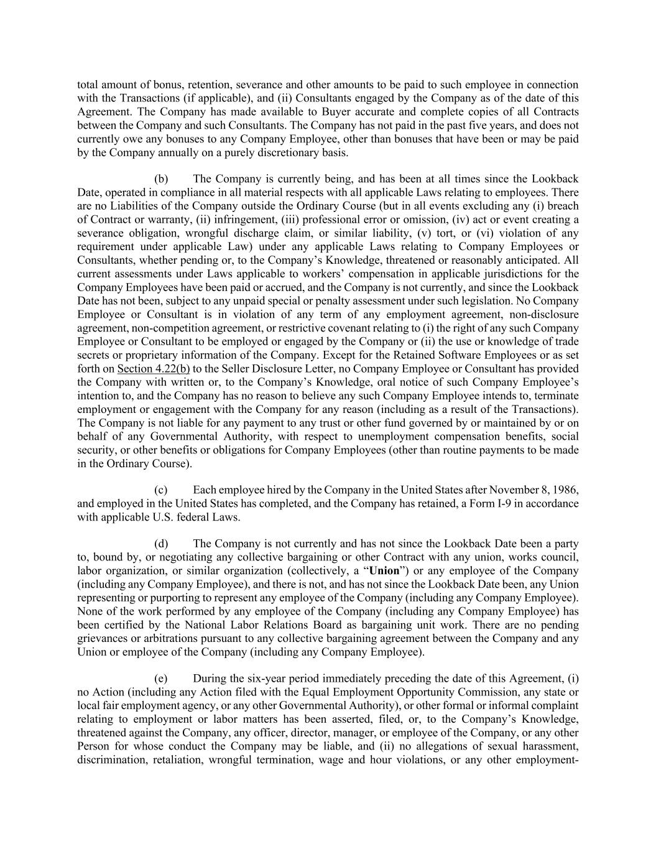
total amount of bonus, retention, severance and other amounts to be paid to such employee in connection with the Transactions (if applicable), and (ii) Consultants engaged by the Company as of the date of this Agreement. The Company has made available to Buyer accurate and complete copies of all Contracts between the Company and such Consultants. The Company has not paid in the past five years, and does not currently owe any bonuses to any Company Employee, other than bonuses that have been or may be paid by the Company annually on a purely discretionary basis. (b) The Company is currently being, and has been at all times since the Lookback Date, operated in compliance in all material respects with all applicable Laws relating to employees. There are no Liabilities of the Company outside the Ordinary Course (but in all events excluding any (i) breach of Contract or warranty, (ii) infringement, (iii) professional error or omission, (iv) act or event creating a severance obligation, wrongful discharge claim, or similar liability, (v) tort, or (vi) violation of any requirement under applicable Law) under any applicable Laws relating to Company Employees or Consultants, whether pending or, to the Company’s Knowledge, threatened or reasonably anticipated. All current assessments under Laws applicable to workers’ compensation in applicable jurisdictions for the Company Employees have been paid or accrued, and the Company is not currently, and since the Lookback Date has not been, subject to any unpaid special or penalty assessment under such legislation. No Company Employee or Consultant is in violation of any term of any employment agreement, non-disclosure agreement, non-competition agreement, or restrictive covenant relating to (i) the right of any such Company Employee or Consultant to be employed or engaged by the Company or (ii) the use or knowledge of trade secrets or proprietary information of the Company. Except for the Retained Software Employees or as set forth on Section 4.22(b) to the Seller Disclosure Letter, no Company Employee or Consultant has provided the Company with written or, to the Company’s Knowledge, oral notice of such Company Employee’s intention to, and the Company has no reason to believe any such Company Employee intends to, terminate employment or engagement with the Company for any reason (including as a result of the Transactions). The Company is not liable for any payment to any trust or other fund governed by or maintained by or on behalf of any Governmental Authority, with respect to unemployment compensation benefits, social security, or other benefits or obligations for Company Employees (other than routine payments to be made in the Ordinary Course). (c) Each employee hired by the Company in the United States after November 8, 1986, and employed in the United States has completed, and the Company has retained, a Form I-9 in accordance with applicable U.S. federal Laws. (d) The Company is not currently and has not since the Lookback Date been a party to, bound by, or negotiating any collective bargaining or other Contract with any union, works council, labor organization, or similar organization (collectively, a “Union”) or any employee of the Company (including any Company Employee), and there is not, and has not since the Lookback Date been, any Union representing or purporting to represent any employee of the Company (including any Company Employee). None of the work performed by any employee of the Company (including any Company Employee) has been certified by the National Labor Relations Board as bargaining unit work. There are no pending grievances or arbitrations pursuant to any collective bargaining agreement between the Company and any Union or employee of the Company (including any Company Employee). (e) During the six-year period immediately preceding the date of this Agreement, (i) no Action (including any Action filed with the Equal Employment Opportunity Commission, any state or local fair employment agency, or any other Governmental Authority), or other formal or informal complaint relating to employment or labor matters has been asserted, filed, or, to the Company’s Knowledge, threatened against the Company, any officer, director, manager, or employee of the Company, or any other Person for whose conduct the Company may be liable, and (ii) no allegations of sexual harassment, discrimination, retaliation, wrongful termination, wage and hour violations, or any other employment-

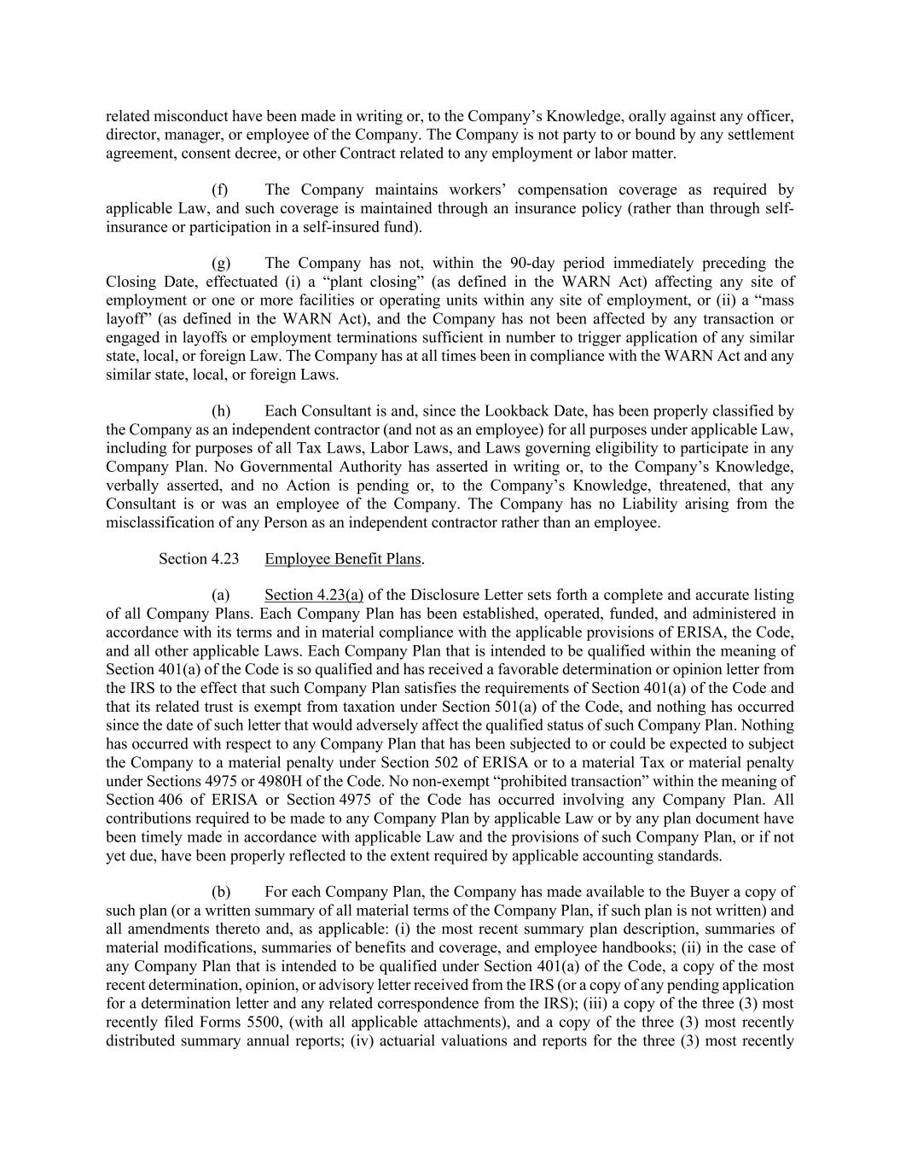
related misconduct have been made in writing or, to the Company’s Knowledge, orally against any officer, director, manager, or employee of the Company. The Company is not party to or bound by any settlement agreement, consent decree, or other Contract related to any employment or labor matter. (f) The Company maintains workers’ compensation coverage as required by applicable Law, and such coverage is maintained through an insurance policy (rather than through self- insurance or participation in a self-insured fund). (g) The Company has not, within the 90-day period immediately preceding the Closing Date, effectuated (i) a “plant closing” (as defined in the WARN Act) affecting any site of employment or one or more facilities or operating units within any site of employment, or (ii) a “mass layoff” (as defined in the WARN Act), and the Company has not been affected by any transaction or engaged in layoffs or employment terminations sufficient in number to trigger application of any similar state, local, or foreign Law. The Company has at all times been in compliance with the WARN Act and any similar state, local, or foreign Laws. (h) Each Consultant is and, since the Lookback Date, has been properly classified by the Company as an independent contractor (and not as an employee) for all purposes under applicable Law, including for purposes of all Tax Laws, Labor Laws, and Laws governing eligibility to participate in any Company Plan. No Governmental Authority has asserted in writing or, to the Company’s Knowledge, verbally asserted, and no Action is pending or, to the Company’s Knowledge, threatened, that any Consultant is or was an employee of the Company. The Company has no Liability arising from the misclassification of any Person as an independent contractor rather than an employee. Section 4.23 Employee Benefit Plans. (a) Section 4.23(a) of the Disclosure Letter sets forth a complete and accurate listing of all Company Plans. Each Company Plan has been established, operated, funded, and administered in accordance with its terms and in material compliance with the applicable provisions of ERISA, the Code, and all other applicable Laws. Each Company Plan that is intended to be qualified within the meaning of Section 401(a) of the Code is so qualified and has received a favorable determination or opinion letter from the IRS to the effect that such Company Plan satisfies the requirements of Section 401(a) of the Code and that its related trust is exempt from taxation under Section 501(a) of the Code, and nothing has occurred since the date of such letter that would adversely affect the qualified status of such Company Plan. Nothing has occurred with respect to any Company Plan that has been subjected to or could be expected to subject the Company to a material penalty under Section 502 of ERISA or to a material Tax or material penalty under Sections 4975 or 4980H of the Code. No non-exempt “prohibited transaction” within the meaning of Section 406 of ERISA or Section 4975 of the Code has occurred involving any Company Plan. All contributions required to be made to any Company Plan by applicable Law or by any plan document have been timely made in accordance with applicable Law and the provisions of such Company Plan, or if not yet due, have been properly reflected to the extent required by applicable accounting standards. (b) For each Company Plan, the Company has made available to the Buyer a copy of such plan (or a written summary of all material terms of the Company Plan, if such plan is not written) and all amendments thereto and, as applicable: (i) the most recent summary plan description, summaries of material modifications, summaries of benefits and coverage, and employee handbooks; (ii) in the case of any Company Plan that is intended to be qualified under Section 401(a) of the Code, a copy of the most recent determination, opinion, or advisory letter received from the IRS (or a copy of any pending application for a determination letter and any related correspondence from the IRS); (iii) a copy of the three (3) most recently filed Forms 5500, (with all applicable attachments), and a copy of the three (3) most recently distributed summary annual reports; (iv) actuarial valuations and reports for the three (3) most recently

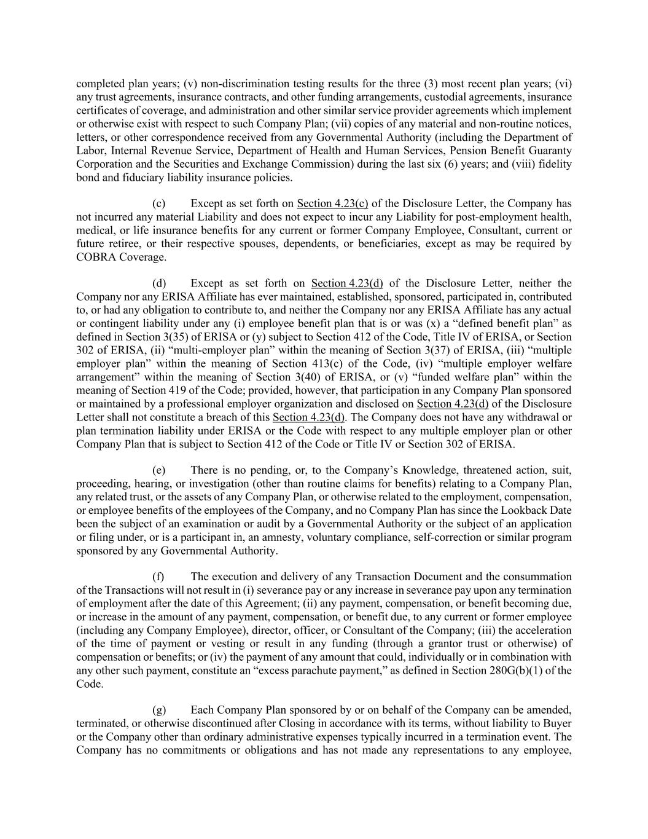
completed plan years; (v) non-discrimination testing results for the three (3) most recent plan years; (vi) any trust agreements, insurance contracts, and other funding arrangements, custodial agreements, insurance certificates of coverage, and administration and other similar service provider agreements which implement or otherwise exist with respect to such Company Plan; (vii) copies of any material and non-routine notices, letters, or other correspondence received from any Governmental Authority (including the Department of Labor, Internal Revenue Service, Department of Health and Human Services, Pension Benefit Guaranty Corporation and the Securities and Exchange Commission) during the last six (6) years; and (viii) fidelity bond and fiduciary liability insurance policies. (c) Except as set forth on Section 4.23(c) of the Disclosure Letter, the Company has not incurred any material Liability and does not expect to incur any Liability for post-employment health, medical, or life insurance benefits for any current or former Company Employee, Consultant, current or future retiree, or their respective spouses, dependents, or beneficiaries, except as may be required by COBRA Coverage. (d) Except as set forth on Section 4.23(d) of the Disclosure Letter, neither the Company nor any ERISA Affiliate has ever maintained, established, sponsored, participated in, contributed to, or had any obligation to contribute to, and neither the Company nor any ERISA Affiliate has any actual or contingent liability under any (i) employee benefit plan that is or was (x) a “defined benefit plan” as defined in Section 3(35) of ERISA or (y) subject to Section 412 of the Code, Title IV of ERISA, or Section 302 of ERISA, (ii) “multi-employer plan” within the meaning of Section 3(37) of ERISA, (iii) “multiple employer plan” within the meaning of Section 413(c) of the Code, (iv) “multiple employer welfare arrangement” within the meaning of Section 3(40) of ERISA, or (v) “funded welfare plan” within the meaning of Section 419 of the Code; provided, however, that participation in any Company Plan sponsored or maintained by a professional employer organization and disclosed on Section 4.23(d) of the Disclosure Letter shall not constitute a breach of this Section 4.23(d). The Company does not have any withdrawal or plan termination liability under ERISA or the Code with respect to any multiple employer plan or other Company Plan that is subject to Section 412 of the Code or Title IV or Section 302 of ERISA. (e) There is no pending, or, to the Company’s Knowledge, threatened action, suit, proceeding, hearing, or investigation (other than routine claims for benefits) relating to a Company Plan, any related trust, or the assets of any Company Plan, or otherwise related to the employment, compensation, or employee benefits of the employees of the Company, and no Company Plan has since the Lookback Date been the subject of an examination or audit by a Governmental Authority or the subject of an application or filing under, or is a participant in, an amnesty, voluntary compliance, self-correction or similar program sponsored by any Governmental Authority. (f) The execution and delivery of any Transaction Document and the consummation of the Transactions will not result in (i) severance pay or any increase in severance pay upon any termination of employment after the date of this Agreement; (ii) any payment, compensation, or benefit becoming due, or increase in the amount of any payment, compensation, or benefit due, to any current or former employee (including any Company Employee), director, officer, or Consultant of the Company; (iii) the acceleration of the time of payment or vesting or result in any funding (through a grantor trust or otherwise) of compensation or benefits; or (iv) the payment of any amount that could, individually or in combination with any other such payment, constitute an “excess parachute payment,” as defined in Section 280G(b)(1) of the Code. (g) Each Company Plan sponsored by or on behalf of the Company can be amended, terminated, or otherwise discontinued after Closing in accordance with its terms, without liability to Buyer or the Company other than ordinary administrative expenses typically incurred in a termination event. The Company has no commitments or obligations and has not made any representations to any employee,

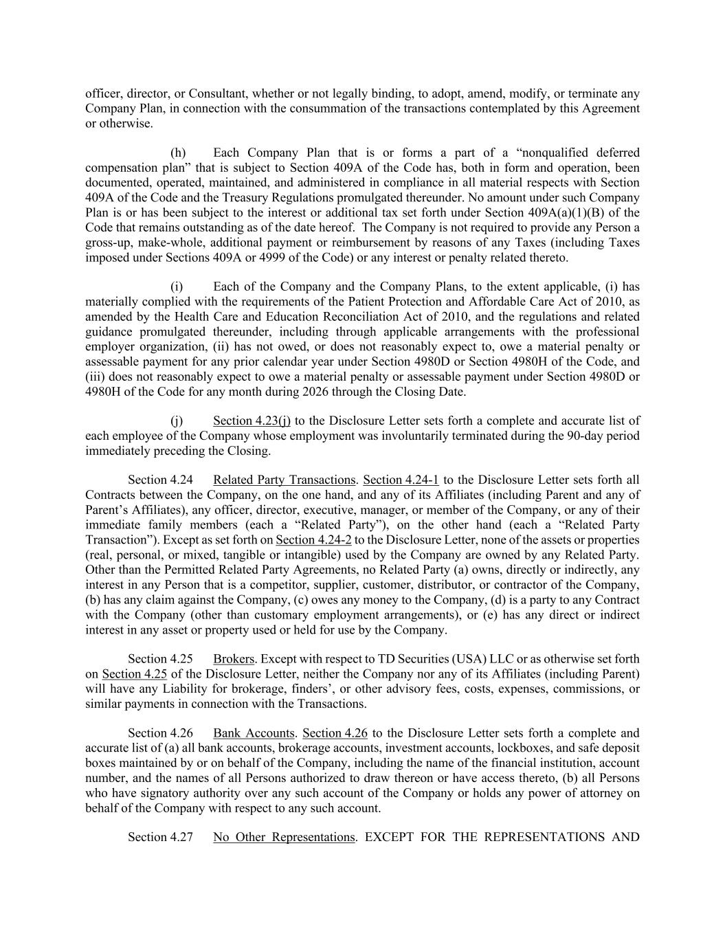
officer, director, or Consultant, whether or not legally binding, to adopt, amend, modify, or terminate any Company Plan, in connection with the consummation of the transactions contemplated by this Agreement or otherwise. (h) Each Company Plan that is or forms a part of a “nonqualified deferred compensation plan” that is subject to Section 409A of the Code has, both in form and operation, been documented, operated, maintained, and administered in compliance in all material respects with Section 409A of the Code and the Treasury Regulations promulgated thereunder. No amount under such Company Plan is or has been subject to the interest or additional tax set forth under Section 409A(a)(1)(B) of the Code that remains outstanding as of the date hereof. The Company is not required to provide any Person a gross-up, make-whole, additional payment or reimbursement by reasons of any Taxes (including Taxes imposed under Sections 409A or 4999 of the Code) or any interest or penalty related thereto. (i) Each of the Company and the Company Plans, to the extent applicable, (i) has materially complied with the requirements of the Patient Protection and Affordable Care Act of 2010, as amended by the Health Care and Education Reconciliation Act of 2010, and the regulations and related guidance promulgated thereunder, including through applicable arrangements with the professional employer organization, (ii) has not owed, or does not reasonably expect to, owe a material penalty or assessable payment for any prior calendar year under Section 4980D or Section 4980H of the Code, and (iii) does not reasonably expect to owe a material penalty or assessable payment under Section 4980D or 4980H of the Code for any month during 2026 through the Closing Date. (j) Section 4.23(j) to the Disclosure Letter sets forth a complete and accurate list of each employee of the Company whose employment was involuntarily terminated during the 90-day period immediately preceding the Closing. Section 4.24 Related Party Transactions. Section 4.24-1 to the Disclosure Letter sets forth all Contracts between the Company, on the one hand, and any of its Affiliates (including Parent and any of Parent’s Affiliates), any officer, director, executive, manager, or member of the Company, or any of their immediate family members (each a “Related Party”), on the other hand (each a “Related Party Transaction”). Except as set forth on Section 4.24-2 to the Disclosure Letter, none of the assets or properties (real, personal, or mixed, tangible or intangible) used by the Company are owned by any Related Party. Other than the Permitted Related Party Agreements, no Related Party (a) owns, directly or indirectly, any interest in any Person that is a competitor, supplier, customer, distributor, or contractor of the Company, (b) has any claim against the Company, (c) owes any money to the Company, (d) is a party to any Contract with the Company (other than customary employment arrangements), or (e) has any direct or indirect interest in any asset or property used or held for use by the Company. Section 4.25 Brokers. Except with respect to TD Securities (USA) LLC or as otherwise set forth on Section 4.25 of the Disclosure Letter, neither the Company nor any of its Affiliates (including Parent) will have any Liability for brokerage, finders’, or other advisory fees, costs, expenses, commissions, or similar payments in connection with the Transactions. Section 4.26 Bank Accounts. Section 4.26 to the Disclosure Letter sets forth a complete and accurate list of (a) all bank accounts, brokerage accounts, investment accounts, lockboxes, and safe deposit boxes maintained by or on behalf of the Company, including the name of the financial institution, account number, and the names of all Persons authorized to draw thereon or have access thereto, (b) all Persons who have signatory authority over any such account of the Company or holds any power of attorney on behalf of the Company with respect to any such account. Section 4.27 No Other Representations. EXCEPT FOR THE REPRESENTATIONS AND

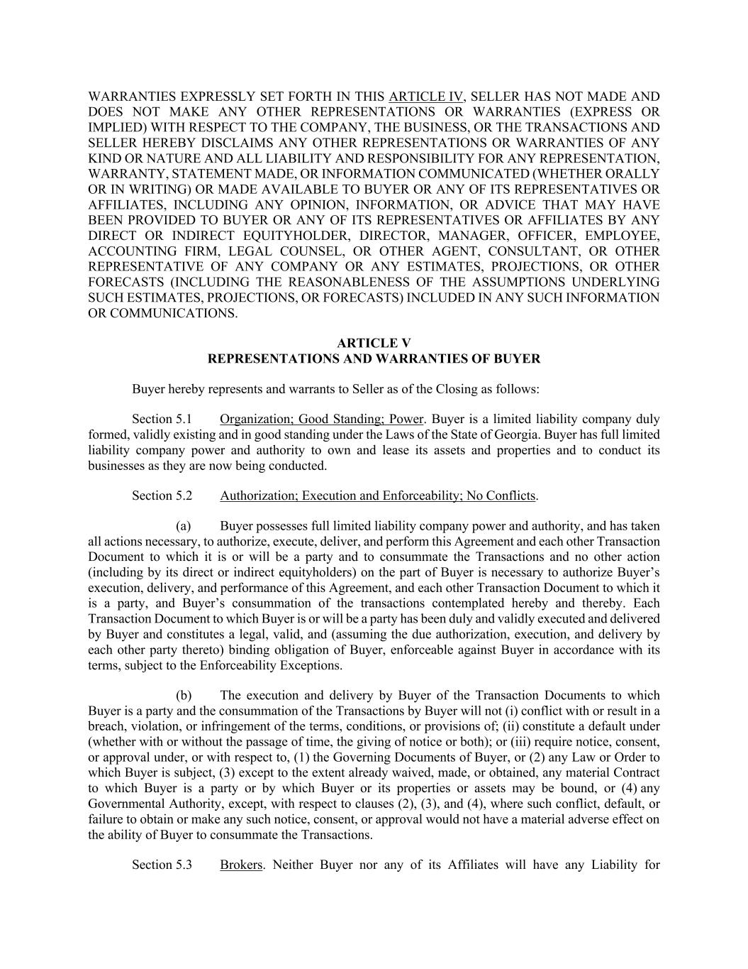
WARRANTIES EXPRESSLY SET FORTH IN THIS ARTICLE IV, SELLER HAS NOT MADE AND DOES NOT MAKE ANY OTHER REPRESENTATIONS OR WARRANTIES (EXPRESS OR IMPLIED) WITH RESPECT TO THE COMPANY, THE BUSINESS, OR THE TRANSACTIONS AND SELLER HEREBY DISCLAIMS ANY OTHER REPRESENTATIONS OR WARRANTIES OF ANY KIND OR NATURE AND ALL LIABILITY AND RESPONSIBILITY FOR ANY REPRESENTATION, WARRANTY, STATEMENT MADE, OR INFORMATION COMMUNICATED (WHETHER ORALLY OR IN WRITING) OR MADE AVAILABLE TO BUYER OR ANY OF ITS REPRESENTATIVES OR AFFILIATES, INCLUDING ANY OPINION, INFORMATION, OR ADVICE THAT MAY HAVE BEEN PROVIDED TO BUYER OR ANY OF ITS REPRESENTATIVES OR AFFILIATES BY ANY DIRECT OR INDIRECT EQUITYHOLDER, DIRECTOR, MANAGER, OFFICER, EMPLOYEE, ACCOUNTING FIRM, LEGAL COUNSEL, OR OTHER AGENT, CONSULTANT, OR OTHER REPRESENTATIVE OF ANY COMPANY OR ANY ESTIMATES, PROJECTIONS, OR OTHER FORECASTS (INCLUDING THE REASONABLENESS OF THE ASSUMPTIONS UNDERLYING SUCH ESTIMATES, PROJECTIONS, OR FORECASTS) INCLUDED IN ANY SUCH INFORMATION OR COMMUNICATIONS. ARTICLE V REPRESENTATIONS AND WARRANTIES OF BUYER Buyer hereby represents and warrants to Seller as of the Closing as follows: Section 5.1 Organization; Good Standing; Power. Buyer is a limited liability company duly formed, validly existing and in good standing under the Laws of the State of Georgia. Buyer has full limited liability company power and authority to own and lease its assets and properties and to conduct its businesses as they are now being conducted. Section 5.2 Authorization; Execution and Enforceability; No Conflicts. (a) Buyer possesses full limited liability company power and authority, and has taken all actions necessary, to authorize, execute, deliver, and perform this Agreement and each other Transaction Document to which it is or will be a party and to consummate the Transactions and no other action (including by its direct or indirect equityholders) on the part of Buyer is necessary to authorize Buyer’s execution, delivery, and performance of this Agreement, and each other Transaction Document to which it is a party, and Buyer’s consummation of the transactions contemplated hereby and thereby. Each Transaction Document to which Buyer is or will be a party has been duly and validly executed and delivered by Buyer and constitutes a legal, valid, and (assuming the due authorization, execution, and delivery by each other party thereto) binding obligation of Buyer, enforceable against Buyer in accordance with its terms, subject to the Enforceability Exceptions. (b) The execution and delivery by Buyer of the Transaction Documents to which Buyer is a party and the consummation of the Transactions by Buyer will not (i) conflict with or result in a breach, violation, or infringement of the terms, conditions, or provisions of; (ii) constitute a default under (whether with or without the passage of time, the giving of notice or both); or (iii) require notice, consent, or approval under, or with respect to, (1) the Governing Documents of Buyer, or (2) any Law or Order to which Buyer is subject, (3) except to the extent already waived, made, or obtained, any material Contract to which Buyer is a party or by which Buyer or its properties or assets may be bound, or (4) any Governmental Authority, except, with respect to clauses (2), (3), and (4), where such conflict, default, or failure to obtain or make any such notice, consent, or approval would not have a material adverse effect on the ability of Buyer to consummate the Transactions. Section 5.3 Brokers. Neither Buyer nor any of its Affiliates will have any Liability for

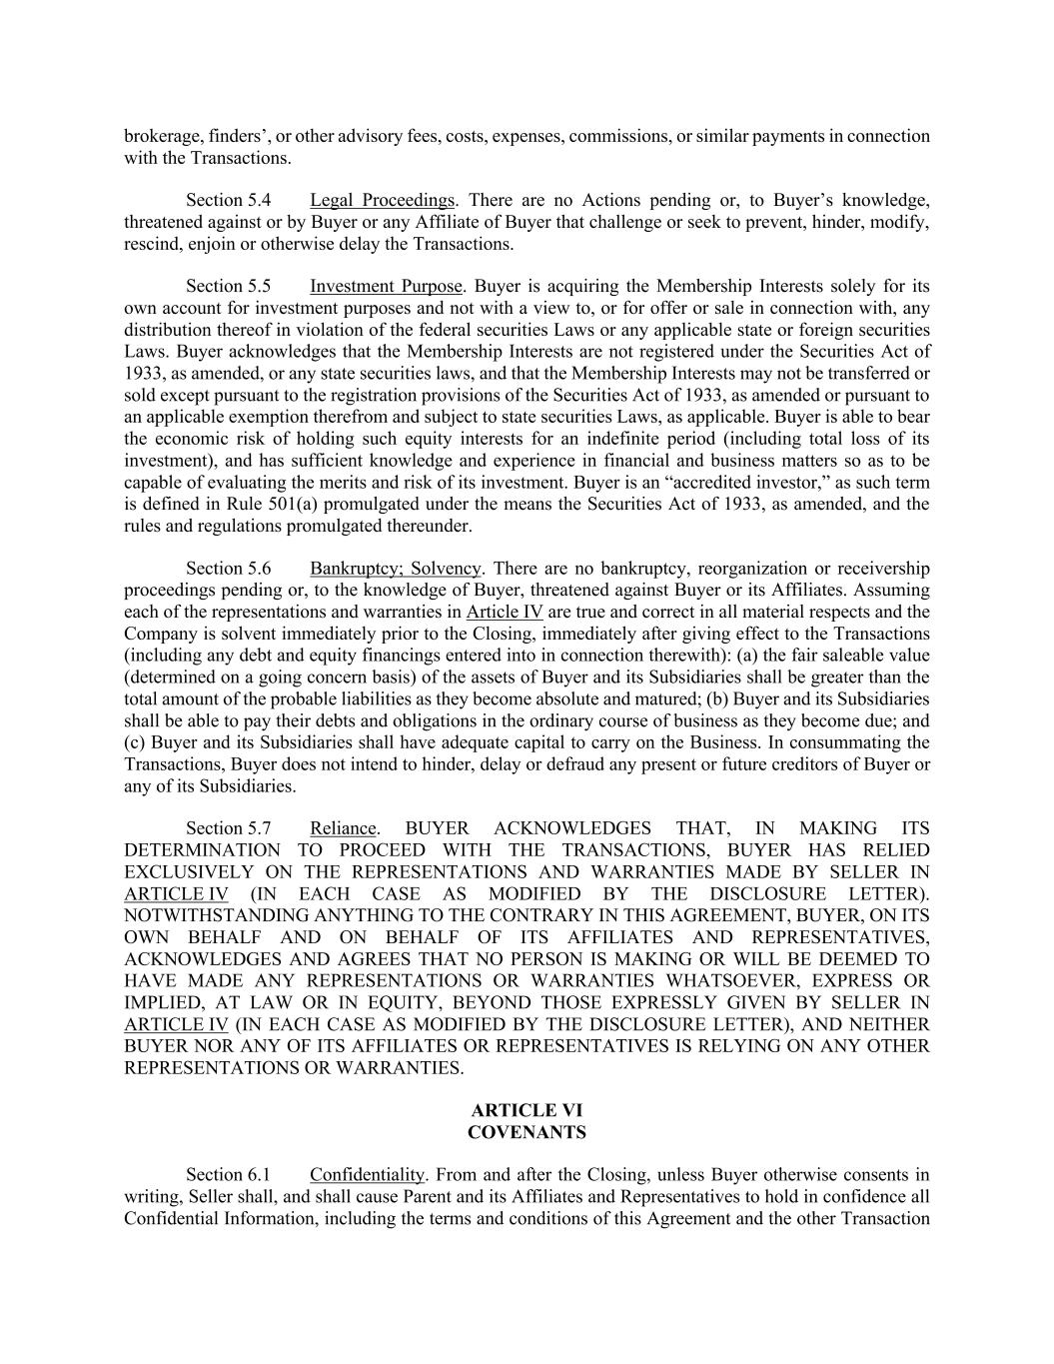
brokerage, finders’, or other advisory fees, costs, expenses, commissions, or similar payments in connection with the Transactions. Section 5.4 Legal Proceedings. There are no Actions pending or, to Buyer’s knowledge, threatened against or by Buyer or any Affiliate of Buyer that challenge or seek to prevent, hinder, modify, rescind, enjoin or otherwise delay the Transactions. Section 5.5 Investment Purpose. Buyer is acquiring the Membership Interests solely for its own account for investment purposes and not with a view to, or for offer or sale in connection with, any distribution thereof in violation of the federal securities Laws or any applicable state or foreign securities Laws. Buyer acknowledges that the Membership Interests are not registered under the Securities Act of 1933, as amended, or any state securities laws, and that the Membership Interests may not be transferred or sold except pursuant to the registration provisions of the Securities Act of 1933, as amended or pursuant to an applicable exemption therefrom and subject to state securities Laws, as applicable. Buyer is able to bear the economic risk of holding such equity interests for an indefinite period (including total loss of its investment), and has sufficient knowledge and experience in financial and business matters so as to be capable of evaluating the merits and risk of its investment. Buyer is an “accredited investor,” as such term is defined in Rule 501(a) promulgated under the means the Securities Act of 1933, as amended, and the rules and regulations promulgated thereunder. Section 5.6 Bankruptcy; Solvency. There are no bankruptcy, reorganization or receivership proceedings pending or, to the knowledge of Buyer, threatened against Buyer or its Affiliates. Assuming each of the representations and warranties in Article IV are true and correct in all material respects and the Company is solvent immediately prior to the Closing, immediately after giving effect to the Transactions (including any debt and equity financings entered into in connection therewith): (a) the fair saleable value (determined on a going concern basis) of the assets of Buyer and its Subsidiaries shall be greater than the total amount of the probable liabilities as they become absolute and matured; (b) Buyer and its Subsidiaries shall be able to pay their debts and obligations in the ordinary course of business as they become due; and (c) Buyer and its Subsidiaries shall have adequate capital to carry on the Business. In consummating the Transactions, Buyer does not intend to hinder, delay or defraud any present or future creditors of Buyer or any of its Subsidiaries. Section 5.7 Reliance. BUYER ACKNOWLEDGES THAT, IN MAKING ITS DETERMINATION TO PROCEED WITH THE TRANSACTIONS, BUYER HAS RELIED EXCLUSIVELY ON THE REPRESENTATIONS AND WARRANTIES MADE BY SELLER IN ARTICLE IV (IN EACH CASE AS MODIFIED BY THE DISCLOSURE LETTER). NOTWITHSTANDING ANYTHING TO THE CONTRARY IN THIS AGREEMENT, BUYER, ON ITS OWN BEHALF AND ON BEHALF OF ITS AFFILIATES AND REPRESENTATIVES, ACKNOWLEDGES AND AGREES THAT NO PERSON IS MAKING OR WILL BE DEEMED TO HAVE MADE ANY REPRESENTATIONS OR WARRANTIES WHATSOEVER, EXPRESS OR IMPLIED, AT LAW OR IN EQUITY, BEYOND THOSE EXPRESSLY GIVEN BY SELLER IN ARTICLE IV (IN EACH CASE AS MODIFIED BY THE DISCLOSURE LETTER), AND NEITHER BUYER NOR ANY OF ITS AFFILIATES OR REPRESENTATIVES IS RELYING ON ANY OTHER REPRESENTATIONS OR WARRANTIES. ARTICLE VI COVENANTS Section 6.1 Confidentiality. From and after the Closing, unless Buyer otherwise consents in writing, Seller shall, and shall cause Parent and its Affiliates and Representatives to hold in confidence all Confidential Information, including the terms and conditions of this Agreement and the other Transaction

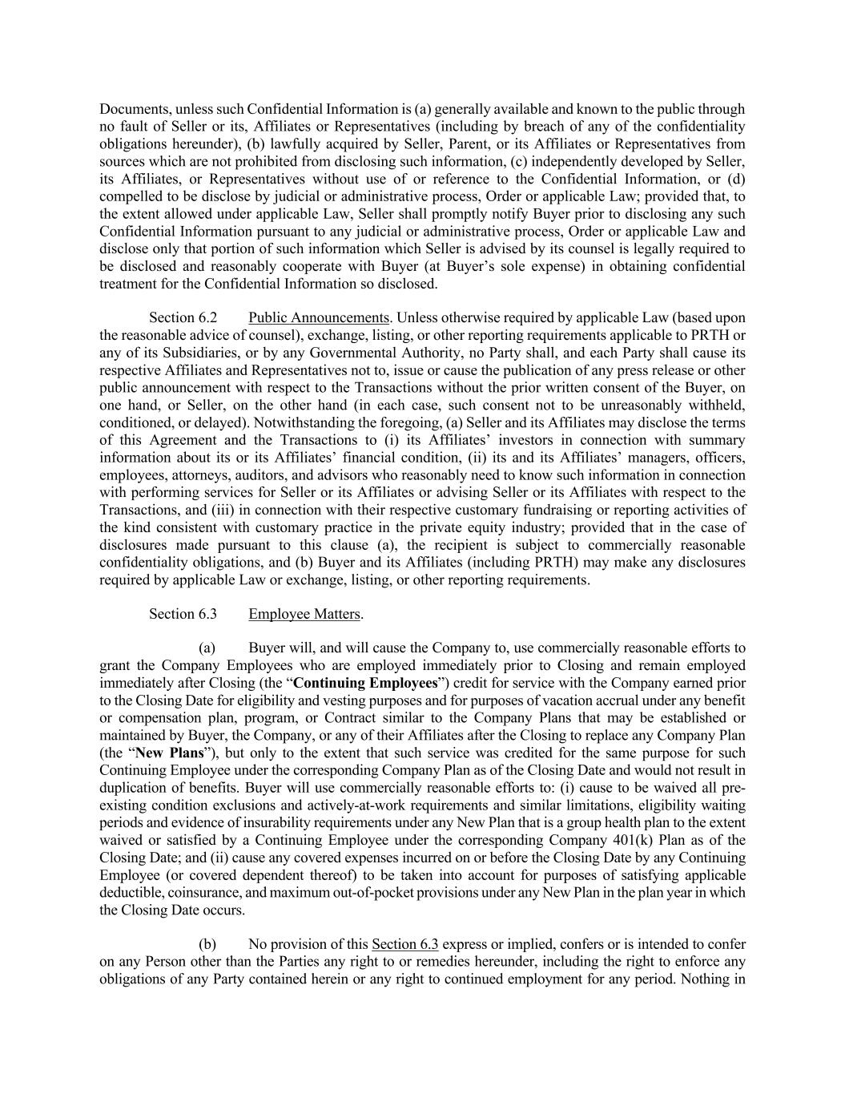
Documents, unless such Confidential Information is (a) generally available and known to the public through no fault of Seller or its, Affiliates or Representatives (including by breach of any of the confidentiality obligations hereunder), (b) lawfully acquired by Seller, Parent, or its Affiliates or Representatives from sources which are not prohibited from disclosing such information, (c) independently developed by Seller, its Affiliates, or Representatives without use of or reference to the Confidential Information, or (d) compelled to be disclose by judicial or administrative process, Order or applicable Law; provided that, to the extent allowed under applicable Law, Seller shall promptly notify Buyer prior to disclosing any such Confidential Information pursuant to any judicial or administrative process, Order or applicable Law and disclose only that portion of such information which Seller is advised by its counsel is legally required to be disclosed and reasonably cooperate with Buyer (at Buyer’s sole expense) in obtaining confidential treatment for the Confidential Information so disclosed. Section 6.2 Public Announcements. Unless otherwise required by applicable Law (based upon the reasonable advice of counsel), exchange, listing, or other reporting requirements applicable to PRTH or any of its Subsidiaries, or by any Governmental Authority, no Party shall, and each Party shall cause its respective Affiliates and Representatives not to, issue or cause the publication of any press release or other public announcement with respect to the Transactions without the prior written consent of the Buyer, on one hand, or Seller, on the other hand (in each case, such consent not to be unreasonably withheld, conditioned, or delayed). Notwithstanding the foregoing, (a) Seller and its Affiliates may disclose the terms of this Agreement and the Transactions to (i) its Affiliates’ investors in connection with summary information about its or its Affiliates’ financial condition, (ii) its and its Affiliates’ managers, officers, employees, attorneys, auditors, and advisors who reasonably need to know such information in connection with performing services for Seller or its Affiliates or advising Seller or its Affiliates with respect to the Transactions, and (iii) in connection with their respective customary fundraising or reporting activities of the kind consistent with customary practice in the private equity industry; provided that in the case of disclosures made pursuant to this clause (a), the recipient is subject to commercially reasonable confidentiality obligations, and (b) Buyer and its Affiliates (including PRTH) may make any disclosures required by applicable Law or exchange, listing, or other reporting requirements. Section 6.3 Employee Matters. (a) Buyer will, and will cause the Company to, use commercially reasonable efforts to grant the Company Employees who are employed immediately prior to Closing and remain employed immediately after Closing (the “Continuing Employees”) credit for service with the Company earned prior to the Closing Date for eligibility and vesting purposes and for purposes of vacation accrual under any benefit or compensation plan, program, or Contract similar to the Company Plans that may be established or maintained by Buyer, the Company, or any of their Affiliates after the Closing to replace any Company Plan (the “New Plans”), but only to the extent that such service was credited for the same purpose for such Continuing Employee under the corresponding Company Plan as of the Closing Date and would not result in duplication of benefits. Buyer will use commercially reasonable efforts to: (i) cause to be waived all pre- existing condition exclusions and actively-at-work requirements and similar limitations, eligibility waiting periods and evidence of insurability requirements under any New Plan that is a group health plan to the extent waived or satisfied by a Continuing Employee under the corresponding Company 401(k) Plan as of the Closing Date; and (ii) cause any covered expenses incurred on or before the Closing Date by any Continuing Employee (or covered dependent thereof) to be taken into account for purposes of satisfying applicable deductible, coinsurance, and maximum out-of-pocket provisions under any New Plan in the plan year in which the Closing Date occurs. (b) No provision of this Section 6.3 express or implied, confers or is intended to confer on any Person other than the Parties any right to or remedies hereunder, including the right to enforce any obligations of any Party contained herein or any right to continued employment for any period. Nothing in

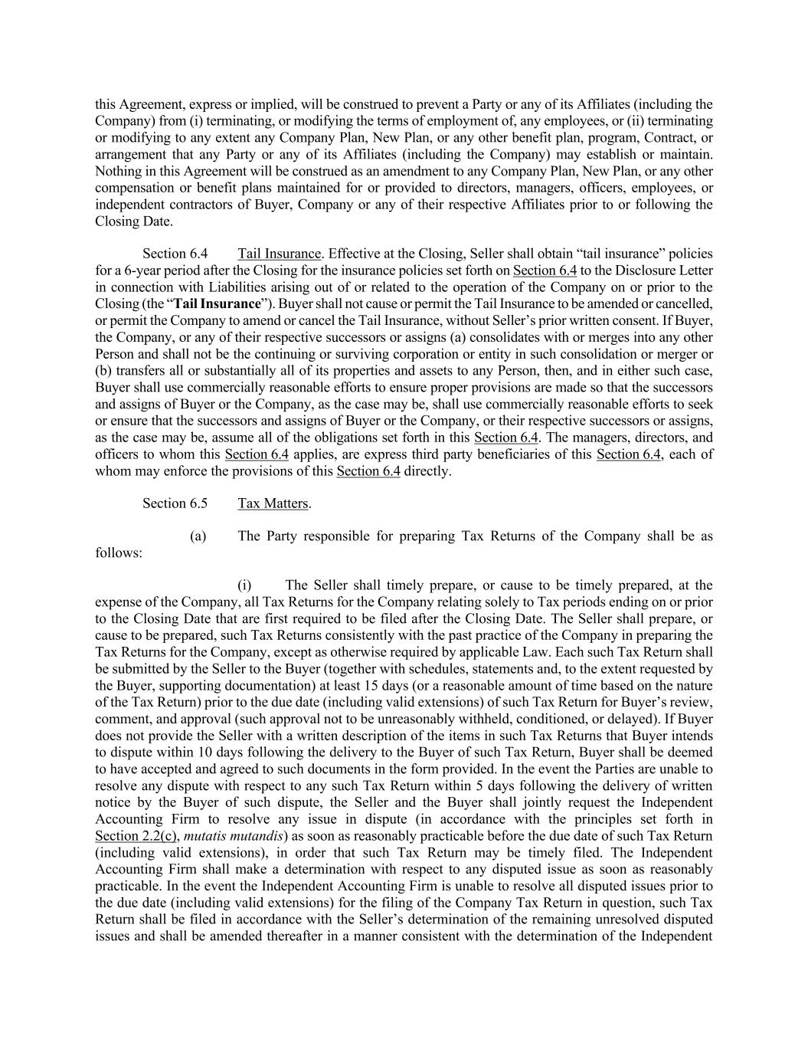
this Agreement, express or implied, will be construed to prevent a Party or any of its Affiliates (including the Company) from (i) terminating, or modifying the terms of employment of, any employees, or (ii) terminating or modifying to any extent any Company Plan, New Plan, or any other benefit plan, program, Contract, or arrangement that any Party or any of its Affiliates (including the Company) may establish or maintain. Nothing in this Agreement will be construed as an amendment to any Company Plan, New Plan, or any other compensation or benefit plans maintained for or provided to directors, managers, officers, employees, or independent contractors of Buyer, Company or any of their respective Affiliates prior to or following the Closing Date. Section 6.4 Tail Insurance. Effective at the Closing, Seller shall obtain “tail insurance” policies for a 6-year period after the Closing for the insurance policies set forth on Section 6.4 to the Disclosure Letter in connection with Liabilities arising out of or related to the operation of the Company on or prior to the Closing (the “Tail Insurance”). Buyer shall not cause or permit the Tail Insurance to be amended or cancelled, or permit the Company to amend or cancel the Tail Insurance, without Seller’s prior written consent. If Buyer, the Company, or any of their respective successors or assigns (a) consolidates with or merges into any other Person and shall not be the continuing or surviving corporation or entity in such consolidation or merger or (b) transfers all or substantially all of its properties and assets to any Person, then, and in either such case, Buyer shall use commercially reasonable efforts to ensure proper provisions are made so that the successors and assigns of Buyer or the Company, as the case may be, shall use commercially reasonable efforts to seek or ensure that the successors and assigns of Buyer or the Company, or their respective successors or assigns, as the case may be, assume all of the obligations set forth in this Section 6.4. The managers, directors, and officers to whom this Section 6.4 applies, are express third party beneficiaries of this Section 6.4, each of whom may enforce the provisions of this Section 6.4 directly. Section 6.5 Tax Matters. (a) The Party responsible for preparing Tax Returns of the Company shall be as follows: (i) The Seller shall timely prepare, or cause to be timely prepared, at the expense of the Company, all Tax Returns for the Company relating solely to Tax periods ending on or prior to the Closing Date that are first required to be filed after the Closing Date. The Seller shall prepare, or cause to be prepared, such Tax Returns consistently with the past practice of the Company in preparing the Tax Returns for the Company, except as otherwise required by applicable Law. Each such Tax Return shall be submitted by the Seller to the Buyer (together with schedules, statements and, to the extent requested by the Buyer, supporting documentation) at least 15 days (or a reasonable amount of time based on the nature of the Tax Return) prior to the due date (including valid extensions) of such Tax Return for Buyer’s review, comment, and approval (such approval not to be unreasonably withheld, conditioned, or delayed). If Buyer does not provide the Seller with a written description of the items in such Tax Returns that Buyer intends to dispute within 10 days following the delivery to the Buyer of such Tax Return, Buyer shall be deemed to have accepted and agreed to such documents in the form provided. In the event the Parties are unable to resolve any dispute with respect to any such Tax Return within 5 days following the delivery of written notice by the Buyer of such dispute, the Seller and the Buyer shall jointly request the Independent Accounting Firm to resolve any issue in dispute (in accordance with the principles set forth in Section 2.2(c), mutatis mutandis) as soon as reasonably practicable before the due date of such Tax Return (including valid extensions), in order that such Tax Return may be timely filed. The Independent Accounting Firm shall make a determination with respect to any disputed issue as soon as reasonably practicable. In the event the Independent Accounting Firm is unable to resolve all disputed issues prior to the due date (including valid extensions) for the filing of the Company Tax Return in question, such Tax Return shall be filed in accordance with the Seller’s determination of the remaining unresolved disputed issues and shall be amended thereafter in a manner consistent with the determination of the Independent

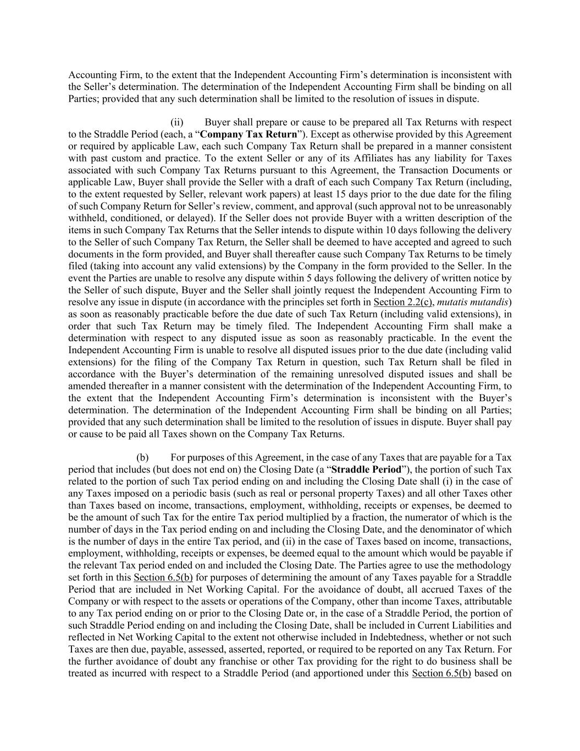
Accounting Firm, to the extent that the Independent Accounting Firm’s determination is inconsistent with the Seller’s determination. The determination of the Independent Accounting Firm shall be binding on all Parties; provided that any such determination shall be limited to the resolution of issues in dispute. (ii) Buyer shall prepare or cause to be prepared all Tax Returns with respect to the Straddle Period (each, a “Company Tax Return”). Except as otherwise provided by this Agreement or required by applicable Law, each such Company Tax Return shall be prepared in a manner consistent with past custom and practice. To the extent Seller or any of its Affiliates has any liability for Taxes associated with such Company Tax Returns pursuant to this Agreement, the Transaction Documents or applicable Law, Buyer shall provide the Seller with a draft of each such Company Tax Return (including, to the extent requested by Seller, relevant work papers) at least 15 days prior to the due date for the filing of such Company Return for Seller’s review, comment, and approval (such approval not to be unreasonably withheld, conditioned, or delayed). If the Seller does not provide Buyer with a written description of the items in such Company Tax Returns that the Seller intends to dispute within 10 days following the delivery to the Seller of such Company Tax Return, the Seller shall be deemed to have accepted and agreed to such documents in the form provided, and Buyer shall thereafter cause such Company Tax Returns to be timely filed (taking into account any valid extensions) by the Company in the form provided to the Seller. In the event the Parties are unable to resolve any dispute within 5 days following the delivery of written notice by the Seller of such dispute, Buyer and the Seller shall jointly request the Independent Accounting Firm to resolve any issue in dispute (in accordance with the principles set forth in Section 2.2(c), mutatis mutandis) as soon as reasonably practicable before the due date of such Tax Return (including valid extensions), in order that such Tax Return may be timely filed. The Independent Accounting Firm shall make a determination with respect to any disputed issue as soon as reasonably practicable. In the event the Independent Accounting Firm is unable to resolve all disputed issues prior to the due date (including valid extensions) for the filing of the Company Tax Return in question, such Tax Return shall be filed in accordance with the Buyer’s determination of the remaining unresolved disputed issues and shall be amended thereafter in a manner consistent with the determination of the Independent Accounting Firm, to the extent that the Independent Accounting Firm’s determination is inconsistent with the Buyer’s determination. The determination of the Independent Accounting Firm shall be binding on all Parties; provided that any such determination shall be limited to the resolution of issues in dispute. Buyer shall pay or cause to be paid all Taxes shown on the Company Tax Returns. (b) For purposes of this Agreement, in the case of any Taxes that are payable for a Tax period that includes (but does not end on) the Closing Date (a “Straddle Period”), the portion of such Tax related to the portion of such Tax period ending on and including the Closing Date shall (i) in the case of any Taxes imposed on a periodic basis (such as real or personal property Taxes) and all other Taxes other than Taxes based on income, transactions, employment, withholding, receipts or expenses, be deemed to be the amount of such Tax for the entire Tax period multiplied by a fraction, the numerator of which is the number of days in the Tax period ending on and including the Closing Date, and the denominator of which is the number of days in the entire Tax period, and (ii) in the case of Taxes based on income, transactions, employment, withholding, receipts or expenses, be deemed equal to the amount which would be payable if the relevant Tax period ended on and included the Closing Date. The Parties agree to use the methodology set forth in this Section 6.5(b) for purposes of determining the amount of any Taxes payable for a Straddle Period that are included in Net Working Capital. For the avoidance of doubt, all accrued Taxes of the Company or with respect to the assets or operations of the Company, other than income Taxes, attributable to any Tax period ending on or prior to the Closing Date or, in the case of a Straddle Period, the portion of such Straddle Period ending on and including the Closing Date, shall be included in Current Liabilities and reflected in Net Working Capital to the extent not otherwise included in Indebtedness, whether or not such Taxes are then due, payable, assessed, asserted, reported, or required to be reported on any Tax Return. For the further avoidance of doubt any franchise or other Tax providing for the right to do business shall be treated as incurred with respect to a Straddle Period (and apportioned under this Section 6.5(b) based on

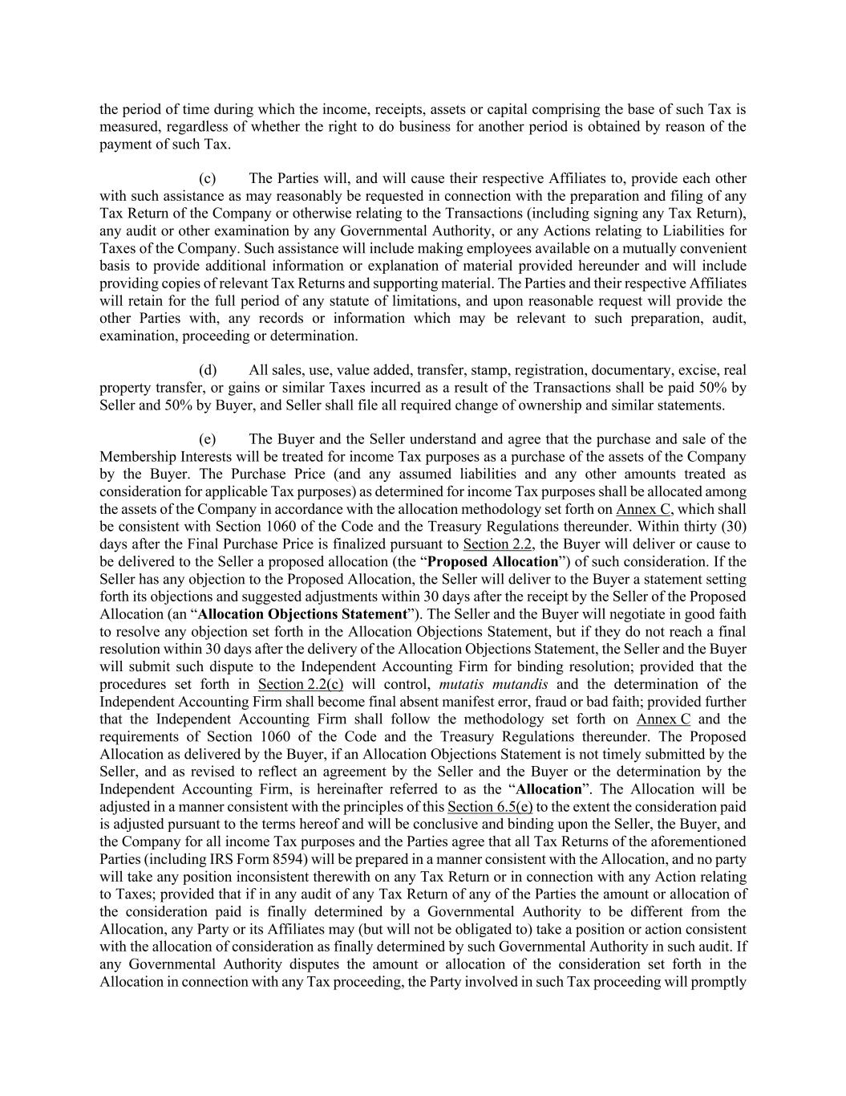
the period of time during which the income, receipts, assets or capital comprising the base of such Tax is measured, regardless of whether the right to do business for another period is obtained by reason of the payment of such Tax. (c) The Parties will, and will cause their respective Affiliates to, provide each other with such assistance as may reasonably be requested in connection with the preparation and filing of any Tax Return of the Company or otherwise relating to the Transactions (including signing any Tax Return), any audit or other examination by any Governmental Authority, or any Actions relating to Liabilities for Taxes of the Company. Such assistance will include making employees available on a mutually convenient basis to provide additional information or explanation of material provided hereunder and will include providing copies of relevant Tax Returns and supporting material. The Parties and their respective Affiliates will retain for the full period of any statute of limitations, and upon reasonable request will provide the other Parties with, any records or information which may be relevant to such preparation, audit, examination, proceeding or determination. (d) All sales, use, value added, transfer, stamp, registration, documentary, excise, real property transfer, or gains or similar Taxes incurred as a result of the Transactions shall be paid 50% by Seller and 50% by Buyer, and Seller shall file all required change of ownership and similar statements. (e) The Buyer and the Seller understand and agree that the purchase and sale of the Membership Interests will be treated for income Tax purposes as a purchase of the assets of the Company by the Buyer. The Purchase Price (and any assumed liabilities and any other amounts treated as consideration for applicable Tax purposes) as determined for income Tax purposes shall be allocated among the assets of the Company in accordance with the allocation methodology set forth on Annex C, which shall be consistent with Section 1060 of the Code and the Treasury Regulations thereunder. Within thirty (30) days after the Final Purchase Price is finalized pursuant to Section 2.2, the Buyer will deliver or cause to be delivered to the Seller a proposed allocation (the “Proposed Allocation”) of such consideration. If the Seller has any objection to the Proposed Allocation, the Seller will deliver to the Buyer a statement setting forth its objections and suggested adjustments within 30 days after the receipt by the Seller of the Proposed Allocation (an “Allocation Objections Statement”). The Seller and the Buyer will negotiate in good faith to resolve any objection set forth in the Allocation Objections Statement, but if they do not reach a final resolution within 30 days after the delivery of the Allocation Objections Statement, the Seller and the Buyer will submit such dispute to the Independent Accounting Firm for binding resolution; provided that the procedures set forth in Section 2.2(c) will control, mutatis mutandis and the determination of the Independent Accounting Firm shall become final absent manifest error, fraud or bad faith; provided further that the Independent Accounting Firm shall follow the methodology set forth on Annex C and the requirements of Section 1060 of the Code and the Treasury Regulations thereunder. The Proposed Allocation as delivered by the Buyer, if an Allocation Objections Statement is not timely submitted by the Seller, and as revised to reflect an agreement by the Seller and the Buyer or the determination by the Independent Accounting Firm, is hereinafter referred to as the “Allocation”. The Allocation will be adjusted in a manner consistent with the principles of this Section 6.5(e) to the extent the consideration paid is adjusted pursuant to the terms hereof and will be conclusive and binding upon the Seller, the Buyer, and the Company for all income Tax purposes and the Parties agree that all Tax Returns of the aforementioned Parties (including IRS Form 8594) will be prepared in a manner consistent with the Allocation, and no party will take any position inconsistent therewith on any Tax Return or in connection with any Action relating to Taxes; provided that if in any audit of any Tax Return of any of the Parties the amount or allocation of the consideration paid is finally determined by a Governmental Authority to be different from the Allocation, any Party or its Affiliates may (but will not be obligated to) take a position or action consistent with the allocation of consideration as finally determined by such Governmental Authority in such audit. If any Governmental Authority disputes the amount or allocation of the consideration set forth in the Allocation in connection with any Tax proceeding, the Party involved in such Tax proceeding will promptly

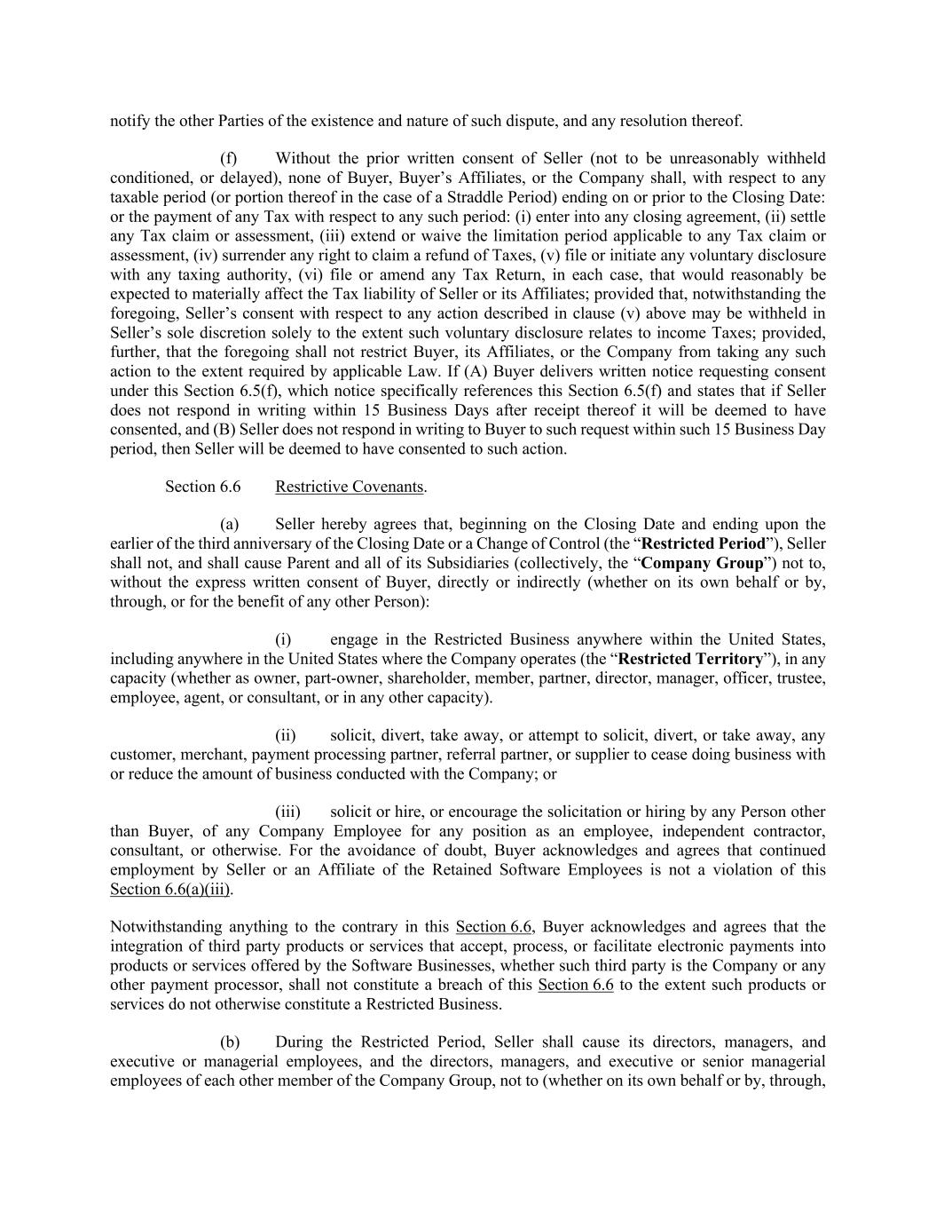
notify the other Parties of the existence and nature of such dispute, and any resolution thereof. (f) Without the prior written consent of Seller (not to be unreasonably withheld conditioned, or delayed), none of Buyer, Buyer’s Affiliates, or the Company shall, with respect to any taxable period (or portion thereof in the case of a Straddle Period) ending on or prior to the Closing Date: or the payment of any Tax with respect to any such period: (i) enter into any closing agreement, (ii) settle any Tax claim or assessment, (iii) extend or waive the limitation period applicable to any Tax claim or assessment, (iv) surrender any right to claim a refund of Taxes, (v) file or initiate any voluntary disclosure with any taxing authority, (vi) file or amend any Tax Return, in each case, that would reasonably be expected to materially affect the Tax liability of Seller or its Affiliates; provided that, notwithstanding the foregoing, Seller’s consent with respect to any action described in clause (v) above may be withheld in Seller’s sole discretion solely to the extent such voluntary disclosure relates to income Taxes; provided, further, that the foregoing shall not restrict Buyer, its Affiliates, or the Company from taking any such action to the extent required by applicable Law. If (A) Buyer delivers written notice requesting consent under this Section 6.5(f), which notice specifically references this Section 6.5(f) and states that if Seller does not respond in writing within 15 Business Days after receipt thereof it will be deemed to have consented, and (B) Seller does not respond in writing to Buyer to such request within such 15 Business Day period, then Seller will be deemed to have consented to such action. Section 6.6 Restrictive Covenants. (a) Seller hereby agrees that, beginning on the Closing Date and ending upon the earlier of the third anniversary of the Closing Date or a Change of Control (the “Restricted Period”), Seller shall not, and shall cause Parent and all of its Subsidiaries (collectively, the “Company Group”) not to, without the express written consent of Buyer, directly or indirectly (whether on its own behalf or by, through, or for the benefit of any other Person): (i) engage in the Restricted Business anywhere within the United States, including anywhere in the United States where the Company operates (the “Restricted Territory”), in any capacity (whether as owner, part-owner, shareholder, member, partner, director, manager, officer, trustee, employee, agent, or consultant, or in any other capacity). (ii) solicit, divert, take away, or attempt to solicit, divert, or take away, any customer, merchant, payment processing partner, referral partner, or supplier to cease doing business with or reduce the amount of business conducted with the Company; or (iii) solicit or hire, or encourage the solicitation or hiring by any Person other than Buyer, of any Company Employee for any position as an employee, independent contractor, consultant, or otherwise. For the avoidance of doubt, Buyer acknowledges and agrees that continued employment by Seller or an Affiliate of the Retained Software Employees is not a violation of this Section 6.6(a)(iii). Notwithstanding anything to the contrary in this Section 6.6, Buyer acknowledges and agrees that the integration of third party products or services that accept, process, or facilitate electronic payments into products or services offered by the Software Businesses, whether such third party is the Company or any other payment processor, shall not constitute a breach of this Section 6.6 to the extent such products or services do not otherwise constitute a Restricted Business. (b) During the Restricted Period, Seller shall cause its directors, managers, and executive or managerial employees, and the directors, managers, and executive or senior managerial employees of each other member of the Company Group, not to (whether on its own behalf or by, through,

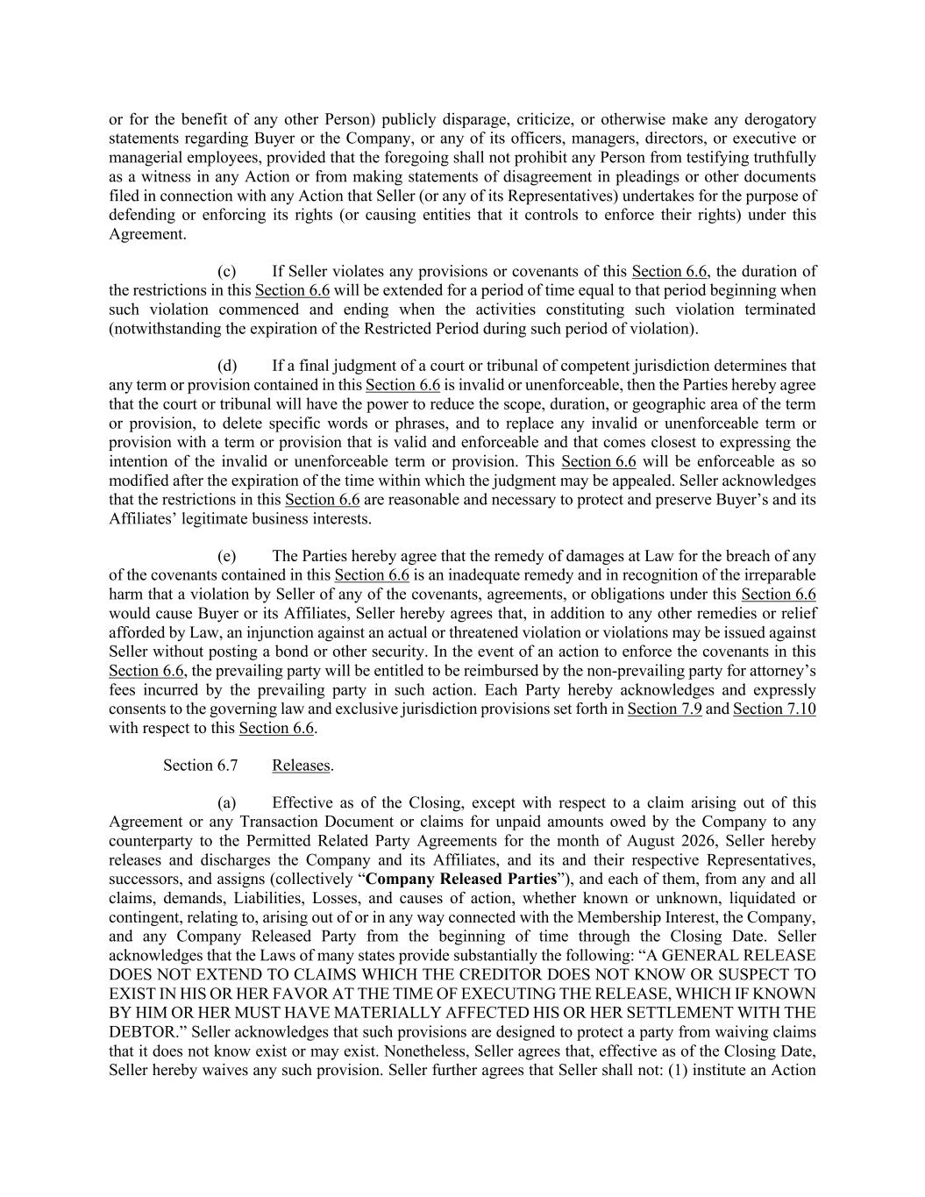
or for the benefit of any other Person) publicly disparage, criticize, or otherwise make any derogatory statements regarding Buyer or the Company, or any of its officers, managers, directors, or executive or managerial employees, provided that the foregoing shall not prohibit any Person from testifying truthfully as a witness in any Action or from making statements of disagreement in pleadings or other documents filed in connection with any Action that Seller (or any of its Representatives) undertakes for the purpose of defending or enforcing its rights (or causing entities that it controls to enforce their rights) under this Agreement. (c) If Seller violates any provisions or covenants of this Section 6.6, the duration of the restrictions in this Section 6.6 will be extended for a period of time equal to that period beginning when such violation commenced and ending when the activities constituting such violation terminated (notwithstanding the expiration of the Restricted Period during such period of violation). (d) If a final judgment of a court or tribunal of competent jurisdiction determines that any term or provision contained in this Section 6.6 is invalid or unenforceable, then the Parties hereby agree that the court or tribunal will have the power to reduce the scope, duration, or geographic area of the term or provision, to delete specific words or phrases, and to replace any invalid or unenforceable term or provision with a term or provision that is valid and enforceable and that comes closest to expressing the intention of the invalid or unenforceable term or provision. This Section 6.6 will be enforceable as so modified after the expiration of the time within which the judgment may be appealed. Seller acknowledges that the restrictions in this Section 6.6 are reasonable and necessary to protect and preserve Buyer’s and its Affiliates’ legitimate business interests. (e) The Parties hereby agree that the remedy of damages at Law for the breach of any of the covenants contained in this Section 6.6 is an inadequate remedy and in recognition of the irreparable harm that a violation by Seller of any of the covenants, agreements, or obligations under this Section 6.6 would cause Buyer or its Affiliates, Seller hereby agrees that, in addition to any other remedies or relief afforded by Law, an injunction against an actual or threatened violation or violations may be issued against Seller without posting a bond or other security. In the event of an action to enforce the covenants in this Section 6.6, the prevailing party will be entitled to be reimbursed by the non-prevailing party for attorney’s fees incurred by the prevailing party in such action. Each Party hereby acknowledges and expressly consents to the governing law and exclusive jurisdiction provisions set forth in Section 7.9 and Section 7.10 with respect to this Section 6.6. Section 6.7 Releases. (a) Effective as of the Closing, except with respect to a claim arising out of this Agreement or any Transaction Document or claims for unpaid amounts owed by the Company to any counterparty to the Permitted Related Party Agreements for the month of August 2026, Seller hereby releases and discharges the Company and its Affiliates, and its and their respective Representatives, successors, and assigns (collectively “Company Released Parties”), and each of them, from any and all claims, demands, Liabilities, Losses, and causes of action, whether known or unknown, liquidated or contingent, relating to, arising out of or in any way connected with the Membership Interest, the Company, and any Company Released Party from the beginning of time through the Closing Date. Seller acknowledges that the Laws of many states provide substantially the following: “A GENERAL RELEASE DOES NOT EXTEND TO CLAIMS WHICH THE CREDITOR DOES NOT KNOW OR SUSPECT TO EXIST IN HIS OR HER FAVOR AT THE TIME OF EXECUTING THE RELEASE, WHICH IF KNOWN BY HIM OR HER MUST HAVE MATERIALLY AFFECTED HIS OR HER SETTLEMENT WITH THE DEBTOR.” Seller acknowledges that such provisions are designed to protect a party from waiving claims that it does not know exist or may exist. Nonetheless, Seller agrees that, effective as of the Closing Date, Seller hereby waives any such provision. Seller further agrees that Seller shall not: (1) institute an Action

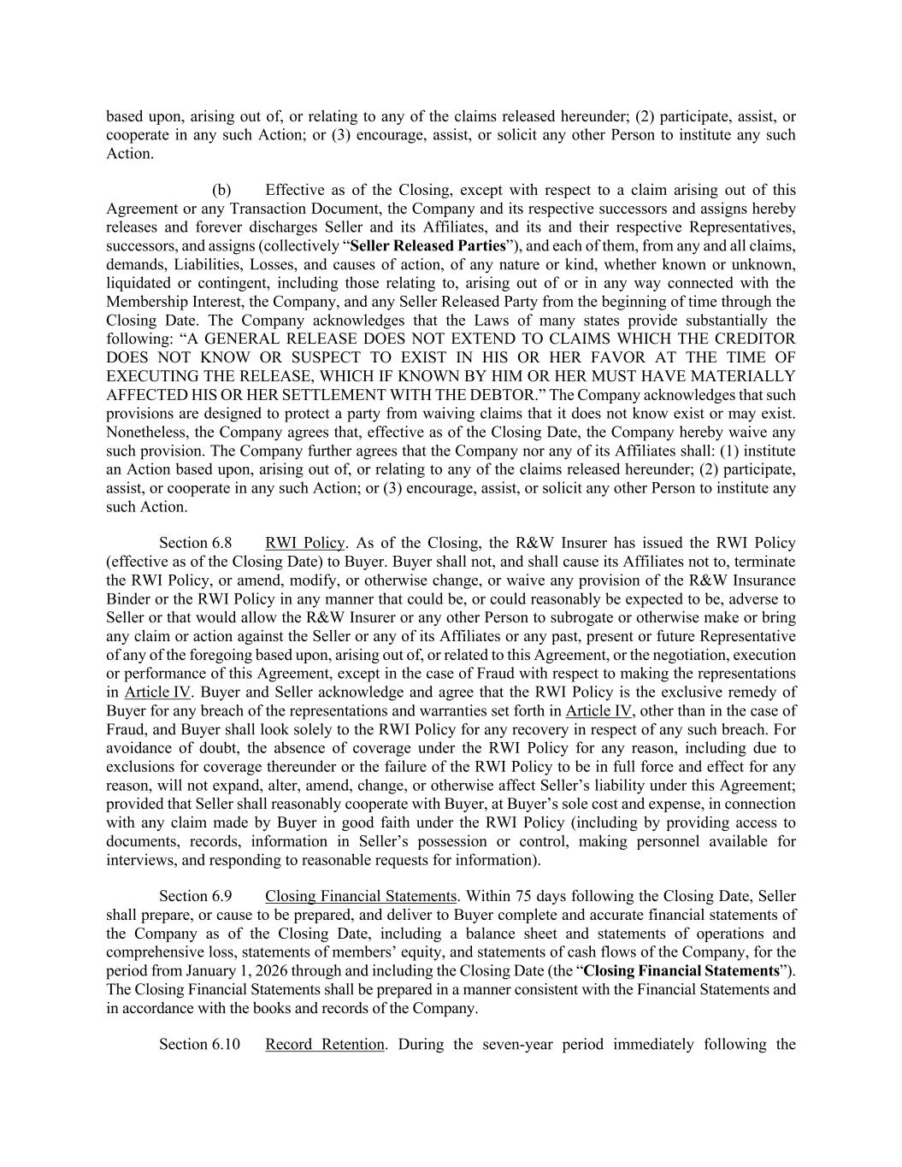
based upon, arising out of, or relating to any of the claims released hereunder; (2) participate, assist, or cooperate in any such Action; or (3) encourage, assist, or solicit any other Person to institute any such Action. (b) Effective as of the Closing, except with respect to a claim arising out of this Agreement or any Transaction Document, the Company and its respective successors and assigns hereby releases and forever discharges Seller and its Affiliates, and its and their respective Representatives, successors, and assigns (collectively “Seller Released Parties”), and each of them, from any and all claims, demands, Liabilities, Losses, and causes of action, of any nature or kind, whether known or unknown, liquidated or contingent, including those relating to, arising out of or in any way connected with the Membership Interest, the Company, and any Seller Released Party from the beginning of time through the Closing Date. The Company acknowledges that the Laws of many states provide substantially the following: “A GENERAL RELEASE DOES NOT EXTEND TO CLAIMS WHICH THE CREDITOR DOES NOT KNOW OR SUSPECT TO EXIST IN HIS OR HER FAVOR AT THE TIME OF EXECUTING THE RELEASE, WHICH IF KNOWN BY HIM OR HER MUST HAVE MATERIALLY AFFECTED HIS OR HER SETTLEMENT WITH THE DEBTOR.” The Company acknowledges that such provisions are designed to protect a party from waiving claims that it does not know exist or may exist. Nonetheless, the Company agrees that, effective as of the Closing Date, the Company hereby waive any such provision. The Company further agrees that the Company nor any of its Affiliates shall: (1) institute an Action based upon, arising out of, or relating to any of the claims released hereunder; (2) participate, assist, or cooperate in any such Action; or (3) encourage, assist, or solicit any other Person to institute any such Action. Section 6.8 RWI Policy. As of the Closing, the R&W Insurer has issued the RWI Policy (effective as of the Closing Date) to Buyer. Buyer shall not, and shall cause its Affiliates not to, terminate the RWI Policy, or amend, modify, or otherwise change, or waive any provision of the R&W Insurance Binder or the RWI Policy in any manner that could be, or could reasonably be expected to be, adverse to Seller or that would allow the R&W Insurer or any other Person to subrogate or otherwise make or bring any claim or action against the Seller or any of its Affiliates or any past, present or future Representative of any of the foregoing based upon, arising out of, or related to this Agreement, or the negotiation, execution or performance of this Agreement, except in the case of Fraud with respect to making the representations in Article IV. Buyer and Seller acknowledge and agree that the RWI Policy is the exclusive remedy of Buyer for any breach of the representations and warranties set forth in Article IV, other than in the case of Fraud, and Buyer shall look solely to the RWI Policy for any recovery in respect of any such breach. For avoidance of doubt, the absence of coverage under the RWI Policy for any reason, including due to exclusions for coverage thereunder or the failure of the RWI Policy to be in full force and effect for any reason, will not expand, alter, amend, change, or otherwise affect Seller’s liability under this Agreement; provided that Seller shall reasonably cooperate with Buyer, at Buyer’s sole cost and expense, in connection with any claim made by Buyer in good faith under the RWI Policy (including by providing access to documents, records, information in Seller’s possession or control, making personnel available for interviews, and responding to reasonable requests for information). Section 6.9 Closing Financial Statements. Within 75 days following the Closing Date, Seller shall prepare, or cause to be prepared, and deliver to Buyer complete and accurate financial statements of the Company as of the Closing Date, including a balance sheet and statements of operations and comprehensive loss, statements of members’ equity, and statements of cash flows of the Company, for the period from January 1, 2026 through and including the Closing Date (the “Closing Financial Statements”). The Closing Financial Statements shall be prepared in a manner consistent with the Financial Statements and in accordance with the books and records of the Company. Section 6.10 Record Retention. During the seven-year period immediately following the

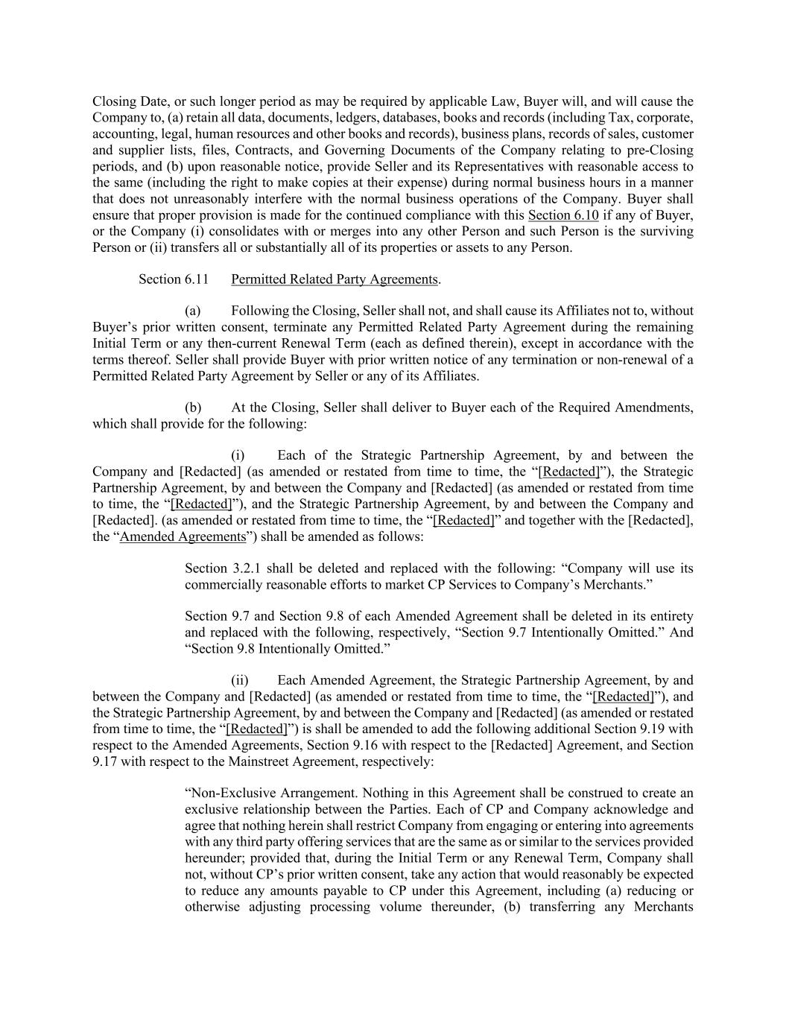
Closing Date, or such longer period as may be required by applicable Law, Buyer will, and will cause the Company to, (a) retain all data, documents, ledgers, databases, books and records (including Tax, corporate, accounting, legal, human resources and other books and records), business plans, records of sales, customer and supplier lists, files, Contracts, and Governing Documents of the Company relating to pre-Closing periods, and (b) upon reasonable notice, provide Seller and its Representatives with reasonable access to the same (including the right to make copies at their expense) during normal business hours in a manner that does not unreasonably interfere with the normal business operations of the Company. Buyer shall ensure that proper provision is made for the continued compliance with this Section 6.10 if any of Buyer, or the Company (i) consolidates with or merges into any other Person and such Person is the surviving Person or (ii) transfers all or substantially all of its properties or assets to any Person. Section 6.11 Permitted Related Party Agreements. (a) Following the Closing, Seller shall not, and shall cause its Affiliates not to, without Buyer’s prior written consent, terminate any Permitted Related Party Agreement during the remaining Initial Term or any then-current Renewal Term (each as defined therein), except in accordance with the terms thereof. Seller shall provide Buyer with prior written notice of any termination or non-renewal of a Permitted Related Party Agreement by Seller or any of its Affiliates. (b) At the Closing, Seller shall deliver to Buyer each of the Required Amendments, which shall provide for the following: (i) Each of the Strategic Partnership Agreement, by and between the Company and [Redacted] (as amended or restated from time to time, the “[Redacted]”), the Strategic Partnership Agreement, by and between the Company and [Redacted] (as amended or restated from time to time, the “[Redacted]”), and the Strategic Partnership Agreement, by and between the Company and [Redacted]. (as amended or restated from time to time, the “[Redacted]” and together with the [Redacted], the “Amended Agreements”) shall be amended as follows: Section 3.2.1 shall be deleted and replaced with the following: “Company will use its commercially reasonable efforts to market CP Services to Company’s Merchants.” Section 9.7 and Section 9.8 of each Amended Agreement shall be deleted in its entirety and replaced with the following, respectively, “Section 9.7 Intentionally Omitted.” And “Section 9.8 Intentionally Omitted.” (ii) Each Amended Agreement, the Strategic Partnership Agreement, by and between the Company and [Redacted] (as amended or restated from time to time, the “[Redacted]”), and the Strategic Partnership Agreement, by and between the Company and [Redacted] (as amended or restated from time to time, the “[Redacted]”) is shall be amended to add the following additional Section 9.19 with respect to the Amended Agreements, Section 9.16 with respect to the [Redacted] Agreement, and Section 9.17 with respect to the Mainstreet Agreement, respectively: “Non-Exclusive Arrangement. Nothing in this Agreement shall be construed to create an exclusive relationship between the Parties. Each of CP and Company acknowledge and agree that nothing herein shall restrict Company from engaging or entering into agreements with any third party offering services that are the same as or similar to the services provided hereunder; provided that, during the Initial Term or any Renewal Term, Company shall not, without CP’s prior written consent, take any action that would reasonably be expected to reduce any amounts payable to CP under this Agreement, including (a) reducing or otherwise adjusting processing volume thereunder, (b) transferring any Merchants

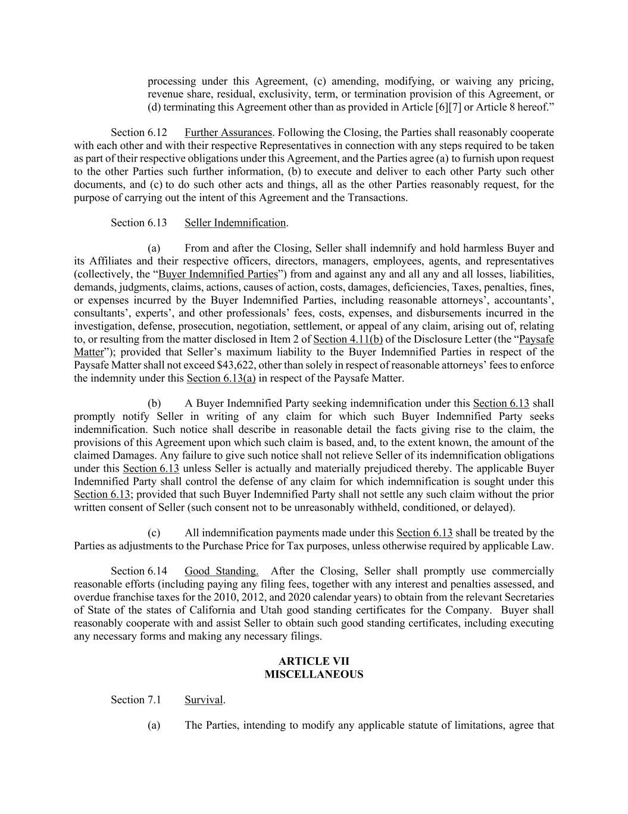
processing under this Agreement, (c) amending, modifying, or waiving any pricing, revenue share, residual, exclusivity, term, or termination provision of this Agreement, or (d) terminating this Agreement other than as provided in Article [6][7] or Article 8 hereof.” Section 6.12 Further Assurances. Following the Closing, the Parties shall reasonably cooperate with each other and with their respective Representatives in connection with any steps required to be taken as part of their respective obligations under this Agreement, and the Parties agree (a) to furnish upon request to the other Parties such further information, (b) to execute and deliver to each other Party such other documents, and (c) to do such other acts and things, all as the other Parties reasonably request, for the purpose of carrying out the intent of this Agreement and the Transactions. Section 6.13 Seller Indemnification. (a) From and after the Closing, Seller shall indemnify and hold harmless Buyer and its Affiliates and their respective officers, directors, managers, employees, agents, and representatives (collectively, the “Buyer Indemnified Parties”) from and against any and all any and all losses, liabilities, demands, judgments, claims, actions, causes of action, costs, damages, deficiencies, Taxes, penalties, fines, or expenses incurred by the Buyer Indemnified Parties, including reasonable attorneys’, accountants’, consultants’, experts’, and other professionals’ fees, costs, expenses, and disbursements incurred in the investigation, defense, prosecution, negotiation, settlement, or appeal of any claim, arising out of, relating to, or resulting from the matter disclosed in Item 2 of Section 4.11(b) of the Disclosure Letter (the “Paysafe Matter”); provided that Seller’s maximum liability to the Buyer Indemnified Parties in respect of the Paysafe Matter shall not exceed $43,622, other than solely in respect of reasonable attorneys’ fees to enforce the indemnity under this Section 6.13(a) in respect of the Paysafe Matter. (b) A Buyer Indemnified Party seeking indemnification under this Section 6.13 shall promptly notify Seller in writing of any claim for which such Buyer Indemnified Party seeks indemnification. Such notice shall describe in reasonable detail the facts giving rise to the claim, the provisions of this Agreement upon which such claim is based, and, to the extent known, the amount of the claimed Damages. Any failure to give such notice shall not relieve Seller of its indemnification obligations under this Section 6.13 unless Seller is actually and materially prejudiced thereby. The applicable Buyer Indemnified Party shall control the defense of any claim for which indemnification is sought under this Section 6.13; provided that such Buyer Indemnified Party shall not settle any such claim without the prior written consent of Seller (such consent not to be unreasonably withheld, conditioned, or delayed). (c) All indemnification payments made under this Section 6.13 shall be treated by the Parties as adjustments to the Purchase Price for Tax purposes, unless otherwise required by applicable Law. Section 6.14 Good Standing. After the Closing, Seller shall promptly use commercially reasonable efforts (including paying any filing fees, together with any interest and penalties assessed, and overdue franchise taxes for the 2010, 2012, and 2020 calendar years) to obtain from the relevant Secretaries of State of the states of California and Utah good standing certificates for the Company. Buyer shall reasonably cooperate with and assist Seller to obtain such good standing certificates, including executing any necessary forms and making any necessary filings. ARTICLE VII MISCELLANEOUS Section 7.1 Survival. (a) The Parties, intending to modify any applicable statute of limitations, agree that

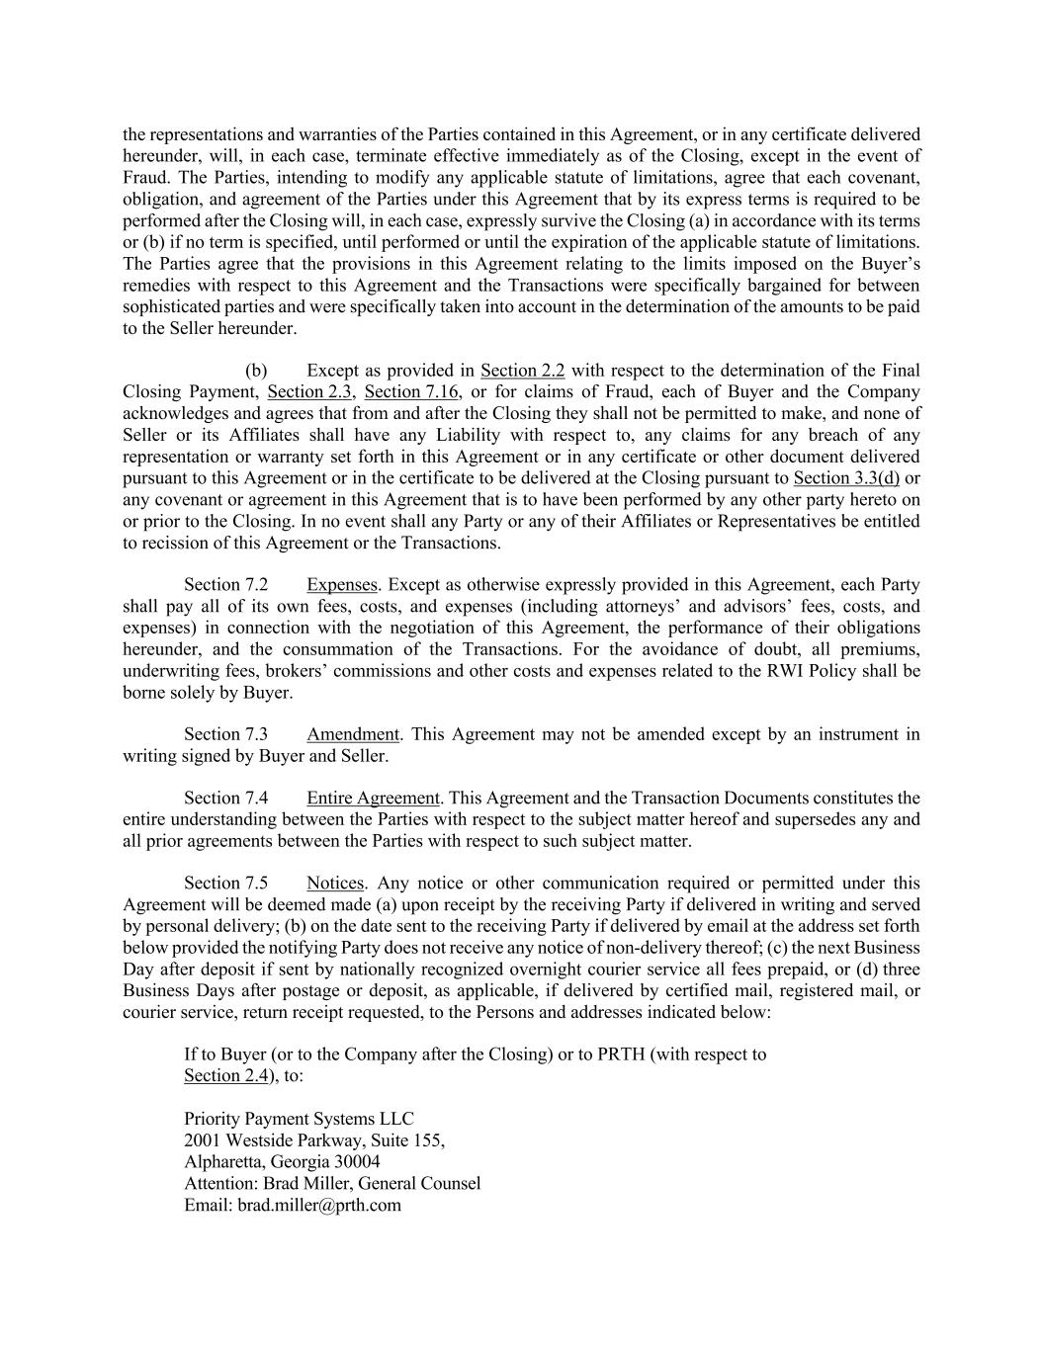
the representations and warranties of the Parties contained in this Agreement, or in any certificate delivered hereunder, will, in each case, terminate effective immediately as of the Closing, except in the event of Fraud. The Parties, intending to modify any applicable statute of limitations, agree that each covenant, obligation, and agreement of the Parties under this Agreement that by its express terms is required to be performed after the Closing will, in each case, expressly survive the Closing (a) in accordance with its terms or (b) if no term is specified, until performed or until the expiration of the applicable statute of limitations. The Parties agree that the provisions in this Agreement relating to the limits imposed on the Buyer’s remedies with respect to this Agreement and the Transactions were specifically bargained for between sophisticated parties and were specifically taken into account in the determination of the amounts to be paid to the Seller hereunder. (b) Except as provided in Section 2.2 with respect to the determination of the Final Closing Payment, Section 2.3, Section 7.16, or for claims of Fraud, each of Buyer and the Company acknowledges and agrees that from and after the Closing they shall not be permitted to make, and none of Seller or its Affiliates shall have any Liability with respect to, any claims for any breach of any representation or warranty set forth in this Agreement or in any certificate or other document delivered pursuant to this Agreement or in the certificate to be delivered at the Closing pursuant to Section 3.3(d) or any covenant or agreement in this Agreement that is to have been performed by any other party hereto on or prior to the Closing. In no event shall any Party or any of their Affiliates or Representatives be entitled to recission of this Agreement or the Transactions. Section 7.2 Expenses. Except as otherwise expressly provided in this Agreement, each Party shall pay all of its own fees, costs, and expenses (including attorneys’ and advisors’ fees, costs, and expenses) in connection with the negotiation of this Agreement, the performance of their obligations hereunder, and the consummation of the Transactions. For the avoidance of doubt, all premiums, underwriting fees, brokers’ commissions and other costs and expenses related to the RWI Policy shall be borne solely by Buyer. Section 7.3 Amendment. This Agreement may not be amended except by an instrument in writing signed by Buyer and Seller. Section 7.4 Entire Agreement. This Agreement and the Transaction Documents constitutes the entire understanding between the Parties with respect to the subject matter hereof and supersedes any and all prior agreements between the Parties with respect to such subject matter. Section 7.5 Notices. Any notice or other communication required or permitted under this Agreement will be deemed made (a) upon receipt by the receiving Party if delivered in writing and served by personal delivery; (b) on the date sent to the receiving Party if delivered by email at the address set forth below provided the notifying Party does not receive any notice of non-delivery thereof; (c) the next Business Day after deposit if sent by nationally recognized overnight courier service all fees prepaid, or (d) three Business Days after postage or deposit, as applicable, if delivered by certified mail, registered mail, or courier service, return receipt requested, to the Persons and addresses indicated below: If to Buyer (or to the Company after the Closing) or to PRTH (with respect to Section 2.4), to: Priority Payment Systems LLC 2001 Westside Parkway, Suite 155, Alpharetta, Georgia 30004 Attention: Brad Miller, General Counsel Email: brad.miller@prth.com

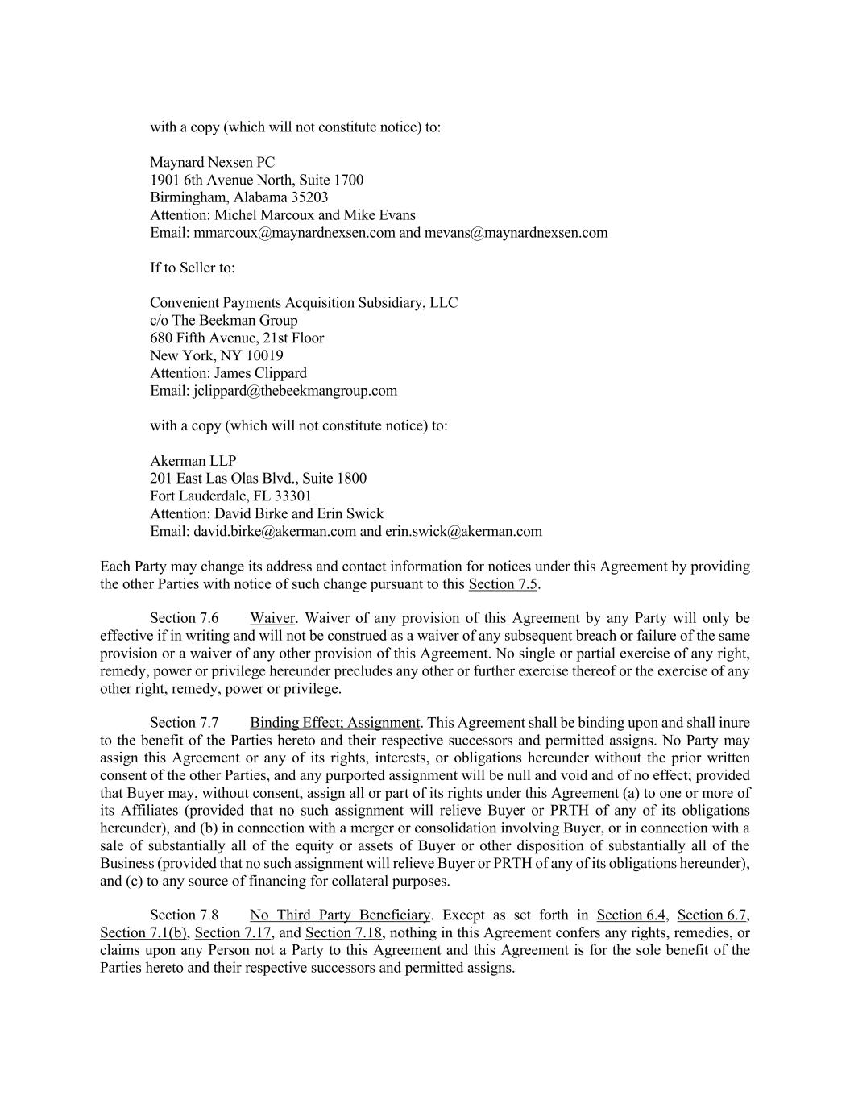
with a copy (which will not constitute notice) to: Maynard Nexsen PC 1901 6th Avenue North, Suite 1700 Birmingham, Alabama 35203 Attention: Michel Marcoux and Mike Evans Email: mmarcoux@maynardnexsen.com and mevans@maynardnexsen.com If to Seller to: Convenient Payments Acquisition Subsidiary, LLC c/o The Beekman Group 680 Fifth Avenue, 21st Floor New York, NY 10019 Attention: James Clippard Email: jclippard@thebeekmangroup.com with a copy (which will not constitute notice) to: Akerman LLP 201 East Las Olas Blvd., Suite 1800 Fort Lauderdale, FL 33301 Attention: David Birke and Erin Swick Email: david.birke@akerman.com and erin.swick@akerman.com Each Party may change its address and contact information for notices under this Agreement by providing the other Parties with notice of such change pursuant to this Section 7.5. Section 7.6 Waiver. Waiver of any provision of this Agreement by any Party will only be effective if in writing and will not be construed as a waiver of any subsequent breach or failure of the same provision or a waiver of any other provision of this Agreement. No single or partial exercise of any right, remedy, power or privilege hereunder precludes any other or further exercise thereof or the exercise of any other right, remedy, power or privilege. Section 7.7 Binding Effect; Assignment. This Agreement shall be binding upon and shall inure to the benefit of the Parties hereto and their respective successors and permitted assigns. No Party may assign this Agreement or any of its rights, interests, or obligations hereunder without the prior written consent of the other Parties, and any purported assignment will be null and void and of no effect; provided that Buyer may, without consent, assign all or part of its rights under this Agreement (a) to one or more of its Affiliates (provided that no such assignment will relieve Buyer or PRTH of any of its obligations hereunder), and (b) in connection with a merger or consolidation involving Buyer, or in connection with a sale of substantially all of the equity or assets of Buyer or other disposition of substantially all of the Business (provided that no such assignment will relieve Buyer or PRTH of any of its obligations hereunder), and (c) to any source of financing for collateral purposes. Section 7.8 No Third Party Beneficiary. Except as set forth in Section 6.4, Section 6.7, Section 7.1(b), Section 7.17, and Section 7.18, nothing in this Agreement confers any rights, remedies, or claims upon any Person not a Party to this Agreement and this Agreement is for the sole benefit of the Parties hereto and their respective successors and permitted assigns.

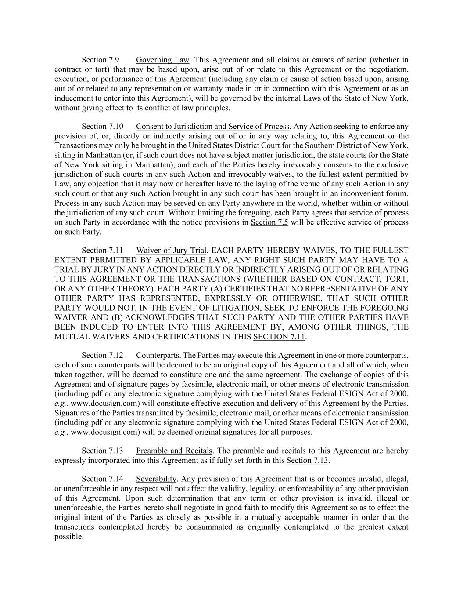
Section 7.9 Governing Law. This Agreement and all claims or causes of action (whether in contract or tort) that may be based upon, arise out of or relate to this Agreement or the negotiation, execution, or performance of this Agreement (including any claim or cause of action based upon, arising out of or related to any representation or warranty made in or in connection with this Agreement or as an inducement to enter into this Agreement), will be governed by the internal Laws of the State of New York, without giving effect to its conflict of law principles. Section 7.10 Consent to Jurisdiction and Service of Process. Any Action seeking to enforce any provision of, or, directly or indirectly arising out of or in any way relating to, this Agreement or the Transactions may only be brought in the United States District Court for the Southern District of New York, sitting in Manhattan (or, if such court does not have subject matter jurisdiction, the state courts for the State of New York sitting in Manhattan), and each of the Parties hereby irrevocably consents to the exclusive jurisdiction of such courts in any such Action and irrevocably waives, to the fullest extent permitted by Law, any objection that it may now or hereafter have to the laying of the venue of any such Action in any such court or that any such Action brought in any such court has been brought in an inconvenient forum. Process in any such Action may be served on any Party anywhere in the world, whether within or without the jurisdiction of any such court. Without limiting the foregoing, each Party agrees that service of process on such Party in accordance with the notice provisions in Section 7.5 will be effective service of process on such Party. Section 7.11 Waiver of Jury Trial. EACH PARTY HEREBY WAIVES, TO THE FULLEST EXTENT PERMITTED BY APPLICABLE LAW, ANY RIGHT SUCH PARTY MAY HAVE TO A TRIAL BY JURY IN ANY ACTION DIRECTLY OR INDIRECTLY ARISING OUT OF OR RELATING TO THIS AGREEMENT OR THE TRANSACTIONS (WHETHER BASED ON CONTRACT, TORT, OR ANY OTHER THEORY). EACH PARTY (A) CERTIFIES THAT NO REPRESENTATIVE OF ANY OTHER PARTY HAS REPRESENTED, EXPRESSLY OR OTHERWISE, THAT SUCH OTHER PARTY WOULD NOT, IN THE EVENT OF LITIGATION, SEEK TO ENFORCE THE FOREGOING WAIVER AND (B) ACKNOWLEDGES THAT SUCH PARTY AND THE OTHER PARTIES HAVE BEEN INDUCED TO ENTER INTO THIS AGREEMENT BY, AMONG OTHER THINGS, THE MUTUAL WAIVERS AND CERTIFICATIONS IN THIS SECTION 7.11. Section 7.12 Counterparts. The Parties may execute this Agreement in one or more counterparts, each of such counterparts will be deemed to be an original copy of this Agreement and all of which, when taken together, will be deemed to constitute one and the same agreement. The exchange of copies of this Agreement and of signature pages by facsimile, electronic mail, or other means of electronic transmission (including pdf or any electronic signature complying with the United States Federal ESIGN Act of 2000, e.g., www.docusign.com) will constitute effective execution and delivery of this Agreement by the Parties. Signatures of the Parties transmitted by facsimile, electronic mail, or other means of electronic transmission (including pdf or any electronic signature complying with the United States Federal ESIGN Act of 2000, e.g., www.docusign.com) will be deemed original signatures for all purposes. Section 7.13 Preamble and Recitals. The preamble and recitals to this Agreement are hereby expressly incorporated into this Agreement as if fully set forth in this Section 7.13. Section 7.14 Severability. Any provision of this Agreement that is or becomes invalid, illegal, or unenforceable in any respect will not affect the validity, legality, or enforceability of any other provision of this Agreement. Upon such determination that any term or other provision is invalid, illegal or unenforceable, the Parties hereto shall negotiate in good faith to modify this Agreement so as to effect the original intent of the Parties as closely as possible in a mutually acceptable manner in order that the transactions contemplated hereby be consummated as originally contemplated to the greatest extent possible.

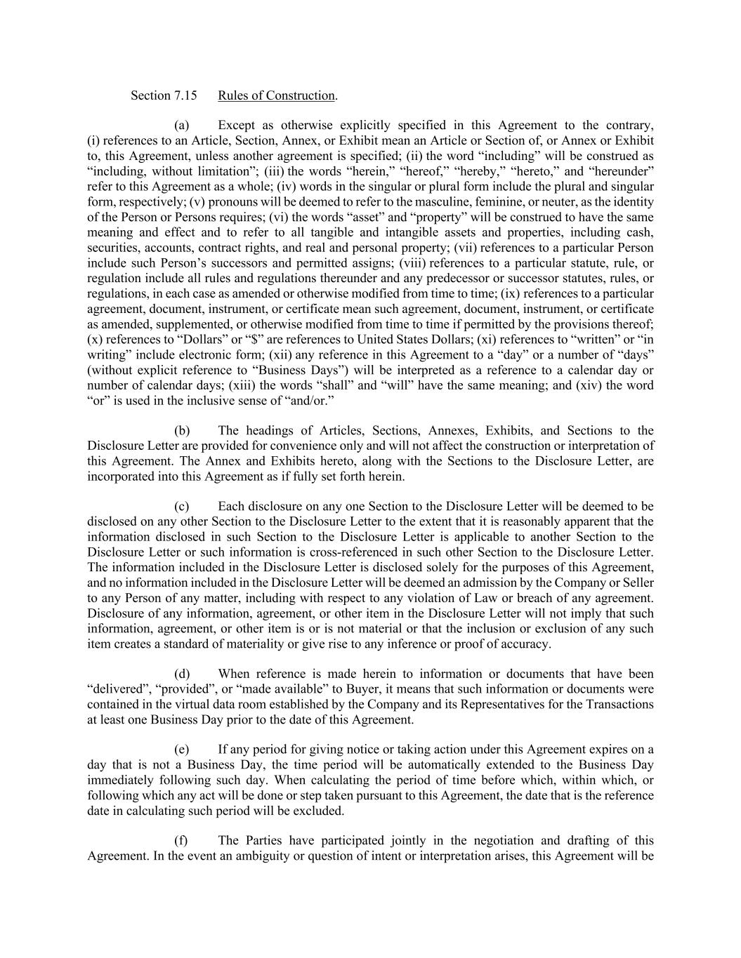
Section 7.15 Rules of Construction. (a) Except as otherwise explicitly specified in this Agreement to the contrary, (i) references to an Article, Section, Annex, or Exhibit mean an Article or Section of, or Annex or Exhibit to, this Agreement, unless another agreement is specified; (ii) the word “including” will be construed as “including, without limitation”; (iii) the words “herein,” “hereof,” “hereby,” “hereto,” and “hereunder” refer to this Agreement as a whole; (iv) words in the singular or plural form include the plural and singular form, respectively; (v) pronouns will be deemed to refer to the masculine, feminine, or neuter, as the identity of the Person or Persons requires; (vi) the words “asset” and “property” will be construed to have the same meaning and effect and to refer to all tangible and intangible assets and properties, including cash, securities, accounts, contract rights, and real and personal property; (vii) references to a particular Person include such Person’s successors and permitted assigns; (viii) references to a particular statute, rule, or regulation include all rules and regulations thereunder and any predecessor or successor statutes, rules, or regulations, in each case as amended or otherwise modified from time to time; (ix) references to a particular agreement, document, instrument, or certificate mean such agreement, document, instrument, or certificate as amended, supplemented, or otherwise modified from time to time if permitted by the provisions thereof; (x) references to “Dollars” or “$” are references to United States Dollars; (xi) references to “written” or “in writing” include electronic form; (xii) any reference in this Agreement to a “day” or a number of “days” (without explicit reference to “Business Days”) will be interpreted as a reference to a calendar day or number of calendar days; (xiii) the words “shall” and “will” have the same meaning; and (xiv) the word “or” is used in the inclusive sense of “and/or.” (b) The headings of Articles, Sections, Annexes, Exhibits, and Sections to the Disclosure Letter are provided for convenience only and will not affect the construction or interpretation of this Agreement. The Annex and Exhibits hereto, along with the Sections to the Disclosure Letter, are incorporated into this Agreement as if fully set forth herein. (c) Each disclosure on any one Section to the Disclosure Letter will be deemed to be disclosed on any other Section to the Disclosure Letter to the extent that it is reasonably apparent that the information disclosed in such Section to the Disclosure Letter is applicable to another Section to the Disclosure Letter or such information is cross-referenced in such other Section to the Disclosure Letter. The information included in the Disclosure Letter is disclosed solely for the purposes of this Agreement, and no information included in the Disclosure Letter will be deemed an admission by the Company or Seller to any Person of any matter, including with respect to any violation of Law or breach of any agreement. Disclosure of any information, agreement, or other item in the Disclosure Letter will not imply that such information, agreement, or other item is or is not material or that the inclusion or exclusion of any such item creates a standard of materiality or give rise to any inference or proof of accuracy. (d) When reference is made herein to information or documents that have been “delivered”, “provided”, or “made available” to Buyer, it means that such information or documents were contained in the virtual data room established by the Company and its Representatives for the Transactions at least one Business Day prior to the date of this Agreement. (e) If any period for giving notice or taking action under this Agreement expires on a day that is not a Business Day, the time period will be automatically extended to the Business Day immediately following such day. When calculating the period of time before which, within which, or following which any act will be done or step taken pursuant to this Agreement, the date that is the reference date in calculating such period will be excluded. (f) The Parties have participated jointly in the negotiation and drafting of this Agreement. In the event an ambiguity or question of intent or interpretation arises, this Agreement will be

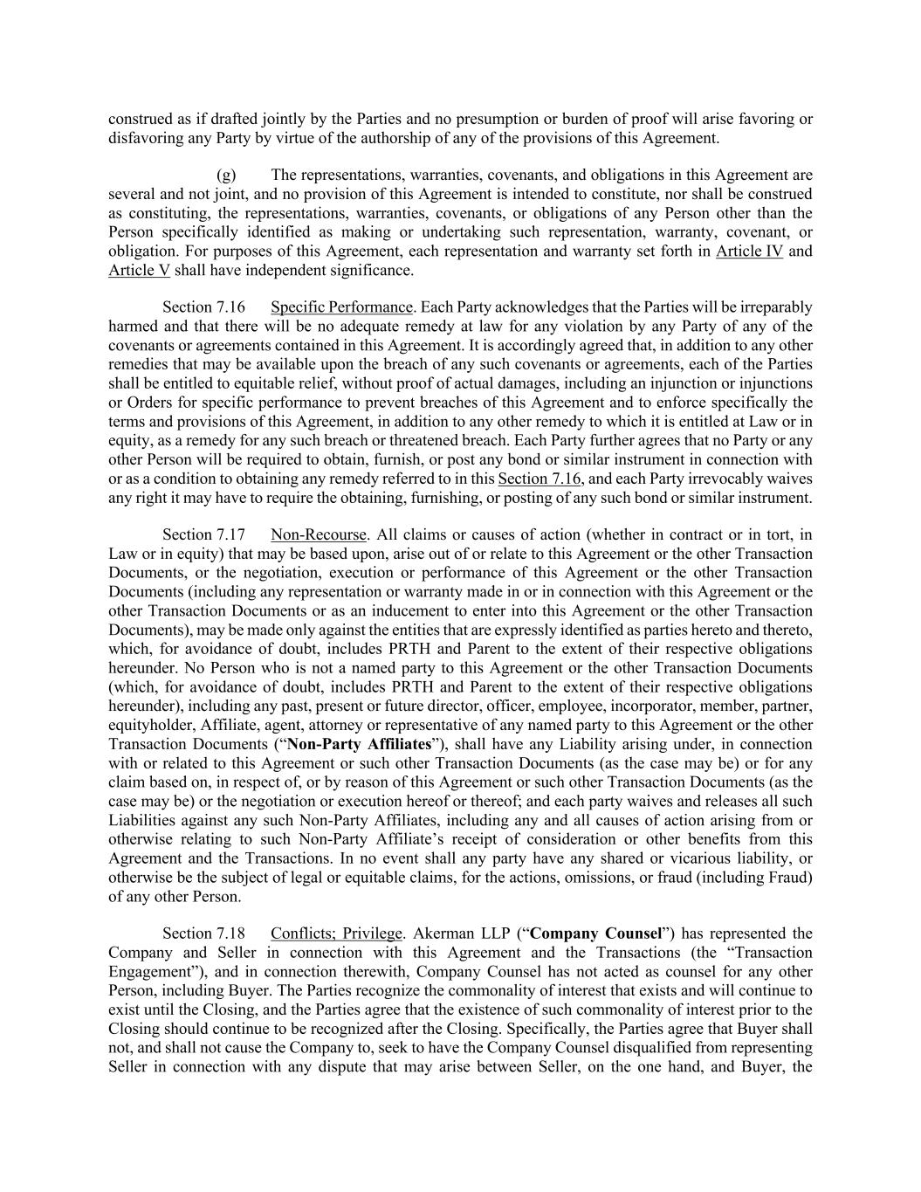
construed as if drafted jointly by the Parties and no presumption or burden of proof will arise favoring or disfavoring any Party by virtue of the authorship of any of the provisions of this Agreement. (g) The representations, warranties, covenants, and obligations in this Agreement are several and not joint, and no provision of this Agreement is intended to constitute, nor shall be construed as constituting, the representations, warranties, covenants, or obligations of any Person other than the Person specifically identified as making or undertaking such representation, warranty, covenant, or obligation. For purposes of this Agreement, each representation and warranty set forth in Article IV and Article V shall have independent significance. Section 7.16 Specific Performance. Each Party acknowledges that the Parties will be irreparably harmed and that there will be no adequate remedy at law for any violation by any Party of any of the covenants or agreements contained in this Agreement. It is accordingly agreed that, in addition to any other remedies that may be available upon the breach of any such covenants or agreements, each of the Parties shall be entitled to equitable relief, without proof of actual damages, including an injunction or injunctions or Orders for specific performance to prevent breaches of this Agreement and to enforce specifically the terms and provisions of this Agreement, in addition to any other remedy to which it is entitled at Law or in equity, as a remedy for any such breach or threatened breach. Each Party further agrees that no Party or any other Person will be required to obtain, furnish, or post any bond or similar instrument in connection with or as a condition to obtaining any remedy referred to in this Section 7.16, and each Party irrevocably waives any right it may have to require the obtaining, furnishing, or posting of any such bond or similar instrument. Section 7.17 Non-Recourse. All claims or causes of action (whether in contract or in tort, in Law or in equity) that may be based upon, arise out of or relate to this Agreement or the other Transaction Documents, or the negotiation, execution or performance of this Agreement or the other Transaction Documents (including any representation or warranty made in or in connection with this Agreement or the other Transaction Documents or as an inducement to enter into this Agreement or the other Transaction Documents), may be made only against the entities that are expressly identified as parties hereto and thereto, which, for avoidance of doubt, includes PRTH and Parent to the extent of their respective obligations hereunder. No Person who is not a named party to this Agreement or the other Transaction Documents (which, for avoidance of doubt, includes PRTH and Parent to the extent of their respective obligations hereunder), including any past, present or future director, officer, employee, incorporator, member, partner, equityholder, Affiliate, agent, attorney or representative of any named party to this Agreement or the other Transaction Documents (“Non-Party Affiliates”), shall have any Liability arising under, in connection with or related to this Agreement or such other Transaction Documents (as the case may be) or for any claim based on, in respect of, or by reason of this Agreement or such other Transaction Documents (as the case may be) or the negotiation or execution hereof or thereof; and each party waives and releases all such Liabilities against any such Non-Party Affiliates, including any and all causes of action arising from or otherwise relating to such Non-Party Affiliate’s receipt of consideration or other benefits from this Agreement and the Transactions. In no event shall any party have any shared or vicarious liability, or otherwise be the subject of legal or equitable claims, for the actions, omissions, or fraud (including Fraud) of any other Person. Section 7.18 Conflicts; Privilege. Akerman LLP (“Company Counsel”) has represented the Company and Seller in connection with this Agreement and the Transactions (the “Transaction Engagement”), and in connection therewith, Company Counsel has not acted as counsel for any other Person, including Buyer. The Parties recognize the commonality of interest that exists and will continue to exist until the Closing, and the Parties agree that the existence of such commonality of interest prior to the Closing should continue to be recognized after the Closing. Specifically, the Parties agree that Buyer shall not, and shall not cause the Company to, seek to have the Company Counsel disqualified from representing Seller in connection with any dispute that may arise between Seller, on the one hand, and Buyer, the

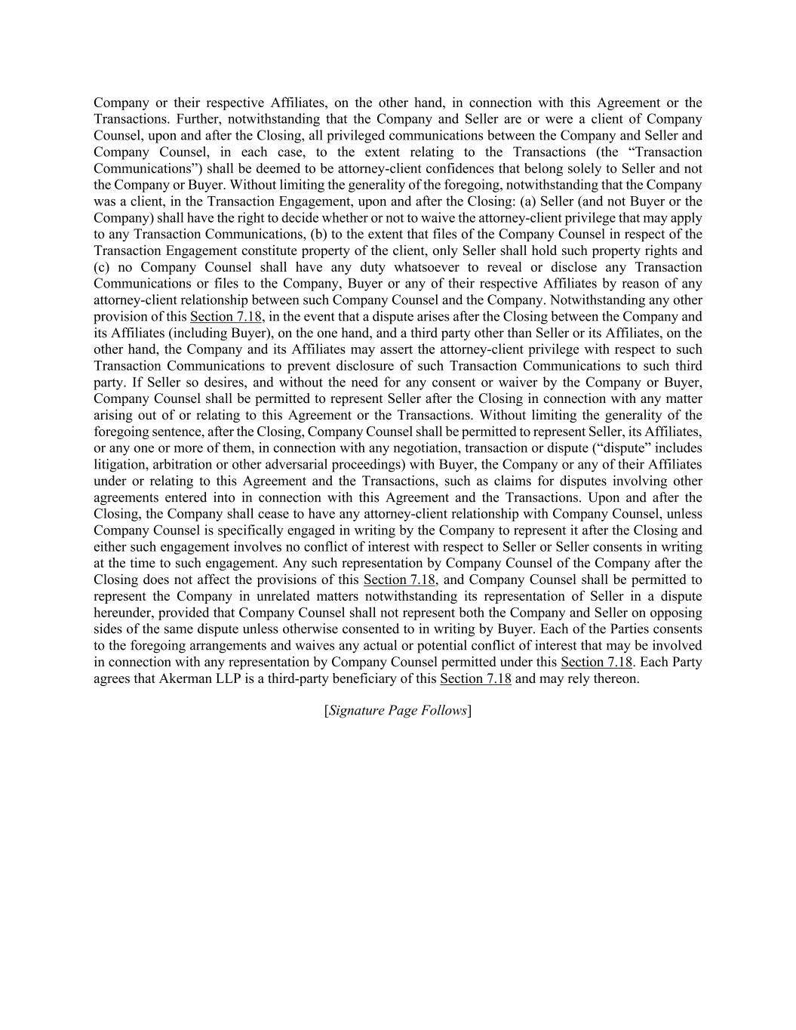
Company or their respective Affiliates, on the other hand, in connection with this Agreement or the Transactions. Further, notwithstanding that the Company and Seller are or were a client of Company Counsel, upon and after the Closing, all privileged communications between the Company and Seller and Company Counsel, in each case, to the extent relating to the Transactions (the “Transaction Communications”) shall be deemed to be attorney-client confidences that belong solely to Seller and not the Company or Buyer. Without limiting the generality of the foregoing, notwithstanding that the Company was a client, in the Transaction Engagement, upon and after the Closing: (a) Seller (and not Buyer or the Company) shall have the right to decide whether or not to waive the attorney-client privilege that may apply to any Transaction Communications, (b) to the extent that files of the Company Counsel in respect of the Transaction Engagement constitute property of the client, only Seller shall hold such property rights and (c) no Company Counsel shall have any duty whatsoever to reveal or disclose any Transaction Communications or files to the Company, Buyer or any of their respective Affiliates by reason of any attorney-client relationship between such Company Counsel and the Company. Notwithstanding any other provision of this Section 7.18, in the event that a dispute arises after the Closing between the Company and its Affiliates (including Buyer), on the one hand, and a third party other than Seller or its Affiliates, on the other hand, the Company and its Affiliates may assert the attorney-client privilege with respect to such Transaction Communications to prevent disclosure of such Transaction Communications to such third party. If Seller so desires, and without the need for any consent or waiver by the Company or Buyer, Company Counsel shall be permitted to represent Seller after the Closing in connection with any matter arising out of or relating to this Agreement or the Transactions. Without limiting the generality of the foregoing sentence, after the Closing, Company Counsel shall be permitted to represent Seller, its Affiliates, or any one or more of them, in connection with any negotiation, transaction or dispute (“dispute” includes litigation, arbitration or other adversarial proceedings) with Buyer, the Company or any of their Affiliates under or relating to this Agreement and the Transactions, such as claims for disputes involving other agreements entered into in connection with this Agreement and the Transactions. Upon and after the Closing, the Company shall cease to have any attorney-client relationship with Company Counsel, unless Company Counsel is specifically engaged in writing by the Company to represent it after the Closing and either such engagement involves no conflict of interest with respect to Seller or Seller consents in writing at the time to such engagement. Any such representation by Company Counsel of the Company after the Closing does not affect the provisions of this Section 7.18, and Company Counsel shall be permitted to represent the Company in unrelated matters notwithstanding its representation of Seller in a dispute hereunder, provided that Company Counsel shall not represent both the Company and Seller on opposing sides of the same dispute unless otherwise consented to in writing by Buyer. Each of the Parties consents to the foregoing arrangements and waives any actual or potential conflict of interest that may be involved in connection with any representation by Company Counsel permitted under this Section 7.18. Each Party agrees that Akerman LLP is a third-party beneficiary of this Section 7.18 and may rely thereon. [Signature Page Follows]

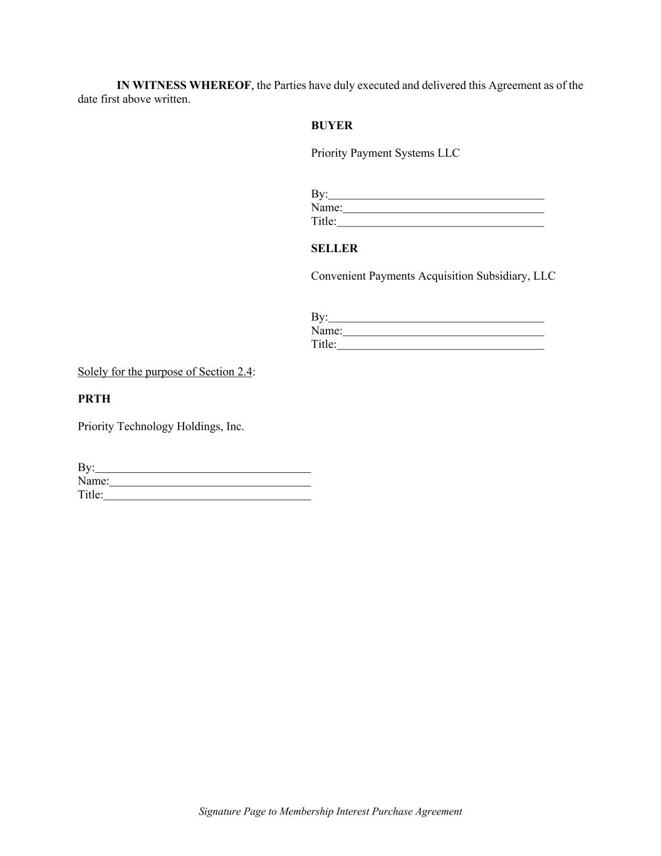
Signature Page to Membership Interest Purchase Agreement IN WITNESS WHEREOF, the Parties have duly executed and delivered this Agreement as of the date first above written. BUYER Priority Payment Systems LLC By: Name: Title: SELLER Convenient Payments Acquisition Subsidiary, LLC By: Name: Title: Solely for the purpose of Section 2.4: PRTH Priority Technology Holdings, Inc. By: Name: Title:

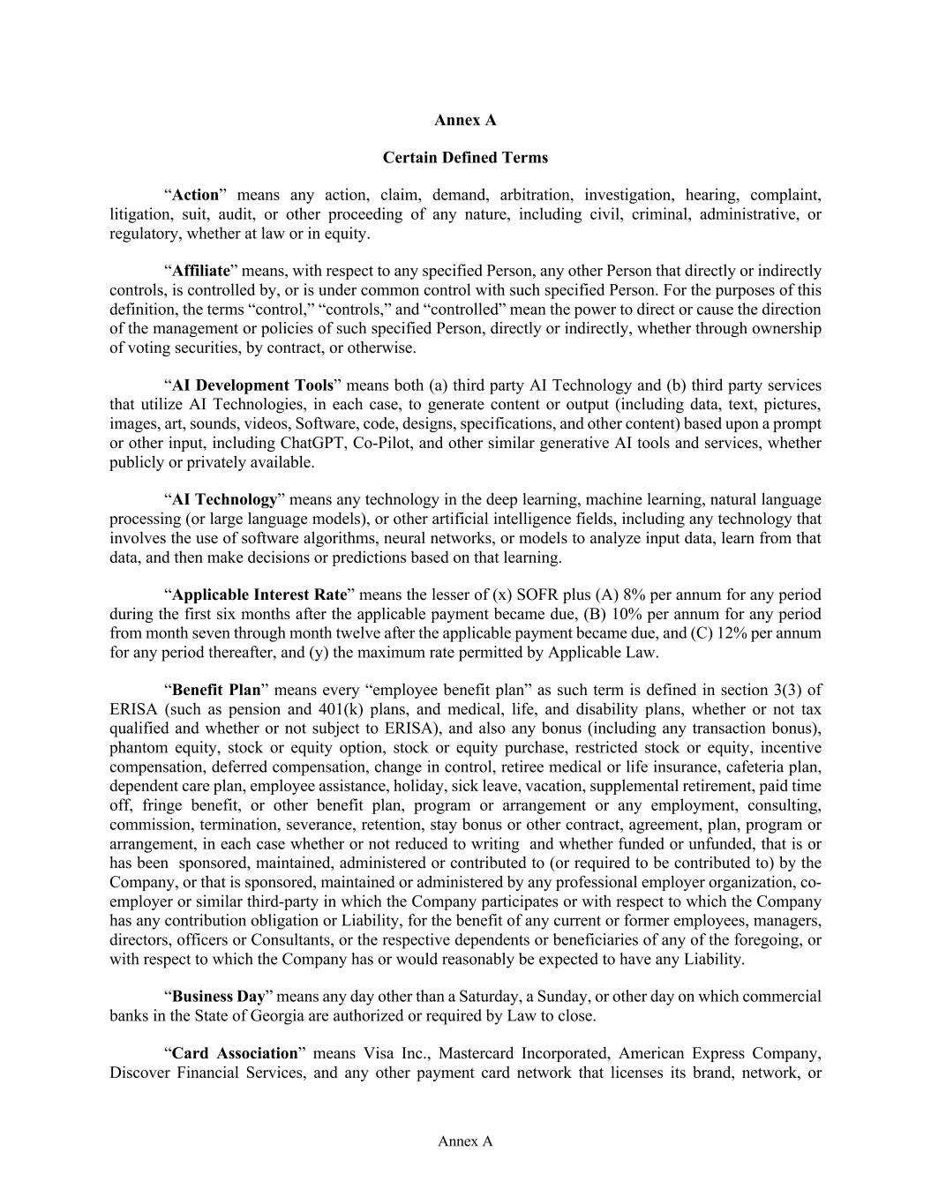
Annex A Annex A Certain Defined Terms “Action” means any action, claim, demand, arbitration, investigation, hearing, complaint, litigation, suit, audit, or other proceeding of any nature, including civil, criminal, administrative, or regulatory, whether at law or in equity. “Affiliate” means, with respect to any specified Person, any other Person that directly or indirectly controls, is controlled by, or is under common control with such specified Person. For the purposes of this definition, the terms “control,” “controls,” and “controlled” mean the power to direct or cause the direction of the management or policies of such specified Person, directly or indirectly, whether through ownership of voting securities, by contract, or otherwise. “AI Development Tools” means both (a) third party AI Technology and (b) third party services that utilize AI Technologies, in each case, to generate content or output (including data, text, pictures, images, art, sounds, videos, Software, code, designs, specifications, and other content) based upon a prompt or other input, including ChatGPT, Co-Pilot, and other similar generative AI tools and services, whether publicly or privately available. “AI Technology” means any technology in the deep learning, machine learning, natural language processing (or large language models), or other artificial intelligence fields, including any technology that involves the use of software algorithms, neural networks, or models to analyze input data, learn from that data, and then make decisions or predictions based on that learning. “Applicable Interest Rate” means the lesser of (x) SOFR plus (A) 8% per annum for any period during the first six months after the applicable payment became due, (B) 10% per annum for any period from month seven through month twelve after the applicable payment became due, and (C) 12% per annum for any period thereafter, and (y) the maximum rate permitted by Applicable Law. “Benefit Plan” means every “employee benefit plan” as such term is defined in section 3(3) of ERISA (such as pension and 401(k) plans, and medical, life, and disability plans, whether or not tax qualified and whether or not subject to ERISA), and also any bonus (including any transaction bonus), phantom equity, stock or equity option, stock or equity purchase, restricted stock or equity, incentive compensation, deferred compensation, change in control, retiree medical or life insurance, cafeteria plan, dependent care plan, employee assistance, holiday, sick leave, vacation, supplemental retirement, paid time off, fringe benefit, or other benefit plan, program or arrangement or any employment, consulting, commission, termination, severance, retention, stay bonus or other contract, agreement, plan, program or arrangement, in each case whether or not reduced to writing and whether funded or unfunded, that is or has been sponsored, maintained, administered or contributed to (or required to be contributed to) by the Company, or that is sponsored, maintained or administered by any professional employer organization, co- employer or similar third-party in which the Company participates or with respect to which the Company has any contribution obligation or Liability, for the benefit of any current or former employees, managers, directors, officers or Consultants, or the respective dependents or beneficiaries of any of the foregoing, or with respect to which the Company has or would reasonably be expected to have any Liability. “Business Day” means any day other than a Saturday, a Sunday, or other day on which commercial banks in the State of Georgia are authorized or required by Law to close. “Card Association” means Visa Inc., Mastercard Incorporated, American Express Company, Discover Financial Services, and any other payment card network that licenses its brand, network, or

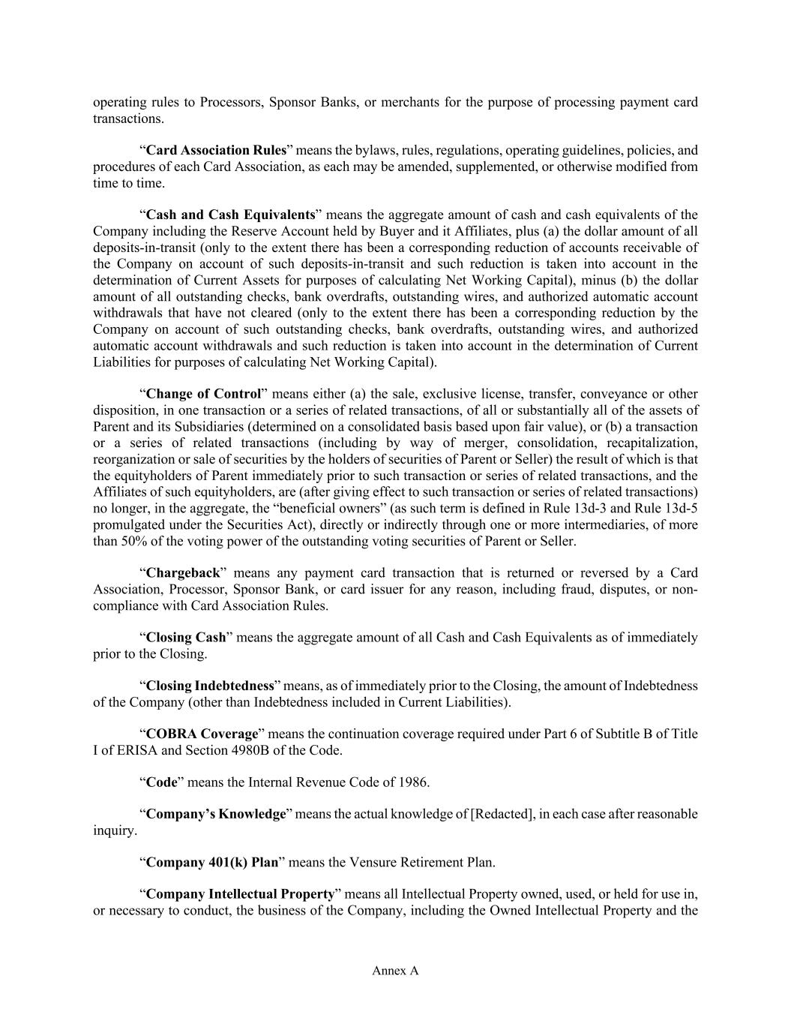
Annex A operating rules to Processors, Sponsor Banks, or merchants for the purpose of processing payment card transactions. “Card Association Rules” means the bylaws, rules, regulations, operating guidelines, policies, and procedures of each Card Association, as each may be amended, supplemented, or otherwise modified from time to time. “Cash and Cash Equivalents” means the aggregate amount of cash and cash equivalents of the Company including the Reserve Account held by Buyer and it Affiliates, plus (a) the dollar amount of all deposits-in-transit (only to the extent there has been a corresponding reduction of accounts receivable of the Company on account of such deposits-in-transit and such reduction is taken into account in the determination of Current Assets for purposes of calculating Net Working Capital), minus (b) the dollar amount of all outstanding checks, bank overdrafts, outstanding wires, and authorized automatic account withdrawals that have not cleared (only to the extent there has been a corresponding reduction by the Company on account of such outstanding checks, bank overdrafts, outstanding wires, and authorized automatic account withdrawals and such reduction is taken into account in the determination of Current Liabilities for purposes of calculating Net Working Capital). “Change of Control” means either (a) the sale, exclusive license, transfer, conveyance or other disposition, in one transaction or a series of related transactions, of all or substantially all of the assets of Parent and its Subsidiaries (determined on a consolidated basis based upon fair value), or (b) a transaction or a series of related transactions (including by way of merger, consolidation, recapitalization, reorganization or sale of securities by the holders of securities of Parent or Seller) the result of which is that the equityholders of Parent immediately prior to such transaction or series of related transactions, and the Affiliates of such equityholders, are (after giving effect to such transaction or series of related transactions) no longer, in the aggregate, the “beneficial owners” (as such term is defined in Rule 13d-3 and Rule 13d-5 promulgated under the Securities Act), directly or indirectly through one or more intermediaries, of more than 50% of the voting power of the outstanding voting securities of Parent or Seller. “Chargeback” means any payment card transaction that is returned or reversed by a Card Association, Processor, Sponsor Bank, or card issuer for any reason, including fraud, disputes, or non- compliance with Card Association Rules. “Closing Cash” means the aggregate amount of all Cash and Cash Equivalents as of immediately prior to the Closing. “Closing Indebtedness” means, as of immediately prior to the Closing, the amount of Indebtedness of the Company (other than Indebtedness included in Current Liabilities). “COBRA Coverage” means the continuation coverage required under Part 6 of Subtitle B of Title I of ERISA and Section 4980B of the Code. “Code” means the Internal Revenue Code of 1986. “Company’s Knowledge” means the actual knowledge of [Redacted], in each case after reasonable inquiry. “Company 401(k) Plan” means the Vensure Retirement Plan. “Company Intellectual Property” means all Intellectual Property owned, used, or held for use in, or necessary to conduct, the business of the Company, including the Owned Intellectual Property and the

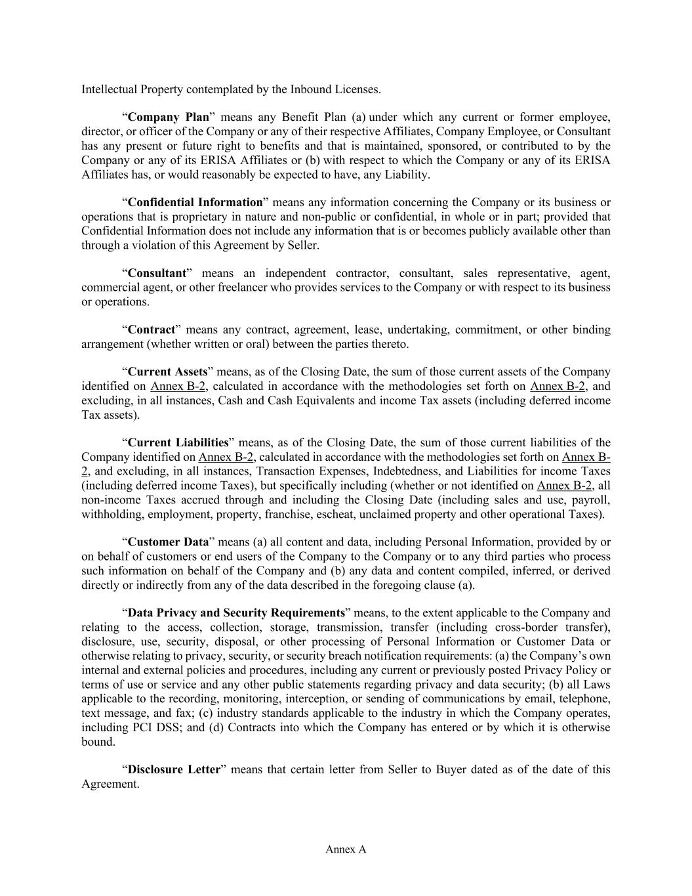
Annex A Intellectual Property contemplated by the Inbound Licenses. “Company Plan” means any Benefit Plan (a) under which any current or former employee, director, or officer of the Company or any of their respective Affiliates, Company Employee, or Consultant has any present or future right to benefits and that is maintained, sponsored, or contributed to by the Company or any of its ERISA Affiliates or (b) with respect to which the Company or any of its ERISA Affiliates has, or would reasonably be expected to have, any Liability. “Confidential Information” means any information concerning the Company or its business or operations that is proprietary in nature and non-public or confidential, in whole or in part; provided that Confidential Information does not include any information that is or becomes publicly available other than through a violation of this Agreement by Seller. “Consultant” means an independent contractor, consultant, sales representative, agent, commercial agent, or other freelancer who provides services to the Company or with respect to its business or operations. “Contract” means any contract, agreement, lease, undertaking, commitment, or other binding arrangement (whether written or oral) between the parties thereto. “Current Assets” means, as of the Closing Date, the sum of those current assets of the Company identified on Annex B-2, calculated in accordance with the methodologies set forth on Annex B-2, and excluding, in all instances, Cash and Cash Equivalents and income Tax assets (including deferred income Tax assets). “Current Liabilities” means, as of the Closing Date, the sum of those current liabilities of the Company identified on Annex B-2, calculated in accordance with the methodologies set forth on Annex B- 2, and excluding, in all instances, Transaction Expenses, Indebtedness, and Liabilities for income Taxes (including deferred income Taxes), but specifically including (whether or not identified on Annex B-2, all non-income Taxes accrued through and including the Closing Date (including sales and use, payroll, withholding, employment, property, franchise, escheat, unclaimed property and other operational Taxes). “Customer Data” means (a) all content and data, including Personal Information, provided by or on behalf of customers or end users of the Company to the Company or to any third parties who process such information on behalf of the Company and (b) any data and content compiled, inferred, or derived directly or indirectly from any of the data described in the foregoing clause (a). “Data Privacy and Security Requirements” means, to the extent applicable to the Company and relating to the access, collection, storage, transmission, transfer (including cross-border transfer), disclosure, use, security, disposal, or other processing of Personal Information or Customer Data or otherwise relating to privacy, security, or security breach notification requirements: (a) the Company’s own internal and external policies and procedures, including any current or previously posted Privacy Policy or terms of use or service and any other public statements regarding privacy and data security; (b) all Laws applicable to the recording, monitoring, interception, or sending of communications by email, telephone, text message, and fax; (c) industry standards applicable to the industry in which the Company operates, including PCI DSS; and (d) Contracts into which the Company has entered or by which it is otherwise bound. “Disclosure Letter” means that certain letter from Seller to Buyer dated as of the date of this Agreement.

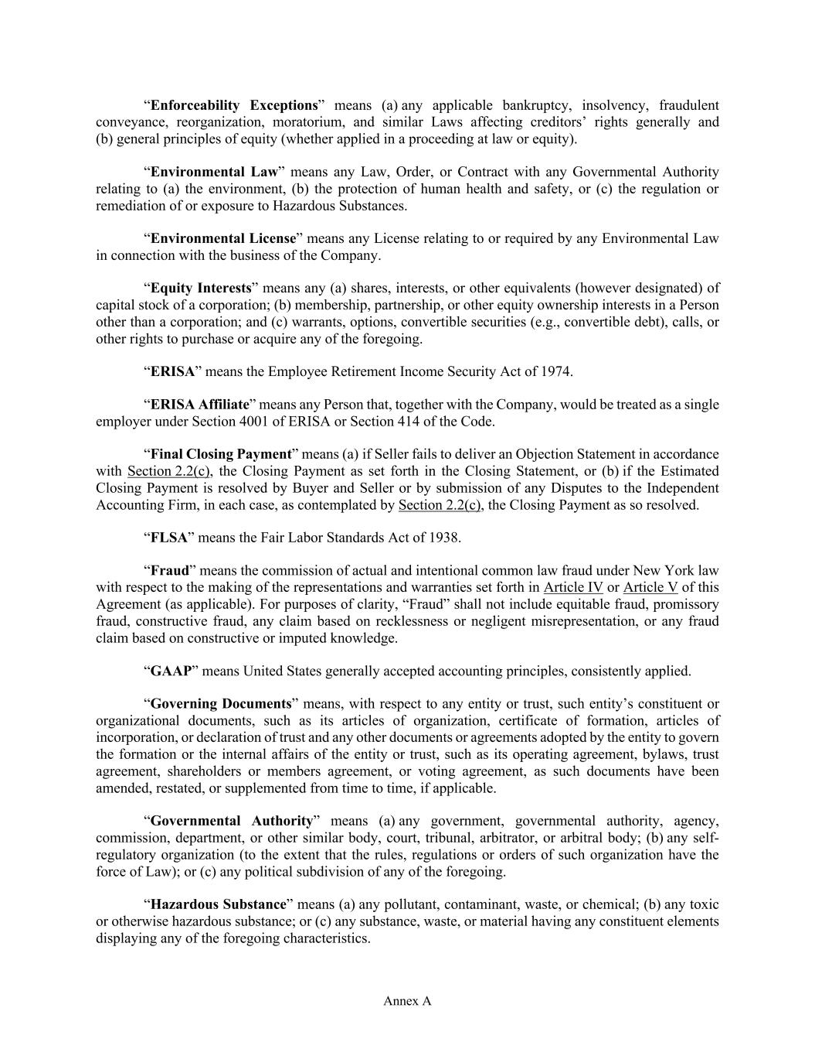
Annex A “Enforceability Exceptions” means (a) any applicable bankruptcy, insolvency, fraudulent conveyance, reorganization, moratorium, and similar Laws affecting creditors’ rights generally and (b) general principles of equity (whether applied in a proceeding at law or equity). “Environmental Law” means any Law, Order, or Contract with any Governmental Authority relating to (a) the environment, (b) the protection of human health and safety, or (c) the regulation or remediation of or exposure to Hazardous Substances. “Environmental License” means any License relating to or required by any Environmental Law in connection with the business of the Company. “Equity Interests” means any (a) shares, interests, or other equivalents (however designated) of capital stock of a corporation; (b) membership, partnership, or other equity ownership interests in a Person other than a corporation; and (c) warrants, options, convertible securities (e.g., convertible debt), calls, or other rights to purchase or acquire any of the foregoing. “ERISA” means the Employee Retirement Income Security Act of 1974. “ERISA Affiliate” means any Person that, together with the Company, would be treated as a single employer under Section 4001 of ERISA or Section 414 of the Code. “Final Closing Payment” means (a) if Seller fails to deliver an Objection Statement in accordance with Section 2.2(c), the Closing Payment as set forth in the Closing Statement, or (b) if the Estimated Closing Payment is resolved by Buyer and Seller or by submission of any Disputes to the Independent Accounting Firm, in each case, as contemplated by Section 2.2(c), the Closing Payment as so resolved. “FLSA” means the Fair Labor Standards Act of 1938. “Fraud” means the commission of actual and intentional common law fraud under New York law with respect to the making of the representations and warranties set forth in Article IV or Article V of this Agreement (as applicable). For purposes of clarity, “Fraud” shall not include equitable fraud, promissory fraud, constructive fraud, any claim based on recklessness or negligent misrepresentation, or any fraud claim based on constructive or imputed knowledge. “GAAP” means United States generally accepted accounting principles, consistently applied. “Governing Documents” means, with respect to any entity or trust, such entity’s constituent or organizational documents, such as its articles of organization, certificate of formation, articles of incorporation, or declaration of trust and any other documents or agreements adopted by the entity to govern the formation or the internal affairs of the entity or trust, such as its operating agreement, bylaws, trust agreement, shareholders or members agreement, or voting agreement, as such documents have been amended, restated, or supplemented from time to time, if applicable. “Governmental Authority” means (a) any government, governmental authority, agency, commission, department, or other similar body, court, tribunal, arbitrator, or arbitral body; (b) any self- regulatory organization (to the extent that the rules, regulations or orders of such organization have the force of Law); or (c) any political subdivision of any of the foregoing. “Hazardous Substance” means (a) any pollutant, contaminant, waste, or chemical; (b) any toxic or otherwise hazardous substance; or (c) any substance, waste, or material having any constituent elements displaying any of the foregoing characteristics.

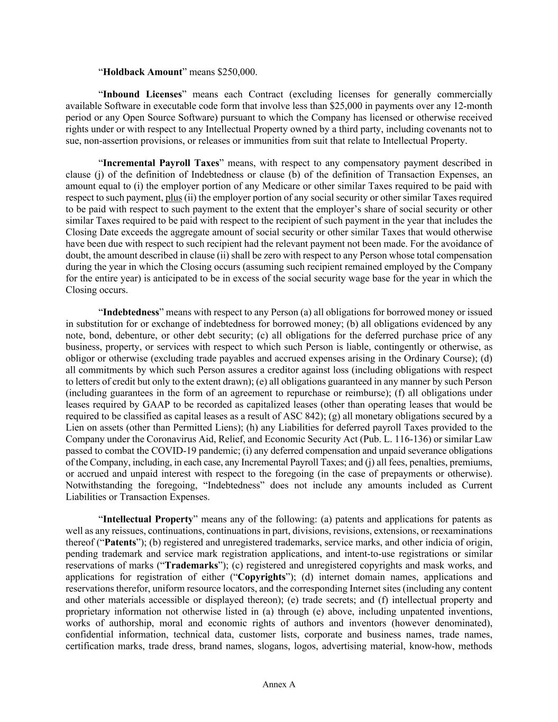
Annex A “Holdback Amount” means $250,000. “Inbound Licenses” means each Contract (excluding licenses for generally commercially available Software in executable code form that involve less than $25,000 in payments over any 12-month period or any Open Source Software) pursuant to which the Company has licensed or otherwise received rights under or with respect to any Intellectual Property owned by a third party, including covenants not to sue, non-assertion provisions, or releases or immunities from suit that relate to Intellectual Property. “Incremental Payroll Taxes” means, with respect to any compensatory payment described in clause (j) of the definition of Indebtedness or clause (b) of the definition of Transaction Expenses, an amount equal to (i) the employer portion of any Medicare or other similar Taxes required to be paid with respect to such payment, plus (ii) the employer portion of any social security or other similar Taxes required to be paid with respect to such payment to the extent that the employer’s share of social security or other similar Taxes required to be paid with respect to the recipient of such payment in the year that includes the Closing Date exceeds the aggregate amount of social security or other similar Taxes that would otherwise have been due with respect to such recipient had the relevant payment not been made. For the avoidance of doubt, the amount described in clause (ii) shall be zero with respect to any Person whose total compensation during the year in which the Closing occurs (assuming such recipient remained employed by the Company for the entire year) is anticipated to be in excess of the social security wage base for the year in which the Closing occurs. “Indebtedness” means with respect to any Person (a) all obligations for borrowed money or issued in substitution for or exchange of indebtedness for borrowed money; (b) all obligations evidenced by any note, bond, debenture, or other debt security; (c) all obligations for the deferred purchase price of any business, property, or services with respect to which such Person is liable, contingently or otherwise, as obligor or otherwise (excluding trade payables and accrued expenses arising in the Ordinary Course); (d) all commitments by which such Person assures a creditor against loss (including obligations with respect to letters of credit but only to the extent drawn); (e) all obligations guaranteed in any manner by such Person (including guarantees in the form of an agreement to repurchase or reimburse); (f) all obligations under leases required by GAAP to be recorded as capitalized leases (other than operating leases that would be required to be classified as capital leases as a result of ASC 842); (g) all monetary obligations secured by a Lien on assets (other than Permitted Liens); (h) any Liabilities for deferred payroll Taxes provided to the Company under the Coronavirus Aid, Relief, and Economic Security Act (Pub. L. 116-136) or similar Law passed to combat the COVID-19 pandemic; (i) any deferred compensation and unpaid severance obligations of the Company, including, in each case, any Incremental Payroll Taxes; and (j) all fees, penalties, premiums, or accrued and unpaid interest with respect to the foregoing (in the case of prepayments or otherwise). Notwithstanding the foregoing, “Indebtedness” does not include any amounts included as Current Liabilities or Transaction Expenses. “Intellectual Property” means any of the following: (a) patents and applications for patents as well as any reissues, continuations, continuations in part, divisions, revisions, extensions, or reexaminations thereof (“Patents”); (b) registered and unregistered trademarks, service marks, and other indicia of origin, pending trademark and service mark registration applications, and intent-to-use registrations or similar reservations of marks (“Trademarks”); (c) registered and unregistered copyrights and mask works, and applications for registration of either (“Copyrights”); (d) internet domain names, applications and reservations therefor, uniform resource locators, and the corresponding Internet sites (including any content and other materials accessible or displayed thereon); (e) trade secrets; and (f) intellectual property and proprietary information not otherwise listed in (a) through (e) above, including unpatented inventions, works of authorship, moral and economic rights of authors and inventors (however denominated), confidential information, technical data, customer lists, corporate and business names, trade names, certification marks, trade dress, brand names, slogans, logos, advertising material, know-how, methods

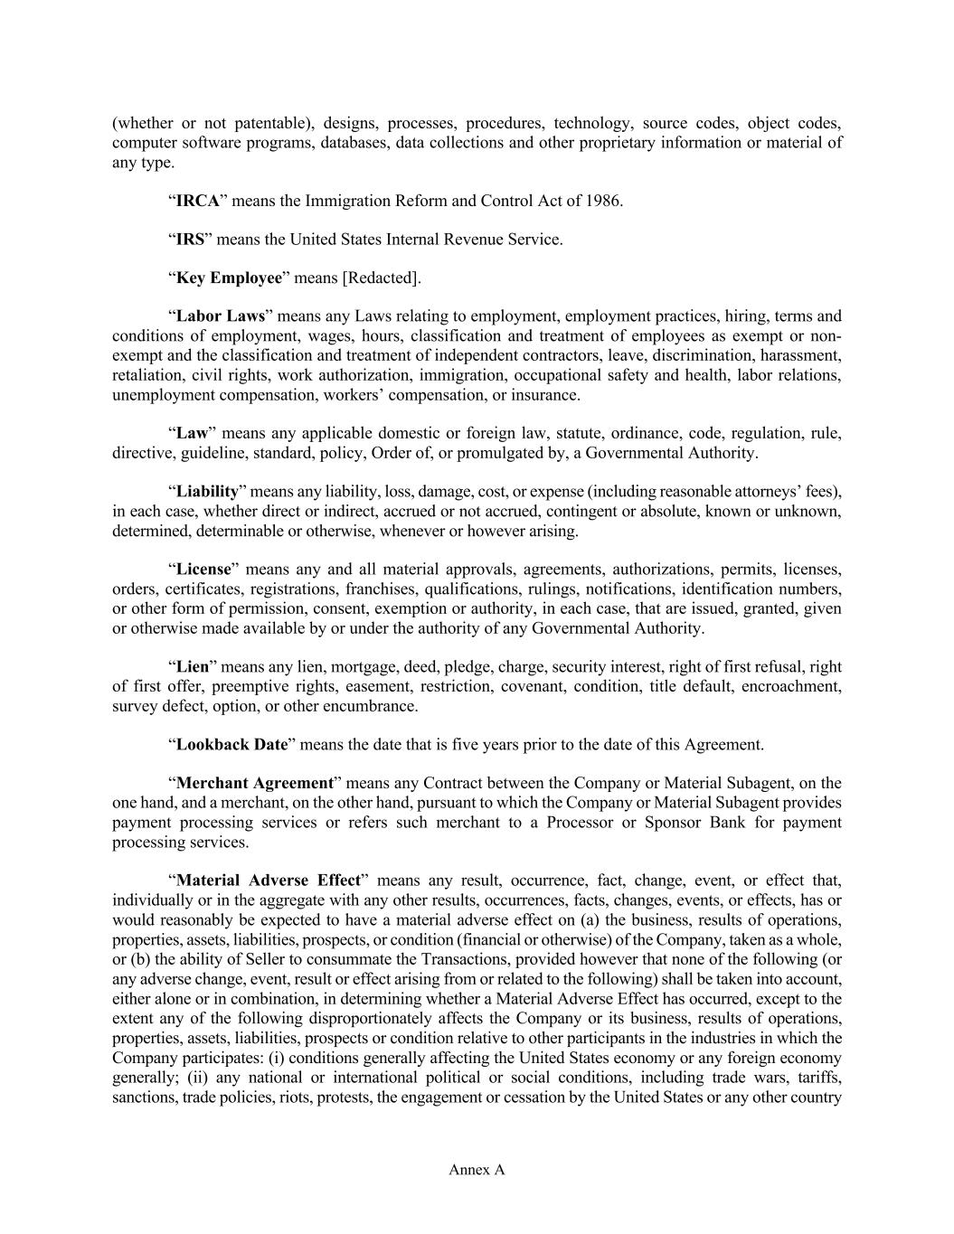
Annex A (whether or not patentable), designs, processes, procedures, technology, source codes, object codes, computer software programs, databases, data collections and other proprietary information or material of any type. “IRCA” means the Immigration Reform and Control Act of 1986. “IRS” means the United States Internal Revenue Service. “Key Employee” means [Redacted]. “Labor Laws” means any Laws relating to employment, employment practices, hiring, terms and conditions of employment, wages, hours, classification and treatment of employees as exempt or non- exempt and the classification and treatment of independent contractors, leave, discrimination, harassment, retaliation, civil rights, work authorization, immigration, occupational safety and health, labor relations, unemployment compensation, workers’ compensation, or insurance. “Law” means any applicable domestic or foreign law, statute, ordinance, code, regulation, rule, directive, guideline, standard, policy, Order of, or promulgated by, a Governmental Authority. “Liability” means any liability, loss, damage, cost, or expense (including reasonable attorneys’ fees), in each case, whether direct or indirect, accrued or not accrued, contingent or absolute, known or unknown, determined, determinable or otherwise, whenever or however arising. “License” means any and all material approvals, agreements, authorizations, permits, licenses, orders, certificates, registrations, franchises, qualifications, rulings, notifications, identification numbers, or other form of permission, consent, exemption or authority, in each case, that are issued, granted, given or otherwise made available by or under the authority of any Governmental Authority. “Lien” means any lien, mortgage, deed, pledge, charge, security interest, right of first refusal, right of first offer, preemptive rights, easement, restriction, covenant, condition, title default, encroachment, survey defect, option, or other encumbrance. “Lookback Date” means the date that is five years prior to the date of this Agreement. “Merchant Agreement” means any Contract between the Company or Material Subagent, on the one hand, and a merchant, on the other hand, pursuant to which the Company or Material Subagent provides payment processing services or refers such merchant to a Processor or Sponsor Bank for payment processing services. “Material Adverse Effect” means any result, occurrence, fact, change, event, or effect that, individually or in the aggregate with any other results, occurrences, facts, changes, events, or effects, has or would reasonably be expected to have a material adverse effect on (a) the business, results of operations, properties, assets, liabilities, prospects, or condition (financial or otherwise) of the Company, taken as a whole, or (b) the ability of Seller to consummate the Transactions, provided however that none of the following (or any adverse change, event, result or effect arising from or related to the following) shall be taken into account, either alone or in combination, in determining whether a Material Adverse Effect has occurred, except to the extent any of the following disproportionately affects the Company or its business, results of operations, properties, assets, liabilities, prospects or condition relative to other participants in the industries in which the Company participates: (i) conditions generally affecting the United States economy or any foreign economy generally; (ii) any national or international political or social conditions, including trade wars, tariffs, sanctions, trade policies, riots, protests, the engagement or cessation by the United States or any other country

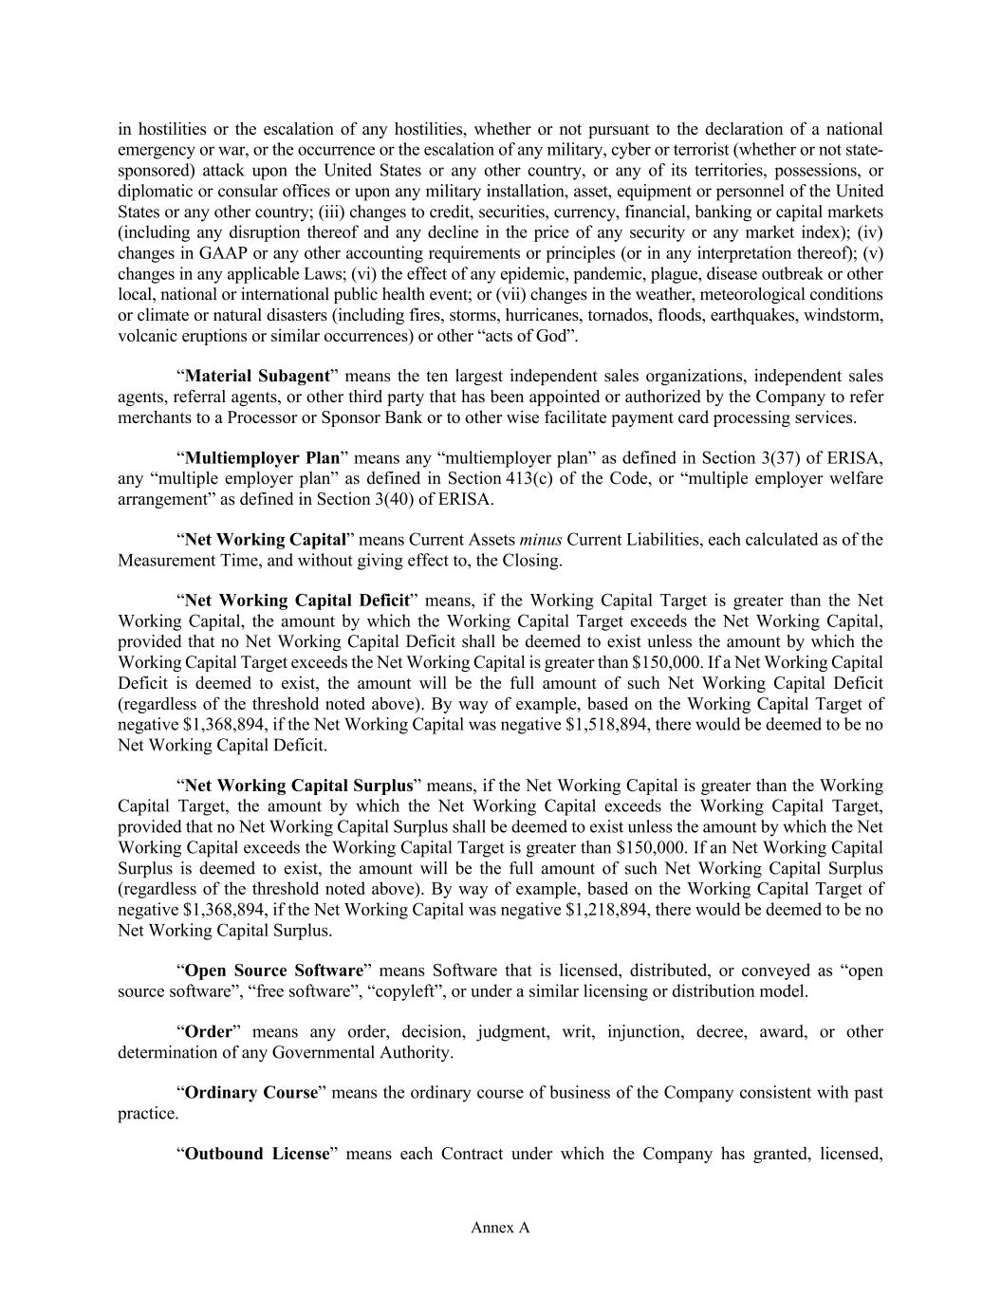
Annex A in hostilities or the escalation of any hostilities, whether or not pursuant to the declaration of a national emergency or war, or the occurrence or the escalation of any military, cyber or terrorist (whether or not state- sponsored) attack upon the United States or any other country, or any of its territories, possessions, or diplomatic or consular offices or upon any military installation, asset, equipment or personnel of the United States or any other country; (iii) changes to credit, securities, currency, financial, banking or capital markets (including any disruption thereof and any decline in the price of any security or any market index); (iv) changes in GAAP or any other accounting requirements or principles (or in any interpretation thereof); (v) changes in any applicable Laws; (vi) the effect of any epidemic, pandemic, plague, disease outbreak or other local, national or international public health event; or (vii) changes in the weather, meteorological conditions or climate or natural disasters (including fires, storms, hurricanes, tornados, floods, earthquakes, windstorm, volcanic eruptions or similar occurrences) or other “acts of God”. “Material Subagent” means the ten largest independent sales organizations, independent sales agents, referral agents, or other third party that has been appointed or authorized by the Company to refer merchants to a Processor or Sponsor Bank or to other wise facilitate payment card processing services. “Multiemployer Plan” means any “multiemployer plan” as defined in Section 3(37) of ERISA, any “multiple employer plan” as defined in Section 413(c) of the Code, or “multiple employer welfare arrangement” as defined in Section 3(40) of ERISA. “Net Working Capital” means Current Assets minus Current Liabilities, each calculated as of the Measurement Time, and without giving effect to, the Closing. “Net Working Capital Deficit” means, if the Working Capital Target is greater than the Net Working Capital, the amount by which the Working Capital Target exceeds the Net Working Capital, provided that no Net Working Capital Deficit shall be deemed to exist unless the amount by which the Working Capital Target exceeds the Net Working Capital is greater than $150,000. If a Net Working Capital Deficit is deemed to exist, the amount will be the full amount of such Net Working Capital Deficit (regardless of the threshold noted above). By way of example, based on the Working Capital Target of negative $1,368,894, if the Net Working Capital was negative $1,518,894, there would be deemed to be no Net Working Capital Deficit. “Net Working Capital Surplus” means, if the Net Working Capital is greater than the Working Capital Target, the amount by which the Net Working Capital exceeds the Working Capital Target, provided that no Net Working Capital Surplus shall be deemed to exist unless the amount by which the Net Working Capital exceeds the Working Capital Target is greater than $150,000. If an Net Working Capital Surplus is deemed to exist, the amount will be the full amount of such Net Working Capital Surplus (regardless of the threshold noted above). By way of example, based on the Working Capital Target of negative $1,368,894, if the Net Working Capital was negative $1,218,894, there would be deemed to be no Net Working Capital Surplus. “Open Source Software” means Software that is licensed, distributed, or conveyed as “open source software”, “free software”, “copyleft”, or under a similar licensing or distribution model. “Order” means any order, decision, judgment, writ, injunction, decree, award, or other determination of any Governmental Authority. “Ordinary Course” means the ordinary course of business of the Company consistent with past practice. “Outbound License” means each Contract under which the Company has granted, licensed,

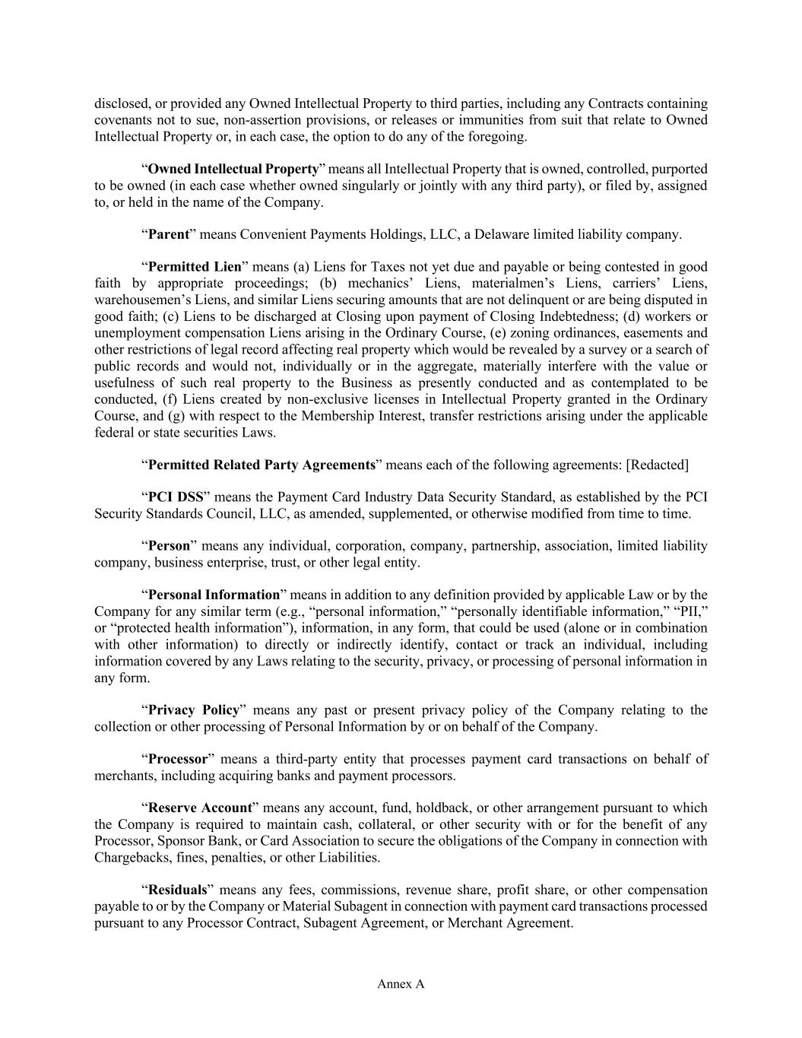
Annex A disclosed, or provided any Owned Intellectual Property to third parties, including any Contracts containing covenants not to sue, non-assertion provisions, or releases or immunities from suit that relate to Owned Intellectual Property or, in each case, the option to do any of the foregoing. “Owned Intellectual Property” means all Intellectual Property that is owned, controlled, purported to be owned (in each case whether owned singularly or jointly with any third party), or filed by, assigned to, or held in the name of the Company. “Parent” means Convenient Payments Holdings, LLC, a Delaware limited liability company. “Permitted Lien” means (a) Liens for Taxes not yet due and payable or being contested in good faith by appropriate proceedings; (b) mechanics’ Liens, materialmen’s Liens, carriers’ Liens, warehousemen’s Liens, and similar Liens securing amounts that are not delinquent or are being disputed in good faith; (c) Liens to be discharged at Closing upon payment of Closing Indebtedness; (d) workers or unemployment compensation Liens arising in the Ordinary Course, (e) zoning ordinances, easements and other restrictions of legal record affecting real property which would be revealed by a survey or a search of public records and would not, individually or in the aggregate, materially interfere with the value or usefulness of such real property to the Business as presently conducted and as contemplated to be conducted, (f) Liens created by non-exclusive licenses in Intellectual Property granted in the Ordinary Course, and (g) with respect to the Membership Interest, transfer restrictions arising under the applicable federal or state securities Laws. “Permitted Related Party Agreements” means each of the following agreements: [Redacted] “PCI DSS” means the Payment Card Industry Data Security Standard, as established by the PCI Security Standards Council, LLC, as amended, supplemented, or otherwise modified from time to time. “Person” means any individual, corporation, company, partnership, association, limited liability company, business enterprise, trust, or other legal entity. “Personal Information” means in addition to any definition provided by applicable Law or by the Company for any similar term (e.g., “personal information,” “personally identifiable information,” “PII,” or “protected health information”), information, in any form, that could be used (alone or in combination with other information) to directly or indirectly identify, contact or track an individual, including information covered by any Laws relating to the security, privacy, or processing of personal information in any form. “Privacy Policy” means any past or present privacy policy of the Company relating to the collection or other processing of Personal Information by or on behalf of the Company. “Processor” means a third-party entity that processes payment card transactions on behalf of merchants, including acquiring banks and payment processors. “Reserve Account” means any account, fund, holdback, or other arrangement pursuant to which the Company is required to maintain cash, collateral, or other security with or for the benefit of any Processor, Sponsor Bank, or Card Association to secure the obligations of the Company in connection with Chargebacks, fines, penalties, or other Liabilities. “Residuals” means any fees, commissions, revenue share, profit share, or other compensation payable to or by the Company or Material Subagent in connection with payment card transactions processed pursuant to any Processor Contract, Subagent Agreement, or Merchant Agreement.

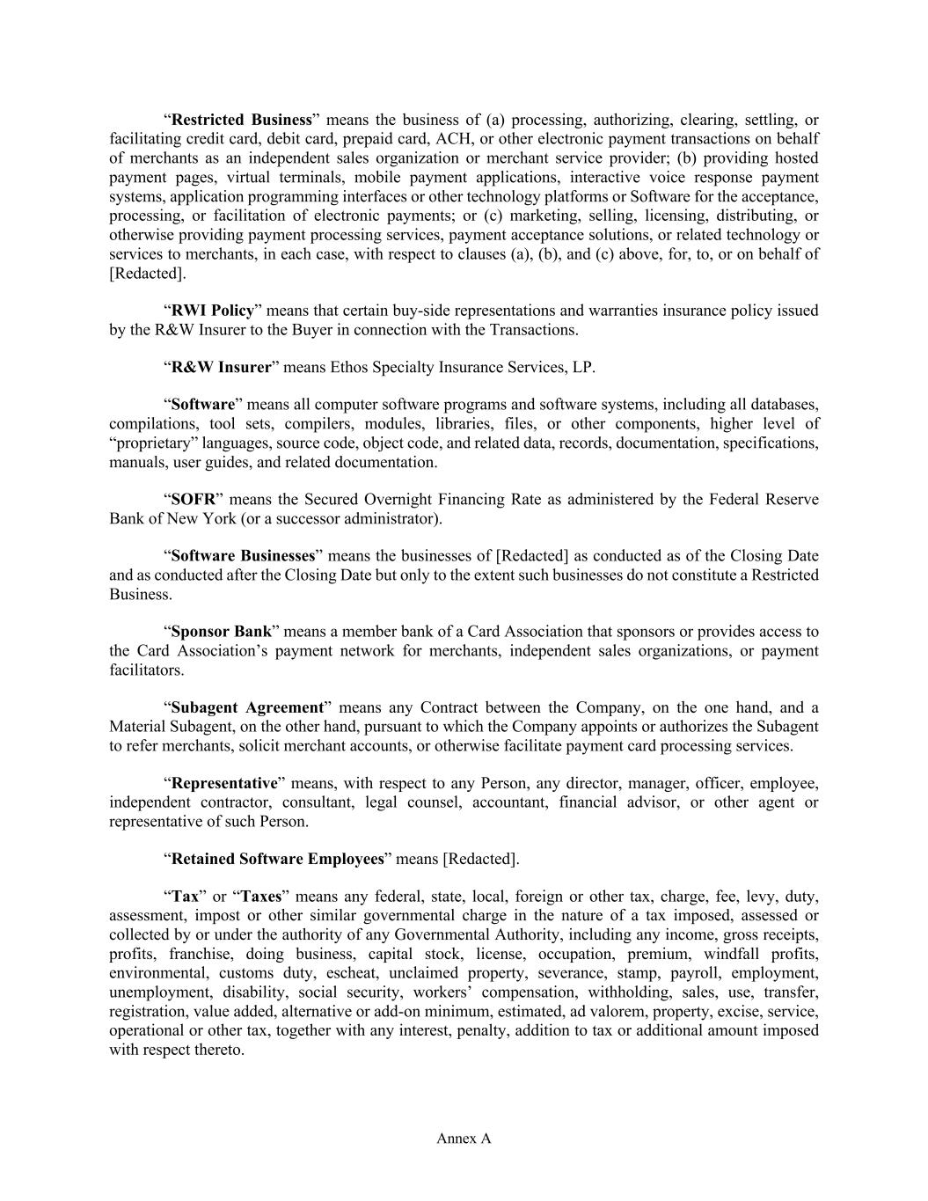
Annex A “Restricted Business” means the business of (a) processing, authorizing, clearing, settling, or facilitating credit card, debit card, prepaid card, ACH, or other electronic payment transactions on behalf of merchants as an independent sales organization or merchant service provider; (b) providing hosted payment pages, virtual terminals, mobile payment applications, interactive voice response payment systems, application programming interfaces or other technology platforms or Software for the acceptance, processing, or facilitation of electronic payments; or (c) marketing, selling, licensing, distributing, or otherwise providing payment processing services, payment acceptance solutions, or related technology or services to merchants, in each case, with respect to clauses (a), (b), and (c) above, for, to, or on behalf of [Redacted]. “RWI Policy” means that certain buy-side representations and warranties insurance policy issued by the R&W Insurer to the Buyer in connection with the Transactions. “R&W Insurer” means Ethos Specialty Insurance Services, LP. “Software” means all computer software programs and software systems, including all databases, compilations, tool sets, compilers, modules, libraries, files, or other components, higher level of “proprietary” languages, source code, object code, and related data, records, documentation, specifications, manuals, user guides, and related documentation. “SOFR” means the Secured Overnight Financing Rate as administered by the Federal Reserve Bank of New York (or a successor administrator). “Software Businesses” means the businesses of [Redacted] as conducted as of the Closing Date and as conducted after the Closing Date but only to the extent such businesses do not constitute a Restricted Business. “Sponsor Bank” means a member bank of a Card Association that sponsors or provides access to the Card Association’s payment network for merchants, independent sales organizations, or payment facilitators. “Subagent Agreement” means any Contract between the Company, on the one hand, and a Material Subagent, on the other hand, pursuant to which the Company appoints or authorizes the Subagent to refer merchants, solicit merchant accounts, or otherwise facilitate payment card processing services. “Representative” means, with respect to any Person, any director, manager, officer, employee, independent contractor, consultant, legal counsel, accountant, financial advisor, or other agent or representative of such Person. “Retained Software Employees” means [Redacted]. “Tax” or “Taxes” means any federal, state, local, foreign or other tax, charge, fee, levy, duty, assessment, impost or other similar governmental charge in the nature of a tax imposed, assessed or collected by or under the authority of any Governmental Authority, including any income, gross receipts, profits, franchise, doing business, capital stock, license, occupation, premium, windfall profits, environmental, customs duty, escheat, unclaimed property, severance, stamp, payroll, employment, unemployment, disability, social security, workers’ compensation, withholding, sales, use, transfer, registration, value added, alternative or add-on minimum, estimated, ad valorem, property, excise, service, operational or other tax, together with any interest, penalty, addition to tax or additional amount imposed with respect thereto.

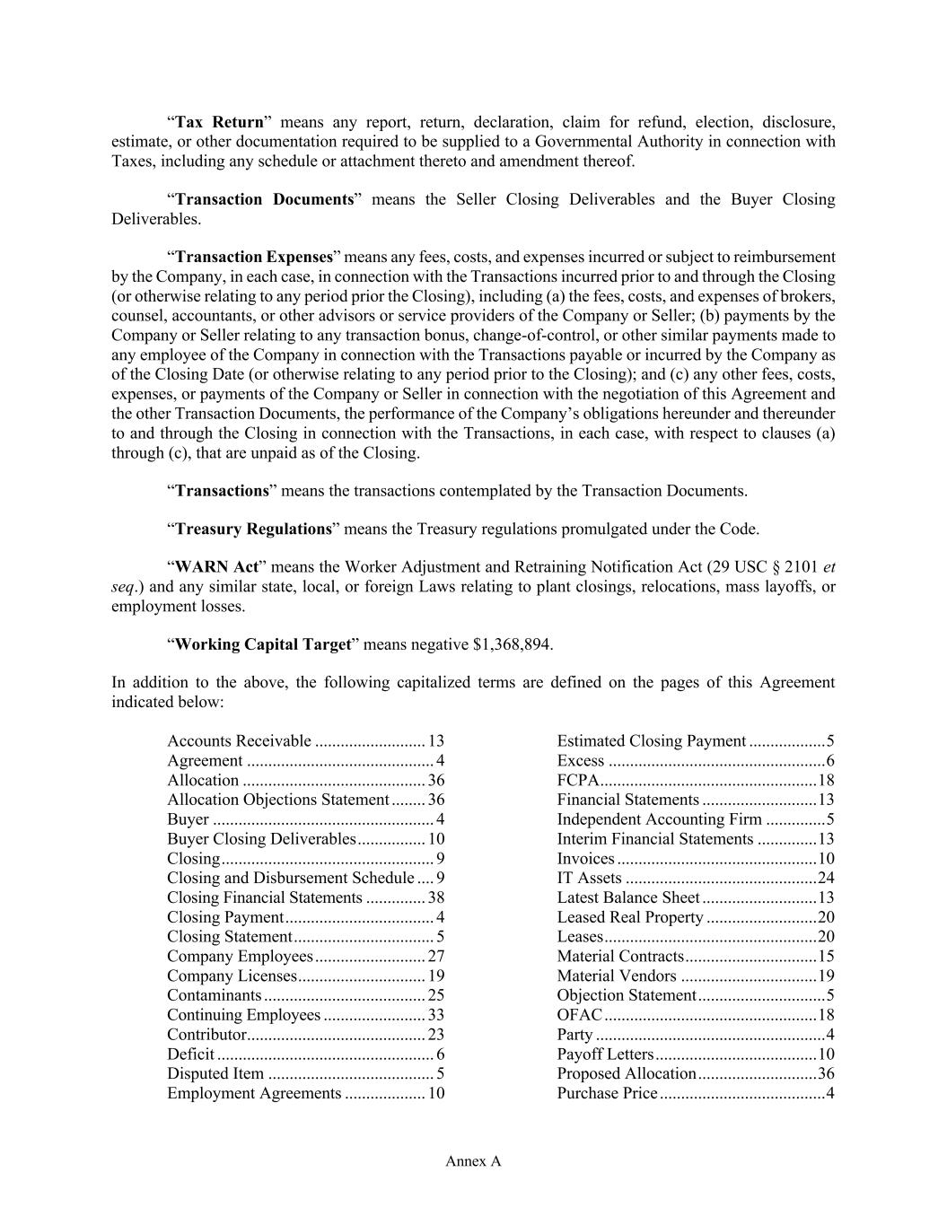
Annex A “Tax Return” means any report, return, declaration, claim for refund, election, disclosure, estimate, or other documentation required to be supplied to a Governmental Authority in connection with Taxes, including any schedule or attachment thereto and amendment thereof. “Transaction Documents” means the Seller Closing Deliverables and the Buyer Closing Deliverables. “Transaction Expenses” means any fees, costs, and expenses incurred or subject to reimbursement by the Company, in each case, in connection with the Transactions incurred prior to and through the Closing (or otherwise relating to any period prior the Closing), including (a) the fees, costs, and expenses of brokers, counsel, accountants, or other advisors or service providers of the Company or Seller; (b) payments by the Company or Seller relating to any transaction bonus, change-of-control, or other similar payments made to any employee of the Company in connection with the Transactions payable or incurred by the Company as of the Closing Date (or otherwise relating to any period prior to the Closing); and (c) any other fees, costs, expenses, or payments of the Company or Seller in connection with the negotiation of this Agreement and the other Transaction Documents, the performance of the Company’s obligations hereunder and thereunder to and through the Closing in connection with the Transactions, in each case, with respect to clauses (a) through (c), that are unpaid as of the Closing. “Transactions” means the transactions contemplated by the Transaction Documents. “Treasury Regulations” means the Treasury regulations promulgated under the Code. “WARN Act” means the Worker Adjustment and Retraining Notification Act (29 USC § 2101 et seq.) and any similar state, local, or foreign Laws relating to plant closings, relocations, mass layoffs, or employment losses. “Working Capital Target” means negative $1,368,894. In addition to the above, the following capitalized terms are defined on the pages of this Agreement indicated below: Accounts Receivable .......................... 13 Agreement ............................................ 4 Allocation ........................................... 36 Allocation Objections Statement ........ 36 Buyer .................................................... 4 Buyer Closing Deliverables ................ 10 Closing .................................................. 9 Closing and Disbursement Schedule .... 9 Closing Financial Statements .............. 38 Closing Payment ................................... 4 Closing Statement ................................. 5 Company Employees .......................... 27 Company Licenses .............................. 19 Contaminants ...................................... 25 Continuing Employees ........................ 33 Contributor .......................................... 23 Deficit ................................................... 6 Disputed Item ....................................... 5 Employment Agreements ................... 10 Estimated Closing Payment .................. 5 Excess ................................................... 6 FCPA ................................................... 18 Financial Statements ........................... 13 Independent Accounting Firm .............. 5 Interim Financial Statements .............. 13 Invoices ............................................... 10 IT Assets ............................................. 24 Latest Balance Sheet ........................... 13 Leased Real Property .......................... 20 Leases .................................................. 20 Material Contracts ............................... 15 Material Vendors ................................ 19 Objection Statement .............................. 5 OFAC .................................................. 18 Party ...................................................... 4 Payoff Letters ...................................... 10 Proposed Allocation ............................ 36 Purchase Price ....................................... 4

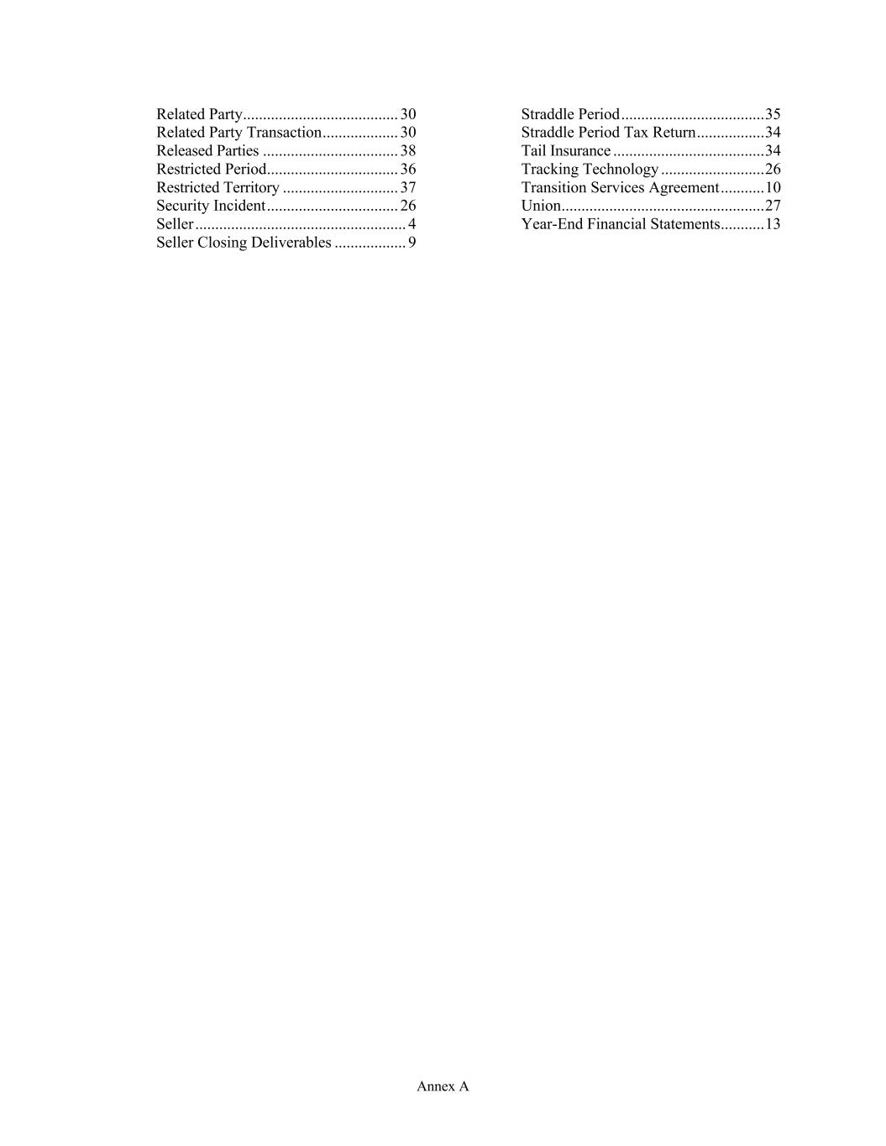
Annex A Related Party ....................................... 30 Related Party Transaction ................... 30 Released Parties .................................. 38 Restricted Period ................................. 36 Restricted Territory ............................. 37 Security Incident ................................. 26 Seller ..................................................... 4 Seller Closing Deliverables .................. 9 Straddle Period .................................... 35 Straddle Period Tax Return ................. 34 Tail Insurance ...................................... 34 Tracking Technology .......................... 26 Transition Services Agreement ........... 10 Union ................................................... 27 Year-End Financial Statements ........... 13


Annex B-1 Annex B-1 Estimated Closing Statement See attached.

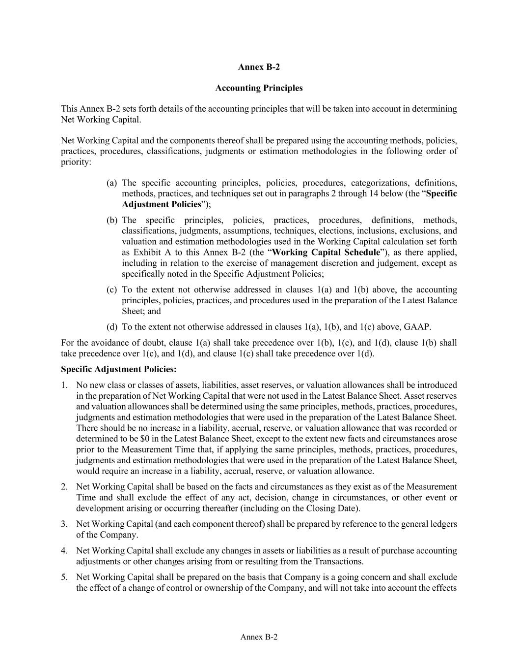
Annex B-2 Annex B-2 Accounting Principles This Annex B-2 sets forth details of the accounting principles that will be taken into account in determining Net Working Capital. Net Working Capital and the components thereof shall be prepared using the accounting methods, policies, practices, procedures, classifications, judgments or estimation methodologies in the following order of priority: (a) The specific accounting principles, policies, procedures, categorizations, definitions, methods, practices, and techniques set out in paragraphs 2 through 14 below (the “Specific Adjustment Policies”); (b) The specific principles, policies, practices, procedures, definitions, methods, classifications, judgments, assumptions, techniques, elections, inclusions, exclusions, and valuation and estimation methodologies used in the Working Capital calculation set forth as Exhibit A to this Annex B-2 (the “Working Capital Schedule”), as there applied, including in relation to the exercise of management discretion and judgement, except as specifically noted in the Specific Adjustment Policies; (c) To the extent not otherwise addressed in clauses 1(a) and 1(b) above, the accounting principles, policies, practices, and procedures used in the preparation of the Latest Balance Sheet; and (d) To the extent not otherwise addressed in clauses 1(a), 1(b), and 1(c) above, GAAP. For the avoidance of doubt, clause 1(a) shall take precedence over 1(b), 1(c), and 1(d), clause 1(b) shall take precedence over 1(c), and 1(d), and clause 1(c) shall take precedence over 1(d). Specific Adjustment Policies: 1. No new class or classes of assets, liabilities, asset reserves, or valuation allowances shall be introduced in the preparation of Net Working Capital that were not used in the Latest Balance Sheet. Asset reserves and valuation allowances shall be determined using the same principles, methods, practices, procedures, judgments and estimation methodologies that were used in the preparation of the Latest Balance Sheet. There should be no increase in a liability, accrual, reserve, or valuation allowance that was recorded or determined to be $0 in the Latest Balance Sheet, except to the extent new facts and circumstances arose prior to the Measurement Time that, if applying the same principles, methods, practices, procedures, judgments and estimation methodologies that were used in the preparation of the Latest Balance Sheet, would require an increase in a liability, accrual, reserve, or valuation allowance. 2. Net Working Capital shall be based on the facts and circumstances as they exist as of the Measurement Time and shall exclude the effect of any act, decision, change in circumstances, or other event or development arising or occurring thereafter (including on the Closing Date). 3. Net Working Capital (and each component thereof) shall be prepared by reference to the general ledgers of the Company. 4. Net Working Capital shall exclude any changes in assets or liabilities as a result of purchase accounting adjustments or other changes arising from or resulting from the Transactions. 5. Net Working Capital shall be prepared on the basis that Company is a going concern and shall exclude the effect of a change of control or ownership of the Company, and will not take into account the effects

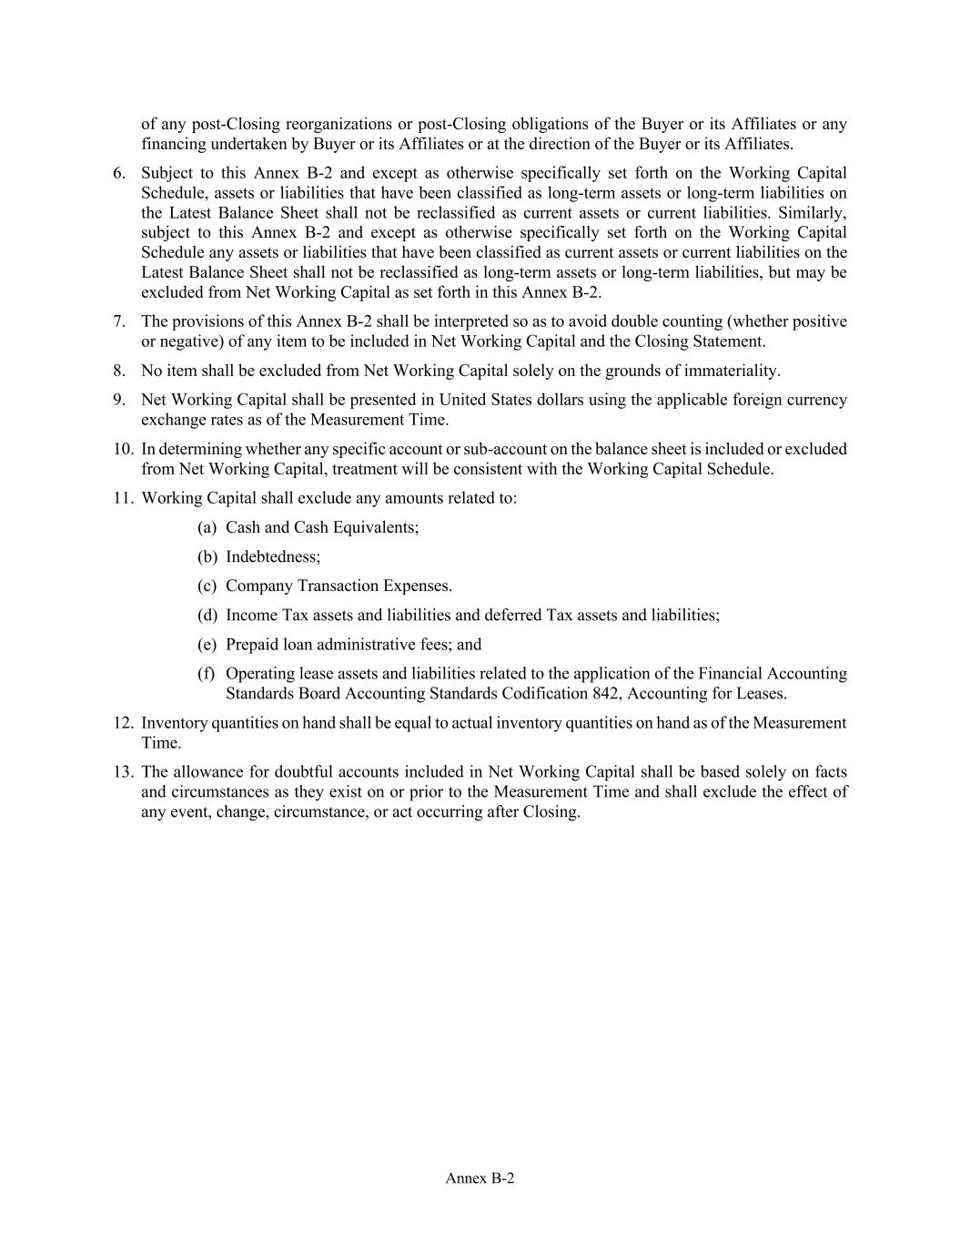
Annex B-2 of any post-Closing reorganizations or post-Closing obligations of the Buyer or its Affiliates or any financing undertaken by Buyer or its Affiliates or at the direction of the Buyer or its Affiliates. 6. Subject to this Annex B-2 and except as otherwise specifically set forth on the Working Capital Schedule, assets or liabilities that have been classified as long-term assets or long-term liabilities on the Latest Balance Sheet shall not be reclassified as current assets or current liabilities. Similarly, subject to this Annex B-2 and except as otherwise specifically set forth on the Working Capital Schedule any assets or liabilities that have been classified as current assets or current liabilities on the Latest Balance Sheet shall not be reclassified as long-term assets or long-term liabilities, but may be excluded from Net Working Capital as set forth in this Annex B-2. 7. The provisions of this Annex B-2 shall be interpreted so as to avoid double counting (whether positive or negative) of any item to be included in Net Working Capital and the Closing Statement. 8. No item shall be excluded from Net Working Capital solely on the grounds of immateriality. 9. Net Working Capital shall be presented in United States dollars using the applicable foreign currency exchange rates as of the Measurement Time. 10. In determining whether any specific account or sub-account on the balance sheet is included or excluded from Net Working Capital, treatment will be consistent with the Working Capital Schedule. 11. Working Capital shall exclude any amounts related to: (a) Cash and Cash Equivalents; (b) Indebtedness; (c) Company Transaction Expenses. (d) Income Tax assets and liabilities and deferred Tax assets and liabilities; (e) Prepaid loan administrative fees; and (f) Operating lease assets and liabilities related to the application of the Financial Accounting Standards Board Accounting Standards Codification 842, Accounting for Leases. 12. Inventory quantities on hand shall be equal to actual inventory quantities on hand as of the Measurement Time. 13. The allowance for doubtful accounts included in Net Working Capital shall be based solely on facts and circumstances as they exist on or prior to the Measurement Time and shall exclude the effect of any event, change, circumstance, or act occurring after Closing.


Annex B-3 Annex B-3 Earnout Methodology [Redacted]


Annex C Annex C Allocation Methodology See attached.

Exhibit 99.1



Priority Commerce Announces Acquisition of IntelliPay

ALPHARETTA, Ga. – August 26, 2026 – Priority Technology Holdings, Inc. (NASDAQ: PRTH) (“Priority Commerce” or the “Company”) today announced it has entered into a membership interest purchase agreement to acquire IntelliPay, whose software enables government agencies, educational institutions, and healthcare organizations to securely accept and manage payments.

The acquisition will establish Priority Commerce Government, extending the company's enterprise payments business into the public sector. Priority Commerce Government is expected to contribute just over $4 million of incremental revenue to Priority Commerce for the balance of 2026.

“IntelliPay has been a longstanding partner and has built a strong business serving state and local municipalities with unique payment acceptance and billing needs,” said Tom Priore, CEO of Priority Commerce. “Acquiring high-performing partners in our ecosystem is an important part of our strategy to build out key verticals. Our shared vision for streamlining financial operations in the public sector makes IntelliPay a natural fit as we bring seamless payments and treasury solutions to this critical market.”

"Priority Commerce shares our commitment to helping organizations modernize the way they accept and manage payments,” said Casey Leloux, CEO of IntelliPay. “Together, we'll be able to bring our solutions to more customers while continuing to serve the public sector with the reliability and integration capabilities our clients expect."

About Priority Commerce
Priority Commerce delivers payments and banking solutions that power connected commerce. Through a unified platform of payables, merchant services, and banking and treasury, we help businesses manage money more effectively and unlock growth. The Priority Commerce Engine accelerates cash flow, improves working capital, reduces costs, and creates new revenue opportunities. Learn more about Priority Commerce (NASDAQ: PRTH) at prioritycommerce.com.

About Intellipay
IntelliPay develops software that enables government agencies, educational institutions, healthcare organizations and other organizations to accept and manage payments while integrating with existing financial and business systems. Its solutions support card and ACH
Exhibit 99.1

payments across online, mobile, in-person and recurring payment channels. For more information, visit IntelliPay.com.

Forward-Looking Statements
This press release contains "forward-looking statements" within the meaning of the Private Securities Litigation Reform Act of 1995. Such statements include, but are not limited to, statements about future financial and operating results, our plans, objectives, expectations and intentions with respect to future operations, products and services, and other statements identified by words such as "may," "will," "should," "anticipates," "believes," "expects," "plans," "future," "intends," "could," "estimate," "predict," "projects," "targeting," "potential" or "contingent," "guidance," "outlook" or words of similar meaning. These forward-looking statements include, but are not limited to, our 2026 outlook and statements regarding our market and growth opportunities.

Such forward-looking statements are based upon the current beliefs and expectations of our management and are inherently subject to significant business, economic and competitive risks, trends and uncertainties that could cause actual results to differ materially from those projected, expressed, or implied by such forward-looking statements. Our actual results could differ materially, and potentially adversely, from those discussed or implied herein.

We caution that it is very difficult to predict the impact of known factors, and it is impossible for us to anticipate all factors that could affect our actual results. All forward-looking statements are expressly qualified in their entirety by these cautionary statements. You should evaluate all forward-looking statements made in this press release in the context of the risks and uncertainties disclosed in our SEC filings, including our most recent Annual Report on Form 10-K filed with the SEC on March 10, 2026. These filings are available online at www.sec.gov or www.prioritycommerce.com.

We caution you that the important factors referenced above may not contain all of the factors that are important to you. In addition, we cannot assure you that we will realize the results or developments we expect or anticipate or, even if substantially realized, that they will result in the consequences we anticipate or affect us or our operations in the way we expect. You are cautioned not to place undue reliance on forward-looking statements as a predictor of future performance.

The forward-looking statements included in this press release are made only as of the date hereof. We undertake no obligation to publicly update or revise any forward-looking statement as a result of new information, future events or otherwise, except as otherwise required by law. If we do update one or more forward-looking statements, no inference should be made that we will make additional updates with respect to those or other forward-looking statements. We qualify all of our forward-looking statements by these cautionary statements.

Media Contact:
alison.jones@prth.com

Exhibit 99.1

Investor Contact:
PriorityIR@icrinc.com

