SEC Form 4

FORM 4

Check this box if no longer subject to Section 16. Form 4 or Form 5 obligations may continue. See Instruction 1(b).

UNITED STATES SECURITIES AND EXCHANGE COMMISSION
Washington, D.C. 20549
Washington, D.C. 20549 |  | OMB APPROVAL
STATEMENT OF CHANGES IN BENEFICIAL OWNERSHIP
STATEMENT OF CHANGES IN BENEFICIAL OWNERSHIP |  | OMB Number: | 3235-0287
 |  | Estimated average burden
Filed pursuant to Section 16(a) of the Securities Exchange Act of 1934 |  | hours per response: | 0.5
or Section 30(h) of the Investment Company Act of 1940
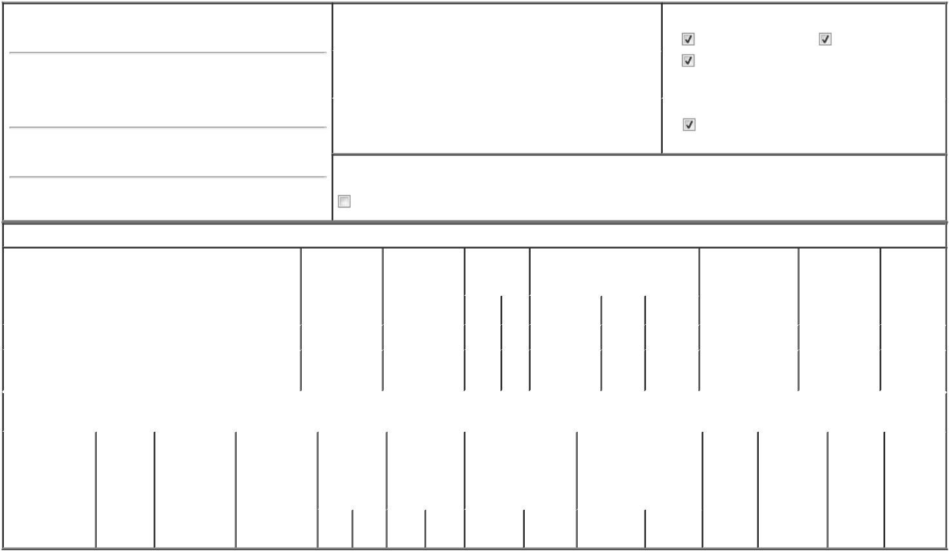

1. Name and Address of Reporting Person*
Priore Thomas Charles

(Last) (First) (Middle)

C/O PRIORITY TECHNOLOGY HOLDINGS, INC. 2001 WESTSIDE PARKWAY, SUITE 155

(Street)

ALPHARETTA GA 30004

(City) (State) (Zip)

2. |  | Issuer Name and Ticker or Trading Symbol |  | 5. Relationship of Reporting Person(s) to Issuer
Priority Technology Holdings, Inc. [ PRTH ] |  |  |  | (Check all applicable)
 |  |  |  | Director | 10% Owner
 |  |  |  | Officer (give title | Other (specify
3. |  | Date of Earliest Transaction (Month/Day/Year) |  | Officer (give title | Other (specify
 |  |  |  | below) | below)
06/14/2024 |  |  |  | below) | below)
 |  |  |  | President, CEO and Chairman
4. |  | If Amendment, Date of Original Filed (Month/Day/Year) |  | 6. Individual or Joint/Group Filing (Check Applicable Line)
 |  |  |  | Form filed by One Reporting Person
 |  |  |  | Form filed by More than One Reporting Person

Rule 10b5-1(c) Transaction Indication

Check this box to indicate that a transaction was made pursuant to a contract, instruction or written plan that is intended to satisfy the affirmative defense conditions of Rule 10b5-1(c). See Instruction 10.

Table I - Non-Derivative Securities Acquired, Disposed of, or Beneficially Owned

1. Title of Security (Instr. 3) |  |  | 2. Transaction |  |  | 2A. Deemed |  | 3. | 4. Securities Acquired (A) or Disposed |  |  |  |  | 5. Amount of |  | 6. Ownership |  | 7. Nature of
 |  |  | Date |  |  | Execution Date, |  | Transaction | Of (D) (Instr. 3, 4 and 5) |  |  |  |  | Securities |  | Form: Direct (D) |  | Indirect
 |  |  | (Month/Day/Year) |  |  | if any |  | Code (Instr. |  |  |  |  |  | Beneficially Owned |  | or Indirect (I) |  | Beneficial
 |  |  |  |  |  | (Month/Day/Year) |  | 8) |  |  |  |  |  | Following Reported |  | (Instr. 4) |  | Ownership
 |  |  |  |  |  |  |  |  |  |  |  |  |  | Transaction(s) (Instr. |  |  |  | (Instr. 4)
 |  |  |  |  |  |  |  | Code V | Amount |  | (A) or | Price |  | 3 and 4)
 |  |  |  |  |  |  |  | Code V | Amount |  | (D)
Common Stock |  |  |  | 06/14/2024 |  |  |  | P | 598,187 |  | A | $3.56 |  | 34,319,476 |  |  | D
Common Stock |  |  |  |  |  |  |  |  |  |  |  |  |  | 12,500,000 |  |  | I | see
Common Stock |  |  |  |  |  |  |  |  |  |  |  |  |  |  |  |  | I | footnote⁽¹⁾
 |  |  | Table II - Derivative Securities Acquired, Disposed of, or Beneficially Owned
 |  |  | (e.g., puts, calls, warrants, options, convertible securities)
1. Title of Derivative | 2. | 3. Transaction | 3A. Deemed |  | 4. Transaction | 5. Number of |  | 6. Date Exercisable and |  | 7. Title and Amount of |  |  |  | 8. Price of | 9. Number of |  | 10. | 11. Nature of
Security (Instr. 3) | Conversion | Date | Execution Date, |  | Code (Instr. 8) | Derivative |  | Expiration Date |  | Securities Underlying |  |  |  | Derivative | derivative |  | Ownership | Indirect
 | or Exercise | (Month/Day/Year) | if any |  |  | Securities |  | (Month/Day/Year) |  | Derivative Security (Instr. 3 |  |  |  | Security | Securities |  | Form: | Beneficial
 | Price of |  | (Month/Day/Year) |  |  | Acquired (A) or |  |  |  | and 4) |  |  |  | (Instr. 5) | Beneficially |  | Direct (D) | Ownership
 | Derivative |  |  |  |  | Disposed of (D) |  |  |  |  |  |  |  |  | Owned |  | or Indirect | (Instr. 4)
 | Security |  |  |  |  | (Instr. 3, 4 and |  |  |  |  |  |  |  |  | Following |  | (I) (Instr. 4)
 |  |  |  |  |  | 5) |  |  |  |  |  |  |  |  | Reported
 |  |  |  |  |  |  |  |  |  |  |  |  |  |  | Transaction(s)
 |  |  |  |  |  |  |  |  |  |  |  | Amount or |  |  | (Instr. 4)
 |  |  |  |  |  |  |  | Date | Expiration |  |  | Number of
 |  |  |  |  | Code V | (A) | (D) | Exercisable | Date | Title |  | Shares

Explanation of Responses:

- Includes 2,500,000 shares of PRTH common stock held by Lori A. Priore, the spouse of Thomas C. Priore, and Bernard H. Smyers, in their capacity as trustees of the Thomas C. Priore Irrevocable Insurance Trust u/a/d 1/8/2010, for the benefit of Lori A. Priore and the children of Thomas C. Priore and Lori A. Priore. Also includes 10,000,000 shares of PRTH common stock held by Lori A. Priore, the spouse of Thomas C. Priore, in her capacity as trustee of the Thomas Priore 2019 GRAT, for the benefit of Lori A. Priore and the children of Thomas C. Priore and Lori A. Priore.

Remarks:

/s/ Bradley J. Miller, Attorney-in- |  |  | 06/18/2024
Fact |  |  | 06/18/2024
** Signature of Reporting Person |  |  | Date

Reminder: Report on a separate line for each class of securities beneficially owned directly or indirectly.

* If the form is filed by more than one reporting person, see Instruction 4 (b)(v).

- Intentional misstatements or omissions of facts constitute Federal Criminal Violations See 18 U.S.C. 1001 and 15 U.S.C. 78ff(a). Note: File three copies of this Form, one of which must be manually signed. If space is insufficient, see Instruction 6 for procedure.
Persons who respond to the collection of information contained in this form are not required to respond unless the form displays a currently valid OMB Number.



